

NM DEEPIKA

CHADA HASIKA

2520030372
CSE
CO4 – Shortest Paths

Case Study Topic: BMTC Bus-Route Shortest Path with Surge-Zone Penalties

Work Done Summary:
BMTC operates a route network connecting major hubs such as MJC (Majestic), KEM (Kempegowda), JAY (Jayanagar), KOR (Koramangala), WHF (Whitefield), HBR (HBR Layout), and MRT (Marathahalli). The
objective is to determine the shortest travel path from MJC to every other hub during peak hours. Since one
route (WHF → MRT) has a negative edge weight (-3 minutes) due to dedicated bus lanes, Dijkstra's
Algorithm cannot be applied directly. Therefore, the Bellman-Ford Algorithm is used to compute the shortest
paths efficiently while handling negative edge weights.

Implementation Details:
- BMTC hubs are represented as graph vertices.
- Travel times and surge-zone penalties are represented as directed weighted edges.
- Source node is MJC (Majestic).
- Bellman-Ford Algorithm is applied to handle negative edge weights.
- All edges are relaxed repeatedly for V-1 iterations.
- Shortest distance from MJC to every hub is calculated.
- The algorithm can also detect negative-weight cycles if present.
- Final shortest routes help BMTC dispatchers optimize bus scheduling.
Output:
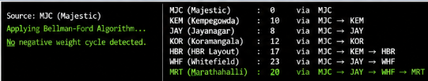
The BMTC Bus-Route Shortest Path system successfully demonstrates the practical application of the Bellman-Ford Algorithm in transportation networks containing negative edge weights. The algorithm accurately
computes the shortest travel times and identifies optimal routes even when special bus-lane bonuses reduce
travel costs.
This approach helps improve route planning, dispatcher decision-making, and overall transportation efficiency.
Github link:

