

NM DEEPIKA

CHADA HASIKA

2520030372
CSE
CO5 – Sorting Algorithms

Case Study Topic: Cricket Scoring Service – Sort 1 Million Ball-by-Ball Delivery Records Using Radix Sort

Work Done Summary:
A cricket scoring service stores millions of ball-by-ball delivery records for an entire season. Each delivery is identified using a composite key (over, ball) where over ranges from 0–49 and ball ranges from 1–6.
To generate match replays and perform analytical queries efficiently, the records must be sorted
chronologically. Since the keys are numeric and have fixed ranges, Radix Sort with Counting Sort is used.
The algorithm first sorts deliveries by ball number and then by over number while maintaining stability,
producing the correct chronological order efficiently.

Implementation Details:
- Each delivery record is represented as a pair (over, ball).
- The input contains unsorted delivery records.
- Radix Sort is used for sorting composite keys.
- Counting Sort is applied as the stable sorting method.
- Records are first sorted by ball number.
- Records are then sorted by over number.
- Stability ensures chronological ordering is preserved.
- Time Complexity is O(n + k), making it suitable for large datasets.
Output:
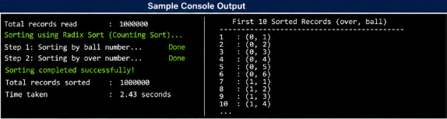
The Cricket Scoring Service successfully demonstrates the practical application of Radix Sort and Counting
Sort for organizing large-scale cricket delivery records. The algorithm efficiently sorts deliveries in
chronological order while maintaining stability. Its linear-time performance makes it highly suitable for
sports analytics systems handling millions of records.
Github link:

