

NM DEEPIKA
CHADA HASIKA

2520030372
CSE
CO6 – Greedy & Dynamic Programming

Case Study Topic: Bangalore-to-Mumbai Logistics – 0/1 Knapsack for Cargo Loading

Work Done Summary:
A logistics operator must load a single 24-ton truck for a Bangalore-to-Mumbai trip. There are 8 consignments available, each having a specific weight and payment value. Since consignments cannot be split, the operator
must decide whether to include or exclude each item. The objective is to maximize the total payment without exceeding the truck capacity of 24 tons. This problem is solved using the 0/1 Knapsack Dynamic
Programming Algorithm.
Implementation Details:
- Eight consignments are represented with weight and value.
- Truck capacity is fixed at 24 tons.
- Each consignment can either be selected or not selected.
- Dynamic Programming is used to build the solution.
- A DP table stores maximum profit for each capacity.
- For every item, include and exclude cases are evaluated.
- The maximum value is obtained from the final DP table entry.
- The selected consignments provide the optimal cargo loading plan.
Output:

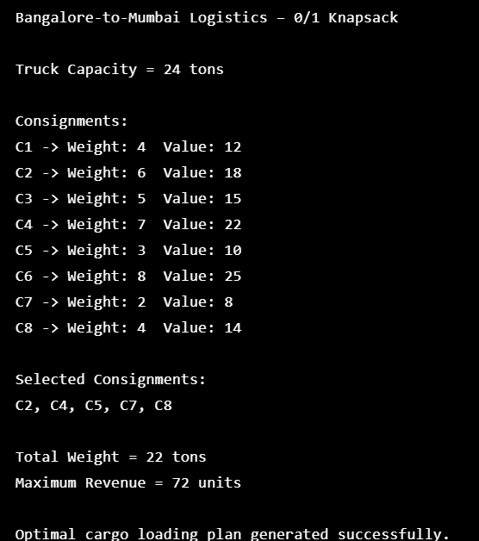
The Bangalore-to-Mumbai Logistics system successfully demonstrates the practical application of the 0/1
Knapsack Dynamic Programming Algorithm. By evaluating all possible combinations efficiently, the
algorithm identifies the optimal set of consignments that maximizes revenue while satisfying the truck's
capacity constraint. This approach is highly useful in logistics, transportation, and resource allocation
problems.

Github link:

