Practical No.01

Aim : Develop Applications using Google AppEngine

Or
Practical 1 (AWS Version): Deploy Application using AWS Elastic Beanstalk
Create a simple "Hello World" Python application and deploy it to the AWS Cloud.

Phase 1: Prepare Your Code


AWS Elastic Beanstalk expects your main file to be named application.py by default (unlike GAE, which uses main.py).
- Create a folder named aws_project.


- Create File 1: application.py

Note: The variable inside must be named application, not app.
Python code :
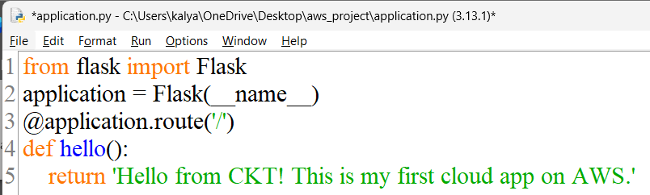

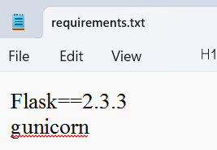
- Create File 2: requirements.txt
Plaintext
Flask==2.3.3
gunicorn

- Create a ZIP file:
  - Select both application.py and requirements.txt.
  - Right-click > Send to > Compressed (zipped) folder.

  - Name it myapp.zip.

Phase 2: Deploy using AWS Console
- Log in to the AWS Management Console.
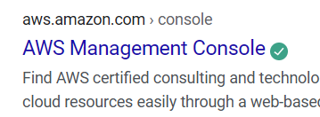
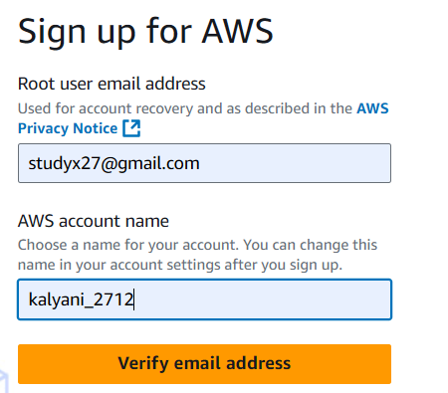

And do Successful Login to bthe aws management console
- In the search bar at the top, type "Elastic Beanstalk" and select it.
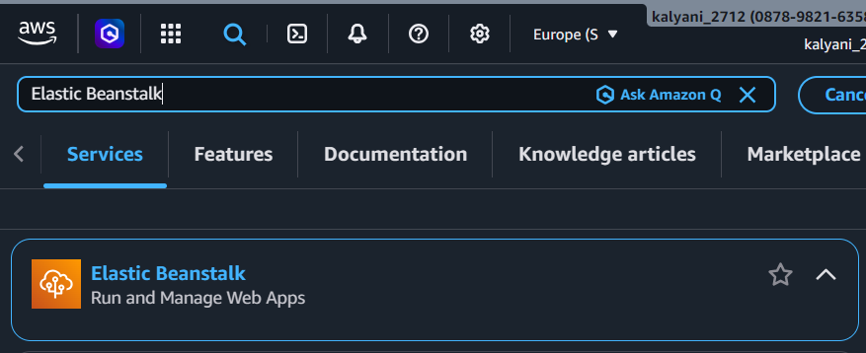
- Click the orange button "Create application". 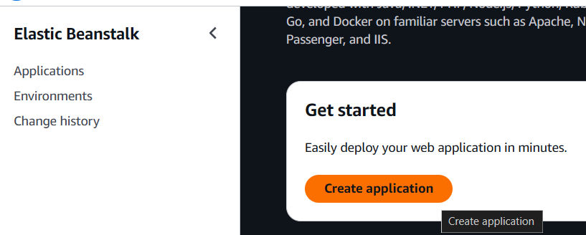
- Configure the Application:
  - Application Name: Enter MyStudentApp. 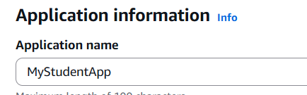
  - Platform: Select Python.
  - Platform Branch: Keep the default (e.g., Python 3.11 running on 64bit Amazon Linux 2023).
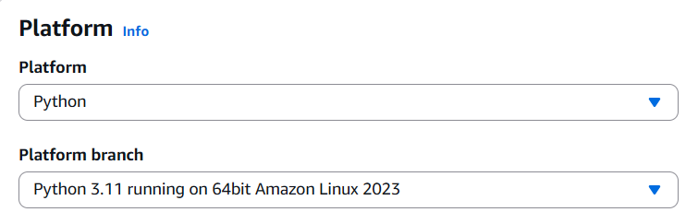
- Application Code:
  - Select "Upload your code".
  - Version Label: Give it a name like v1.
  - Source Code Origin: Select "Local file" and upload the myapp.zip file you created in Phase 1.
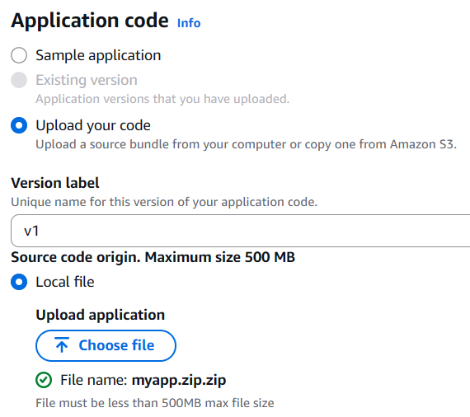
- Presets (Crucial for Free Tier):
- Look for "Presets" options (sometimes hidden under "Configure more options"). Ensure "Single instance (Free Tier eligible)" is selected. This prevents AWS from launching expensive load balancers. 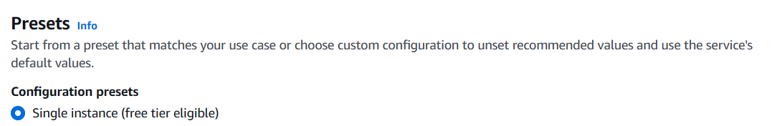
- Create Role for service Role and EC2 Insyance profile .just click on Create role after entering to that page just click next>next>create role it automatically create the roles
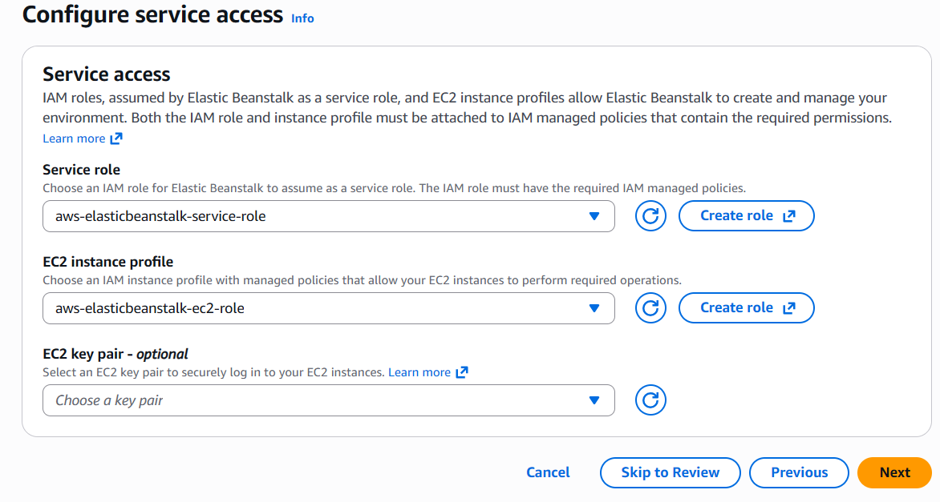
- Click "Next" through the Service Access steps (you may need to create a default service role if this is your first time—AWS will guide you to just click "Create and use new service role").
- Keep clicking "Next" or "Skip to Review" until you see the "Submit" button.
- Click "Submit or Create ".
Phase 3: Verify and Run
- AWS will now create your environment. You will see a black screen with logs scrolling (e.g., "Created EIP", "Created Security Group"). This takes about 3–5 minutes.
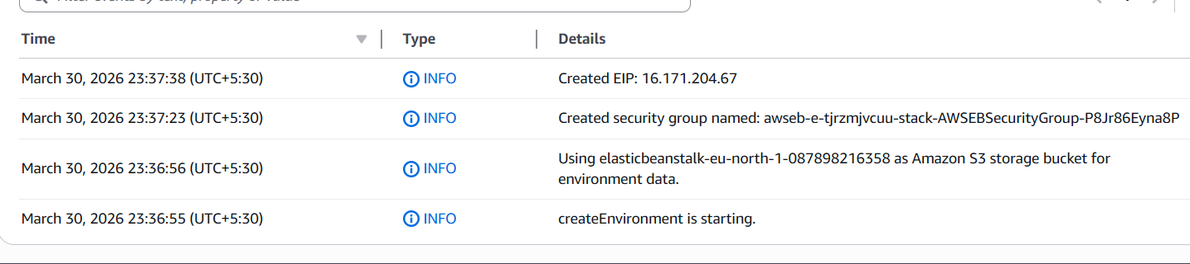
- Once the status turns to a big green checkmark (Health: Ok), look for the Domain link near the top of the screen.
  - It will look something like: mystudentapp-env.eba-xyz.us-east-1.elasticbeanstalk.com.
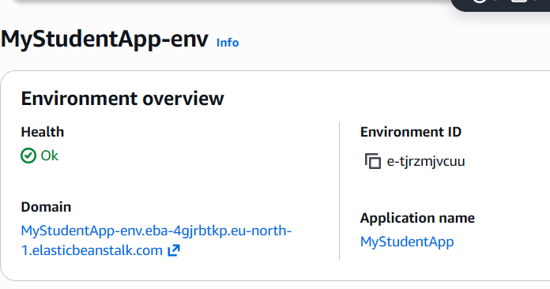
- Click that link.
  - Output: You should see "Hello from CKT! This is my first cloud app on AWS." in your browser.
