Practical No. 8
Aim: Study and implementation of Single-Sign-On.

1. Visit the Auth0 website:

- Open your Chrome browser and go to the URL:
https://auth0.com/learn/how-to-implement-single-sign-on

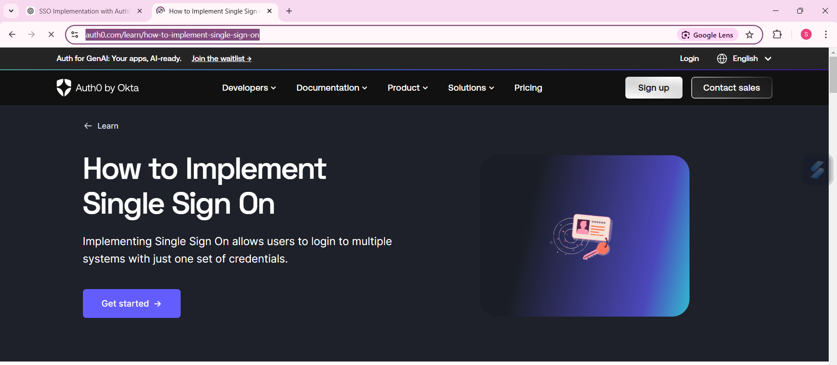

2. Sign up for Auth0:

- If you don’t have an account, you will be prompted to sign up.
- Provide the required details:
- User name (e.g., email or a custom username)
- After entering the username, click Next.
- On the next screen, select:
- Account Type: Personal
- Scroll down, and click Try for Free to proceed.

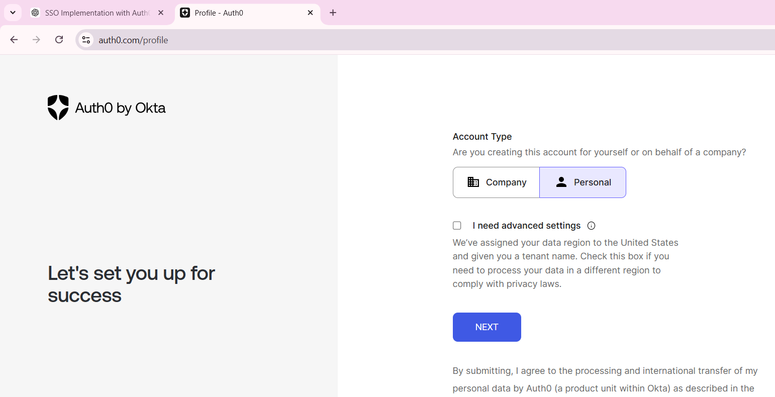

3. Create your account:

- Click Login
- Fill in your information (email, password, etc.), and click Next to complete the signup process.

4. Navigate to the Dashboard:

- After successfully signing up, you will be redirected to your Auth0 Dashboard.
- Here, you can manage applications and services.

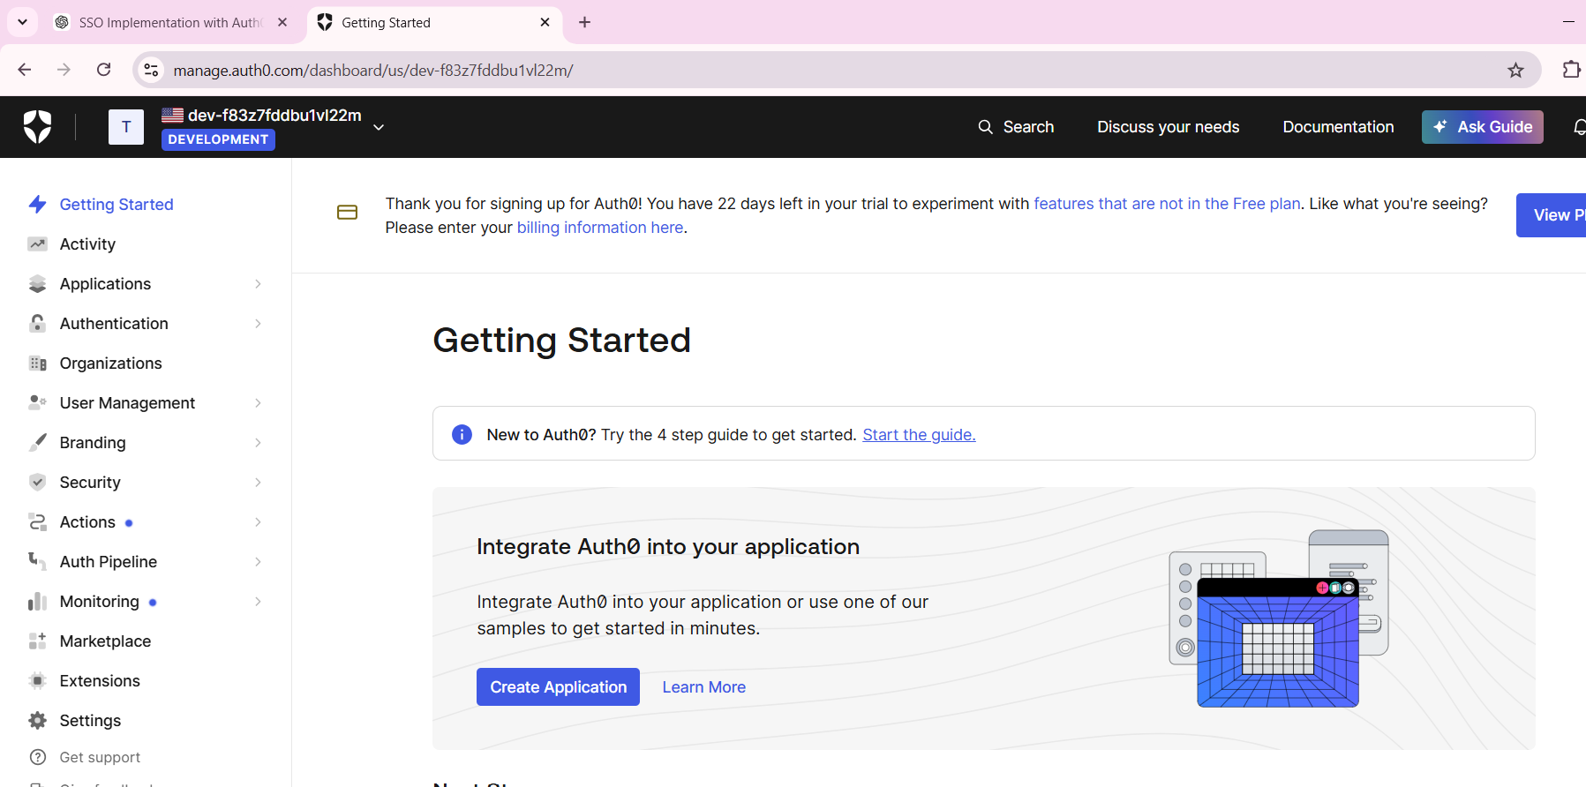

5. Configure Authentication (SSO):

- Click on Authentication from the left sidebar.
- Select Social under the Authentication section.
- From the list of social providers, click on Google OAuth2 (Google will be used for Social Login integration).

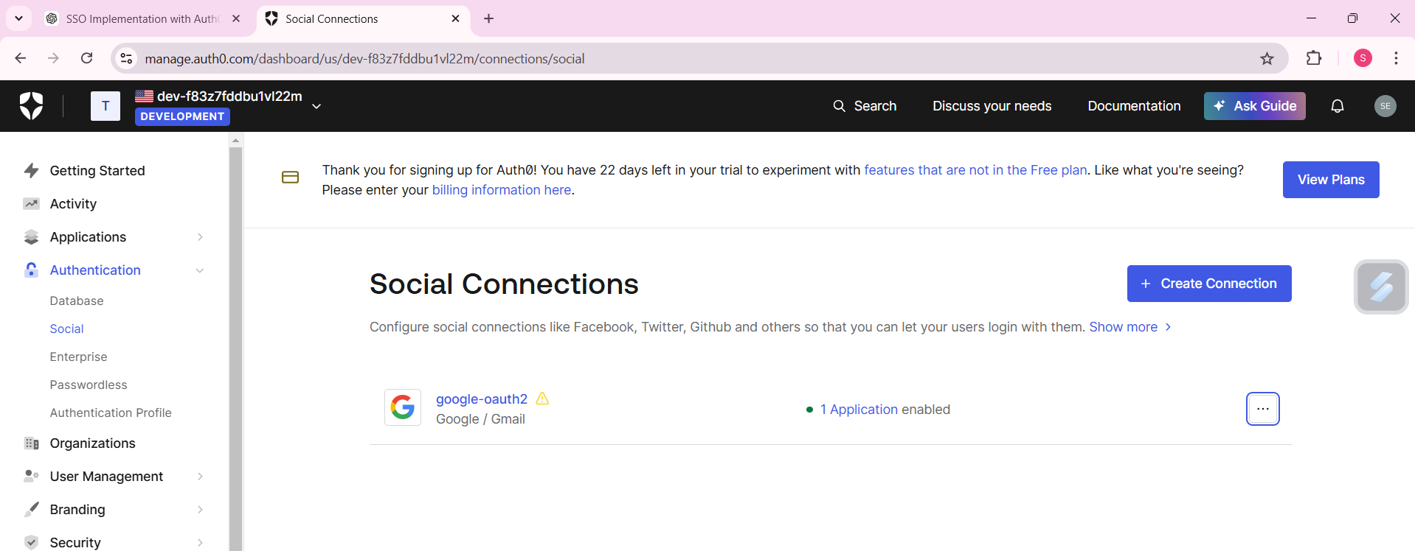

6. Try Connection:

- After selecting Google OAuth2, click on the Try Connection button.
- You will be prompted to sign in with your Google account to complete the setup.
- Once signed in with your Google account, you should see confirmation that the connection has been successfully established.

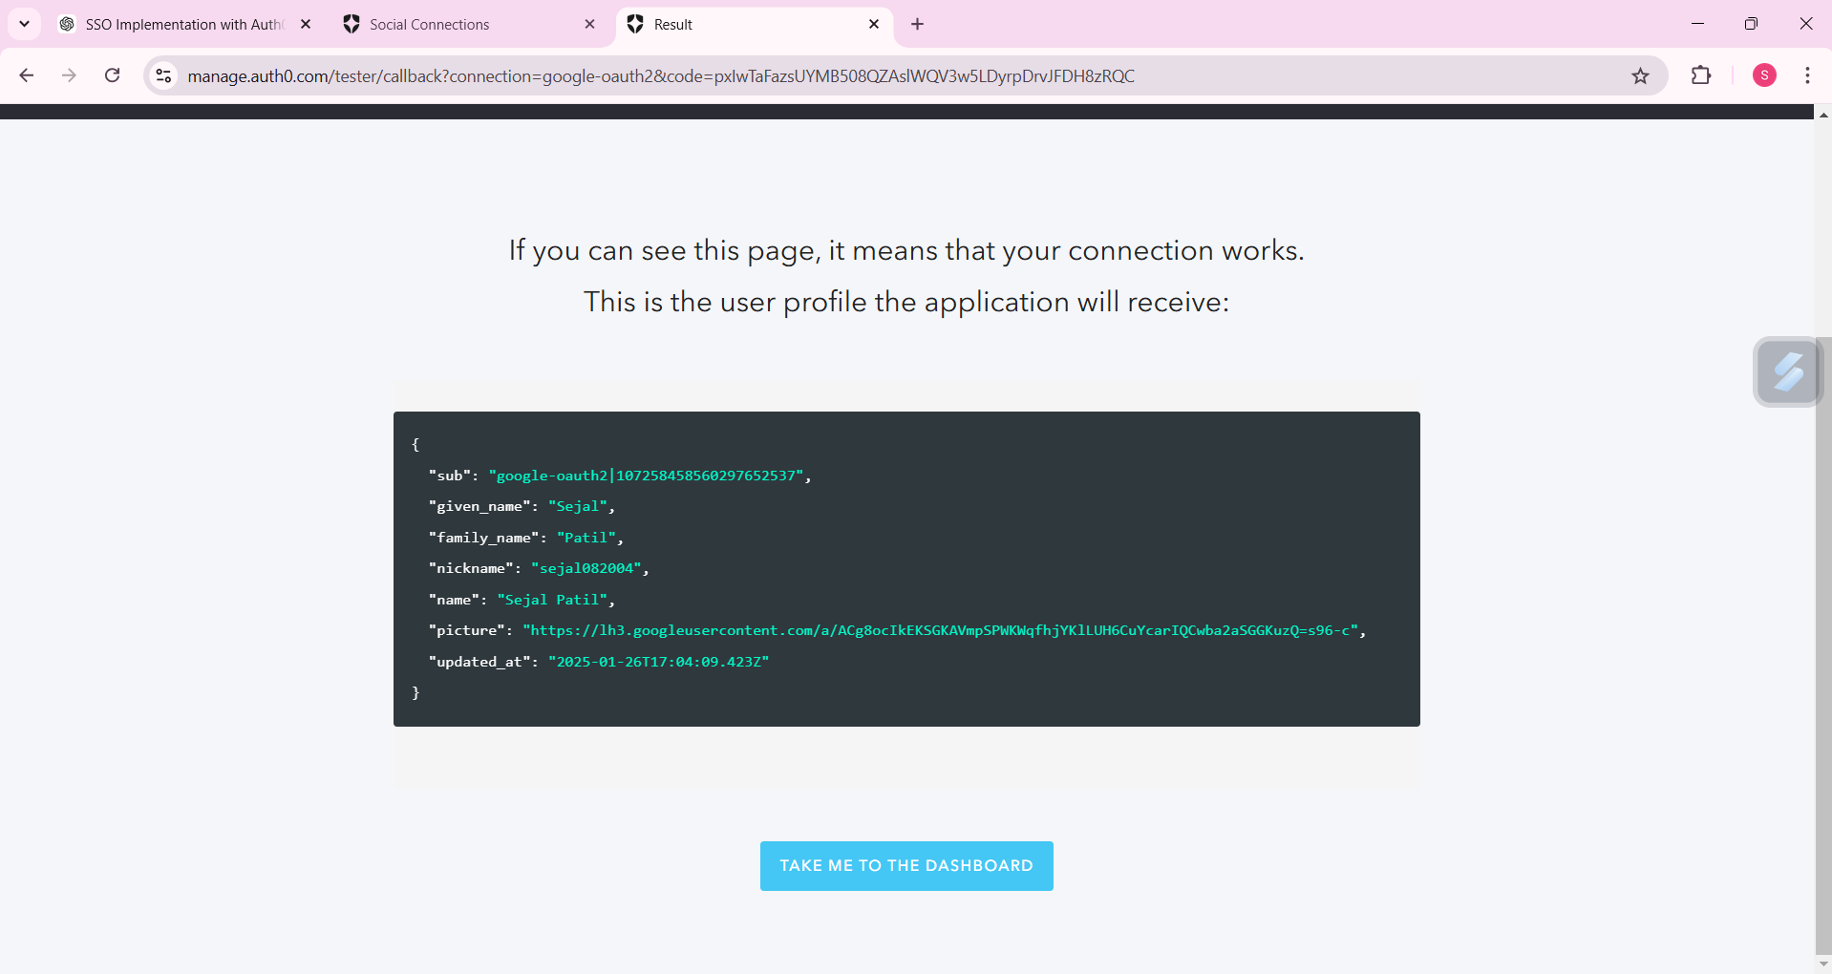

7. Test and Use:

Start the Guide:
- Once your authentication (SSO) is set up, click on Start the Guide to proceed with integration steps for your application.
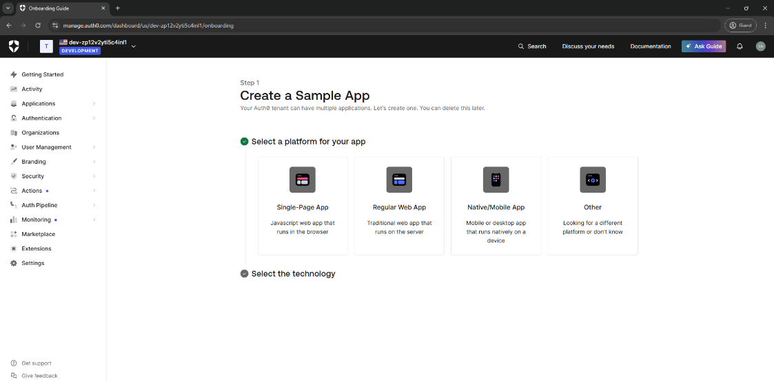
Select Application Type:
- Choose Others to customize the integration according to your needs.
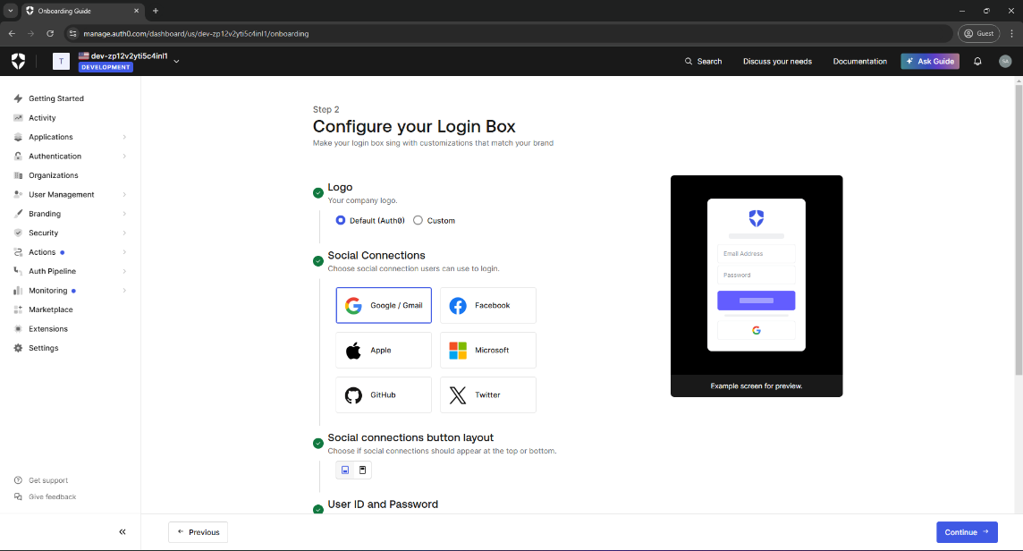
Design Your Application:
- Tailor the application setup based on your requirements and click Continue to proceed with configuration.
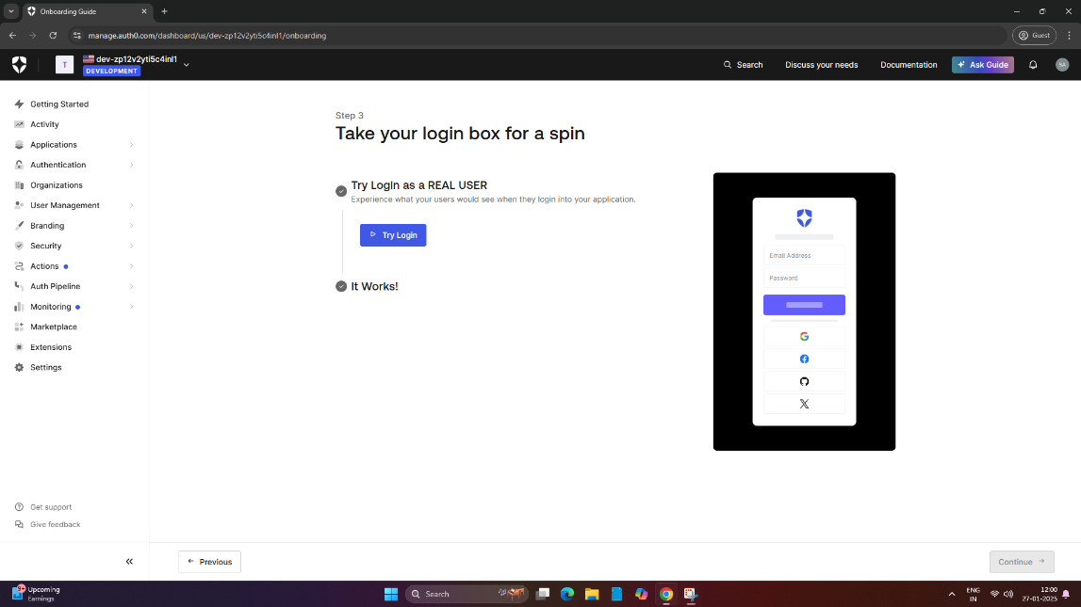
Test Login:
- Click on Try Login to test the SSO process.
- If prompted, choose Continue with Google to authenticate using your Google account.
- If successful, you will be redirected to your Google account page.

