DSRIP Chapter Updates

2023-10-09

# TO DO

* ☐ Color pallete
* ☐ Verify dates and years are correct
* ☐ check table when missing
* ☐ Need to add oeq.R from APM to emilys path

# Questions

* Should I change axis on 1.4 from 17, 18, etc to the same DYY (YYYY)

###### Table II.7 RHP participation rates by year

part_rate

| RHP | DY9 (2020) | DY10 (2021) | DY11 (2022) | Total |
| --- | --- | --- | --- | --- |
| 1 | 85.0%(17) | 50.0%(10) | 95.0%(19) | 20 |
| 2 | 80.0%(12) | 66.7%(10) | 86.7%(13) | 15 |
| 3 | 76.0%(19) | 72.0%(18) | 72.0%(18) | 25 |
| 4 | 81.2%(13) | 37.5%(6) | 100.0%(16) | 16 |
| 5 | 90.0%(9) | 50.0%(5) | 70.0%(7) | 10 |
| 6 | 77.3%(17) | 72.7%(16) | 90.9%(20) | 22 |
| 7 | 100.0%(7) | 71.4%(5) | 85.7%(6) | 7 |
| 8 | 58.3%(7) | 83.3%(10) | 83.3%(10) | 12 |
| 9 | 59.1%(13) | 86.4%(19) | 95.5%(21) | 22 |
| 10 | 62.5%(15) | 91.7%(22) | 95.8%(23) | 24 |
| 11 | 78.6%(11) | 71.4%(10) | 92.9%(13) | 14 |
| 12 | 73.5%(25) | 64.7%(22) | 88.2%(30) | 34 |
| 13 | 76.9%(10) | 84.6%(11) | 84.6%(11) | 13 |
| 14 | 100.0%(8) | 75.0%(6) | 87.5%(7) | 8 |
| 15 | 100.0%(8) | 62.5%(5) | 100.0%(8) | 8 |
| 16 | 100.0%(7) | 71.4%(5) | 85.7%(6) | 7 |
| 17 | 83.3%(10) | 91.7%(11) | 91.7%(11) | 12 |
| 18 | 100.0%(6) | 100.0%(6) | 100.0%(6) | 6 |
| 19 | 81.8%(9) | 90.9%(10) | 90.9%(10) | 11 |
| 20 | 75.0%(3) | 25.0%(1) | 100.0%(4) | 4 |
| Texas | 77.9%(226) | 71.7%(208) | 89.3%(259) | 290 |

###### Measure 1.1.2

(JSD, RS, DSA)

dpm112jsdplot

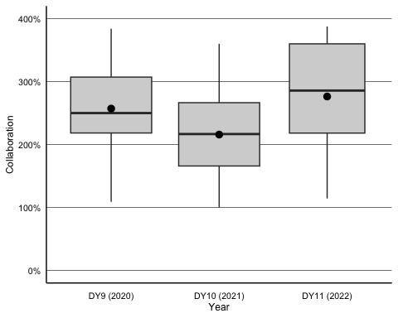

dpm112trsplot

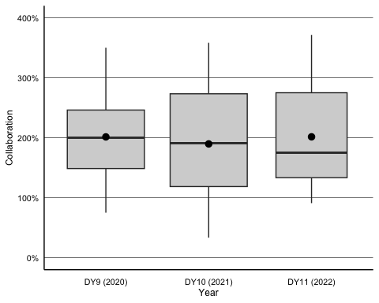

dpm112dsaplot

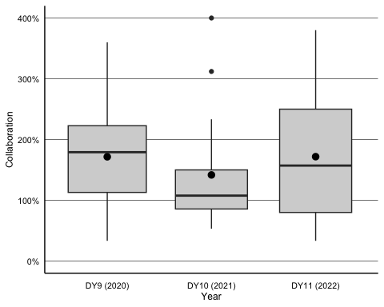

###### Figure II.3. Strength of network ties

(Measure 1.1.3 - Density)

dpm113denplot

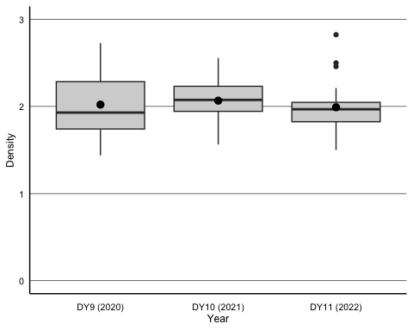

###### Figure II.4. Average density of network ties

(JSD, RS, DSA)

dpm114jsdplot

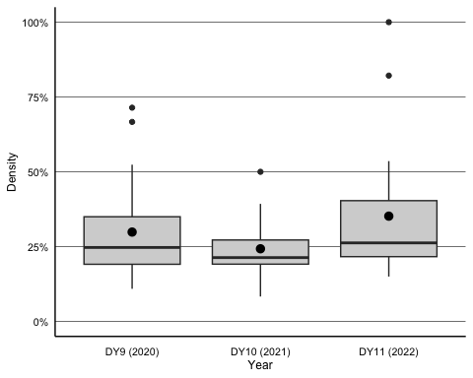

dpm114trsplot

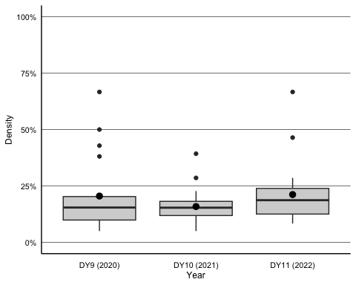

dpm114dsaplot

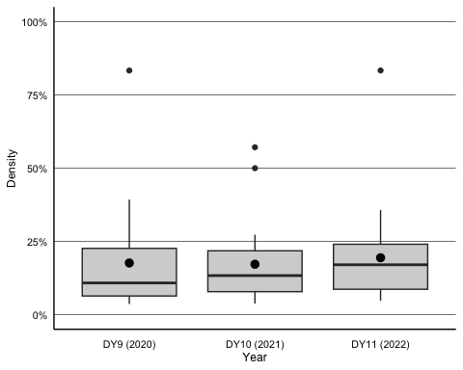

###### Figure II.5. Average centralization of network ties

dpm115jsdplot

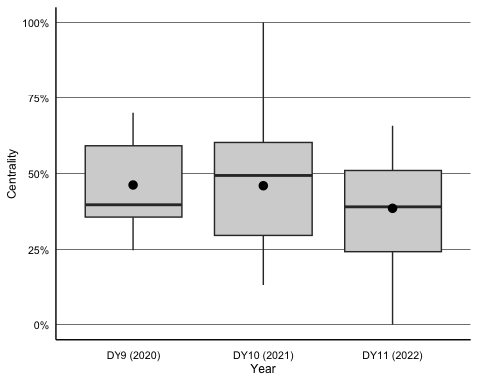

dpm115trsplot

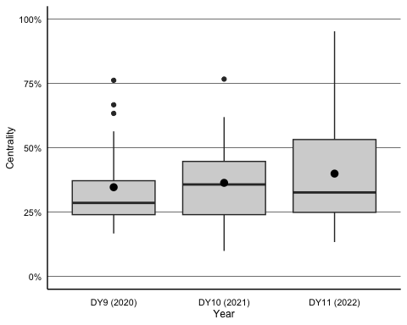

dpm115dsaplot

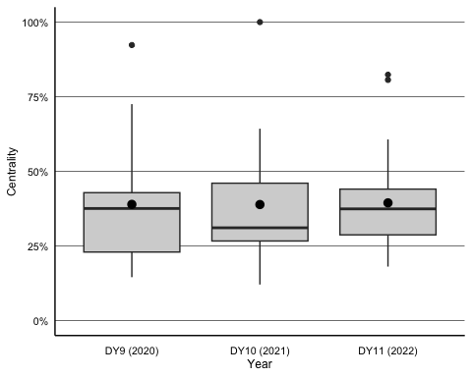

## Measure 1.1.6

Attitude toward Collaboration

To understand the attitudes of DSRIP-participating providers toward DSRIP’s impact on collaborative relationships, specifically care coordination, providers were asked about the extent to which they agreed or disagreed with the following statements:

• DSRIP has increased the level of care coordination between different DSRIP providers.

• DSRIP has increased the level of care coordination between DSRIP and non-DSRIP providers.

###### DSRIP has increased the level of care coordination between different DSRIP providers.

new_dc1$prim_vis_bar_tot

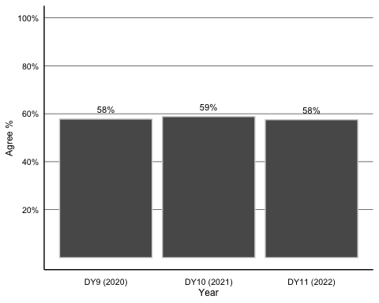

Difference between 2020 responses and 2022 responses is not statistically significant after conducting Wilcoxon Rank Sum Test (p = 0.952 V = 30795.)

###### DSRIP has increased the level of care coordination between DSRIP and non-DSRIP providers.

new_dc2$prim_vis_bar_tot

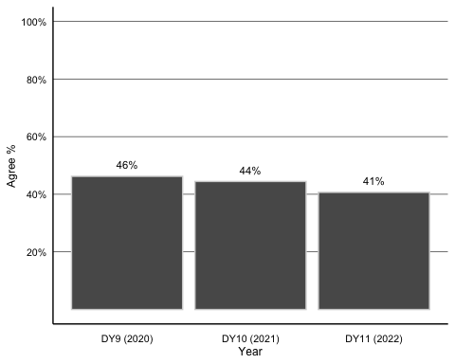

Difference between 2020 responses and 2022 responses is not statistically significant after conducting Wilcoxon Rank Sum Test (p = 0.213 V = 32421.)

###### Table II.11 Health Information Exchanges used by Participating Providers

hie_other_oeq

| Organization | DY9 (2020) | DY10 (2021) | DY11 (2022) |
| --- | --- | --- | --- |
| Care- Quality | 0% (0) | 4% (3) | 6% (5) |
| Cerner Direct | 0% (0) | 6% (4) | 0% (0) |
| Commonwell Health Alliance | 6% (3) | 8% (5) | 6% (5) |
| Epic/ Care Everywhere | 8% (4) | 4% (3) | 2% (1) |
| Greater Houston Healthconnect | 26% (14) | 28% (17) | 20% (17) |
| HIE Texas | 2% (1) | 2% (1) | 26% (21) |
| Healthcare Access San Antonio (HASA) | 20% (10) | 28% (17) | 22% (18) |
| Integrated Care Collaboration (ICC) | 2% (1) | 4% (3) | 4% (3) |
| OTHER | 18% (9) | 2% (1) | 2% (2) |
| Pasa Del Norte Health Information Exchange (PHIX) | 12% (6) | 8% (5) | 8% (7) |
| Rio Grand HIE | 8% (4) | 4% (3) | 4% (3) |

Total number of organization counts for 2020 = 52, 2021 = 62, 2022 = 82.

###### Table II.12 Number and percentage of external organizations that provided DSRIP data

out_data_oeq

| Organization | DY9 (2020) | DY10 (2021) | DY11 (2022) |
| --- | --- | --- | --- |
| Community Clinic | 16% (11) | 10% (8) | 12% (8) |
| Contracted Providers | 18% (12) | 16% (12) | 16% (11) |
| Epic | 2% (1) | 6% (4) | 2% (2) |
| Federal Agency | 8% (6) | 10% (8) | 12% (8) |
| Inpatient Data | 4% (3) | 0% (0) | 2% (2) |
| MedicalSchool or University | 6% (4) | 4% (3) | 2% (1) |
| Other | 10% (7) | 8% (6) | 10% (7) |
| Other HIE Network | 4% (3) | 8% (6) | 6% (4) |
| Outpatient Data | 6% (4) | 6% (5) | 8% (5) |
| Regional HIE | 14% (9) | 6% (5) | 12% (8) |
| State Agency | 12% (8) | 22% (16) | 16% (11) |

Total number of organization counts for 2020 = 68, 2021 = 73, 2022 = 67.

###### Figure II.4 Overall Provider Achievement for A1-508 Rate of ED Visits for Diabetes

m1$prim_vis

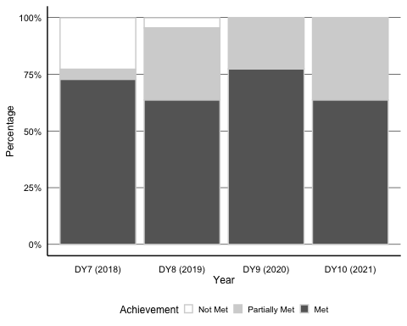

###### Figure II.5 Population Impact: Change in Weighted Mean Rate: A1-508 Rate of ED Visits for Diabetes

ma1$wt_fig

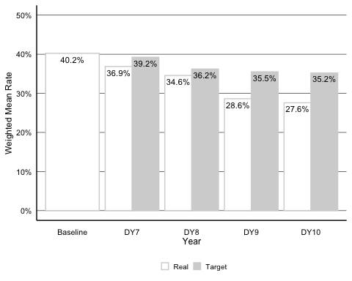

Difference between weighted baseline rate and 2021 weighted rate is statistically significant after conducting a Paired Wilcoxon Signed Rank Test (V = 192, p = 0.033).

###### Figure II.6 Overall Provider Achievement for A2-509 Rate of ED Visits for CHF, Angina, and Hypertension

m2$prim_vis

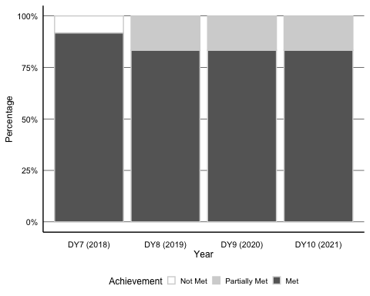

###### Figure II.7 Population Impact: Change in Weighted Mean Rate: A2-509 Rate of ED Visits for CHF, Angina, and Hypertension

ma2$wt_fig

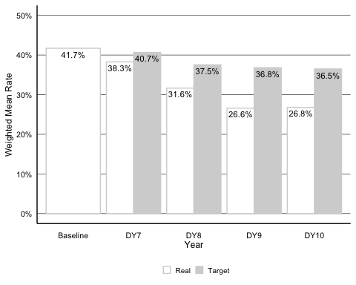

Difference between weighted baseline rate and 2021 weighted rate is not statistically significant after conducting a Paired Wilcoxon Signed Rank Test (V = 64, p = 0.052).

###### Figure II.8 Overall Provider Achievement for H2-510 Rate for Behavioral Health and Substance Abuse

m3$prim_vis

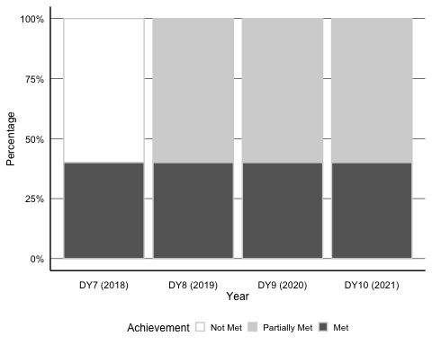

###### Figure II.9 Population Impact: Change in Weighted Mean Rate: H2-510 Rate for Behavioral Health and Substance Abuse

(Comparison of Real and Target Weighted Mean Rates)

ma3$wt_fig

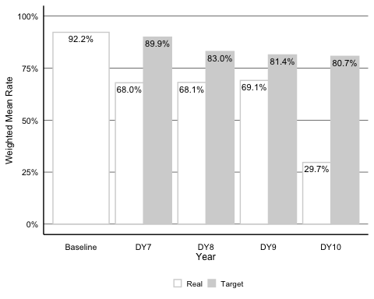

Difference between weighted baseline rate and 2021 weighted rate is not statistically significant after conducting a Paired Wilcoxon Signed Rank Test (V = 15, p = 0.062).

###### Figure II.10 Overall Provider Achievement for C1-502 Rate for the Adult Acute Composite Indicator

m4$prim_vis

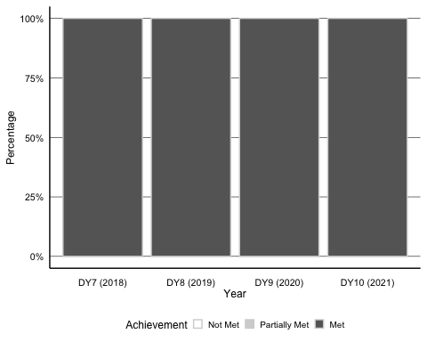

###### Figure II.11 Population Impact: Change in Weighted Mean Rate: C1-502 Rate for the Adult Acute Composite Indicator

(Comparison of Real and Target Weighted Mean Rates)

ma4$wt_fig

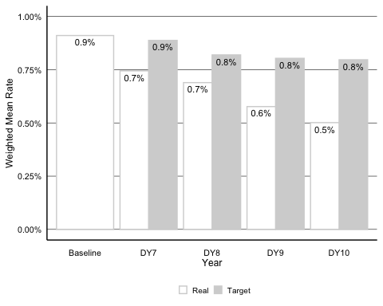

Difference between weighted baseline rate and 2021 weighted rate is statistically significant after conducting a Paired Wilcoxon Signed Rank Test (V = 136, p = 0.003).

###### Figure II.12 Overall Provider Achievement for D1-503 Rate for the Child Acute Composite Indicator

m5$prim_vis

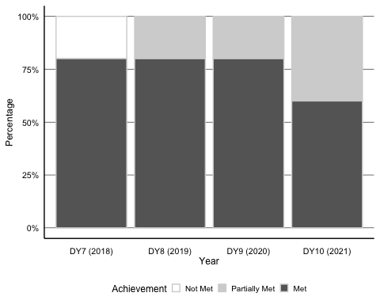

###### Figure II.13 Population Impact: Change in Weighted Mean Rate: D1-503 Rate for the Child Acute Composite Indicator

(Comparison of Real and Target Weighted Mean Rates)

ma5$wt_fig

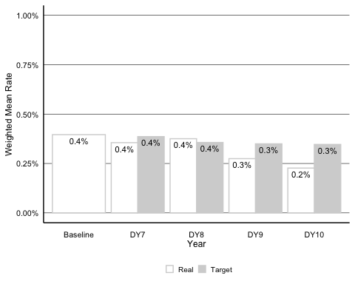

Difference between weighted baseline rate and 2021 weighted rate is not statistically significant after conducting a Paired Wilcoxon Signed Rank Test (V = 41, p = 0.193).

###### Figure II.14 Potentially Preventable Admissions

(PPA) **Change y axis**

ppa_sum_graph_w

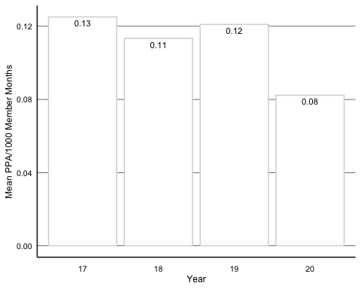

Difference between 2017 and 2020 weighted rates is statistically significant after conducting a Paired Wilcoxon Signed Rank Test (V = 207, p < .05).

###### Figure II.15 Potentially Preventable Readmissions

(PPR)

ppr_sum_graph_w

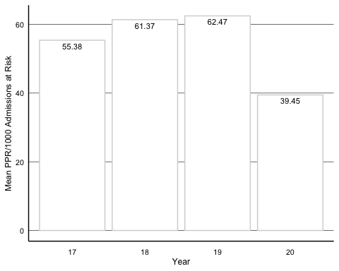

Difference between 2017 and 2020 weighted rates is statistically significant after conducting a Paired Wilcoxon Signed Rank Test (V = 206, p < .05).

###### Figure II.16 Potentially Preventable Complications

(PPC)

ppc_sum_graph_w

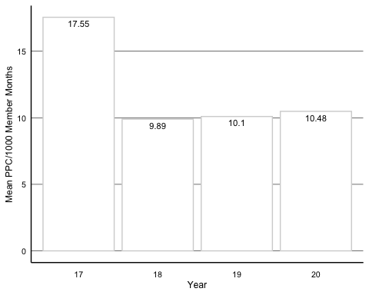

Difference between 2017 and 2020 weighted rates is statistically significant after conducting a Paired Wilcoxon Signed Rank Test (V = 207, p < .05).

###### Figure II.17 Potentially Preventable ED Visits Actual-to-Expected Ratios

(PPV)

ppv_sum_graph_w

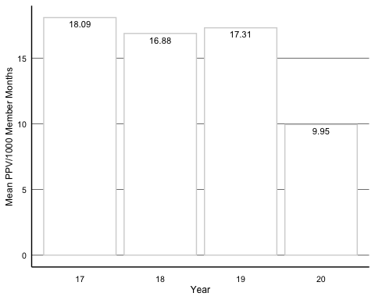

Difference between 2017 and 2020 weighted rates is statistically significant after conducting a Paired Wilcoxon Signed Rank Test (V = 210, p < .05).

# Appendix

###### Table B.20 Provider Measure Achievement: A1-508 Rate of ED Visits for Diabetes

###### Rate of Emergency Department Visits for Diabetes (A1-508: DSRIP Category C Measure 1.3.1)

###### Summary Statistics by Year and Measure Achievement: Rate of Emergency Department Visits for Diabetes

m1$summary_stats

| Measure Achievement | DY7 % (#) (n = 22) | DY8 % (#) (n = 22) | DY9 % (#) (n = 22) | DY10 % (#) (n = 22) |
| --- | --- | --- | --- | --- |
| Not Met | 22.7 (5) | 4.5 (1) | - | - |
| Partially Met | 4.5 (1) | 31.8 (7) | 22.7 (5) | 36.4 (8) |
| Met | 72.7 (16) | 63.6 (14) | 77.3 (17) | 63.6 (14) |

###### Figure B.6 Change in Unweighted Mean Rate: A1-508 Rate of ED Visits for Diabetes

(Comparison of Real and Target Mean Rates)

ma1$uw_fig

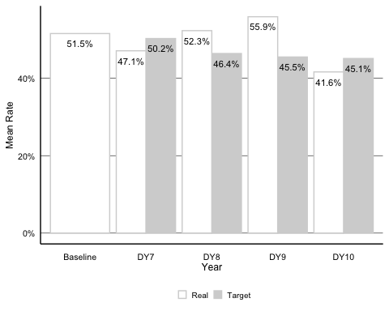

Difference between baseline rate and 2021 rate is not statistically significant after conducting a Paired Wilcoxon Signed Rank Test (V = 186, p = 0.054).

###### Table B.21 Provider Measure Achievement: A2-509 Rate of ED Visits for CHF, Angina, and Hypertension

###### Summary Statistics by Year and Measure Achievement: Rate of Emergency Department Visits for CHF, Angina, and Hypertension

m2$summary_stats

| Measure Achievement | DY7 % (#) (n = 12) | DY8 % (#) (n = 12) | DY9 % (#) (n = 12) | DY10 % (#) (n = 12) |
| --- | --- | --- | --- | --- |
| Not Met | 8.3 (1) | - | - | - |
| Met | 91.7 (11) | 83.3 (10) | 83.3 (10) | 83.3 (10) |
| Partially Met | - | 16.7 (2) | 16.7 (2) | 16.7 (2) |

###### Figure B.3 Change in Unweighted Mean Rate: A2-509 Rate of ED Visits for CHF, Angina, and Hypertension

(Comparison of Real and Target Mean Rates)

ma2$uw_fig

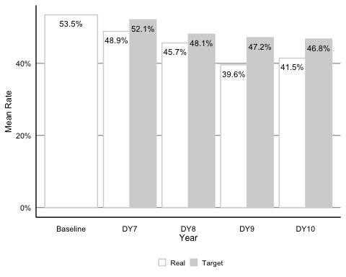

Difference between baseline rate and 2021 rate is not statistically significant after conducting a Paired Wilcoxon Signed Rank Test (V = 62, p = 0.077).

###### Table B.22 Provider Measure Achievement: H2-510 Rate of Emergency Department Visits for Behavioral Health and Substance Abuse

###### Summary Statistics by Year and Measure Achievement: Rate of Emergency Department Visits for Behavioral Health and Substance Abuse

m3$summary_stats

| Measure Achievement | DY7 % (#) (n = 5) | DY8 % (#) (n = 5) | DY9 % (#) (n = 5) | DY10 % (#) (n = 5) |
| --- | --- | --- | --- | --- |
| Not Met | 60 (3) | - | - | - |
| Met | 40 (2) | 40 (2) | 40 (2) | 40 (2) |
| Partially Met | - | 60 (3) | 60 (3) | 60 (3) |

###### Figure B.4 Change in Unweighted Mean Rate: H2-510 Rate of Emergency Department Visits for Behavioral Health and Substance Abuse

(Comparison of Real and Target Mean Rates)

ma3$uw_fig

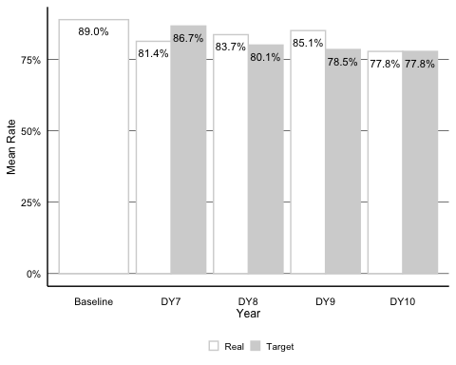

Difference between baseline rate and 2021 rate is not statistically significant after conducting a Paired Wilcoxon Signed Rank Test (V = 10, p = 0.625).

###### Table B.23 Provider Measure Achievement: C1-502 PQI 91 Adult Acute Composite Indicator

###### Summary Statistics by Year and Measure Achievement: Prevention Quality Indicator 91: Adult Acute Composite Indicator

m4$summary_stats

| Measure Achievement | DY7 % (#) (n = 17) | DY8 % (#) (n = 17) | DY9 % (#) (n = 17) | DY10 % (#) (n = 17) |
| --- | --- | --- | --- | --- |
| Met | 100 (17) | 100 (17) | 100 (17) | 100 (17) |

###### Figure B.5 Change in Unweighted Mean Rate: C1-502 PQI 91 Adult Acute Composite Indicator

(Comparison of Real and Target Mean Rates)

ma4$uw_fig

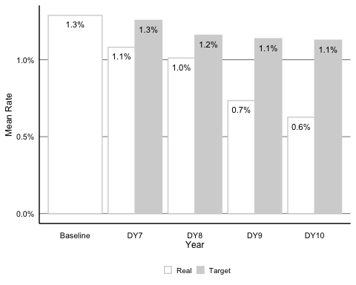

Difference between baseline rate and 2021 rate is statistically significant after conducting a Paired Wilcoxon Signed Rank Test (V = 144, p = 0.001).

###### Table B.24 Provider Measure Achievement: D1-503 PDI 91 Child Acute Composite Indicator

###### Summary Statistics by Year and Measure Achievement: Pediatric Quality Indicator 91: Child Acute Composite Indicator

m5$summary_stats

| Measure Achievement | DY7 % (#) (n = 10) | DY8 % (#) (n = 10) | DY9 % (#) (n = 10) | DY10 % (#) (n = 10) |
| --- | --- | --- | --- | --- |
| Not Met | 20 (2) | - | - | - |
| Met | 80 (8) | 80 (8) | 80 (8) | 60 (6) |
| Partially Met | - | 20 (2) | 20 (2) | 40 (4) |

###### Figure B.6 Change in Unweighted Mean Rate: D1-503 PDI 91 Child Acute Composite Indicator

(Comparison of Real and Target Mean Rates)

ma5$uw_fig

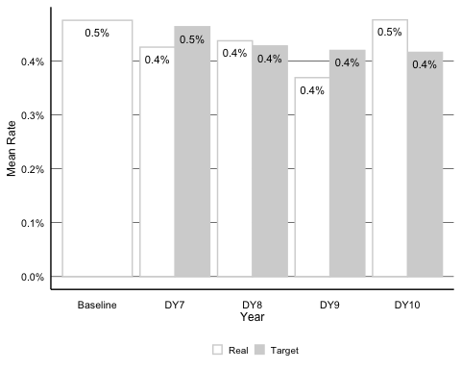

Difference between baseline rate and 2021 rate is not statistically significant after conducting a Paired Wilcoxon Signed Rank Test (V = 26, p = 0.922).

###### Table B.25 Summary Statistics by Year: Potentially Preventable Admissions (PPA)

###### Summary Statistics by Year: 1.4.1 Potentially Preventable Admissions (PPA)

ppa_summary_stats

| Year | Sample Size | Unweighted Mean (SD) | Unweighted Median (IQR) | Weighted Mean (SD) | Weighted Median (IQR) |
| --- | --- | --- | --- | --- | --- |
| 17 | 20 | 0.81 (0.22) | 0.78 (0.33) | 0.13 (0.04) | 0.13 (0.06) |
| 18 | 20 | 0.78 (0.23) | 0.76 (0.22) | 0.11 (0.04) | 0.12 (0.04) |
| 19 | 20 | 0.8 (0.21) | 0.8 (0.21) | 0.12 (0.04) | 0.11 (0.04) |
| 20 | 20 | 0.61 (0.21) | 0.55 (0.19) | 0.08 (0.04) | 0.08 (0.03) |

Difference between 2017 and 2020 unweighted rates is statistically significant after conducting a Paired Wilcoxon Signed Rank Test (V = 207, p < .05). Difference between 2017 and 2020 weighted rates is statistically significant after conducting a Paired Wilcoxon Signed Rank Test (V = 207, p < .05).

###### Table B.26 Summary Statistics by Year: Potentially Preventable Readmissions (PPR)

###### Summary Statistics by Year: 1.4.2 Potentially Preventable Readmissions (PPR)

ppr_summary_stats

| Year | Sample Size | Unweighted Mean (SD) | Unweighted Median (IQR) | Weighted Mean (SD) | Weighted Median (IQR) |
| --- | --- | --- | --- | --- | --- |
| 17 | 20 | 33.88 (10.93) | 32.85 (11.46) | 55.38 (15.79) | 52.64 (21.55) |
| 18 | 20 | 35.67 (10.58) | 33.98 (12.47) | 61.37 (16.52) | 61.49 (19.13) |
| 19 | 20 | 38.8 (11.71) | 37.38 (12.15) | 62.47 (16.97) | 61.79 (22.26) |
| 20 | 20 | 36.07 (12.81) | 34.07 (15.78) | 39.45 (12.16) | 37.89 (13.68) |

Difference between 2017 and 2020 unweighted rates is not statistically significant after conducting a Paired Wilcoxon Signed Rank Test (V = 79, p = 0.348810195922852). Difference between 2017 and 2020 weighted rates is statistically significant after conducting a Paired Wilcoxon Signed Rank Test (V = 206, p < .05).

###### Table B.27 Summary Statistics by Year: Potentially Preventable Complications (PPC)

###### Summary Statistics by Year: 1.4.3 Potentially Preventable Complications (PPC)

ppc_summary_stats

| Year | Sample Size | Unweighted Mean (SD) | Unweighted Median (IQR) | Weighted Mean (SD) | Weighted Median (IQR) |
| --- | --- | --- | --- | --- | --- |
| 17 | 20 | 18.21 (3.71) | 19.05 (4.63) | 17.55 (3.7) | 18.26 (5.08) |
| 18 | 20 | 12.66 (2.47) | 12.84 (3.46) | 9.89 (2.17) | 9.69 (3.06) |
| 19 | 20 | 13.14 (3.46) | 13.57 (3.89) | 10.1 (2.58) | 10.28 (2.7) |
| 20 | 20 | 13.07 (3.19) | 13.94 (3.87) | 10.48 (2.69) | 10.97 (3.34) |

Difference between 2017 and 2020 unweighted rates is statistically significant after conducting a Paired Wilcoxon Signed Rank Test (V = 198, p < .05). Difference between 2017 and 2020 weighted rates is statistically significant after conducting a Paired Wilcoxon Signed Rank Test (V = 207, p < .05).

###### Table B.28 Summary Statistics by Year: Potentially Preventable Emergency Department Visits (PPV)

###### Summary Statistics by Year: 1.4.4 Potentially Preventable Emergency Deparment visits (PPV)

ppv_summary_stats

| Year | Sample Size | Unweighted Mean (SD) | Unweighted Median (IQR) | Weighted Mean (SD) | Weighted Median (IQR) |
| --- | --- | --- | --- | --- | --- |
| 17 | 20 | 33.48 (6.4) | 34.56 (6.5) | 18.09 (3.8) | 19.08 (3.4) |
| 18 | 20 | 31.57 (5.3) | 31.35 (7.1) | 16.88 (3.3) | 16.85 (3.6) |
| 19 | 20 | 32.19 (6.1) | 32.73 (6.4) | 17.31 (3.5) | 17.52 (4.3) |
| 20 | 20 | 20.33 (4.3) | 20.32 (3.5) | 9.95 (2.2) | 9.73 (1.4) |

Difference between 2017 and 2020 unweighted rates is statistically significant after conducting a Paired Wilcoxon Signed Rank Test (V = 210, p < .05). Difference between 2017 and 2020 weighted rates is statistically significant after conducting a Paired Wilcoxon Signed Rank Test (V = 210, p < .05).