  - Texas Healthcare Transformation and Quality Improvement Renewal Evaluation

Report Style Template and Guide
Brian N. Larson
Questions to blarson@law.tamu.edu

X. Section or chapter title (don’t type these headings in ALL CAPS)
Normal text should be styled with the “Normal” Style.
Authors should avoid styling paragraphs manually.
- If you need a new “shape” of paragraph, define a style for it and apply that style to the paragraph.
- If you are uncomfortable with that, you can just style the paragraph manually and highlight the text in the paragraph that you’ve styled manually so that the editorial team can handle it.
Don’t worry if the styling of the paragraphs in the document does not look graphically attractive to you. All the documents will be joined together and styled appropriately later.

Do not place two “return” characters between paragraphs (as demonstrated here). The “Normal” style includes extra space before and after each paragraph to distinguish paragraphs from each other. If, for purposes of your drafting, you would like more space between paragraphs, you can modify the “Normal” style to create it.
If you have already started work on your writing based on a different template, you can continue using it, but please try to use the standard Word styles for formatting paragraphs in your document. (Most standard Word styles use the same names that we are using here.)
Most of all, don’t worry . . . period! If you end up manually formatting stuff that you could have used a style for or not following some other guidance in this style guide, the editorial team will be able to fix it. If you have questions about drafting your report, email blarson@law.tamu.edu.

Figures and Tables (don’t type these headings in ALL CAPS)
Type the headings in “Heading 1” and “Heading 2” styles with the cases you’d use in text. Thus “Section or Chapter Title” or “Figures and Tables.” The style in Word makes the text small caps here (and may make it all caps in the final document).

Figures
Below this paragraph is a figure.
- Insert figures in your immediately before or after the paragraph where you first refer to them. That may make the flow look funny to you, but it will be easier for editorial to make sure figure-number cross-references are correct. We can move the figures to appropriate locations later.
- When inserting figures, put the figure title in “Fig Caption” style, name it “X.Y Descriptive Title.”
- You can provide incremental numbers to replace the “Y.” We will update the figure numbers later.
- If you have descriptive information to be included at the bottom of the figure, style it as “Figure Note.” See the example below.
- As for the figure title, try to refer to it in the text upon its first use. For example:
The results appear in Figure X.Y. Demonstration Timeline Overview, which shows that…. BTW, if you use an indented quotation in your document, use this “Quote” style.
Using this approach allows editors to match the figures reliably to the text in which they are being used and to get the numbers correct later.
Figure X.Y Demonstration Timeline Overview.
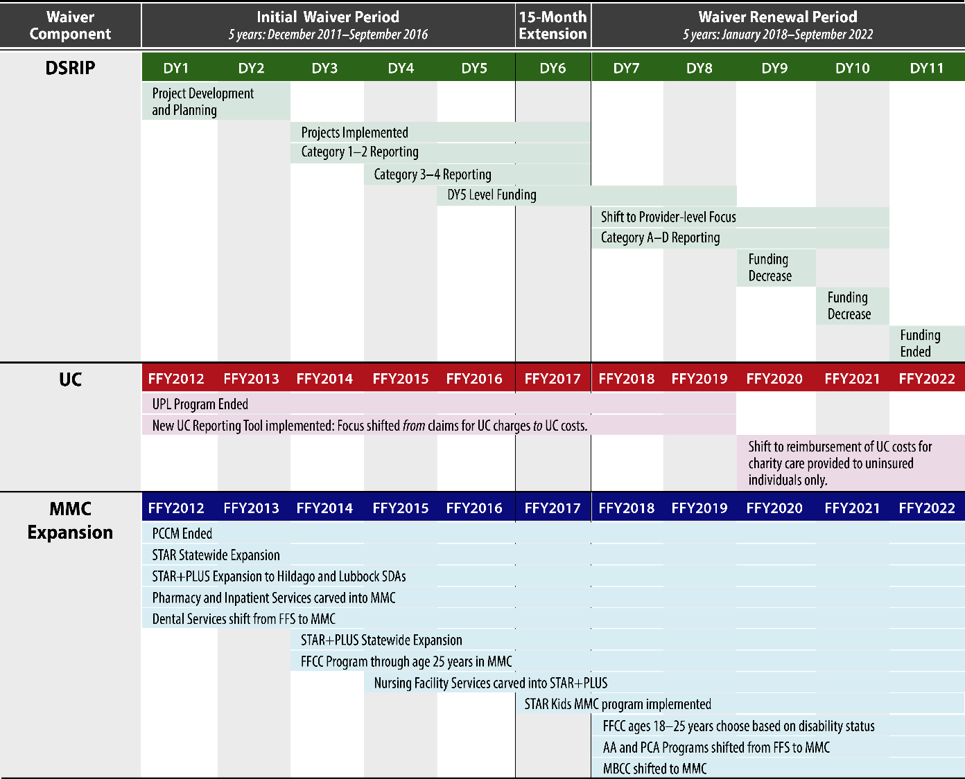
Note: CMS-Approved Evaluation Design. DSRIP = Delivery System Reform Incentive Payment; UC = Uncompensated Care; MMC = Medicaid managed care; DY = Demonstration year, October 1-September 30; FFY = Federal fiscal year, October 1-September 30; UPL = Upper Payment Limit; PCCM = Primary care case management; STAR = MMC program primarily serving children and pregnant women; STAR+PLUS = MMC program serving aged and disabled clients; SDA = Service Delivery Area; FFS = Fee-for-service; FFCC = Former Foster Care Children; STAR Kids = MMC program serving disabled individuals 20 years and younger; AA = Adoption Assistance; PCA = Permanency Care Assistance; MBCC = Medicaid for Breast and Cervical Cancer. Figure I.1 only includes MMC expansion activities evaluated during the Initial Waiver Period (DY1-5) and the Waiver Renewal Period (DY7-11).

Tables
Below this paragraph is a table.
- Insert tables in your immediately before or after the paragraph where you first refer to them. That may make the flow look funny to you, but it will be easier for editorial to make sure figure-number cross-references are correct. We can move the tablesto appropriate locations later.
- When inserting tables, put the figure title in “Table Caption” style, name it “X.Y Descriptive Title.”
- You can provide incremental numbers to replace the “Y.” We will update the table numbers later.
- If you have descriptive information to be included at the bottom of the table, style it as “Table Note.” See the example below.
- As for the table title, try to refer to it in the text upon its first use. For example:
The schedule appears in Table X.Y. Survey Data Collection Schedule, which shows that…. BTW, if you use an indented quotation in your document, use this “Quote” style.
Using this approach allows editors to match the tables reliably to the text in which they are being used and to get the numbers correct later.
- Don’t worry about formatting text within the table; editorial will take care of that.
Table X.Y Survey Data Collection Schedule.
Demonstration Period | Initial Approval Period | Initial Approval Period | Initial Approval Period | Renewal Period
Survey Administration | Survey 1 | Survey 1 | Survey 2 | Survey 3
Survey Reference | T0 | T1 | T2 | T2
Time Period Reflected | 12 months prior to RHP creation | 2013 | 2015 | 2020
Note. Researchers plan to administer the social network survey again in 2021. Results from the final survey administration will be presented in the Summative Report.

Typographical Matters

Bulleted Lists
If you make a bulleted list, use “Normal” for the introductory line.
- Use the “List Paragraph” style for bulleted lists, or just select a “Normal” paragraph and click the Bullets button from the Home ribbon:

- Depending on your Word settings, you may also start a “Normal” paragraph with an asterisk (*) and a space, and Word will assume you are making a list and automatically assign the “List Paragraph” style.
  - If there is a second level in your list, format the bullet as “List Paragraph” and then Tab at the beginning of the line to get it to indent.
    - If there is a third level, hit tab at the beginning of the line you wish to indent further.

Numbered Lists
- Use the “List Paragraph” style for numbered lists, or just select a “Normal” paragraph and click the Numbering button from the Home ribbon:

  - If there is a second level, click Tab from the beginning of the line at the level above.
    - If there is a third, take the same approach.
- Depending on your Word settings, you may also start a “Normal” paragraph with the numeral “1,” a period, and a space, and Word will assume you are making a numbered list and automatically assign the “List Paragraph” style.

Equations
If you use an equation that can be expressed in-line, consider the following example and style the equation using “Equation.” The general form of the DID model is:
Y_{it} = α + β₁(Treat_{i}) + β₂(Post_{t}) + $δ$(Treat_{i}Post_{t}) + φT_{it} + ε_{it}
In this equation:
- Yit refers to the value of a specific diabetes performance metric for a Medicaid client (i) in time period (t).
- Treati is a dummy variable equal to 1 for DSRIP treatment clients (zero for non-DSRIP comparison clients).
- Postt is a dummy variable equal to 1 for post-Demonstration Renewal time periods (zero for time periods before the Demonstration Renewal).
- (TreatiPostt) is an interaction term.
- Tit captures variation in the date of episode initiation within DY7.
- εit is an error term.
At the end of the section, before the reference list, add a page break in Word by selecting “Break / Page Break” from the Insert menu in Word.

References
(The “References” heading should be in Heading 2 style. All references should be formatted with the “Reference” style.)
Agency for Healthcare Research and Quality. (2001). Guide to prevention quality indicators: Hospital admission for ambulatory care sensitive conditions. https://www.ahrq.gov/downloads/pub/ahrqqi/pqiguide.pdf
Austin, P. (2011). An introduction to propensity score methods for reducing the effects of confounding in observational studies. Multivariate Behavioral Research, 46(3), 399–424. https://doi.org/10.1080/00273171.2011.568786

