Fantasy War Game Design Document

“Legions of Orcs, Ogres and Kobolds fall before the mighty armies of good. The elves precision shots and the dwarves pure strength have given the humans the allies to vanquish the forces of evil from the realm and reclaim it for its proper use.”

Jared Knutzon
With Credit to:

Justin Kroona

October 3, 2001

1. Introduction

This document will detail the design of a game by the name of “Fantasy War Game”. The goal of the game is to lead a kingdom to victory over its enemies. There will be two main parts to the game. The world map, which will allow the user to recruit troops, improve their kingdom, and send armies into battle, and the battlefield map, where the user will battle an enemy army.
This game in many respects will emulate the Lords of the Realm game. In that you will have a kingdom to rule and provinces to manage and conquer and you will have to lead armies to destroy enemy armies. It is also in some respects going to be like Shogun:Total War. This games battlefield combat will have more of a unit feel as opposed to an individual soldier feel. A more thorough description of the gameplay can be found in the interface/gameplay sections of this document.
The primary purpose of this document is to layout the components needed for the design of this game. The document will cover how the user interacts with the environment and how the game will handle this interaction. It will also cover how each of the subsystems, will interact with each other.

2. Components of the game

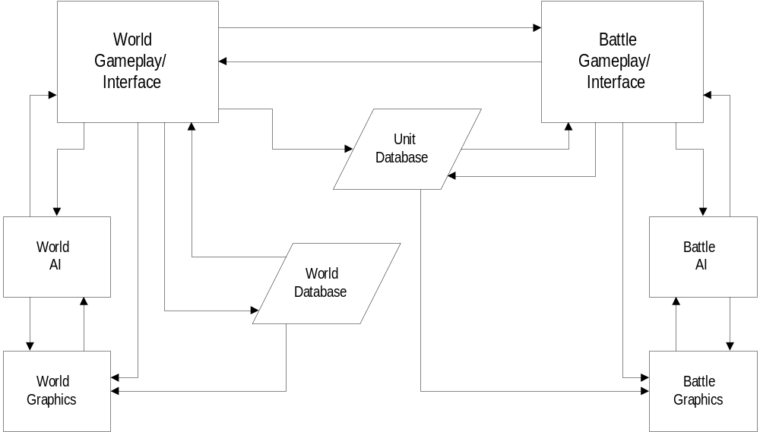In order to understand how the game will work as a whole and for an efficient design the game must be separated into a group of sub-components that will carry out the needed functionality of the game.
Figure 2.0 Component interaction diagram.
After it is understood how these components work with each other it will be easier to design the components by themselves. Figure 2.0 shows the major components. A more detailed description of the responsibilities and interactions of this system will follow.

2.1 Battle Gameplay and Interface
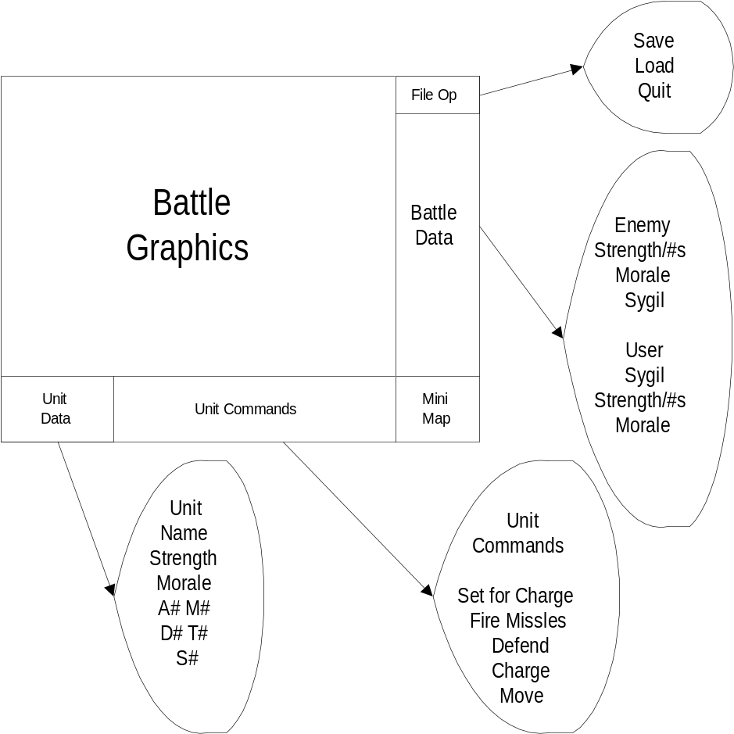This component interacts with the user and directs the other components as needed. The user battle interface will look basically like what is shown in Figure 2.1. The exact graphics will be described in more detail in the battle graphics component section. This section will concentrate on the commands and interactions that this component will issue.

Figure 2.1 Basic Battle Interface

As you can see in Figure 2.1 there are 4 sections that the user can interface with directly by simply looking at the data provided or clicking on the appropriate buttons.

2.1.1 Real Time Interaction
The battlefield will be done in real time. The user will have the option of speeding up or slowing down the speed of the game. This means that commands given to units will be resolved as they are received and not via any turn based mechanic.

2.1.2 User Interaction with Units
The primary thing that must be implemented by this component is the ability to issue orders to the units displayed on the screen. The first thing a user must do to give a command is to select a unit. The user can select a unit via two routes. The user can cycle through their units, using a keystroke, till they find the one they want. The user also has the option of using the mouse to click on the unit to select it. After the user has selected a unit, the vital information for that unit will come up in the Unit Data section of the window. The vital information are things such as: Name: Numbers: Morale: Attack Strength(A): Missile Attack Strength(M): Defense(D): Toughness(T): Speed(S). In addition to this, all commands that can be issued to the unit will show up in the unit commands section, some commands are as follow: Charge: Defend: Fire Missiles: Move: Set for Charge. In this way the user will be able to command his army unit by unit. There will be some provision for selecting multiple units at a time but that hasn’t been defined at this time. The easiest way would be to have the user be able to click and drag over an area that contains the units they wish to select.
The only other thing of note about the user’s interaction with the units is that the units have a very limited AI that will respond to attacks if attacked but will not execute any special maneuvers or move. So a unit under missile fire would be not respond with missile fire or move out of the range of the attacker.
The details of the resolution of combat will be handled by the unit database and described in greater detail there. The main point is to say that there will be a system to resolve combat between units.

2.1.3 World Rotation
The user will be rotate the world around the middle of the battlefield. This should allow the user to look at the battlefield from multiple angles in order to better command their troops.

2.1.4 Battle Simulation
The user will be able to simulate the rest of the battle if he feels that he has the battle in hand. This will involve controlling both sides of the battle with the battle AI. It will show the result of the simulated battle and exit back to the world interface.

2.2 Battle Graphics
This component is obviously responsible for producing the battlefield graphics that the user will use to give orders to his units and to observe enemy action. The view will be looking down at an angle. It will have at least some feel of Civilization II in that you are looking down on a map from above. The differences will be that it will actually have 3d terrain. So it will be a combination of the CivII feel combined with a little bit of a feel of Xcom. The user will be able to rotate the camera so that they can get a different view of the battlefield. The camera will snap back to its original position after the user is done with the different view

2.2.1 Battlefield Graphics
The battlefield will be a 3d textured terrain. There will be hills, trees, rivers, bodies of water. There will be a number of different maps for each of the kingdoms. The maps will have boundaries. These boundaries will be black to signify that nothing is going on in these outside areas.

2.2.2 Unit Graphics
The units will look, as best they can, like groups of miniatures. The number of miniatures will remain the same no matter how many troops are actually in the unit. The groups of miniatures will have animations that they go through, depending on what action they are performing. The miniatures should adapt to the terrain that they are on. What happens when the units are in forests has yet to be determined.

2.3 Battle AI
I have really no idea of how this is going to work but basically their has to be a system that will command the enemy forces in an intelligent manner so that the game will be fun and challenging. There should probably be some sort of difficulty setting to the game so that perhaps the game can be more difficult to increase replayability.

2.4 Unit Database
This unit will handle things like combat and keep track of where units are and what type they are. It will also resolve the commands given to the units based on their stats. Unit type and strength can be found in Appendix A: Unit types and stats.

2.5 World Gameplay and Interface
This section covers the interaction with the world as a whole. This is where the user controls his kingdom and its affairs. The user must be able to recruit troops, send troops into battle, send emissaries, manage provinces, manage trade, manage information networks, and research technology. Figure 2.5(next page) shows basically what the set up would before the world interface. Each one of the things on the bottom row is a button that can be selected to either pop up another window as necessary or perform a specific task.

2.5.1 Turn based Interaction
This part of the game will be turn based. The user will hit enter to proceed to the next turn and to resolve the actions that he initiated this turn. There will be a feature that allows the character to automate the turn so that they can focus more solely on the battles as opposed to the world turn based system.

2.5.2 Recruiting troops and sending them into battle
The user can, by selecting the troop button, manage the troops that they have in that province. The new window that is popped up will allow the user to recruit troops from the province from the available supply. The user has to pay for each unit they recruit and there is only a finite number to be recruited. The user also has the option of sending an army to another province. If that province is controlled by an enemy faction, a battle will result when the next turn button is hit. Other ways that a unit can end up in battle is being in province when an attacking force strikes(at the resolution of a turn). There will be some ongoing battles and you can send multiple armies into a territory. Any attacking army defeated is repelled back to the province they attacked from. Any defending army that loses will be destroyed. The attacking army designates one army as the conquering army. If this army is victorious it means that it captured the province capitol. This means that the attacking army now becomes the defending army and has control over the province. As long as troops of opposing allegiance remain in a province the province will remain at war. The user will have the option of simulating any battles that he chooses not to fight.
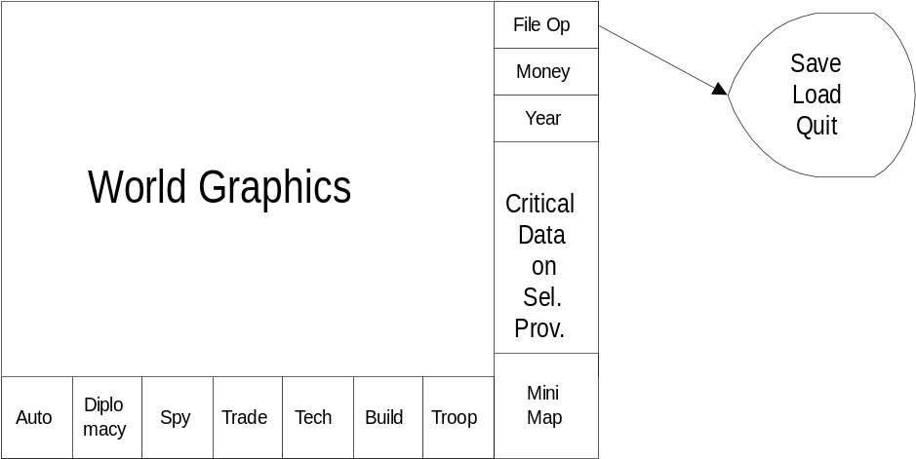
Figure 2.5 World Interface Screen

2.5.3 Dipolomacy
The user will be able to manage his relations with other countries by selecting this button. The diplomacy will be about the country as a whole not by individual provinces. If you manage to gain allegiance with a province you can send troops through their provinces and recruit some of their troops in your provinces that border theirs.

2.5.4 Spy
The user can manage his spy information by clicking this button. He can create spies and send them off to enemy provinces. Once a turn he can get a piece of information from the spies that might prove valuable. What information he gets and how accurate it is will depend on the ranking of the spy. Spies will gain ranking based upon how long they have survived(they have a chance of dying at the end of each turn) and how good their info is… the more they succeed the better they become.

2.5.5 Trade
The user can by selecting this button manage the trade between provinces and kingdoms. This will improve the amount of gold that a province earns. The window will also give basic financial information about the province… i.e. how much money you are making/losing. It will also categorize the credits and debts the province has.

2.5.6 Tech
The user can manage the technology they are currently researching as a kingdom by clicking this button. Technology improvements will allow for new types of buildings, better units, and perhaps even new units.

2.5.7 Build
The user can build something in the province by selecting this button. Buildings will have lists of costs and upkeep costs. The buildings may allow the recruitment of certain types of troops. The buildings in general will improve the value of the province to the kingdom.

2.5.8 Automate Turn
This button will allow the user to skip the rest of their turn by letting the computer manage the kingdom. You can select which parts of the kingdom to manage so that you can still build up troops and send them into battle or control only one aspect of the kingdom and let the computer do the rest.

2.5.9 Selecting a province
Basically there needs to be a way of selecting a province on the screen. You will only be able to select your provinces. When a province is selected it will be highlighted so you will know which one you are looking at. I think the best way would be to select using the mouse.

2.6 World Graphics
The world graphics will basically be very similar to Civ2. Basically a flat view with some 3d impression. Not much more to say about it than that.

2.7 World Database
This unit will manage all of the different kingdom’s information. It will hold a list of all the armies of each kingdom and where they are. It will hold all of the building, trade, tech, etc… information. It will also resolve the end of turn action and figure out what happens.

2.8 World AI
This will manage all of the computer controlled kingdoms sending of troops and building up the internal structure of things. It will also handle the automation of the user’s turn if this is needed.

3-11. Component Descriptions
Definitely not to this point yet…

12. Conclusion and Final Thoughts
Ideally this game will provide a challenge for the experienced strategy and civ player. I think it combines a unique blend of both of these very popular games. The user will be able to fight complicated and demanding battles while still managing a kingdom. It is my hope that the user will feel truly like they would if they were a king during the age of fantasy. I also think that it is a project that is dividable among a large group.

Appendix A: Unit Types and Stats
Each unit would be rated for the following (For now I am using an A, B, C, D, scale with +/-)
A: Attack power
D: Defense power, this is two numbers seperated by a /
the number before the / is the units normal Defense and the number after the / is the unit's defense vs. charge attacks
C: charge rating, if any (cavalry only)
M/R: Missile attack power and the Range of the attack
T: Toughness, how much damage the unit can take before being whipped out
L: Leadership value, how well the unit can absorb casualties without running, and how easy the unit is to rally
S: Speed, how fast and far the unit can move
GP: Price in Gold

Human:
Generally average in all respects, Humans do have the advantage of having access to heavy cavalry, which pretty much no other kingdom does.

Militia
A: D+
D: C-/D
C: -
M/R: -/-
T: D
L: C-
S: C+
GP: 3

Men-at-Arms
A: C
D: C/C-
C: -
M/R: -/-
T: C
L: C+
S: C
GP: 6

Pikemen
A: C-
D: C-/B
C: -
M/R: -/-
T: C
L: C+
S: C
GP: 7 or 8

Crossbows
A: D+
D: C-/D
C: -
M/R: C+/
T: C
L: C+
S: C-
GP: 6

Light Cavalry
A: C+
D: C/C
C: C+
M/R: -/-
T: C+
L: C+
S: B
GP: 8

Human Special units:
Knights
A: B
D: B+/C-
C: A-
M/R :-/-
T: B
L: B+
S: C+
GP: 14

Templars (knights on foot)
A: B
D: A-/B-
C: -
M/R: -/-
T: B
L: B
S: C-
GP: 12

Skirmishers (fast troops armed with bows)
A: C-
D: C-/D
C: -
M/R: C+/
T: C+
L: B-
S: C+
GP: 10

Dwarf:
Dwarf units have high toughness, defense, and leadership but are slow and expensive.

Heavy Infantry
A:
D:
C:
M/R:
T:
L:
S:
GP: 8

Halberds
A:
D:
C:
M/R:
T:
L:
S:
GP: 10

Repeating Crossbows
A:
D:
C:
M/R:
T:
L:
S:
GP: 9

Defenders (super heavy infantry)
A:
D:
C:
M/R:
T:
L:
S:
GP: 14

Dwarf special units:
Cavalry (mounted on dwarven ponies or something)
A:
D:
C:
M/R:
T:
L:
S:
GP: 15

Reavers
A:
D:
C:
M/R:
T:
L:
S:
GP: 16

Champions
A:
D:
C:
M/R:
T:
L:
S:
GP: 18

Elf:
Elves are fast and have hard hitting missile troops, but aren't very tough and lack strong defense. They're cost is somewhere in between human and dwarf units.

Guardians (light infantry)
A: C-
D: D+
C: -
M/R: -/-
T: C
L: C
S: C+
GP: 5

Spearmen
A: D+
D: C-/B
C: -
M/R: -/-
T: C
L: C
S: C+
GP: 7

Long bows
A: D+
D: D
C: -
M/R: B/
T: C
L: C+
S: B-
GP: 8

Outriders (light cavalry)
A:
D:
C:
M/R:
T:
L:
S: A-
GP: 9

Scouts
A:
D:
C:
M/R:
T:
L:
S: B
GP: 9

Elf Elite Units:
Wardancers
A:
D:
C:
M/R:
T:
L:
S: B-
GP: 13

Wild Hunt (medium cavalry)
A:
D:
C:
M/R:
T:
L:
S: A
GP: 14

Rangers
A:
D:
C:
M/R:
T:
L:
S: B-
GP: 14

Evil units:

Hobgoblins:
Hobgoblins are tough and have good attack power. Their missile troops are rather poor, however. They cost about as much as human units.

Conscripts
A: D: C: M/R: T: L: S: GP:

Troopers
A: D: C: M/R: T: L: S: GP:

Spearmen
A: D: C: M/R: T: L: S: GP:

Boar Riders
A: D: C: M/R: T: L: S: GP:

Javelins
A: D: C: M/R: T: L: S: GP:

Hobgoblins Elite Units:

Vazaul's Chosen (Hobgoblin fanatics, Vazaul being their patron diety)
A: D: C: M/R: T: L: S: GP:

Orogs (elite infantry)
A: D: C: M/R: T: L: S: GP:

Goblin fodder (not really "elite", but cheap and plentiful fodder for the Orcs)
A: D: C: M/R: T: L: S: GP:

Ogres/Trolls:
Ogres and Trolls are very strong and tough and quite fast. But they are expensive and generally have poor leadership, meaning that while they take alot of hits to drop, once you kill a few of them, their morale tends to drop quickly.

Ogre Warriors
A: D: C: M/R: T: L: S: GP:

Mountain Trolls ("civilized" trolls who use armor and weapons other than clubs)
A: D: C: M/R: T: L: S: GP:

Ogre Rock Throwers
A: D: C: M/R: T: L: S: GP:

Marsh Trolls (savage trolls)
A: D: C: M/R: T: L: S: GP:

Ogre/Troll Elite Units:

Chaos Trolls (more intelligent Mountain Trolls)
A: D: C: M/R: T: L: S: GP:

Ogre Mutants
A: D: C: M/R: T: L: S: GP:

Troll Cavalry (Chaos Trolls mounted on grizzly bears) or Hill Giants (not really cavalry but fast enough to be considered such)
A: D: C: M/R: T: L: S: GP:

Kobold (or Dark Elf):
Kobolds are cheap and plentiful and are rather quick. Those are their only advantages and they had best use them to the fullest. Dark Elves are slightly tougher than Elves but they aren't as fast.

Scavengers (Constables for Dark Elves), light infantry
A: D: C: M/R: T: L: S: GP:

Short Bows (Crossbows for Dark Elves)
A: D: C: M/R: T: L: S: GP:

Halberds (for Dark Elves)
A: D: C: M/R: T: L: S: GP:

Trippers (for Kobolds, they use ropes and bolas to upset cavalry and then fight with their hand weapons. Good vs. cavalry and thats about it)
A: D: C: M/R: T: L: S: GP:

Sneaks (Scouts for Dark Elves), fast missile troops
A: D: C: M/R: T: L: S: GP:

Wolf Riders (Raiders for Dark Elves), light cavalry
A: D: C: M/R: T: L: S: GP:

Kobold (or Dark Elf) elite units:

Killers (Assassins for Dark Elves), fast, deadly missile troops
A: D: C: M/R: T: L: S: GP:

Spider Riders (for Kobolds only), medium cavalry
A: D: C: M/R: T: L: S: GP:

Shadow Guard (Dark elves only), quick heavy infantry
A: D: C: M/R: T: L: S: GP:

Tunnel Warriors (for Kobolds only), medium infantry
A: D: C: M/R: T: L: S: GP:

Dark Knights (Dark elves only), medium cavalry
A: D: C: M/R: T: L: S: GP:

