ELEC 4700

Assignment 2

Finite Difference Method

Chad Blanchette 100968854

Part 1 a)

The first part of this assignment was to use the finite difference method to solve the electrostatic potential in the LxW region. Although, when the BC’s were not set the figure would not appear because no region or electrostatic potential can be determined. Therefore, I used arbitrary values of W=20, L=30, and V0=2;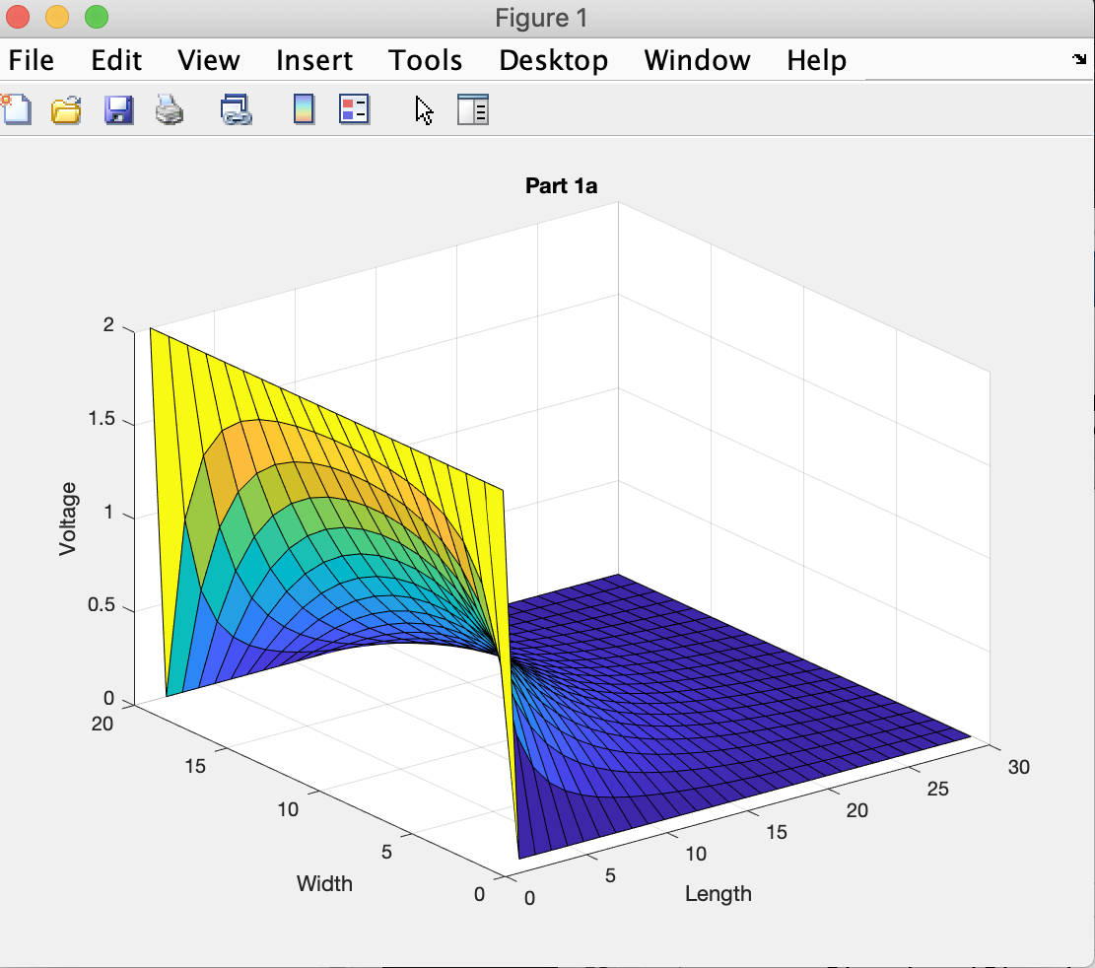

Figure 1: Finite Difference Method Used to Solve 2D Case by Iteration

1b)

This part illustrated the finite difference method using boundary conditions on both sides of the region.

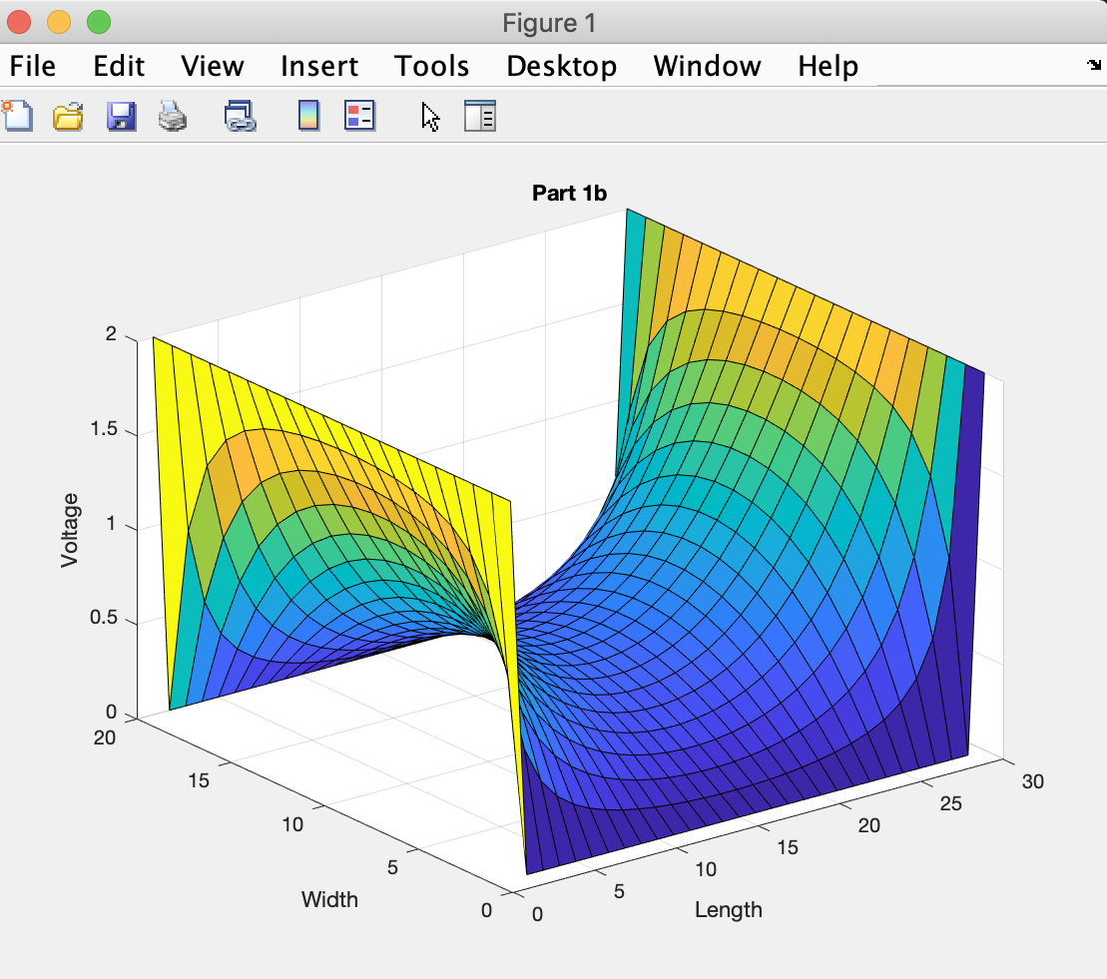

Figure 2: Finite Difference Method Used with Two Boundary Conditions

The following figure is the finite difference method used with the G matrix to get the voltage potential on a single plane.

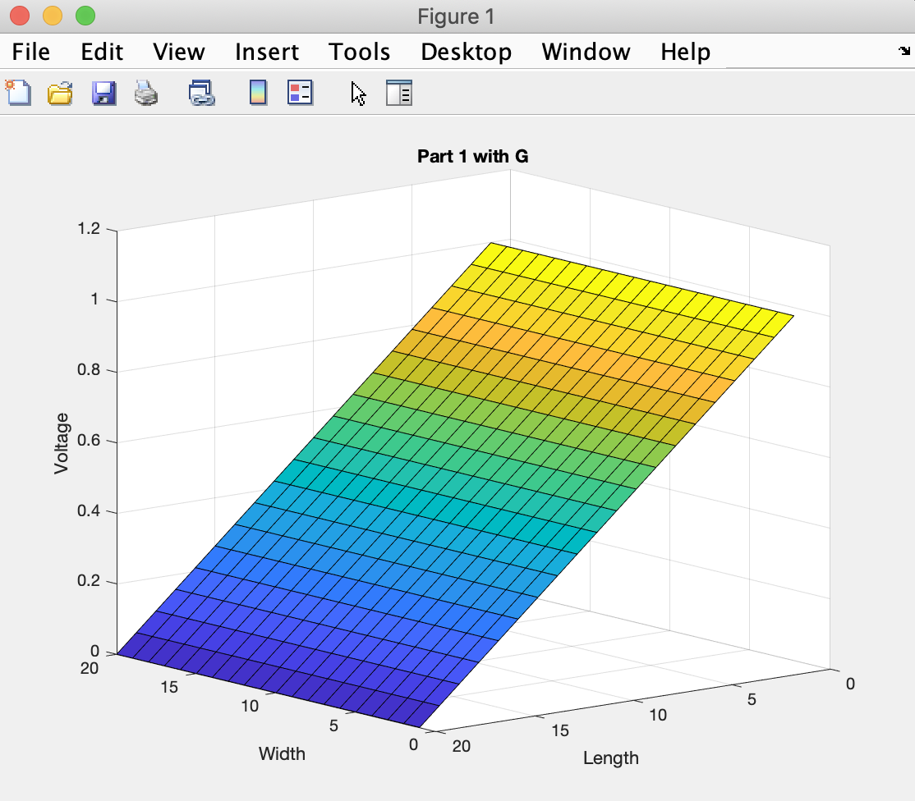

Figure 3: Finite Difference Method Used with the G Matrix to find Voltage Potential

Meshing was used in this experiment to convert the continuous time domains function into the discrete domain which can numerically be solved. The difference between analytical and numerical solutions are that the analytical solutions are exact without any assumptions or finite time steps. Numerical methods are analytical solutions that are an approximation (discretization) of the exact solutions which are used to immolate the real life applications on modern devices.

Part 2

The following figure will illustrate the effects that a bottle neck can have on the conductivity, voltage, and electric/ current densities.

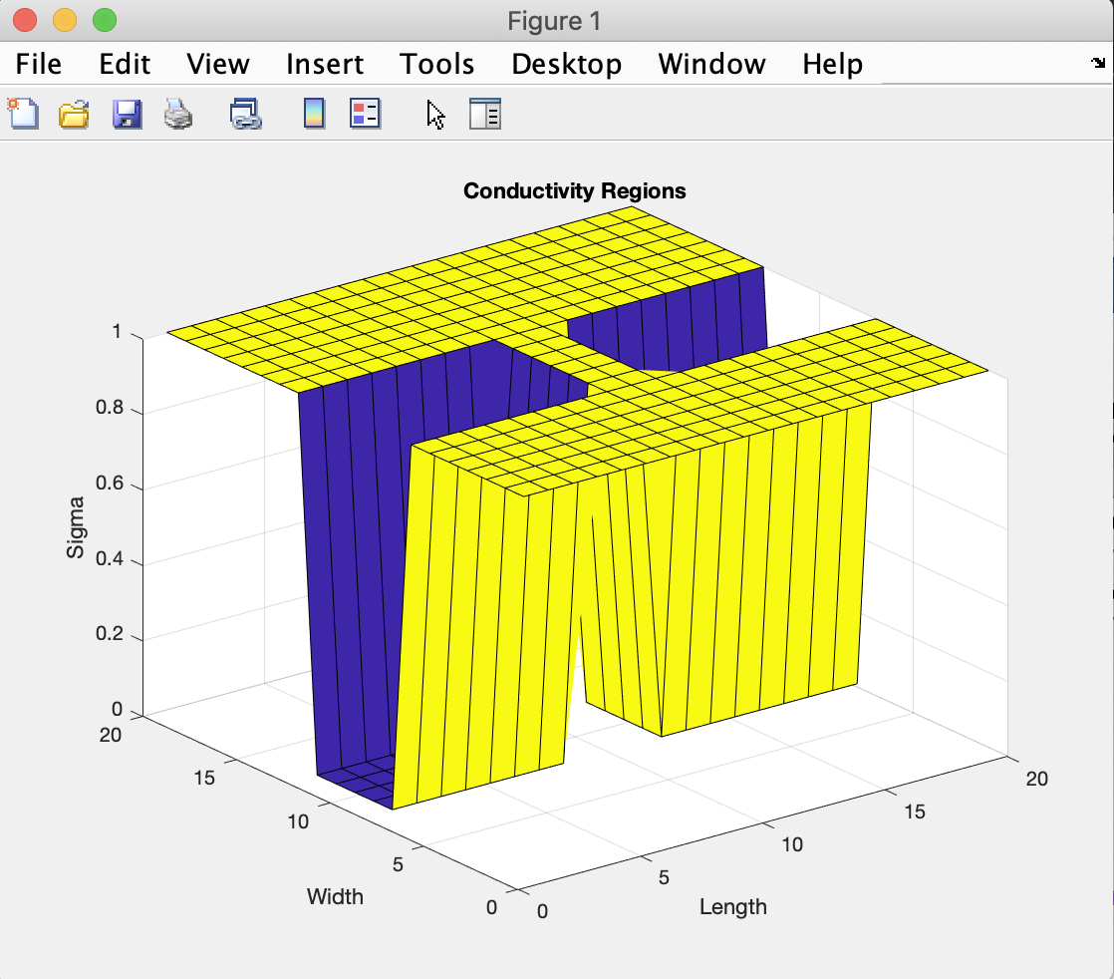

Figure 4: Conductivity Mapping with the bottle neck σ(x,y)

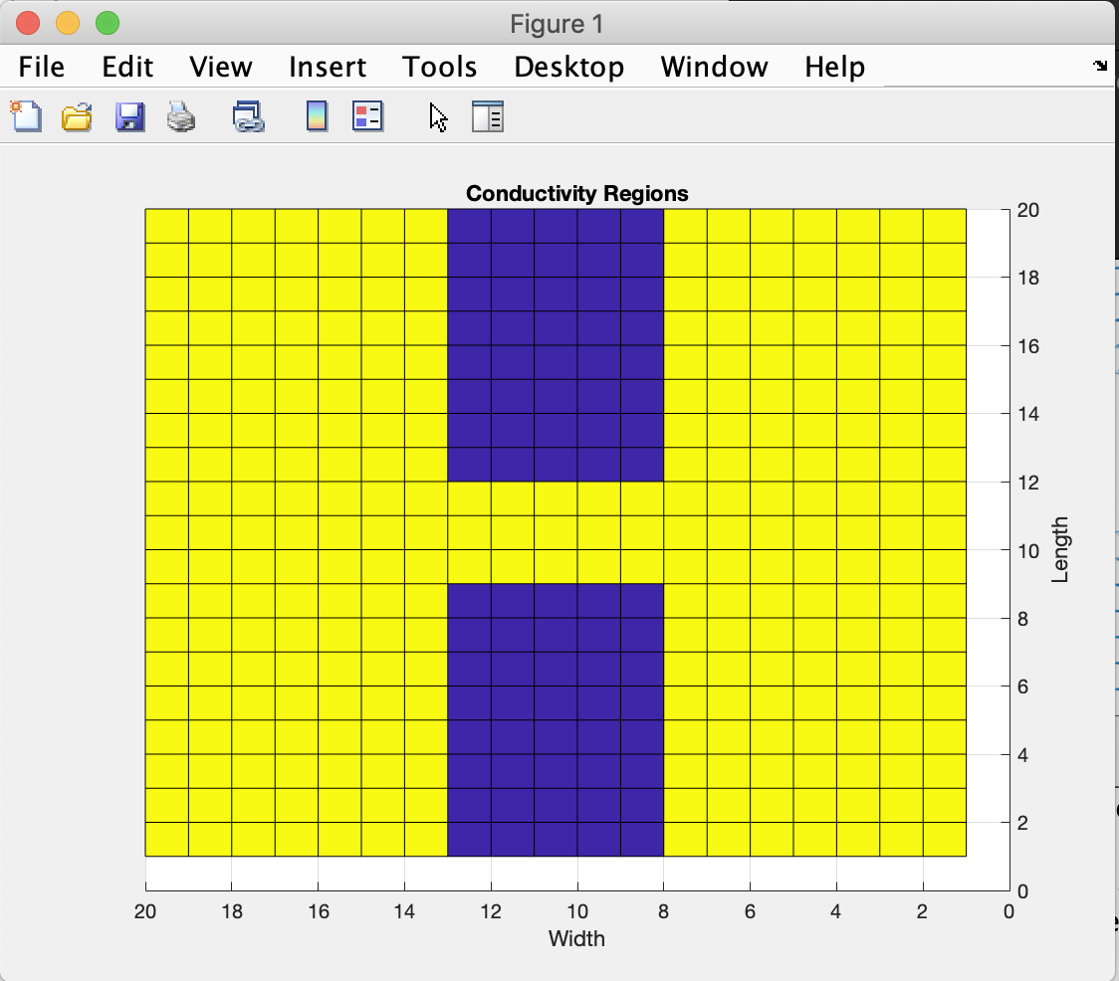

Figure 5: The rectangular region with isolated conducting sides similar to Figure 3 on assignment page

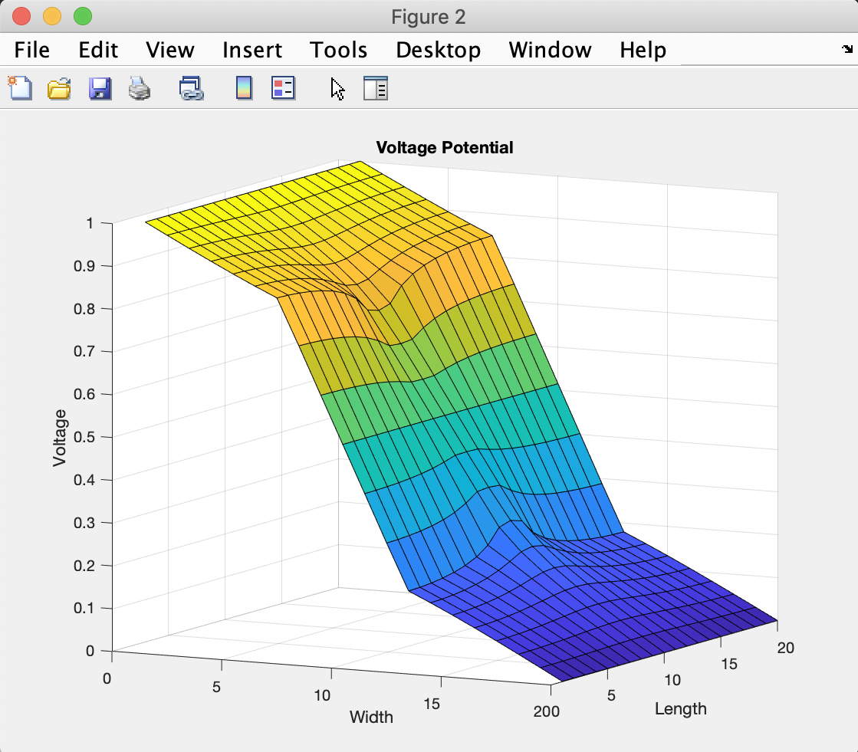

Figure 6: Voltage Potential with bottle neck V(x,y)

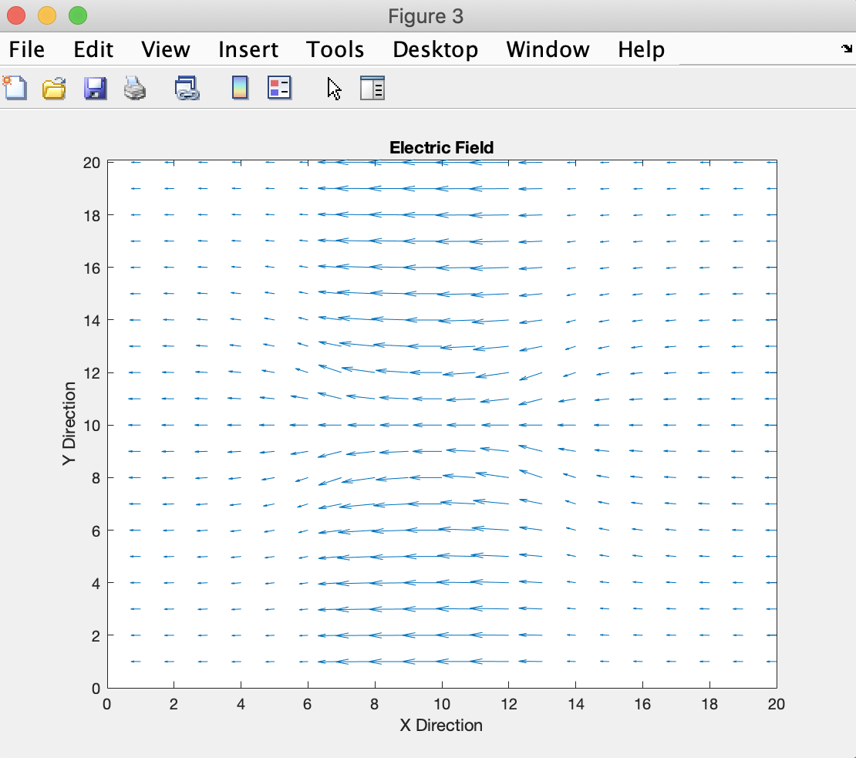

Figure 7: Plotted Electric Field with bottle neck E(x,y)

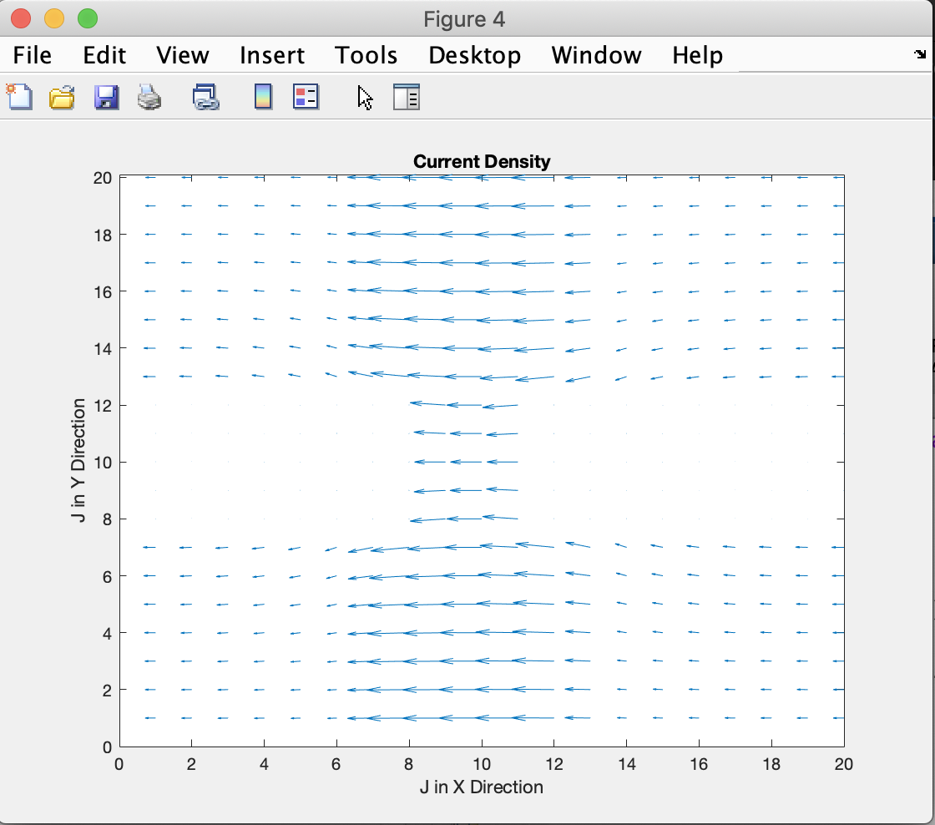

Figure 8: Plotted Current Density with bottle neck J(x,y)

Mesh density refers to the amount of elements in the investigated region, therefore the higher the mesh density the higher the accuracy to the actual analytical solution. To increase the mesh density, simply decrease the time steps for any given code to achieve greater accuracy.

The goal for Part 2 of the assignment was to see how bottlenecking affected Part 1 of the assignment and how to implement such design. Figure 4 shows the conductive regions in yellow while the non-conducting regions are in purple. In Figure 6 the bottle neck showed how it reduced the voltage potential in the middle and the ends had a higher potential. In Figure 7 it showed that the electric field travelled in the negative x direction and going slightly sideways on the upper y and lower y due to the bottle neck. Something similar happened in Figure 8 but this time the current density faded away in the middle region except for between the bottle neck.