ELEC 4700

Assignment 3

Monte Carlo/ Finite Difference Method

Chad Blanchette 100968854

Part 1: Monte Carlo Simulation

The electric field that calculated was Ex = 5\*10^5 V/m, the force on each electron was F= 8.01\*10^-14 N, and the acceleration of the electron were 3.38\*10^17 m/s.

Figure 1: 2D Plot of Particle Trajectories

Figure 2: Temperature Plot over time

This simulation used a sample of 10 particles for the 2D particle trajectory and temperature plot. The temperature plot changes every time due to the randomness of the electron movement.

The relationship between the electron drift current density and the average carrier velocity is that the electron drift current is the electric current generated from the random movements of the electrons. This movement of the electrons is called the average carrier velocity which is generated from the electric field. When the average carrier velocity is found it can be determined which direction most of the electrons are travelling.

Part 2: Finite Difference Method

The results in this section were very similar to assignment 2 except now the voltage potential was calculated with the bottle neck inserted into the code. The electric field was then extracted from the potential using the quiver function.

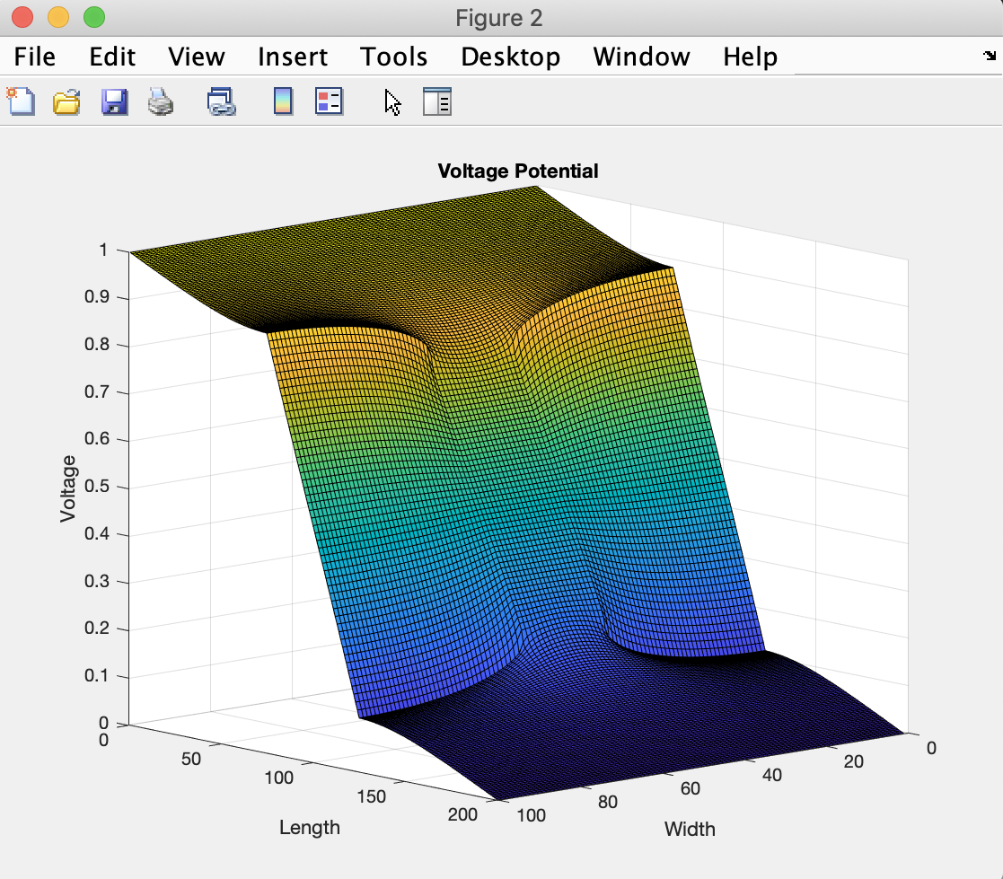

Figure 3: Voltage Potential Plot V(x,y)

Figure 4: 2D Electric Field Vector Plot

Part 3:

I am currently dealing with a bug in the assignment 1 part 3 code which I will be continually trying to fix the issue when I re submit the assignment 1. Therefore, for now the implementation of this part of the assignment was not completed but I will ask the TA for assistance.