
Budget for Annualized Activity and Travel Process (05-06 Academic Year)
Outdoors at uva
p.o. box 400444
charlottesville, va 22904

On my honor as a student, the enclosed information is accurate to the best of my knowledge (Please sign and date).

Treasurer: _________________
Case Taintor
423-240-9577
Caset@virginia.edu

President: _________________
sophie johnson
423-309-3929
sophie@virginia.edu

Appropriations committee representative:
Allison Peck
__________________________
Please use this space to PRIORITZE the requests you are submitting in this process. This will help the committee in their evaluation of your budget!! Let us know if any of the costs are essential to the operating of your group.
1. Travel for all trips, especially the numerous trips to West Virginia for climbing, kayaking, rafting, biking, and backpacking. Essential for club operation.
2. Lodging for all trips, which primarily includes camping fees but also some cabin rentals. Essential for club operation.
2. Overhauls (maintenance, repairs) for the mountain bikes.
3. Equipment for backpacking (sleeping bags, tents, first aid kits, pads).
4. Equipment for climbing (shoes, ropes, guidebooks, carabiners, helmets).
5. Equipment for snow sports (snowshoes, cross country skis, helmets).
6. Equipment for kayaking.
7. Equipment for caving (batteries, headlamps).
8. Registration fees: park passes for Shenandoah National Park.
9. Bike maintenance items (lube, tubes).
10. Website costs.

Part a: Total S.A.F. Fundable Expenditures

Equipment purchase: $6,853.89
Outdoors at UVA has grown immensely in the past few years, due in large part to the amount of gear that we have been able to purchase with SAF money. Last year, the club had a total of 369 due paying members and this year we have 450 already. We expect to pick up at least another 30 people, increasing our membership by over 100 in just a year. We expect next year to be another year of growth, and most of the gear we would like to purchase is in support of that growth. Right now, we have a very wide breadth of gear but are lacking depth of gear in crucial areas. The officers have arranged pro-deals with many companies so that we can get 40% off many new items. These deals have allowed us to buy quality equipment at low prices. The equipment spreadsheet below will reflect these discounts when applicable.
Climbing is by far our most active trip category. With this year, we have had a huge influx of women interested in climbing. Our current shoe collection needs more smaller shoes to accommodate these women. For climbing, it is absolutely critical that a tight enough shoe is used, or else the shoe will not perform as it should. Also, some of the club’s ropes are starting to get old and need replacing. These ropes have been used extensively over the past 3 or 4 years. To that end, we would like to purchase two more ropes for use with sport climbing along with four rope bags to make it easier to transport ropes to and from the rock. Another component of climbing that goes hand in hand with larger trips and more interest is belay devices. This safety equipment is used to hold the rope in place when someone falls. We would like to purchase 4 more belay devices. We would like to buy 10 large locking carabiners, for use with both the new and old belay devices. We would like to expand the number of carabiners we have to accommodate larger amounts of climbing gear and to replace aging carabiners. We would like to buy two more helmets to be used solely for climbing. This safety item is used to protect climbers from falling rocks or from injuring their heads when falling. To round out the additions to our climbing gear, we would also like to extend the number of chalk bags we have.
Our popular activities also include camping and backpacking trips. We have had outstanding leaders in these trips this year and are looking forward to another year of popular backpacking trips. We need more backpacks to better accommodate these trips. Also, with the purchase of cross country skis and snowshoes this school year, we would like to buy more cold weather sleeping bags to accommodate winter camping trips that can get to be quite cold. Currently, most of the club’s sleeping bags are rated for 30 degrees and are practically useless below that temperature. We also need a couple more tents and about five more sleeping pads to allow for multiple large trips during weekends and breaks. A water purifier would make the backcountry trips safer for participants, and a GPS unit would help trip leaders navigate.
Snow sports are becoming increasingly popular, and we need to buy more gear to allow more members to participate. We would like to buy more snowshoes, cross country skis, and bags to transport the skis. Skiing helmets and goggles would increase the safety of our trips for members without these items.
Last year we bought around 20 rechargeable batteries for our caving headlights. Through use, we have discovered that these batteries are not reliable enough for caving trips. To that end, we would like to purchase large quantities of alkaline batteries for use in headlamps. We would also like to buy more headlamps since the current headlamps are old and often have corroded connections, leading to an unreliable and potentially unsafe headlamp.
Finally, our boating trips are still popular, and with the purchase of a new canoe last year, we need to buy new canoe paddles. The current paddles are very, very old wooden paddles of odd sizes. We would like to purchase 4 new paddles using our deeply discounted pro deal account. Our current selection of kayaks lacks kayaks for lighter paddlers. We would like to purchase a couple kayaks that are more fitting for smaller paddlers.
The club also needs guidebooks to make leading trips easier and safer. Our current first aid kits need to be updated and replaced.
We found prices for comparable items that were cheaper on www.rei.com. While some of them were sale prices, there was no “official” sale going on, and we felt that at any given time, some of the items would be on sale. We felt that the “Marker Double Ski Bags” were unnecessary.
Itemized List:
Item | Quantity | Cost Per Unit | total cost | Life Expectancy
Mammut Eiger, Non-Dry Rope | 1 | 149.00 | 149.00 | 3 years
Petzl Am’D Ball Block Carabiner | 10 | 17.50 | 175.00 | 5 years
Black Diamond Dynotron Bent Anodized Carabiner | 20 | 8.95 | 179.00 | 5 years
Petzl Reverso Belay Device | 4 | 24.95 | 99.80 | 5 years
Five Ten Anasazi Rock Shoes | 4 | 70 | 280 | 3 years
Prana Jumbo Chalk Bag | 4 | 15 | 60 | 5 years
Bison Designs Bulk Chalk | 10 | 3.00 | 30.00 | 2 years
Metolius Ropemaster I Rope Bag | 4 | 35.95 | 143.80 | 5 years
Black Diamond Half Dome Climbing Helmet | 2 | 57.50 | 115.00 | 5 years
A Falcon Guide: How to Climb Series: Big Walls | 1 | 12.95 | 12.95 | 10 years
Mountaineering: The Freedom of the Hills | 1 | 29.95 | 29.95 | 10 years
Caving: The Essential Guide to Equipment and Techniques | 1 | 21.95 | 21.95 | 10 years
A Canoe and Kayaking Guide to West Virginia | 1 | 11.53 | 11.53 | 10 years
Boeri Switch Ski Helmet | 4 | 30 | 120 | 5 years
Bolle XP Goggles | 4 | 17 | 68 | 10 years
Garmin Foretrex 101 GPS | 1 | 130.00 | 130.00 | 8 years
MSR Zoid 2 Tent | 2 | 115.97 | 231.94 | 5 years
MSR Miox Water Purifier | 1 | 75.37 | 75.37 | 5 years
MSR Lightning Ascent Snowshoes | 4 | 118 | 472 | 10 years
Ridgerest pads | 5 | 17.67 | 88.35 | 5 years
REI Morning Star 75 Backpack | 5 | 145.00 | 725.00 | 5 years
Marmot Down Sleeping Bad (Never Summer Long model) | 5 | 149.40 | 747.00 | 8 years
Rossignol Quest Cross Country Skis with bindings | 5 | 139.00 | 695.00 | 8 years
Alpina NNN Cross Country Ski boots | 5 | 25 | 125 | 8 years
Black Diamond Vectra Headlamp | 6 | 20 | 120 | 6 years
Energizer, AA, four pack | 10 | 2.84 | 28.40 | 1.5 years
First Aid: Weekender Medical Kit | 5 | 49.99 | 249.95 | 1.5 years
Werner Rec Canoe Paddle | 4 | 20 | 80 | 5 years
Jackson Kayaks 2 Fun (Kayak) | 2 | 794.95* | 1,589.90 | 15 years
* Three price quotes for Jackson Kayaks 2Fun (sized for smaller paddlers):
- $794.95 (Rock Creek Outfitters)
- $799.00 (Alpine Kayak)
- $899.00 (Sierra South)
Money allocated for Equipment Purchase for the 2004-2005 academic year: $ 10540.02

Equipment repair: 1,311.06
Most of our repair expenses pertain to our five mountain bikes. These bikes are used quite often and have seen a lot of use over the past few years. Besides the normal lube, tube, and occasional tire damage, we would like to have all of our bikes completely overhauled. An overhaul involves cleaning and replacing (if need be) all the bearings in the wheels, cleaning and repairing the drive train, truing the wheels, cleaning and lubing the shocks, and basically getting the bike back into the shape it was when it was first purchased. Overhauling these bikes will extend the life of the bikes so that they can be used many years down the road.
Itemized List:

Item | Quantity | Cost Per Unit | total cost | Notes
Bike Overhaul | 5 | 150.00 | 750 | Overhaul for all 5 bikes.  $150 at Blue Wheel Bikes
Performance ATB presta tube | 4 | 6.99 | 27.96 | Replacement tubes in case ours get punctured
IRC Mythos XC ATB tire | 3 | 39.99 | 119.97 | Replacement tire in case ours get damaged or worn
Performance Patch Kit | 4 | 6.99 | 27.96 | Patches to quick fix punctured tubes while riding
Pedros Degreaser, 2 pack | 2 | 19.98 | 39.96 | Need lots of degreaser for chain maintenance
White Lightning Lube/Clean Streak combo | 4 | 13.98 | 55.92 | Need lubrication for chain, bearings, joints, etc to maintain bike
Pedros Syngrease with injector | 3 | 21.99 | 65.97 | Need grease to prevent wear on bearings, fork, etc.
Pedros Ice Wax, 4 oz. Bottle 3 pack | 2 | 19.17 | 38.34 | Wax protects chain in severe conditions
Finish Line Super Clean Kit #3 + chain cleaner | 1 | 84.98 | 84.98 | All Purpose clean kit for general bike cleaning and maintenance; large volume for many uses or multiple bikes
Untimate BRS50 Basic Bike Repair Stand | 1 | 100.00 | 100.00 | The stand facilitates maintenance on bikes.

(Note: To insert more rows, move the cursor to the right of the asterisk (*) above, press right arrow button once then press enter)
Money allocated for Equipment Repair for the 2004-2005 academic year: $ 683.02

Equipment and Room Rentals: $0.00
In order to conserve club funds, Outdoors at UVA no longer pays for rentals for club members. Members themselves pay for rentals. In previous years we have rented a projector for the Newcomb Hall theatre, but we have found a better room that doesn’t require a rental fee for a projector.
Money allocated for Equipment and Room Rentals for the 2004-2005 academic year: $ 90.00

Speakers expenses: $80.00
In the past, we have been contacted by Outdoors Magazine to have a speaker speak. Although the speaker is usually free, we still need to provide lodging expenses for him or her in a local hotel.
Speaker Breakdown:
Name: | Airfare | Total mileage | mileage Reimb. (@ $0.25 per mile) | Meal Costs ($20/ Day) | Lodging ($60/ Night | total cost For Speaker
? Whoever Outside Magazine brings ? | - | - | - | $20 | $60 | $80
(Note: To insert more rows, move the cursor to the right of the asterisk (*) above, press right arrow button once then press enter)
Money allocated for Speakers Expenses for the 2004-2005 academic year: $ 60.00

Advertising: $60.00
We would like to purchase advertising space in the Cavalier Daily and be able to print flyers to hand out at the fall and spring activity fairs.
Itemized List:
Yearly totals: | Quantity | Cost Per Unit | total cost
Cav Daily Ad | 2 | 30 | 60
(Note: To insert more rows, move the cursor to the right of the asterisk (*) above, press right arrow button once then press enter)
Money allocated for Advertising for the 2004-2005 academic year: $ [$0.00]

Member Travel: $17,874
Member travel is by far the most important aspect of Outdoors at UVA. Almost every one of our trips incurs some sort of travel expense through gas or lodging. The excel sheet found on the next page itemizes our expected trips and the associated costs. Many of these costs are referenced at later sections of this budget.
We have tried to make it easy for any of you to make changes to the member travel as you see fit. To do so, double click anywhere on the next page and then edit the cells that you wish to edit. The change will be reflected in the totals.

We cut the three trips which required flying. (Red Rocks Canyon, NV; Sig Sur, CA; Ski Slope, CO), as we felt they were unnecessary All other trips were deemed fundable
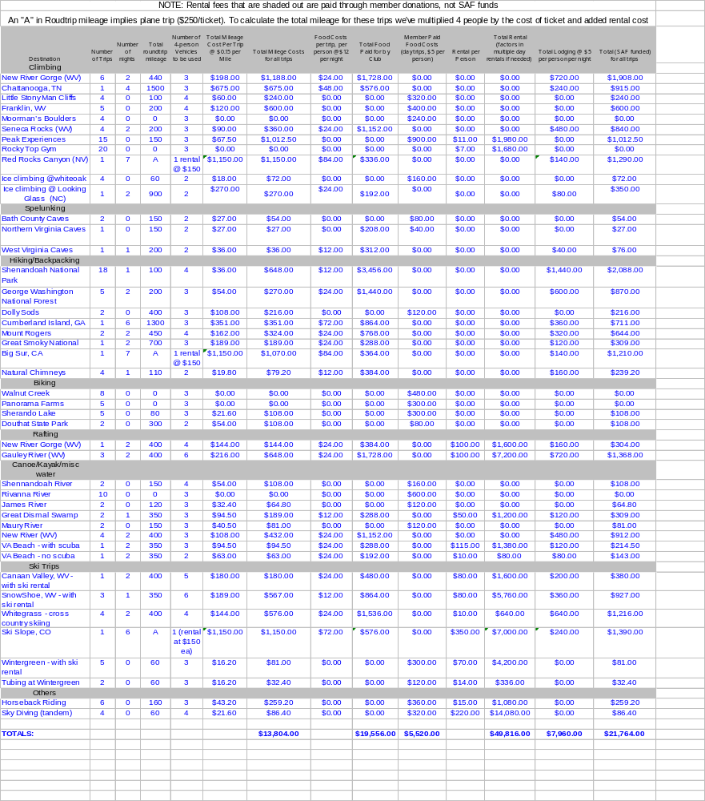

Money allocated for Member Travel for the 2004-2005 academic year: $ 6,292.50

National dues and Registration Fees: $190
Each year we purchase year long Shenandoah National Park passes for cars that enter the park. We have learned through experience that the people that lead these trips usually go again, so this ends up costing us less than buying a day use pass. We also have a few registration fees that occur throughout the year, including the cost of our extensive website. We moved to a website hosting service away from the student council server because the student council server was badly outdated and our club absolutely depends on our website to keep things running. Without the website, it would be impossible to handle as many members as we have.
You can get a mailbox in the SAC. We do not fund websites, because UVA provides free webhosting
Itemized List:
Item | Quantity | Cost Per Unit | total cost
Shenandoah National Park Pass | 8 | $20.00 | $160.00
Fall activities fair | 1 | $15.00 | $15.00
Spring activities fair | 1 | $15.00 | $15.00
(Note: To insert more rows, move the cursor to the right of the asterisk (*) above, press right arrow button once then press enter)
Money allocated for Registration Fees for the 2004-2005 academic year: $ 1029

Office Supplies: $0.00
We have spent a good amount of money on office supplies this year to better accommodate our gear room, but we do not anticipate spending more next year.
Money allocated for Office Supplies for the 2004-2005 academic year: $ [$0.00]

Postage: $45.00
With our moving to Bank of America, we no longer have to pay to mail checks. However, we still occasionally have to mail gear back to get fixed. This gear is usually heavy and can cost a good bit to ship.
Itemized List:
Item | Quantity | Cost Per Unit | total cost
Equipment for repair | 3 | $15.00 | $45.00
(Note: To insert more rows, move the cursor to the right of the asterisk (*) above, press right arrow button once then press enter)
Money allocated for Postage for the 2004-2005 academic year: $ 18.70

Printing and Copying: $6.00
We need to print liability waivers for members to sign at activities fairs, when they are unable to print a waiver out themselves. All other printing costs are related to advertising at the activities fair and are listed above. We have moved to an all electronic gear inventory system, so we no longer require paper to keep track of who has what gear (as in past years).
Itemized List:
Item | Quantity | Cost Per Unit | total cost
Liability Waivers | 200 | $.01 | $2.00
Flyers for two activity fairs | 400 | .01 | 4.00
(Note: To insert more rows, move the cursor to the right of the asterisk (*) above, press right arrow button once then press enter)
Money allocated for Printing and Copying for the 2004-2005 academic year: $ 10.00

Telephone: $0.00
Money allocated for Telephone for the 2004-2005 academic year: $ [$0.00]

Miscellaneous: $0.00
Part B: Non-Fundable (Out of Pocket) Expenditures

Social: $0.00
Although the club has 10-15 purely social activities throughout the year (mainly potlucks and movie nights), the club does not pay for these activities. All food for social activities is purchased by members.

FundRaising Expenses: $0.00
All of our funds are generated through member dues.

Other Expenses: $20,456
Outdoors at UVA pays for all food on overnight trips. We estimate that this equates to spending $12 per person per day. In past years, the club has paid for only half the member’s food, but has still paid for food on day trips. This year, as we saw the number of members grow and grow, we decided to limit our food spending to only overnight trips. This has been very successful and has greatly reduced the amount of money that the club pays out in food each year.
The club also actively encourages members to lead trips. This year we tried to use money as a catalyst by paying a leader the cost of his or her membership upon leading 4 trips.
The club also pays for all gas and lodging for trips that occur over the summer. The cost included below is based on the trips that occurred last summer.
Itemized List:
Item | Quantity | Cost Per Unit | total cost
Food (as displayed on large Excel sheet above) | - | $12 | $19,556
Dues refund for trip leaders | 10 | $30 | $300
Summer Trips | 20 trips | $30 | $600
(Note: To insert more rows, move the cursor to the right of the asterisk (*) above, press right arrow button once then press enter)
Part C: Non-SAF Funds (self Generated Revenues)

Membership Dues: $14,600
Currently, it costs $30 to join the club for the entire year (August to August) and $20 to join the club for the fall or spring and summer semesters. Below are the total dues amounts from last year, the current year, and next year’s projected amounts. The above amount assumes that the dues structure is the same and is a prediction for next year.
Itemized List:
category | Number | Amount | income
2003-2004 Full Year Memberships | 303 | $35 | $10,605
2003 Fall Membership | 10 | $25 | $250
2004 Spring Membership | 43 | $25 | $1,075
2004 Summer Membership | 23 | $15 | $345
TOTAL 2003-2004 Membership Dues | 379 |  | $12,275
2004-2005 Full Memberships | 388 | $30 | $11,640
2004 Fall Memberships | 18 | $20 | $360
2005 Spring/Summer Memberships (projected) | 62 (100) | $20 | $1,240 ($2,000)
TOTAL 2004-2005 Dues (projected) | 468 (506) | - | $13,240 ($14,000)
Projected 2005-2006 Full Memberships | 400 | $30 | $12,000
Projected Semester Memberships | 130 | $20 | $2,600
TOTAL Projected 2005-2006 | 530 | - | $14,600
(Note: To insert more rows, move the cursor to the right of the asterisk (*) above, press right arrow button once then press enter)
Predicted dues revenue for the 2004-2005 year: $ 14,000

Donations: $5,920
Donations mostly include food costs. Members pay for all food on day trips. Members must also pay more for trips over the summer, since student council funds can’t be used over the summer
Itemized List:
type | Amount | Notes
Member Paid Food Costs | $5,520 | Cost of food on day trips
Summer Trip Fees | $400 | Summer money is more restricted, so members pay more for trips
(Note: To insert more rows, move the cursor to the right of the asterisk (*) above, press right arrow button once then press enter)
Predicted donations for the 2004-2005 academic year: $ 50,000

Fundraising Revenue: $0.00
Predicted fundraising receipts for the 2004-2005 academic year: $ 0.00

Bank Account Information
Total Financial Holdings as of the beginning of the Fall 2004 Semester: $0.00, 8/21/04
Total Financial Holdings as of the end of the Fall 2004 Semester: $10,036.70, 12/21/04
Projected Financial Holdings as of the end of the Spring 2005 Semester: $2,000
Projected Financial Holdings as of the beginning of the Fall 2005 Semester: $100.00
Thank you for your cooperation in the Spring 2005 Appropriations Process! Please direct any comments, suggestion or questions to the Committee Co-chairs or to Rebecca Keworth, Vice-President for Organizations at cio-appropriations@virginia.edu

