[Lecture Note] Introduction to Computers and Programming
  - MGS3001 Python Programming for Business, Spring 2025
Chad (Chungil Chae)
Tue, 27 May 2025

Learning Objectives
This chapter begins by giving a very concrete and easy-to-understand explanation of how computers work, how data is stored and manipulated, and why we write programs in high-level languages. An introduction to Python, interactive mode, script mode, and the IDLE environment are also given.

SHORT VIDEO INTRODUCTION
https://www.youtube.com/watch?v=ndvmFlg1WmE

Introduction
Computers can perform such a wide variety of tasks because they can be programmed. This means that computers are not designed to do just one job, but to do any job that their programs tell them to do.

Program and Programmer
- Program: set of instructions that a computer follows to perform a task
  - Commonly referred to as Software
- Programmer: person who can design, create, and test computer programs
  - Also known as software developer

Hardware and Software
- Hardware: The physical devices that make up a computer
  - Computer is a system composed of several components that all work together
- Typical major components: Central processing unit, Main memory, Secondary storage devices, Input and output devices

Central processing unit
- Central processing unit (CPU): the part of the computer that actually runs programs
  - Most important component
  - Without it, cannot run software
  - Used to be a huge device
- Microprocessors: CPUs located on small chips

Main memory
- Main memory: where computer stores a program while program is running, and data used by the program
- Known as Random Access Memory or RAM
  - CPU is able to quickly access data in RAM
  - Volatile memory used for temporary storage while program is running
  - Contents are erased when computer is off

Secondary storage devices
- Secondary storage: can hold data for long periods of time
  - Programs normally stored here and loaded to main memory when needed
- Types of secondary memory
  - Disk drive: magnetically encodes data onto a spinning circular disk
  - Solid state drive: faster than disk drive, no moving parts, stores data in solid state memory
  - Flash memory: portable, no physical disk

Input devices
- Input: data the computer collects from people and other devices
- Input device: component that collects the data
  - Examples: keyboard, mouse, touchscreen, scanner,camera
  - Disk drives can be considered input devices because they load programs into the main memory

Output devices
- Output: data produced by the computer for other people or devices
  - Can be text, image, audio, or bit stream
- Output device: formats and presents output
  - Examples: video display, printer -Disk drives and USB drives can be considered output devices because data is sent to them to be saved

Software
- Everything the computer does is controlled by software
  - General categories:
    - Application software
    - System software
- Application software: programs that make computer useful for every day tasks
- Examples: word processing, email, games, and Web browsers

- System software: programs that control and manage basic operations of a computer
  - Operating system: controls operations of hardware components
  - Utility Program: performs specific task to enhance computer operation or safeguard data
  - Software development tools: used to create, modify, and test software programs

How Computers Store Data
- Principal
- Storing Numbers
- Storing Characters
- Advanced Number Storage
- Other Type of Data

Principal
- All data in a computer is stored in sequences of 0s and 1s
- Byte: just enough memory to store letter or small number
  - Divided into eight bits
  - Bit: electrical component that can hold positive or negative charge, like on/off switch
  - The on/off pattern of bits in a byte represents data stored in the byte
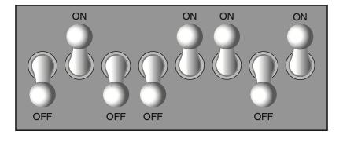

Storing Numbers
- Bit represents two values, 0 and 1
- Computers use binary numbering system
  - Position of digit jis assigned the value 2j-1
  - To determine value of binary number sum position values of the 1s
- Byte size limits are 0 and 255
  - 0 = all bits off; 255 = all bits on
  - To store larger number, use several bytes

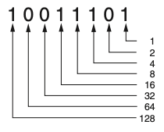
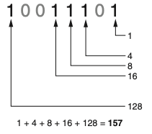
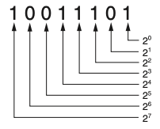

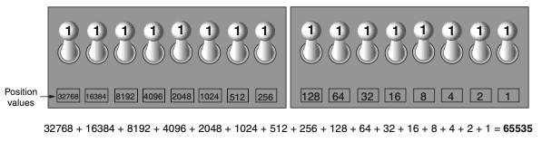

Storing Characters
- Data stored in computer must be stored as binary number
- Characters are converted to numeric code, numeric code stored in memory
  - Most important coding scheme is ASCII
    - ASCII is limited: defines codes for only 128 characters
  - Unicode coding scheme becoming standard
    - Compatible with ASCII
    - Can represent characters for other languages
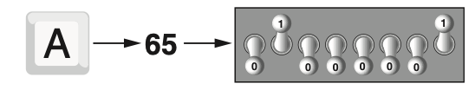

Advanced Number Storage
- To store negative numbers and real numbers, computers use binary numbering and encoding schemes
  - Negative numbers encoded using two’s complement
  - Real numbers encoded using floating-point notation

Other Type of Data
- Digital: describes any device that stores data as binary numbers
- Digital images are composed of pixels
  - To store images, each pixel is converted to a binary number representing the pixel’s color
- Digital music is composed of sections called samples
  - To store music, each sample is converted to a binary number

How a Program Works

CPU
- CPU designed to perform simple operations on pieces of data
  - Examples: reading data, adding, subtracting, multiplying, and dividing numbers
- Understands instructions written in machine language and included in its instruction set
  - Each brand of CPU has its own instruction set
- To carry out meaningful calculation, CPU must perform many operations

- Program must be copied from secondary memory to RAM each time CPU executes it
- CPU executes program in cycle:
  - Fetch: read the next instruction from memory into CPU
  - Decode: CPU decodes fetched instruction to determine which operation to perform
  - Execute: perform the operation

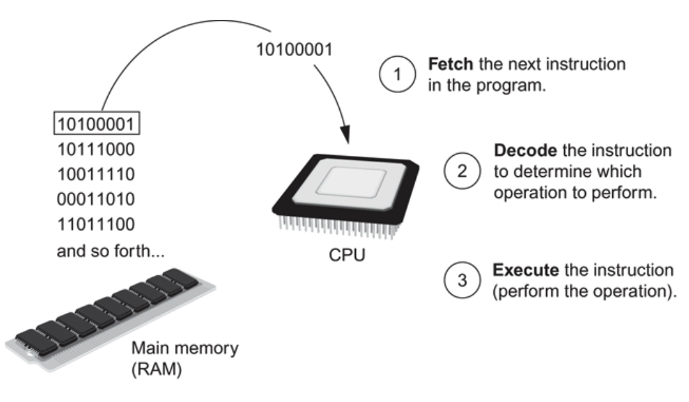

From Machine Language to Assembly Language
- Assembler: translates assembly language to machine language for execution by CPU
- Assembly language: uses short words (mnemonics) for instructions instead of binary numbers
  - Impractical for people to write in machine language
  - Easier for programmers to work with
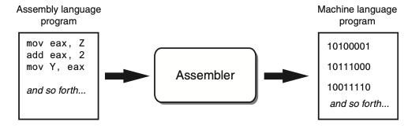

High-Level Languages
- Low-level language: close in nature to machine language
  - Example: assembly language
- High-Level language: allows simple creation of powerful and complex programs
  - No need to know how CPU works or write large number of instructions
  - More intuitive to understand

Keywords, Operators, and Syntax: an Overview
- Keywords: predefined words used to write program in high-level language
- Each keyword has specific meaning
- Operators: perform operations on data
- Example: math operators to perform arithmetic
- Syntax: set of rules to be followed when writing program
- Statement: individual instruction used in high-level language

Compilers and Interpreters
Programs written in high-level languages must be translated into machine language to be executed
- Compiler: translates high-level language program into separate machine language program
  - Machine language program can be executed at any time
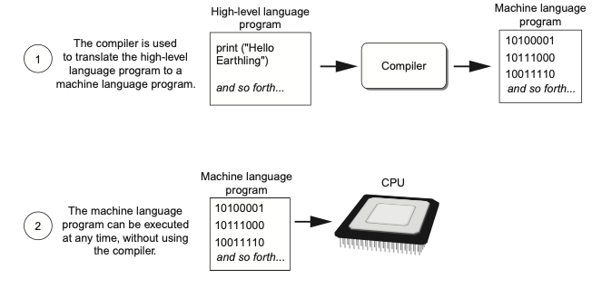

- Interpreter: translates and executes instructions in high-level language program
  - Used by Python language
  - Interprets one instruction at a time
  - No separate machine language program
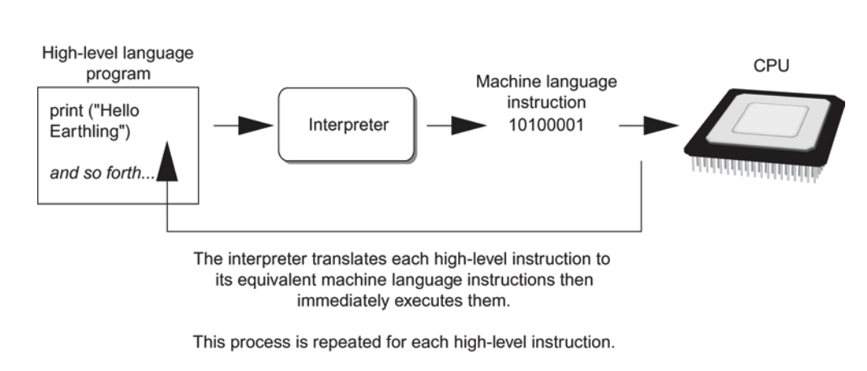

- Source code: statements written by programmer
- Syntax error: prevents code from being translated

Using Python
- Python must be installed and configured prior to use
  - One of the items installed is the Python interpreter
- Python interpreter can be used in two modes:
  - Interactive mode: enter statements on keyboard
  - Script mode: save statements in Python script

Interactive Mode
- When you start Python in interactive mode, you will see a prompt
  - Indicates the interpreter is waiting for a Python statement to be typed
  - Prompt reappears after previous statement is executed
  - Error message displayed If you incorrectly type a statement
- Good way to learn new parts of Python

Writing Python Programs and Running Them in Script Mode
- Statements entered in interactive mode are not saved as a program
- To have a program use script mode
  - Save a set of Python statements in a file
  - The filename should have the .pyextension
  - To run the file, or script, type python filename at the operating system command line

The IDLE Programming Environment
- IDLE (Integrated Development Program): single program that provides tools to write, execute and test a program
- Automatically installed when Python language is installed
- Runs in interactive mode
- Has built-in text editor with features designed to help write Python programs

Summary
- This chapter covered:
  - Main hardware components of the computer
  - Types of software
  - How data is stored in a computer
  - Basic CPU operations and machine language
  - Fetch-decode-execute cycle
  - Complex languages and their translation to machine code
  - Installing Python and the Python interpreter modes

Reference

