[Lecture Note] Input, Processing, and Output
  - MGS3001 Python Programming for Business, Spring 2025
Chad (Chungil Chae)
Tue, 27 May 2025

Learning Objectives
This chapter introduces the program development cycle, variables, data types, and simple programs that are written as sequence structures. The student learns to write simple programs that read input from the keyboard, perform mathematical operations, and produce formatted screen output. Pseudocode and flowcharts are also introduced as tools for designing programs. The chapter also includes an optional introduction to the turtle graphics library(Pajo, 2022).

SHORT VIDEO INTRODUCTION
https://www.youtube.com/watch?v=Fi3_BjVzpqk

Designing a Program
Programs must be carefully designed before they are written. During the design process, programmers use tools such as pseudocode and flowcharts to create models of programs.

The Program Development Cycle
The process of creating a program that works correctly typically requires the five phases known as the program development cycle.
- Design the Program
- Write the Code
- Correct Syntax Errors
- Test the Program
- Correct Logic Errors
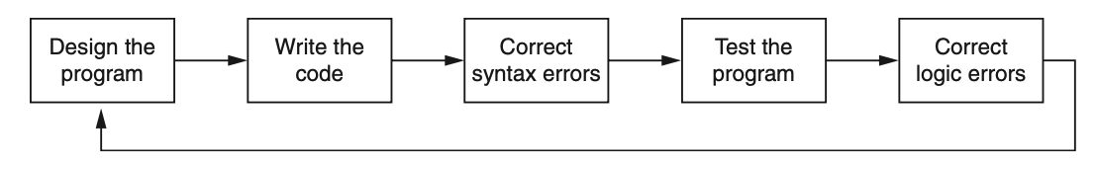
- Design the Program. All professional programmers will tell you that a program should be carefully designed before the code is actually written. When programmers begin a new project, they should never jump right in and start writing code as the first step. They start by creating a design of the program. There are several ways to design a program, and later in this section, we will discuss some techniques that you can use to design your Python programs.
- Write the Code. After designing the program, the programmer begins writing code in a high-level language such as Python. Recall from Chapter 1 that each language has its own rules, known as syntax, that must be followed when writing a program. A language’s syntax rules dictate things such as how keywords, operators, and punctuation characters can be used. A syntax error occurs if the programmer violates any of these rules.
- Correct Syntax Errors. If the program contains a syntax error, or even a simple mistake such as a misspelled keyword, the compiler or interpreter will display an error message indicating what the error is. Virtually all code contains syntax errors when it is first written, so the programmer will typically spend some time correcting these. Once all of the syntax errors and simple typing mistakes have been corrected, the program can be compiled and translated into a machine language program (or executed by an interpreter, depending on the language being used).
- Test the Program. Once the code is in an executable form, it is then tested to determine whether any logic errors exist. A logic error is a mistake that does not prevent the program from running, but causes it to produce incorrect results. (Mathematical mistakes are common causes of logic errors.)
- Correct Logic Errors. If the program produces incorrect results, the programmer debugs the code. This means that the programmer finds and corrects logic errors in the program. Sometimes during this process, the programmer discovers that the program’s original design must be changed. In this event, the program development cycle starts over and continues until no errors can be found.

- Design is the most important part of the program development cycle
- Understand the task that the program is to perform
  - Work with customer to get a sense what the program is supposed to do
  - Ask questions about program details
  - Create one or more software requirements

- Determine the steps that must be taken to perform the task
  - Break down required task into a series of steps
  - Create an algorithm, listing logical steps that must be taken
- Algorithm: set of well-defined logical steps that must be taken to perform a task

Let’s Practice
- Think about some important task
- Make an list of actions to complete the task

Pseudocode
- Pseudocode: fake code read more
  - Informal language that has no syntax rule
  - Not meant to be compiled or executed
  - Used to create model program
    - No need to worry about syntax errors, can focus on program’s design
    - Can be translated directly into actual code in any programming language.

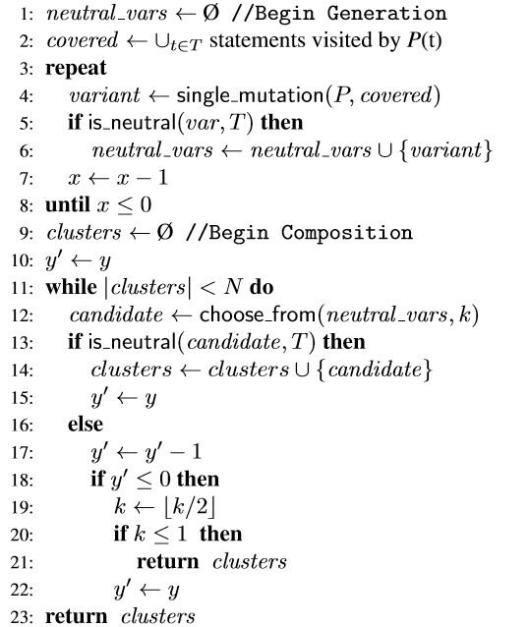

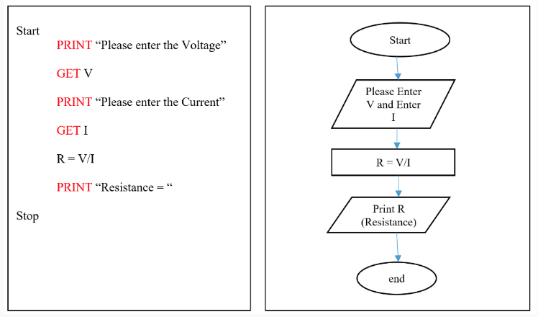

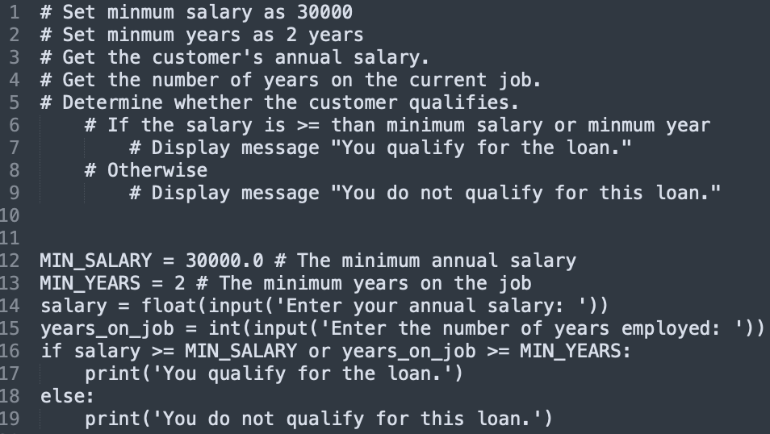

Flowchart
- Flowchart: diagram that graphically depicts the steps in a program read more
  - Ovals are terminal symbols
  - Parallelograms are input and output symbols
  - Rectangles are processing symbols
  - Symbols are connected by arrows that represent the flow of the program

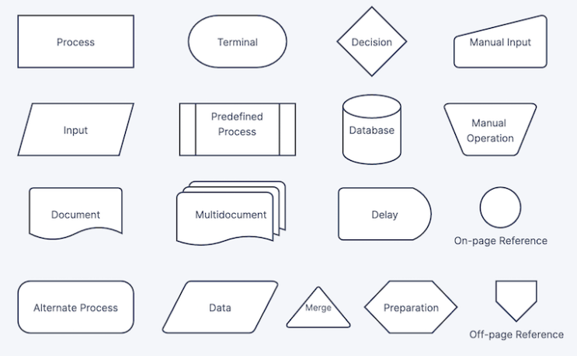

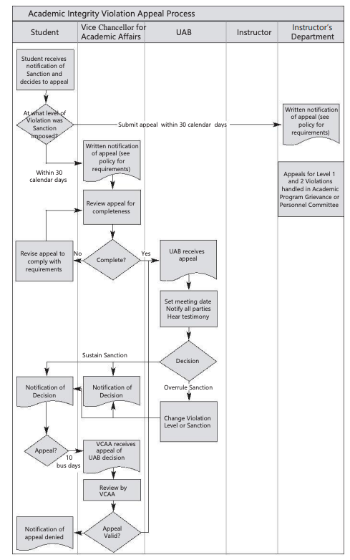

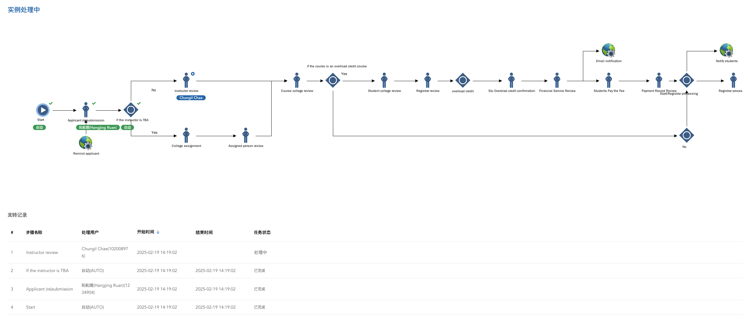

Friendship Algorithm
https://www.youtube.com/watch?v=v7OszHMNiVE

Let’s Practice
- Think about some important task
- Make an list of actions to complete the task
- Set a condition to achieve the task
- Set a loop to achieve the task

Input, Processing, and Output
Input is data that the program receives. When a program receives data, it usually processes it by performing some operation with it. The result of the operation is sent out of the program as output.

IPO
- Typically, computer performs three-step process
  - Receive input
    - Input: any data that the program receives while it is running
  - Perform some process on the input
    - Example: mathematical calculation
  - Produce output
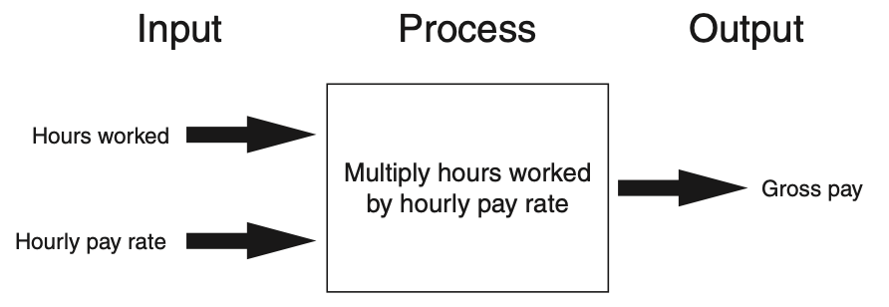

Displaying Output with the print Function
print('Hello world')
Hello world
print('Kate Austen')
Kate Austen
print('123 Full Circle Drive')
123 Full Circle Drive
print('Asheville, NC 28899')
Asheville, NC 28899

Related Concept
- Function: piece of prewritten code that performs an operation
- print function: displays output on the screen
- Argument: data given to a function
  - Example: data that is printed to screen
- Statements in a program execute in the order that they appear
- From top to bottom

Strings and String Literals
- String: sequence of characters that is used as data
- String literal: string that appears in actual code of a program
  - Must be enclosed in single (’) or double (“) quote marks
  - String literal can be enclosed in triple quotes (’’’ or “““)
    - Enclosed string can contain both single and double quotes and can have multiple lines

’’
print('Hello world')
Hello world

“”
print("Hello world")
Hello world

““” ““”
print("""Hello world""")
Hello world

“” with ’’
print("Chad's work was amazing")
Chad's work was amazing

““” ““” with “” “” and ’’
print("""Chad said, "These classes's success factor is preview".""")
Chad said, "These classes's success factor is preview".

Comments
- Comments: notes of explanation within a program
  - Ignored by Python interpreter
    - Intended for a person reading the program’s code
  - Begin with a # character
- End-line comment: appears at the end of a line of code
  - Typically explains the purpose of that line

# Define function for display message
def greet(): # Define greet function
print('Hello World!') # Display Hello World message
greet()
Hello World!

Variables

Overview
- Variable: name that represents a value stored in the computer memory
  - Used to access and manipulate data stored in memory
  - A variable references the value it represents
- Assignment statement: used to create a variable and make it reference data
  - General format is variable = expression
    - Example: age = 29
    - Assignment operator: the equal sign (=)
name = "chad"
age = 20
print(age, name)
20 chad

- In assignment statement, variable receiving value must be on left side
- A variable can be passed as an argument to a function
  - Variable name should not be enclosed in quote marks
- You can only use a variable if a value is assigned to it

Variable Naming Rules
- Rules for naming variables in Python:
  - Variable name cannot be a Python keyword
  - Variable name cannot contain spaces
  - First character must be a letter or an underscore
  - After first character may use letters, digits, or underscores
  - Variable names are case sensitive
  - Variable name should reflect its use

Displaying Multiple Items with the print Function
- Python allows one to display multiple items with a single call to print
  - Items are separated by commas when passed as arguments
  - Arguments displayed in the order they are passed to the function
  - Items are automatically separated by a space when displayed on screen
name = "chad"
age = 20
print("Hello", name+".", "I heard that you got", str(age)+"th", "birthday")
Hello chad. I heard that you got 20th birthday

Variable Reassignment
- Variables can reference different values while program is running
- Garbage collection: removal of values that are no longer referenced by variables
  - Carried out by Python interpreter
- A variable can refer to item of any type
  - Variable that has been assigned to one type can be reassigned to another type
name = "chad"
print(name)
chad
name = "Joe"
print(name)
Joe
name = 20
print(name)
20

Numeric Data Types, Literals, and the str Data Type
- Data types: categorize value in memory
  - e.g., int for integer, float for real number, str used for storing strings in memory
- Numeric literal: number written in a program
  - No decimal point considered int, otherwise, considered float
- Some operations behave differently depending on data type
num1 = 20
num2 = 20.54
num3 = "20.68"
print(num1)
20
print(num2)
20.54
print(num3)
20.68

Reassigning a Variable to a Different Type
- A variable in Python can refer to items of any type

Reading Input from the Keyboard

Overview
Most programs need to read input from the user
- Built-in inputfunction reads input from keyboard
  - Returns the data as a string
  - Format: variable = input(prompt)
    - prompt is typically a string instructing user to enter a value
  - Does not automatically display a space after the prompt

- input function always returns a string
- Built-in functions convert between data types
  - int(item)converts item to an int
  - float(item)converts item to a float
  - Nested function call: general format:
    - function1(function2(argument))
    - value returned by function2 is passed to function1
  - Type conversion only works if item is valid numeric value, otherwise, throws exception
num1 = 20
num2 = 20.54
num3 = "20.68"
print(num1)
20
print(num2)
20.54
print(num3)
20.68
print(float(num1))
20.0
print(int(num2))
20
print(num2 + float(num3))
41.22

Performing Calculations

Overview
- Math expression: performs calculation and gives a value
  - Math operator: tool for performing calculation
  - Operands: values surrounding operator
  - Variables can be used as operands, resulting value typically assigned to variable
- Two types of division:
  - / operator performs floating point division, // operator performs integer division
  - Positive results truncated, negative rounded away from zero
print(1+2)
3
print(58-782)
-724
print(35*72)
2520
print(4/2)
2.0
print(4//2)
2
print(5//2)
2
print(((1+2) * (58-782)) / 35*72)
-4468.114285714286

Operator Precedence and Grouping with Parentheses
Python operator precedence:
- Operations enclosed in parentheses
  - Forces operations to be performed before others
- Exponentiation (**)
- Multiplication (*), division (/ and //), and remainder (%)
- Addition (+) and subtraction (-)
  - Higher precedence performed first
  - Same precedence operators execute from left to right

The Exponent Operator and the
Remainder Operator:
- Exponent operator (**): Raises a number to a power
  - x ** y = xy
- Remainder operator (%): Performs division and returns the remainder
  - a.k.a. modulus operator
  - e.g., 4%2=0, 5%2=1
  - Typically used to convert times and distances, and to detect odd or even numbers
print(4**2)
16
print(4^2)
6
print(4%2)
0
print(5%2)
1

Converting Math Formulas to Programming Statements
- Operator required for any mathematical operation
- When converting mathematical expression to programming statement:
  - May need to add multiplication operators
  - May need to insert parentheses

Mixed-Type Expressions and Data Type Conversion
- Data type resulting from math operation depends on data types of operands
  - Two intvalues: result is an int
  - Two floatvalues: result is a float
  - int and float: int temporarily converted to float, result of the operation is a float
  - Mixed-type expression
    - Type conversion of float to int causes truncation of fractional part
print(10 + 11)
21
print(10.1 + 11.3)
21.4
print(10.1 + 11)
21.1
print(float(10)+11)
21.0
print(int(12.1235845865))
12

Breaking Long Statements into Multiple Lines
- Long statements cannot be viewed on screen without scrolling and cannot be printed without cutting off
- Multiline continuation character (\): Allows to break a statement into multiple lines
result = var1 * 2 + var2 * 3 + \
var3 * 4 + var4 * 5

- Any part of a statement that is enclosed in parentheses can be broken without the line continuation character.
print("Monday's sales are", monday, "and Tuesday's sales are", tuesday, "and Wednesday's sales are", Wednesday)
total = (value1 + value2 + value3 + value4 + value5 + value6)

String Concatenation

Syntex
- To append one string to the end of another string
- Use the + operator to concatenate strings
message = 'Hello' + 'world'
print(message)
Helloworld
- You can use string concatenation to break up a long string literal
print('Enter the amount of ' + 'sales for each day and ' + 'press Enter.')
Enter the amount of sales for each day and press Enter.

Implicit String Literal Concatenation
- Two or more string literals written adjacent to each other are implicitly concatenated into a single string
my_str = 'one' 'two' 'three'
print(my_str)
onetwothree
print('Enter the amount of ' 'sales for each day and ' 'press Enter.')
Enter the amount of sales for each day and press Enter.

More About the print Function

Overview
- print function displays line of output
  - Newline character at end of printed data
  - Special argument end=’delimiter’causes print to place delimiter at end of data instead of newline character
- printfunction uses space as item separator
  - Special argument sep=’delimiter’causes print to use delimiter as item separator Special characters appearing in string literal
  - Preceded by backslash (\)
    - Examples: newline (\n), horizontal tab (\t)
  - Treated as commands embedded in string

Displaying Formatted Output with F-strings

Overview

Basic
- An f-string is a special type of string literal that is prefixed with the letter f
print(f'Hello world')
Hello world

Placeholders
- F-strings support placeholders for variables
name = 'Johnny'
print(f'Hello {name}.')
Hello Johnny.

example1
- Placeholders can also be expressions that are evaluated
print(f'The value is {10 + 2}.')
The value is 12.

example2
val = 10
print(f'The value is {val + 2}.')
The value is 12.

example3 format
- Format specifiers can be used with placeholders
num = 123.456789
print(f'{num:.2f}')
123.46
-.2f means: - round the value to 2 decimal places - display the value as a floating-point number

Number
- Other examples:
num = 1000000.00
print(f'{num:,.2f}')
1,000,000.00

Percentage
discount = 0.5
print(f'{discount:.0%}')
50%

, after
num = 123456789
print(f'{num:,d}')
123,456,789

2 decimal
num = 12345.6789
print(f'{num:.2e}')
1.23e+04

Minimum field
- Specifying a minimum field width:
num = 12345.6789
print(f'The number is {num:12,.2f}')
The number is 12,345.68

Aligning
- Aligning values within a field
  - Use < for left alignment
  - Use > for right alignment
  - Use ^ for center alignment -Examples:
print(f'{num:<20.2f}')
12345.68
print(f'{num:>20.2f}')
12345.68
print(f'{num:^20.2f}')
12345.68

Format specifier
- The order of designators in a format specifier
  - When using multiple designators in a format specifier, write them in this order:
  - [alignment][width][,][.precision][type] -Example:
print(f'{num:^10,.2f}')
12,345.68

Named Constants

Magic Numbers
- A magic number is an unexplained numeric value that appears in a program’s code.
- Example:
amount = balance * 0.069
- What is the value 0.069? An interest rate? A fee percentage? Only the person who wrote the code knows for sure.

The Problem with Magic Numbers
- It can be difficult to determine the purpose of the number.
- If the magic number is used in multiple places in the program, it can take a lot of effort to change the number in each location, should the need arise.
- You take the risk of making a mistake each time you type the magic number in the program’s code.
  - For example, suppose you intend to type 0.069, but you accidentally type .0069. This mistake will cause mathematical errors that can be difficult to find.

Named Constants
- You should use named constants instead of magic numbers.
- A named constant is a name that represents a value that does not change during the program’s execution.
- Example:
INTEREST_RATE = 0.069
- This creates a named constant named INTEREST_RATE, assigned the value 0.069. It can be used instead of the magic number:
amount = balance * INTEREST_RATE

Advantages of Using Named Constants
- Named constants make code self-explanatory (self-documenting)
- Named constants make code easier to maintain (change the value assigned to the constant, and the new value takes effect everywhere the constant is used)
- Named constants help prevent typographical errors that are common when using magic numbers

Introduction to Turtle Graphics

Overview
- Python’s turtle graphics system displays a small cursor known as a turtle.
- You can use Python statements to move the turtle around the screen, drawing lines and shapes.
- To use the turtle graphics system, you must import the turtle module with this statement:
import turtle
This loads the turtle module into memory

Moving the Turtle Forward
- Use the turtle.forward(n)statement to move the turtle forward n pixels.
import turtle
turtle.forward(100)

Turning the Turtle
- The turtle’s initial heading is 0 degrees (east)
- Use the turtle.right(angle)statement to turn the turtle right by angle degrees.
- Use the turtle.left(angle)statement to turn the turtle left by angle degrees.
import turtle
turtle.forward(100)
turtle.left(90)
turtle.forward(100)
import turtle
turtle.forward(100)
turtle.right(45)
turtle.forward(100)

Setting the Turtle’s Heading
- Use the turtle.setheading(angle)statement toset the turtle’s heading to a specific angle.
import turtle
turtle.forward(50)
turtle.setheading(90)
turtle.forward(100)
turtle.setheading(180)
turtle.forward(50)
turtle.setheading(270)
turtle.forward(100)

Setting the Pen Up or Down
- When the turtle’s pen is down, the turtle draws a line as it moves. By default, the pen is down.
- When the turtle’s pen is up, the turtle does not draw as it moves.
- Use the turtle.penup()statement to raise the pen.
- Use the turtle.pendown()statement to lower the pen.
import turtle
turtle.forward(50)
turtle.penup()
turtle.forward(25)
turtle.pendown()
turtle.forward(50)
turtle.penup()
turtle.forward(25)
turtle.pendown()
turtle.forward(50)

Drawing Circles
- Use the turtle.circle(radius)statement to draw a circle with a specified radius.
import turtle
turtle.circle(100)

Drawing Dots
- Use the turtle.dot()statement to draw a simple dot at the turtle’s current location.
import turtle
turtle.dot()
turtle.forward(50)
turtle.dot()
turtle.forward(50)
turtle.dot()
turtle.forward(50)

Changing the Pen Size and Drawing Color
- Use the turtle.pensize(width)statement to change the width of the turtle’s pen, in pixels.
- Use the turtle.pencolor(color)statement to change the turtle’s drawing color.
  - See Appendix D in your textbook for a complete list of colors.
import turtle
turtle.pensize(5)
turtle.pencolor('red')
turtle.circle(100)

Working with the Turtle’s Window
- Use the turtle.bgcolor(color)statement to set the window’s background color.
  - See Appendix D in your textbook for a complete list of colors.
- Use the turtle.setup(width,height)statement to set the size of the turtle’s window, in pixels.
  - The width and height arguments are the width and height, in pixels.
  - For example, the following interactive session creates a graphics window that is 640 pixels wide and 480 pixels high:
import turtle
turtle.setup(640, 480)

Resetting the Turtle’s Window
- The turtle.reset()statement:
  - Erases all drawings that currently appear in the graphics window.
  - Resets the drawing color to black.
  - Resets the turtle to its original position in the center of the screen.
  - Does not reset the graphics window’s background color.
- The turtle.clear()statement:
  - Erases all drawings that currently appear in the graphics window.
  - Does not change the turtle’s position.
  - Does not change the drawing color.
  - Does not change the graphics window’s background color.

- The turtle.clearscreen()statement:
  - Erases all drawings that currently appear in the graphics window.
  - Resets the drawing color to black.
  - Resets the turtle to its original position in the center of the screen.
  - Resets the graphics window’s background color to white.

Working with Coordinates
- The turtle uses Cartesian Coordinates

Moving the Turtle to a Specific Location
- Use the turtle.goto(x, y)statement to move the turtle to a specific location.
import turtle
turtle.goto(0, 100)
turtle.goto(−100, 0)
turtle.goto(0, 0)
- The turtle.pos() statement displays the turtle’s current X,Y coordinates.
- The turtle.xcor() statement displays the turtle’s current X coordinate and the turtle.ycor() statement displays the turtle’s current Y coordinate.

Animation Speed
- Use the turtle.speed(speed)command to change the speed at which the turtle moves.
  - The speed argument is a number in the range of 0 through 10.
  - If you specify 0, then the turtle will make all of its moves instantly (animation is disabled).

Hiding and Displaying the Turtle
- Use the turtle.hideturtle()command to hide the turtle.
  - This command does not change the way graphics are drawn, it simply hides the turtle icon.
- Use the turtle.showturtle()command to display the turtle.

Displaying Text
- Use the turtle.write(text)statement to display text in the turtle’s graphics window.
  - The text argument is a string that you want to display.
  - The lower-left corner of the first character will be positioned at the turtle’s X and Y coordinates.
import turtle
turtle.write('Hello World')

Filling Shapes
- To fill a shape with a color:
  - Use the turtle.begin_fill()command before drawing the shape
  - Then use the turtle.end_fill()command after the shape is drawn.
  - When the turtle.end_fill()command executes, the shape will be filled with the current fill color
import turtle
turtle.hideturtle()
turtle.fillcolor('red')
turtle.begin_fill()
turtle.circle(100)
turtle.end_fill()

Getting Input With a Dialog Box
import turtle
age = turtle.numinput('Input', 'Enter your age')
import turtle
name = turtle.textinput('Input', 'Enter your name')
- Specifying a default value, minimum value, and maximum value with turtle.numinput:
import turtle
num = turtle.numinput('Input', 'Enter a number', default=10, minval=0, maxval=100)
- An error message will be displayed if the input is less than minvalor greater than maxval

Keeping the Graphics Window Open
- When running a turtle graphics program outside IDLE, the graphics window closes immediately when the program is done.
- To prevent this, add the turtle.done()statementto the very end of your turtle graphics programs.
  - This will cause the graphics window to remain open, so you can see its contents after the program finishes executing.

Summary
- This chapter covered:
  - The program development cycle, tools for program design, and the design process
  - Ways in which programs can receive input, particularly from the keyboard
  - Ways in which programs can present and format output
  - Use of comments in programs
  - Uses of variables and named constants
  - Tools for performing calculations in programs
  - The turtle graphics system

House management

Assignment
- What to do
- Requirement
  - PDF format
  - file name should be include your student id and name
    - stuID_name_title.pdf (e.g. 1111111_ChungilChae_SelfIntroduction.pdf)
- Due date
  - by Feb23(Sun) 11:59PM
  - NO LATE SUBMISSION ALLOWED!!!!

Reference
Pajo, B. (2022). Introduction to research methods: A hands-on approach. Sage publications.

