[Lecture Notebook] Analysis Technique Summary
  - Summary of Chapter6 to Chapter20
Chad (Chungil Chae)
Tue, 27 May 2025

Multiple Linear Regression (Ch.6)

Data
# Sample housing dataset
data <- data.frame(
Size = c(1000, 1500, 2000, 2500, 3000, 1800, 1600, 2400, 2200, 2800),
Bedrooms = c(2, 3, 3, 4, 4, 3, 2, 4, 3, 4),
Price = c(200000, 250000, 270000, 310000, 360000, 260000, 230000, 300000, 280000, 340000)
)

Train-Test Split
set.seed(123) # For reproducibility
sample_index <- sample(1:nrow(data), 0.7 * nrow(data))
train_data <- data[sample_index, ]
test_data <- data[-sample_index, ]

Model Training
# Fit the regression model
model <- lm(Price ~ Size + Bedrooms, data = train_data)
# Model summary
summary(model)
Call:
lm(formula = Price ~ Size + Bedrooms, data = train_data)
Residuals:
3 10 2 8 6 9 1
-1739.1 8415.1 6451.6 -9032.3 -462.8 -3015.4 -617.1
Coefficients:
Estimate Std. Error t value Pr(>|t|)
(Intercept) 114754.56 14958.83 7.671 0.00155 **
Size 56.38 12.04 4.683 0.00943 **
Bedrooms 14740.53 10364.62 1.422 0.22804
---
Signif. codes: 0 '***' 0.001 '**' 0.01 '*' 0.05 '.' 0.1 ' ' 1
Residual standard error: 7189 on 4 degrees of freedom
Multiple R-squared: 0.9817, Adjusted R-squared: 0.9725
F-statistic: 107.2 on 2 and 4 DF, p-value: 0.0003356

Prediction
# Predict on test data
predictions <- predict(model, newdata = test_data)
predictions
4 5 7
314670.4 342861.2 234446.0

Evaluation Metrics
#install.packages("Metrics")
library(Metrics)
actuals <- test_data$Price
mae <- mean(abs(actuals - predictions))
rmse <- sqrt(mean((actuals - predictions)^2))
SSE <- sum((actuals - predictions)^2)
SST <- sum((actuals - mean(actuals))^2)
rsq <- 1 - SSE/SST
cat("MAE:", round(mae, 2), "\n")
MAE: 8751.75
cat("RMSE:", round(rmse, 2), "\n")
RMSE: 10572.29
cat("R-squared:", round(rsq, 4), "\n")
R-squared: 0.961

k-Nearest Neighbors (kNN) (Ch.7)

Data
# Sample height-weight-gender dataset
data <- data.frame(
Height = c(5.1, 6.0, 5.5, 6.2, 5.8, 5.3, 5.9, 6.1, 5.4, 5.7),
Weight = c(120, 180, 150, 200, 160, 130, 170, 190, 140, 155),
Gender = as.factor(c("F", "M", "F", "M", "F", "F", "M", "M", "F", "F"))
)

Train-Test Split
set.seed(123)
sample_index <- sample(1:nrow(data), 0.7 * nrow(data))
train_data <- data[sample_index, ]
test_data <- data[-sample_index, ]

Feature Scaling
# Normalize the features
normalize <- function(x) { (x - min(x)) / (max(x) - min(x)) }
train_scaled <- as.data.frame(lapply(train_data[, 1:2], normalize))
test_scaled <- as.data.frame(lapply(test_data[, 1:2], normalize))
# Labels
train_labels <- train_data$Gender
test_labels <- test_data$Gender

kNN Model Training and Prediction

Data
# install.packages("ggplot2")
library(ggplot2)
library(class)
set.seed(123)
# Training data
train_data <- data.frame(
X1 = c(1, 2, 3, 6, 7, 8),
X2 = c(1, 2, 1, 6, 7, 6),
Label = as.factor(c("A", "A", "A", "B", "B", "B"))
)
# Test point
test_data <- data.frame(X1 = c(4), X2 = c(4))

kNN Prediction
# Scale if needed (not necessary in this small example)
train_matrix <- train_data[, 1:2]
test_matrix <- test_data
predicted <- class::knn(train = train_matrix, test = test_matrix, cl = train_data$Label, k = 3)

Visualization
# Add prediction result to test data
test_data$Label <- predicted
# Combine for plotting
combined <- rbind(
data.frame(train_data, Type = "Train"),
data.frame(test_data, Type = "Test")
)
# Plot
ggplot(combined, aes(x = X1, y = X2, color = Label, shape = Type)) +
geom_point(size = 4) +
labs(title = "k-Nearest Neighbors Classification") +
scale_shape_manual(values = c(16, 17)) +
theme_minimal()
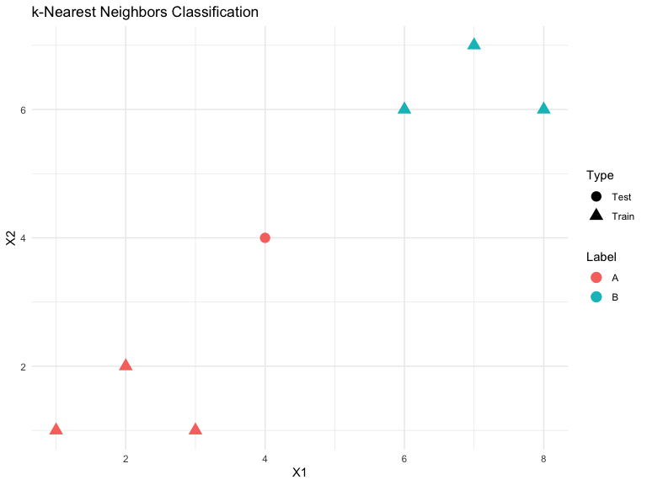

The Naive Bayes Classifier

Data
# Sample weather dataset
data <- data.frame(
Outlook = c("Sunny", "Sunny", "Overcast", "Rain", "Rain", "Rain", "Overcast", "Sunny", "Sunny", "Rain"),
Temp = c("Hot", "Hot", "Hot", "Mild", "Cool", "Cool", "Cool", "Mild", "Cool", "Mild"),
Play = as.factor(c("No", "No", "Yes", "Yes", "Yes", "No", "Yes", "No", "Yes", "Yes"))
)

Train-test split
set.seed(123)
sample_index <- sample(1:nrow(data), 0.7 * nrow(data))
train_data <- data[sample_index, ]
test_data <- data[-sample_index, ]

Naive Bayes model training
library(e1071)
# Train model
model <- naiveBayes(Play ~ ., data = train_data)

Prediction
# Predict on test data
predicted <- predict(model, newdata = test_data)

Evaluation (accuracy & confusion matrix)
# Accuracy
accuracy <- mean(predicted == test_data$Play)
# Confusion matrix
conf_matrix <- table(Predicted = predicted, Actual = test_data$Play)
# Output
cat("Accuracy:", round(accuracy, 2), "\n")
Accuracy: 1
print(conf_matrix)
Actual
Predicted No Yes
No 0 0
Yes 0 3

Classification and Regression Trees

Data
# Customer data for purchase decision
data <- data.frame(
Age = c(25, 45, 35, 33, 50, 29, 40, 38, 48, 55),
Income = as.factor(c("High", "Medium", "Low", "Medium", "High", "Low", "Medium", "High", "Low", "Medium")),
Buy = as.factor(c("No", "Yes", "Yes", "Yes", "No", "Yes", "Yes", "No", "Yes", "Yes"))
)

Train-test split
set.seed(123)
sample_index <- sample(1:nrow(data), 0.7 * nrow(data))
train_data <- data[sample_index, ]
test_data <- data[-sample_index, ]

Tree model training
library(rpart)
# Train decision tree model
tree_model <- rpart(
Buy ~ Age + Income,
data = train_data,
method = "class",
control = rpart.control(minsplit = 1, cp = 0)
)

Prediction
# Predict on test data
predicted <- predict(tree_model, newdata = test_data, type = "class")

Evaluation (accuracy and confusion matrix)
# Accuracy
accuracy <- mean(predicted == test_data$Buy)
# Confusion matrix
conf_matrix <- table(Predicted = predicted, Actual = test_data$Buy)
# Output
cat("Accuracy:", round(accuracy, 2), "\n")
Accuracy: 1
print(conf_matrix)
Actual
Predicted No Yes
No 1 0
Yes 0 2

Tree visualization
# Optional tree visualization
plot(tree_model)
text(tree_model, use.n = TRUE, all = TRUE)
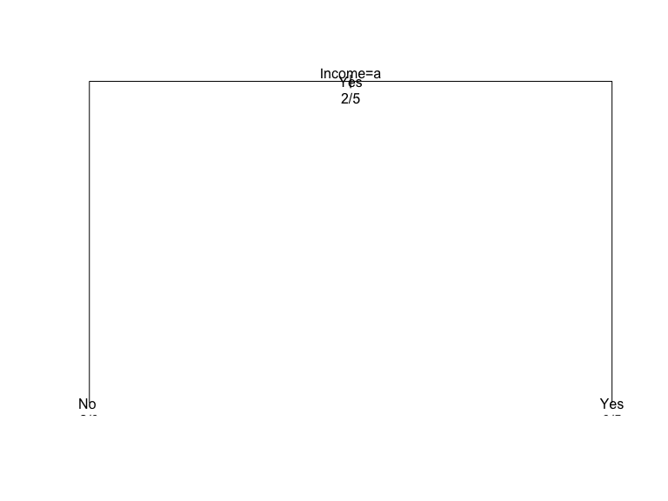
table(train_data$Buy)
No Yes
2 5

Logistic Regression (Ch.10)

Data
# Binary classification dataset (Purchased: 0 = No, 1 = Yes)
data <- data.frame(
Age = c(22, 25, 47, 52, 46, 56, 23, 39, 48, 33),
Salary = c(30000, 35000, 80000, 90000, 70000, 100000, 32000, 61000, 85000, 40000),
Purchased = as.factor(c(0, 0, 1, 1, 1, 1, 0, 1, 1, 0))
)

Train-test split
set.seed(123)
sample_index <- sample(1:nrow(data), 0.7 * nrow(data))
train_data <- data[sample_index, ]
test_data <- data[-sample_index, ]

Logistic model training
# Logistic regression model
model <- glm(Purchased ~ Age + Salary, data = train_data, family = binomial)
summary(model)
Call:
glm(formula = Purchased ~ Age + Salary, family = binomial, data = train_data)
Coefficients:
Estimate Std. Error z value Pr(>|z|)
(Intercept) -7.597e+01 3.180e+05 0 1
Age -1.717e+00 2.262e+04 0 1
Salary 2.717e-03 1.092e+01 0 1
(Dispersion parameter for binomial family taken to be 1)
Null deviance: 9.5607e+00 on 6 degrees of freedom
Residual deviance: 4.1857e-10 on 4 degrees of freedom
AIC: 6
Number of Fisher Scoring iterations: 24

Prediction and evaluation (accuracy, confusion matrix)
# Predict probabilities
predicted_probs <- predict(model, newdata = test_data, type = "response")
# Classify based on 0.5 threshold
predicted_classes <- ifelse(predicted_probs > 0.5, 1, 0)

Evaluation
# Accuracy
actual <- as.numeric(as.character(test_data$Purchased))
accuracy <- mean(predicted_classes == actual)
# Confusion Matrix
conf_matrix <- table(Predicted = predicted_classes, Actual = actual)
# Output
cat("Accuracy:", round(accuracy, 2), "\n")
Accuracy: 1
print(conf_matrix)
Actual
Predicted 0 1
0 1 0
1 0 2

Visualization of decision boundary and probabilities
library(ggplot2)
# Add predicted probabilities to test data
test_data$prob <- predicted_probs
test_data$predicted <- as.factor(predicted_classes)
# Plot Salary vs Age with predicted probability
ggplot(test_data, aes(x = Age, y = Salary)) +
geom_point(aes(color = Purchased), size = 3) +
geom_point(aes(size = prob), color = "black", shape = 1) +
labs(title = "Logistic Regression: Predicted Probabilities",
subtitle = "Point size reflects predicted probability of purchase",
color = "Actual") +
theme_minimal()
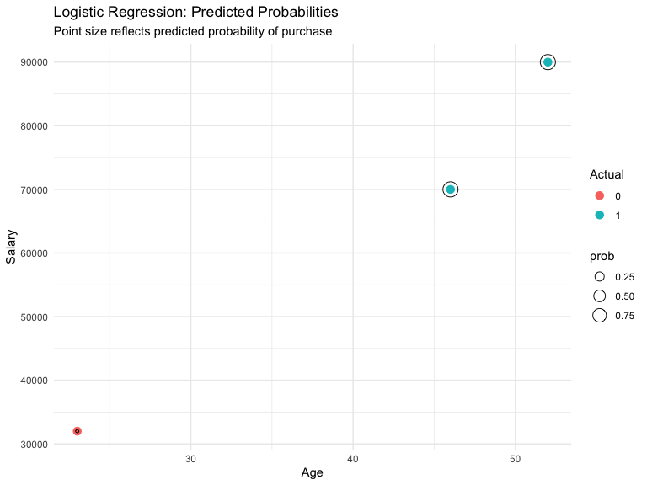

Neural Nets (Ch.11)

Data
# Simulated data: test scores based on study and sleep hours
data <- data.frame(
StudyHours = c(1, 2, 3, 4, 5, 6, 7, 8, 9, 10),
SleepHours = c(7, 6.5, 6, 5.5, 5, 4.5, 4, 3.5, 3, 2.5),
Score = c(50, 55, 60, 65, 70, 72, 74, 76, 78, 80)
)

Feature scaling
# Normalize features to 0-1 range
normalize <- function(x) (x - min(x)) / (max(x) - min(x))
data_scaled <- as.data.frame(lapply(data, normalize))

Train-test split
set.seed(123)
sample_index <- sample(1:nrow(data_scaled), 0.7 * nrow(data_scaled))
train_data <- data_scaled[sample_index, ]
test_data <- data_scaled[-sample_index, ]

Model training
library(nnet)
# Train neural network (1 hidden layer with 3 neurons)
nn_model <- nnet(Score ~ StudyHours + SleepHours,
data = train_data,
size = 3,
linout = TRUE,
maxit = 500,
trace = FALSE)

Prediction and evaluation
# Predict on test data
predicted <- predict(nn_model, newdata = test_data)
# Denormalize (for interpretability)
denormalize <- function(x, orig) x * (max(orig) - min(orig)) + min(orig)
actual_score <- denormalize(test_data$Score, data$Score)
pred_score <- denormalize(predicted, data$Score)
# RMSE
rmse <- sqrt(mean((pred_score - actual_score)^2))
cat("RMSE:", round(rmse, 2), "\n")
RMSE: 0.6

Visualization of predicted vs actual output
library(ggplot2)
df_plot <- data.frame(
Actual = actual_score,
Predicted = pred_score
)
ggplot(df_plot, aes(x = Actual, y = Predicted)) +
geom_point(color = "blue", size = 3) +
geom_abline(slope = 1, intercept = 0, linetype = "dashed", color = "red") +
labs(title = "Neural Network: Predicted vs Actual Scores",
x = "Actual Score", y = "Predicted Score") +
theme_minimal()
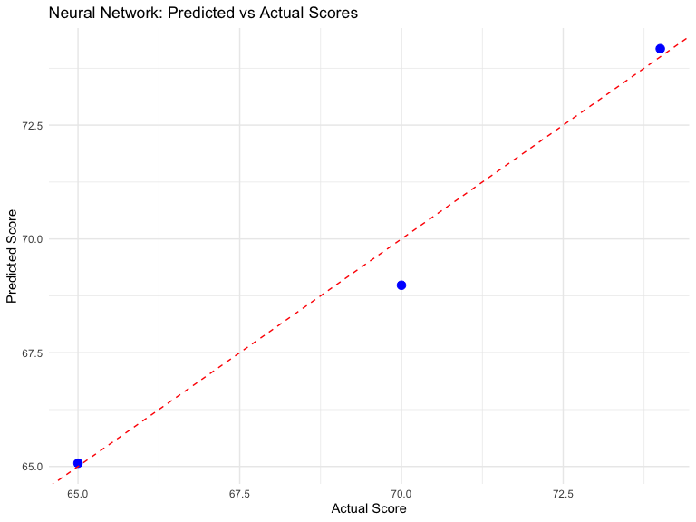

Discriminant Analysis (Ch.12)

Data
# Students classified into classes based on scores
data <- data.frame(
Math = c(80, 60, 70, 90, 50, 85, 45, 78, 66, 74),
Science = c(85, 55, 65, 95, 45, 90, 40, 82, 61, 72),
Class = as.factor(c("A", "B", "B", "A", "B", "A", "B", "A", "B", "A"))
)

Train-test split
set.seed(123)
sample_index <- sample(1:nrow(data), 0.7 * nrow(data))
train_data <- data[sample_index, ]
test_data <- data[-sample_index, ]

Model training with LDA
library(MASS)
lda_model <- lda(Class ~ Math + Science, data = train_data)

Prediction and evaluation
# Predict on test data
lda_pred <- predict(lda_model, newdata = test_data)
# View predicted classes
predicted_classes <- lda_pred$class

Evaluation
# Accuracy
actual_classes <- test_data$Class
accuracy <- mean(predicted_classes == actual_classes)
# Confusion matrix
conf_matrix <- table(Predicted = predicted_classes, Actual = actual_classes)
# Output
cat("Accuracy:", round(accuracy, 2), "\n")
Accuracy: 1
print(conf_matrix)
Actual
Predicted A B
A 1 0
B 0 2

Visualization of discriminant scores
library(ggplot2)
# Combine LDA output with test data for plotting
plot_data <- data.frame(
LD1 = lda_pred$x[,1],
Class = actual_classes,
Predicted = predicted_classes
)
ggplot(plot_data, aes(x = LD1, fill = Class)) +
geom_histogram(binwidth = 0.5, position = "identity", alpha = 0.6) +
labs(title = "Discriminant Analysis: LD1 by Class",
x = "Linear Discriminant 1", y = "Count") +
theme_minimal()
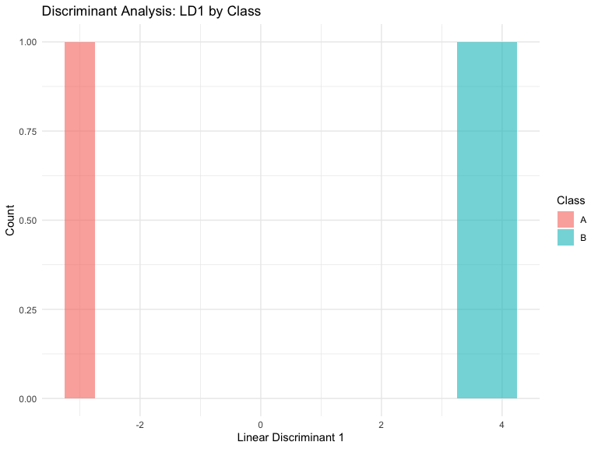

Combining Methods: Ensembles and Uplift Modeling (Ch.13)

Ensemble Learning using a Random Forest

Data
# Binary classification problem
data <- data.frame(
Feature1 = c(2, 4, 6, 8, 10, 1, 3, 5, 7, 9),
Feature2 = c(1, 3, 5, 7, 9, 2, 4, 6, 8, 10),
Label = as.factor(c(0, 0, 1, 1, 1, 0, 0, 1, 1, 1))
)

Train-Test Split
set.seed(123)
sample_index <- sample(1:nrow(data), 0.7 * nrow(data))
train_data <- data[sample_index, ]
test_data <- data[-sample_index, ]

Random Forest Ensemble Model
library(randomForest)
# Train random forest
rf_model <- randomForest(Label ~ ., data = train_data, ntree = 100)
# Predict on test data
predicted <- predict(rf_model, newdata = test_data)
# Accuracy
accuracy <- mean(predicted == test_data$Label)
cat("Random Forest Accuracy:", round(accuracy, 2), "\n")
Random Forest Accuracy: 1

A basic Uplift Modeling case using the tools4uplift package

Data
#install.packages("grf")
library(grf)
set.seed(123)
n <- 500
X <- matrix(rnorm(n * 3), ncol = 3) # Covariates
colnames(X) <- c("X1", "X2", "X3")
W <- rbinom(n, 1, 0.5) # Random treatment assignment
# Outcome depends on features and treatment interaction (heterogeneous effect)
Y <- 0.5 + 0.5 * X[,1] + 0.5 * X[,2] + W * (1 + 0.5 * X[,1]) + rnorm(n)

Train Causal Forset Model
# Train causal forest to estimate conditional average treatment effect (CATE)
cf_model <- causal_forest(X, Y, W)
### Predict uplift scores
# Predict uplift (CATE) for each individual
cate_pred <- predict(cf_model)
# View first few predicted uplift scores
head(cate_pred$predictions)
[1] 0.7134650 0.8063268 1.7933776 1.2126532 1.0135543 1.4721875

Visualization
library(ggplot2)
# Create dataframe for visualization
uplift_df <- data.frame(
uplift = cate_pred$predictions
)
# Histogram of predicted uplift scores
ggplot(uplift_df, aes(x = uplift)) +
geom_histogram(binwidth = 0.1, fill = "skyblue", color = "black") +
labs(title = "Distribution of Predicted Uplift (CATE)",
x = "Estimated Treatment Effect", y = "Count") +
theme_minimal()
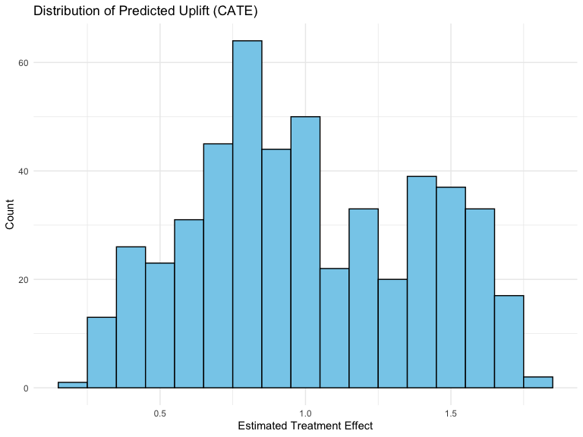

Association Rules and Collaborative Filtering (Ch.14)

Association Rules (Market Basket Analysis)

Data
##install.packages("arulesViz")
#install.packages("arules")
library(arules)
library(arulesViz)
# Simulate simple transaction list
transactions_list <- list(
c("milk", "bread"),
c("bread", "butter"),
c("milk", "eggs"),
c("milk", "bread", "butter"),
c("bread", "eggs"),
c("milk", "bread"),
c("butter", "eggs")
)

Generate association rules
# Convert to transaction format
trans <- as(transactions_list, "transactions")
rules <- apriori(trans, parameter = list(supp = 0.3, conf = 0.6))
Apriori
Parameter specification:
confidence minval smax arem aval originalSupport maxtime support minlen
0.6 0.1 1 none FALSE TRUE 5 0.3 1
maxlen target ext
10 rules TRUE
Algorithmic control:
filter tree heap memopt load sort verbose
0.1 TRUE TRUE FALSE TRUE 2 TRUE
Absolute minimum support count: 2
set item appearances ...[0 item(s)] done [0.00s].
set transactions ...[4 item(s), 7 transaction(s)] done [0.00s].
sorting and recoding items ... [4 item(s)] done [0.00s].
creating transaction tree ... done [0.00s].
checking subsets of size 1 2 done [0.00s].
writing ... [3 rule(s)] done [0.00s].
creating S4 object ... done [0.00s].
arules::inspect(head(rules, n = 5, by = "lift"))
lhs rhs support confidence coverage lift count
[1] {milk} => {bread} 0.4285714 0.7500000 0.5714286 1.05 3
[2] {bread} => {milk} 0.4285714 0.6000000 0.7142857 1.05 3
[3] {} => {bread} 0.7142857 0.7142857 1.0000000 1.00 5

Visualization
# install.packages("arulesViz")
library(arulesViz)
plot(rules, method = "graph", engine = "htmlwidget")

Collaborative Filtering (User-Item Recommendation)

Data
# install.packages("recommenderlab")
library(recommenderlab)
ratings <- matrix(c(
5, NA, 3, 1, # User 1
4, 2, NA, 1, # User 2
NA, 5, 4, 2, # User 3
1, 2, 3, NA # User 4
), nrow = 4, byrow = TRUE)
colnames(ratings) <- c("Item_A", "Item_B", "Item_C", "Item_D")
rownames(ratings) <- paste0("User_", 1:4)
rrm <- as(ratings, "realRatingMatrix")

Train Collaborative Filtering Model
model <- Recommender(rrm, method = "UBCF")

Top2 Recommendations for User 1
prediction1 <- predict(model, rrm[1], n = 2)
as(prediction1, "list")
$`0`
[1] "Item_B"
prediction2 <- predict(model, rrm[2], n = 2)
as(prediction2, "list")
$`0`
[1] "Item_C"
prediction3 <- predict(model, rrm[3], n = 2)
as(prediction3, "list")
$`0`
[1] "Item_A"
prediction4 <- predict(model, rrm[4], n = 2)
as(prediction4, "list")
$`0`
[1] "Item_D"

Cluster Analysis (Ch.15)

Data
# install.packages("ggplot2")
# install.packages("factoextra")
library(ggplot2)
library(factoextra)
# Simulated data for 3 groups
set.seed(123)
group1 <- data.frame(X = rnorm(50, mean = 2), Y = rnorm(50, mean = 2))
group2 <- data.frame(X = rnorm(50, mean = 6), Y = rnorm(50, mean = 6))
group3 <- data.frame(X = rnorm(50, mean = 10), Y = rnorm(50, mean = 2))
data <- rbind(group1, group2, group3)

Clustering with k-means
set.seed(123)
kmeans_result <- kmeans(data, centers = 3, nstart = 25)
# Append cluster labels
data$cluster <- as.factor(kmeans_result$cluster)

Visualization using ggplot2 and factoextra
# Simple scatter plot
ggplot(data, aes(x = X, y = Y, color = cluster)) +
geom_point(size = 3) +
labs(title = "K-Means Cluster Visualization") +
theme_minimal()
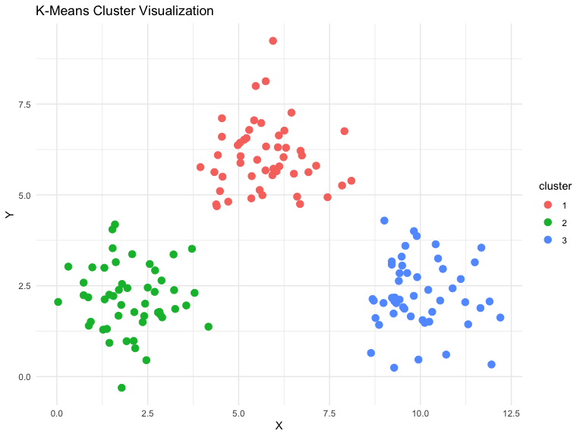
fviz_cluster(kmeans_result, data = data[, 1:2],
ellipse.type = "norm", repel = TRUE,
ggtheme = theme_minimal())
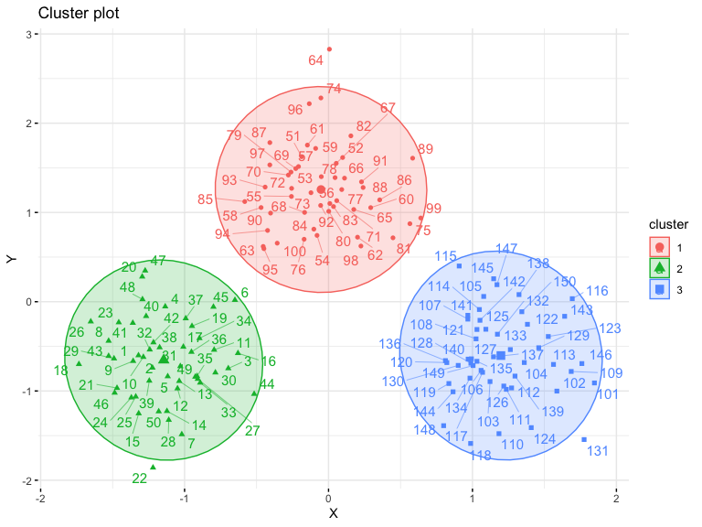

Evaluation using cluster plots
fviz_nbclust(data[, 1:2], kmeans, method = "wss") +
labs(title = "Elbow Method for Optimal K")
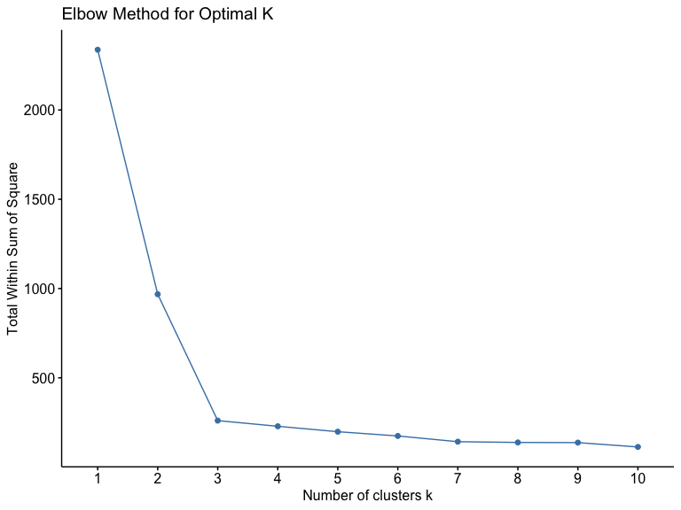

Handling Time Series (Ch.16)

Data
# install.packages("forecast")
# install.packages("tseries")
library(forecast)
library(tseries)
# Monthly sales data over 3 years
sales <- c(120, 130, 125, 140, 160, 155, 170, 180, 175, 190, 195, 200,
210, 215, 220, 225, 230, 240, 245, 250, 255, 260, 265, 270,
275, 280, 285, 290, 295, 300, 310, 315, 320, 325, 330, 335)
ts_data <- ts(sales, start = c(2020, 1), frequency = 12)
plot(ts_data, main = "Monthly Sales Over Time", ylab = "Sales", xlab = "Time")
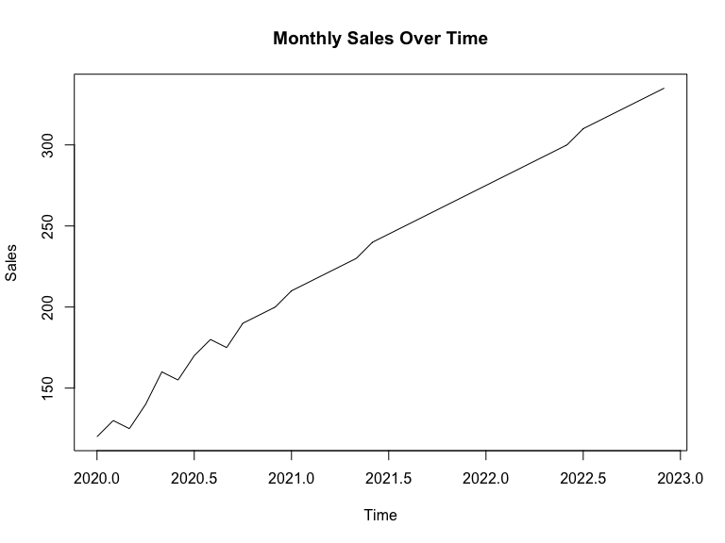

Decomposition into trend, seasonality, and residuals
decomp <- stats::decompose(ts_data)
plot(decomp)
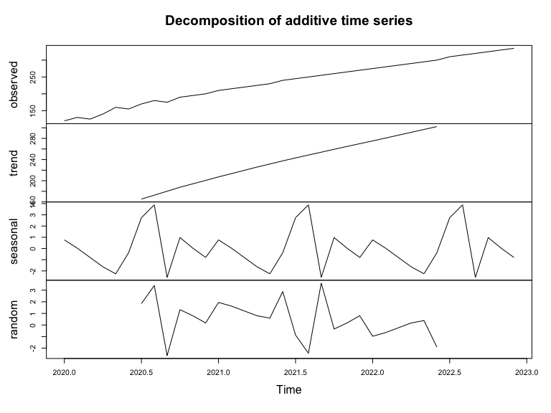

Stationarity testing
adf.test(ts_data) # Augmented Dickey-Fuller Test
Augmented Dickey-Fuller Test
data: ts_data
Dickey-Fuller = -5.5852, Lag order = 3, p-value = 0.01
alternative hypothesis: stationary

Forecasting using ARIMA
model <- auto.arima(ts_data)
summary(model)
Series: ts_data
ARIMA(3,1,0) with drift
Coefficients:
ar1 ar2 ar3 drift
-0.3691 -0.2281 0.5243 6.1481
s.e. 0.1426 0.1514 0.1459 0.5115
sigma^2 = 12.32: log likelihood = -92.47
AIC=194.95 AICc=197.02 BIC=202.72
Training set error measures:
ME RMSE MAE MPE MAPE MASE
Training set -0.05025393 3.256568 2.264695 0.07513985 1.160768 0.0316004
ACF1
Training set 0.05778946

Visualization with forecast and ggplot2
forecast_values <- forecast(model, h = 12) # forecast next 12 months
plot(forecast_values)
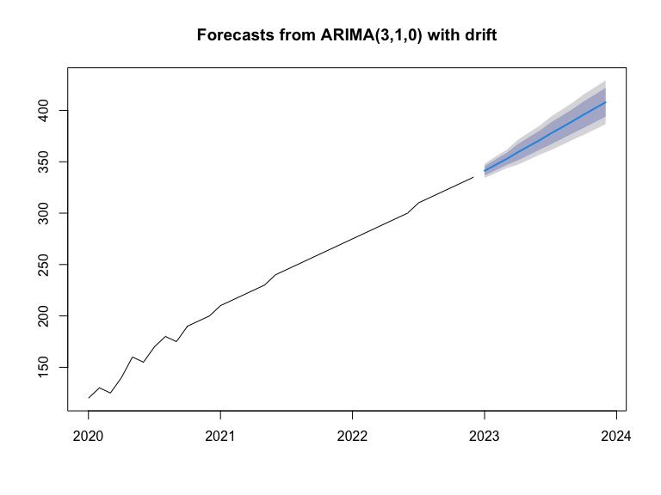

Regression-Based Forecasting (Ch.17)

Data
# install.packages("ggplot2")
# install.packages("forecast")
library(ggplot2)
library(forecast)
# Monthly sales with a linear upward trend and slight seasonality
months <- 1:36
sales <- 100 + 2 * months + 10 * sin(2 * pi * months / 12) + rnorm(36, 0, 5)
data <- data.frame(Month = months, Sales = sales)

Fit Time-based Regression Model
# Include a seasonal dummy variable (month as factor)
data$Season <- as.factor((data$Month - 1) %% 12 + 1)
# Fit regression model with time and seasonality
reg_model <- lm(Sales ~ Month + Season, data = data)
summary(reg_model)
Call:
lm(formula = Sales ~ Month + Season, data = data)
Residuals:
Min 1Q Median 3Q Max
-7.8235 -1.9715 0.1086 1.6818 6.2781
Coefficients:
Estimate Std. Error t value Pr(>|t|)
(Intercept) 101.94068 2.57741 39.552 < 2e-16 ***
Month 1.90714 0.07091 26.894 < 2e-16 ***
Season2 11.62849 3.40461 3.416 0.00237 **
Season3 7.29403 3.40682 2.141 0.04310 *
Season4 6.92547 3.41051 2.031 0.05401 .
Season5 4.60199 3.41567 1.347 0.19100
Season6 -2.60163 3.42229 -0.760 0.45486
Season7 -4.42403 3.43036 -1.290 0.20998
Season8 -8.07087 3.43988 -2.346 0.02795 *
Season9 -7.60636 3.45082 -2.204 0.03779 *
Season10 -9.59260 3.46319 -2.770 0.01090 *
Season11 0.22835 3.47695 0.066 0.94820
Season12 -0.94182 3.49211 -0.270 0.78980
---
Signif. codes: 0 '***' 0.001 '**' 0.01 '*' 0.05 '.' 0.1 ' ' 1
Residual standard error: 4.169 on 23 degrees of freedom
Multiple R-squared: 0.9716, Adjusted R-squared: 0.9567
F-statistic: 65.51 on 12 and 23 DF, p-value: 7.543e-15

Forecast Futrue Sales (Next 12 Months)
future <- data.frame(
Month = 37:48,
Season = as.factor((37:48 - 1) %% 12 + 1)
)
future$Prediction <- predict(reg_model, newdata = future)

Visualize Actual + Forecated values
# Combine for plotting
combined <- rbind(
data.frame(Month = data$Month, Sales = data$Sales, Type = "Actual"),
data.frame(Month = future$Month, Sales = future$Prediction, Type = "Forecast")
)
ggplot(combined, aes(x = Month, y = Sales, color = Type)) +
geom_line(size = 1.2) +
labs(title = "Regression-Based Sales Forecasting",
x = "Month", y = "Sales") +
theme_minimal()
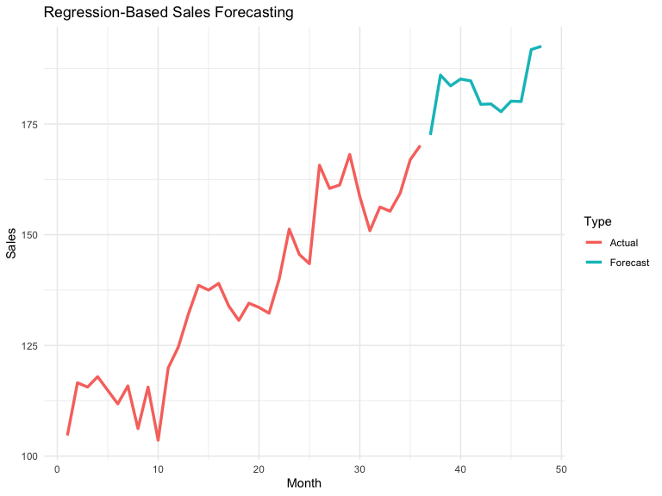

Smoothing Methods (Ch.18)

Data
# install.packages("forecast")
# install.packages("ggplot2")
library(forecast)
library(ggplot2)
# Monthly visitor data
# Extended visitor data (3 years of monthly values)
visitors <- c(
100, 105, 102, 108, 110, 115, 120, 118, 125, 130, 128, 135,
140, 145, 142, 148, 150, 155, 160, 158, 165, 170, 168, 175,
180, 185, 182, 188, 190, 195, 200, 198, 205, 210, 208, 215
)
ts_data <- ts(visitors, start = c(2021, 1), frequency = 12)

Apply simple moving average (SMA)
# SMA with 3-month window
sma_values <- ma(ts_data, order = 3)
# Plot original + SMA
autoplot(ts_data, series = "Original") +
autolayer(sma_values, series = "3-Month SMA") +
labs(title = "Simple Moving Average", y = "Visitors", x = "Time") +
theme_minimal()
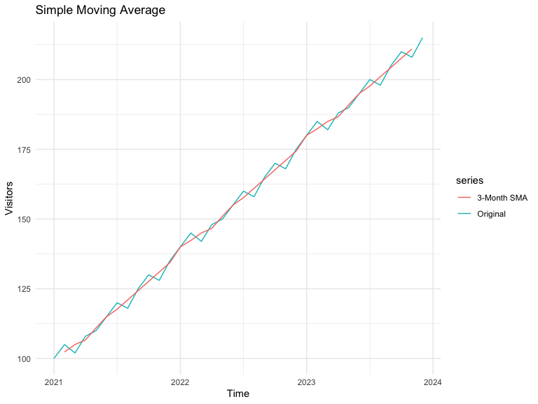

Apply9ing simple exponential smoothing (SES)
ses_model <- ses(ts_data, h = 6)
autoplot(ses_model) +
labs(title = "Simple Exponential Smoothing Forecast")
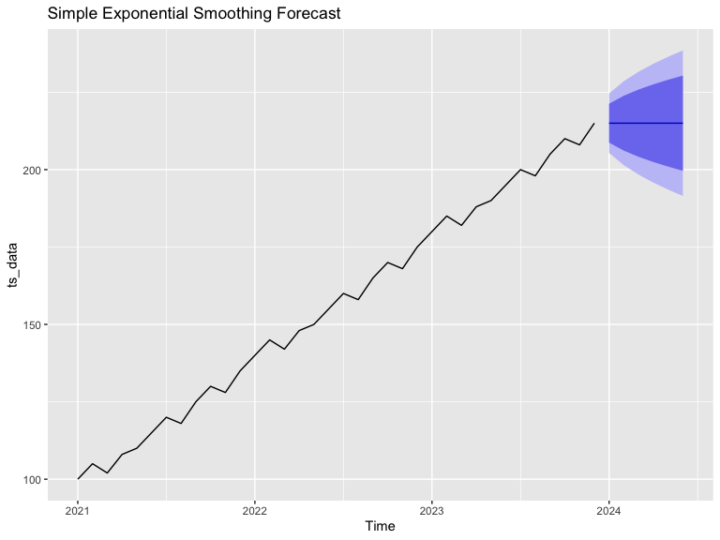

Holt’s Linear Trend Method
holt_model <- holt(ts_data, h = 6)
autoplot(holt_model) +
labs(title = "Holt's Linear Trend Forecast")
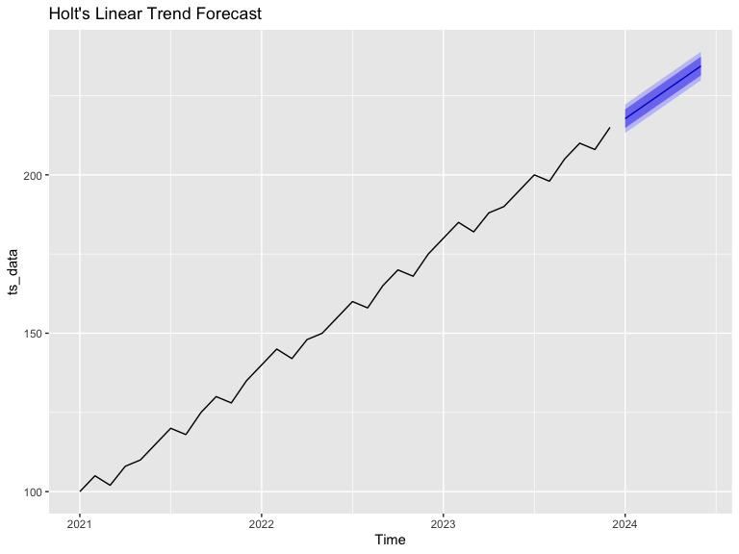

Holt-Winters (Seasonal Smoothing)
hw_model <- hw(ts_data, h = 6, seasonal = "additive")
autoplot(hw_model) +
labs(title = "Holt-Winters Additive Forecast")
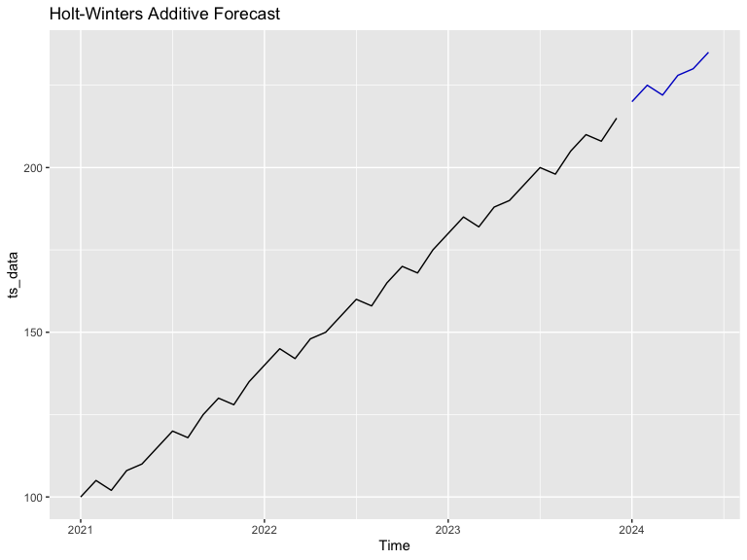

Social Network Analytics (Ch.19)

Data
# install.packages("igraph")
library(igraph)
# Sample edge list (directed network)
edges <- data.frame(
from = c("A", "A", "B", "C", "D", "E", "F", "G", "G", "H"),
to = c("B", "C", "C", "D", "E", "F", "G", "H", "A", "F")
)

Create graph object
g <- graph_from_data_frame(edges, directed = TRUE)
g
IGRAPH b2cd053 DN-- 8 10 --
+ attr: name (v/c)
+ edges from b2cd053 (vertex names):
[1] A->B A->C B->C C->D D->E E->F F->G G->H G->A H->F

Plot the graph
plot(g,
vertex.color = "skyblue",
vertex.size = 30,
vertex.label.color = "black",
edge.arrow.size = 0.5,
main = "Directed Social Network Graph")
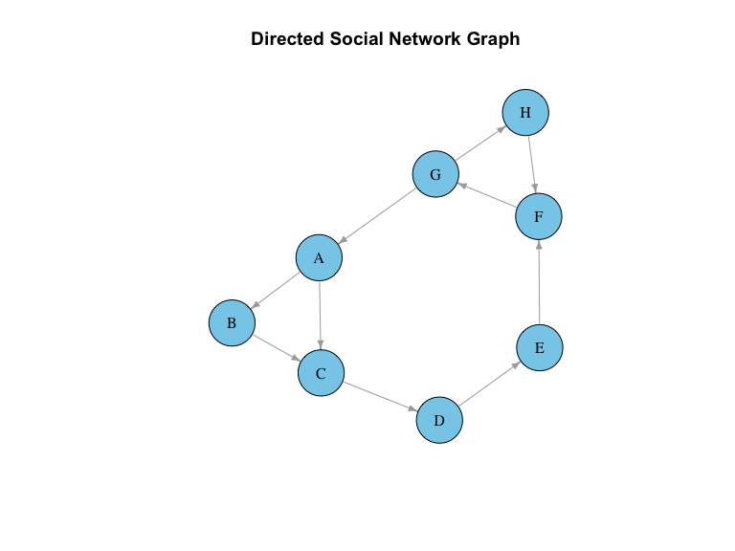

Analyze key metrics (centrality, degree, components)
# Degree Centrality
deg <- degree(g, mode = "all")
cat("Degree Centrality:\n")
Degree Centrality:
print(deg)
A B C D E F G H
3 2 3 2 2 3 3 2
# Betweenness Centrality
btw <- betweenness(g)
cat("\nBetweenness Centrality:\n")
Betweenness Centrality:
print(btw)
A B C D E F G H
18 0 18 18 18 26 26 1
# Closeness Centrality
cls <- closeness(g)
cat("\nCloseness Centrality:\n")
Closeness Centrality:
print(cls)
A B C D E F G
0.04545455 0.03703704 0.03846154 0.04166667 0.04545455 0.05000000 0.06666667
H
0.04000000
# Components
components(g)
$membership
A B C D E F G H
1 1 1 1 1 1 1 1
$csize
[1] 8
$no
[1] 1

Visualize node importance
V(g)$size <- deg * 5 # scale node size by degree
V(g)$color <- ifelse(deg == max(deg), "tomato", "skyblue")
plot(g,
vertex.label.cex = 1.2,
vertex.label.color = "black",
edge.arrow.size = 0.4,
main = "Node Size ∝ Degree Centrality")
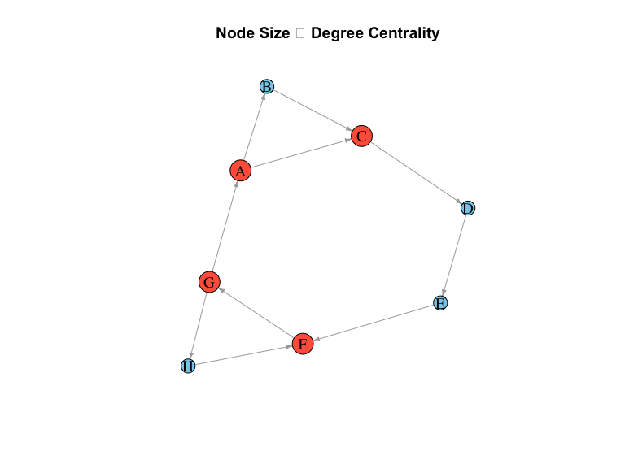

Text Mining (Ch.20)

Data
# install.packages("tm")
# install.packages("wordcloud")
# install.packages("RColorBrewer")
library(tm)
library(wordcloud)
library(RColorBrewer)
texts <- c(
"Data mining is fun and useful.",
"Machine learning is powerful and flexible.",
"Text mining extracts meaning from documents.",
"Natural language processing is a branch of AI.",
"Data science combines statistics and computing."
)
corpus <- Corpus(VectorSource(texts))

Text preprocessing (cleaning, tokenizing)
corpus_clean <- tm_map(corpus, content_transformer(tolower))
corpus_clean <- tm_map(corpus_clean, removePunctuation)
corpus_clean <- tm_map(corpus_clean, removeNumbers)
corpus_clean <- tm_map(corpus_clean, removeWords, stopwords("english"))
corpus_clean <- tm_map(corpus_clean, stripWhitespace)

Document-Term Matrix creation
dtm <- DocumentTermMatrix(corpus_clean)
matrix <- as.matrix(dtm)
word_freq <- sort(colSums(matrix), decreasing = TRUE)
head(word_freq)
data mining fun useful flexible learning
2 2 1 1 1 1

Frequency analysis
word_freq
data mining fun useful flexible learning machine
2 2 1 1 1 1 1
powerful documents extracts meaning text branch language
1 1 1 1 1 1 1
natural processing combines computing science statistics
1 1 1 1 1 1

Visualization (Word cloud and bar plot)
barplot(word_freq[1:10],
las = 2,
col = "steelblue",
main = "Top 10 Frequent Words",
ylab = "Frequency")
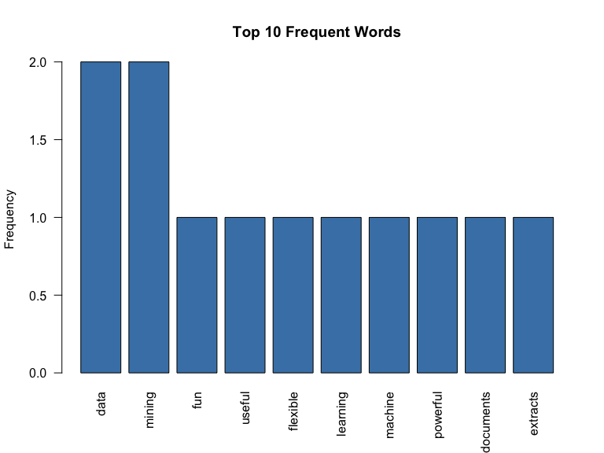
set.seed(123)
wordcloud(
words = names(word_freq),
freq = word_freq,
min.freq = 1,
scale = c(4, 0.8),
colors = brewer.pal(8, "Dark2")
)


