[Lecture Note] Introduction and House Keeping
  - MGS3701 Data Mining, Spring 2025
Chad (Chungil Chae)
Tue, 27 May 2025

Learning Objectives
- Instructor
- Course Introduction
- Course Information and Syllabus
- House Rule
- Resource

SHORT VIDEO INTRODUCTION
YOUTUBE_URL_OR_FILE_LOCATION_HERE

Instructor
- Professor
- Teaching Assitant

Professor

Chad (Dr. Chungil Chae)

- Chad (Chungil Chae)
- CBPM B223 | cchae@kean.edu
- Assistant Professor at CBPM, WKU since 2020 Fall
- Call ma Chad, but in formal situation and space, Dr.Chae or Prof.Chae
- Teaching business analytics major courses
  - MGS 3001: Python for Business
  - MGS 3101: Foundation of Business Analytics
  - MGS 3701: Data Mining
  - MGS 4701: Application of Business Analytics

Teaching Assistant

Shengie Yang (Bruce)

- 1234948@wku.edu.cn
- Major in Business Analytics
- Interested in emotions and inherent psychological pursuits and flaws within human hearts

Zhien Yu (June)

- 1308043@wku.edu.cn
- Major in Management (Business Analytics Option)
- Interested in Python and data mining

Course Introduction
- MGS*3701 DATA MINING IN BUSINESS (3 Credits)
  - Data is one of the most valuable and strategic assets that organizations have. Data mining is a continuous process that is crucial for many organizations to discover and extract information and patterns from their data to make business-related decisions using data-driven approaches. The objective of the course is to familiarize the students with the data mining process and applications from a managerial perspective to help discover information and knowledge in large data sets to support the business needs.

Overview
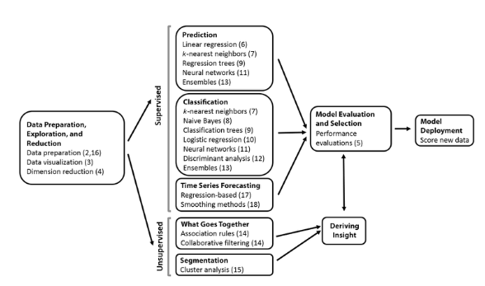

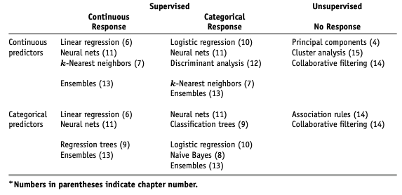

Part Contents
- Part I (Chapters 1–2) gives a general overview of data mining and its components.
- Part II (Chapters 3–4) focuses on the early stages of data exploration and dimension reduction.
- Part III (Chapter 5) discusses performance evaluation. Although it contains only one chapter, we discuss a variety of topics, from predictive performance metrics to misclassification costs. The principles covered in this part are crucial for the proper evaluation and comparison of supervised learning methods.
- Part IV includes eight chapters (Chapters 6–13), covering a variety of popular supervised learning methods (for classification and/or prediction). Within this part, the topics are generally organized according to the level of sophistication of the algorithms, their popularity, and ease of understanding. The final chapter introduces ensembles and combinations of methods.

- Part V focuses on unsupervised mining of relationships. It presents association rules and collaborative filtering (Chapter 14) and cluster analysis (Chapter15).
- Part VI includes three chapters (Chapters 16–18), with the focus on forecasting time series. The first chapter covers general issues related to handling and understanding time series. The next two chapters present two popular forecasting approaches: regression-based forecasting and smoothing methods.
- Part VII (Chapters 19–20) presents two broad data analytics topics: social network analysis and text mining. These methods apply data mining to specialized data structures: social networks and text.
- Finally, part VIII includes a set of cases. Although the topics in the book can be covered in the order of the chapters, each chapter stands alone. We advise, however, to read parts I–III before proceeding to chapters in parts IV–V. Similarly, Chapter 16 should precede other chapters in part VI.

Course Information and Syllabus

Class Information
- MGS3701: Data Mining
- Class time: T, TH 4:00 pm - 5:15 pm
- Class room: CBPM A202

House Rule
- In class
- Attendence and Absent
- Integration
- AI Useges

In CLass
- You are expected to read chapter and course material before class
- Based on your class participation, you will get extra score
- Computer and other digital device is allowed ONLY students uses it for class related purpose.
- In case instuctor find unauthorized useage of digital device, you will be asked to leave class.

Attendence and Absent
- DON”T SENT ME EMAIL or ANY MESSAGE about YOUR ABSENT in ADVANCE
- More than three times of absents automatically will be marked as F
- Attendence will be managed in student performance application
- When instructor or TA check your attendence and if you are not in class, no matter what reason, your attendence will be marked as absent.
- However, if you have proper and official evidence that WKU allow for absent, bring it to your instructor for revise your absent mark to attendece.

Integration
- Plagiarism is not tolerated
  - Right after find plagiarism, it will be reported to Office of Vice Chancellor for Academic Affairs directly
  - Student will be kicked out from class immediately
  - Read Academic Integrity Policy

Generative AI Use
Students are permitted to use AI tools, including, but not limited to, ChatGhT, in this course to generate ideas and brainstorm.
- Think of generative AI as an always-available brainstorming partner. However, you should note that the material generated by these programs may be inaccurate, incomplete, or otherwise problematic. Beware that use may also stifle your independent thinking and creativity.
- Academic work involves developing essential skills such as critical thinking, problem-solving, and effective communication, which cannot be fully developed by relying solely on Artificial Intelligence (AI).

- Your independent research, reading, writing, and discussions with peers and instructors are crucial components of academic work that bring unique value and should not be overlooked or replaced by technology.
- Students should never submit Al-generated work as their original work, as this would constitute a plagiarism violation as defined by the University Academic Integrity Policy and subject to appropriate sanctions.
- The inclusion of Al generated material must always be cited appropriately, like any other reference material.

- Using an Al tool to generate content without proper attribution qualifies as academic dishonesty. Additionally, be aware that information derived from these tools is often incomplete or inaccurate. How to cite ChatGPT - American Psychological Association
- Any assignment found to have been plagiarized or to have used unauthorized Al tools may receive a zero and/or be reported. This underscores the serious consequences of misusing Al tools and the importance of using them responsibly.
- Any use of generative Al-programs such as ChatGPT, GPT 4, DALL-E, Vertex, and many others to come—is subject to the same citation rules as ideas, text, speech, or imagery derived from human authors.

- Any student who is unsure of expectations regarding generative Al tools is encouraged to ask their instructor for clarification.
- This course only accepts 0-10% AI-generated writing in any assignment submission. Any student who submits an assignment with more than 10% AI-generated writing will be asked to revise the work. Failure to make the necessary revisions will result in a no grade failure on those assignments.

