[Lecture Note] Data Visualization
  - MGS3701 Data Mining, Spring 2025
Chad (Chungil Chae)
Tue, 27 May 2025

Learning Objectives
- A set of plots that can be used to explore the multidimensional nature of a data set.
  - Basic plots (bar charts, line graphs, and scatter plots),
  - Distribution plots (boxplots and histograms), and
  - Different enhancements that expand the capabilities of these plots to visualize more information.
- How the different visualizations and operations can support data mining tasks, from supervised tasks (prediction, classification, and time series forecasting) to unsupervised tasks, and provide a few guidelines on specific visualizations to use with each data mining task.
- Advantages of interactive visualization over static plots.

SHORT VIDEO INTRODUCTION
https://www.youtube.com/watch?v=5Zg-C8AAIGg

Uses of Data Visualization
- The saying “a picture is worth a thousand words” means visuals can summarize information better than words alone.
- Data visualization helps us quickly explore and present numerical information.
- Visuals are very useful during the early stages of the data mining process.

Importance of Visualization in Data Mining
Visualization plays an important role in data mining, especially during preprocessing:
- Data cleaning: Identifies incorrect or missing values, duplicates, and constants.
- Variable selection: Helps find useful variables and reveals redundant ones.
- Grouping (binning): Shows how variables can be grouped or categorized.
- Deciding what data to collect: Helps choose which variables matter, saving collection costs and effort.
Although our main focus here is exploring data visually (for predictive analytics), some plots discussed elsewhere in this book cover specific visualizations used to present data mining results.

Note
- The term “graph” in statistics has two meanings:
  - Popular use: any chart like bar or line charts.
  - Technical use: network visualizations.
- To avoid confusion, we use “plot” to describe data visualizations.

Why Graphical Exploration?
- Visual data exploration helps:
  - Understand data structure quickly.
  - Identify incorrect and unusual values.
  - Find initial patterns and relationships.
  - Ask meaningful research questions.
- You can do graphical exploration in multiple ways:
  - Free-form, for general understanding.
  - Focused exploration, to tackle specific questions.
Usually, a combination of both methods works best.

Base R or ggplot?
- ggplot: Professional-quality graphics, flexible, but requires time to learn.
- Base R graphics: Easier, faster for basic exploratory visuals.
This chapter mainly shows examples in base R; ggplot code is sometimes provided.

Data Examples

Example 1: Boston Housing Data
- This dataset includes information from Boston neighborhoods, with variables like crime rate, home price (MEDV), and school data. It has a created variable (CAT.MEDV) that categorizes homes as high or low value.
- Possible analysis tasks:
  - House price prediction (numerical outcome).
  - Classify homes as above or below $30K median price (categorical outcome).
  - Group similar neighborhoods (clustering, unsupervised learning).

Example 2: Ridership on Amtrak Trains
- Monthly passenger counts between 1991–2004 are used to forecast future ridership (time series prediction).

Basic Charts: Bar Charts, Line Graphs, and Scatter Plots
- Basic plots are useful first steps for data exploration.
  - Line graphs: Show trends or patterns over time (ridership example).
  - Bar charts: Compare simple statistics (average, percentage) across groups.
  - Scatter plots: Examine relationships between two numerical variables.
Basic charts quickly reveal patterns, differences, and relationships among key variables.

Distribution Plots: Boxplots and Histograms
- Histograms: Show numerical variable frequency distributions.
- Boxplots: Summarize numerical distributions (median, quartile, outliers) and offer useful side-by-side comparisons.

Heatmaps: Correlations and Missing Values
- Heatmaps: Use color to visualize data tables of numbers.
  - Quickly identify correlations and missing-data patterns.

Multidimensional Visualization

Enhancing Plots with Additional Variables:
- Categorical variables: represented by color, shape, or multiple panels.
- Numerical variables: added through color intensity or marker size.
- Animation: useful for showing changes over time.

Manipulation Techniques
- Rescaling: Makes skewed distributions clearer (e.g., log-scale).
- Aggregation: Shows patterns by grouping data differently (monthly, yearly, etc.).
- Zooming and panning: Helps observe specific regions closely.
- Filtering: Removes unnecessary points to highlight details clearly.

Reference Tools for Interpretation
- Trend lines: Highlight overall patterns clearly.
- In-plot labels: Mark special points for better context and interpretation.

Dealing with Large Datasets
- Sample data randomly for clarity.
- Reduce marker sizes, adjust transparency.
- Use small multiple-panel charts.
- Use jittering (small random shifts in location).

Multivariate Plot: Parallel Coordinates Plot
- Lines connect data points for each observation across several numerical variables.
- Good for detecting clusters and variable importance visually.

Interactive Visualization
- Interactive exploration (e.g., Tableau, Spotfire) allows rapid and continuous data interaction via:
  - Quick plot changes.
  - Multiple coordinated charts viewed simultaneously.
  - Easy manipulation (zooming, filtering, aggregating).
Interactive charts help speed exploration and uncover deeper insights than static plots alone.

Specialized Visualization

Visualizing Networked Data
- Uses nodes and edges to show relationships (e.g., social networks, consumer products associations).
- Useful in identifying influential nodes and relationship clusters.

Visualizing Hierarchical Data: Treemaps
- Rectangles arranged in a nesting structure to show hierarchy and details visually.
- Size and color intensity can represent additional variables.

Visualizing Geographical Data: Map Charts
- Data overlaid on geographic maps to highlight regional patterns and spatial information.

Summary: Major Visualizations and Operations, by Data Mining Goal

Prediction
- Boxplots, scatterplots, histograms.
- Transformations and rescaling.
- Variable interactions checks.

Classification
- Bar charts, color-coded scatterplots, boxplots.
- Parallel coordinate plots to explore classification outcomes visually.

Time Series Forecasting
- Line graphs with zoom/pan.
- Temporal aggregations (monthly/yearly).
- Trend-line overlays for trends and patterns.

Unsupervised Learning
- Scatter plot matrix.
- Correlation heatmaps.
- Parallel coordinate plots for cluster and outlier identification.

R Graph Gallery
- Distribution: Violin, density plot, histogram, boxplot, ridgeline chart, Beeswam plot
- Correlation: Scatter plot, heatmap, correlogram, bubble plot, connected scatter plot, 2D density chart
- Ranking: barplot, radar, wordcloud, parallel, lollipop plot, circular barplot, table
- Part of Whole: Grouped and stacked barplot, treemap, donut chart, pie chart, dendrogram, circular packing, waffle chart
- Evolution: line chart, area chart, stacked area chart, streamgraph, time series graph
- Map: background map, choropleth map, hexbin map, catogram, connection map, bubble map
- Flow: chord diragram, network diagram, shankey diagram, arc diagram, hierachical edge bundling

Distribution
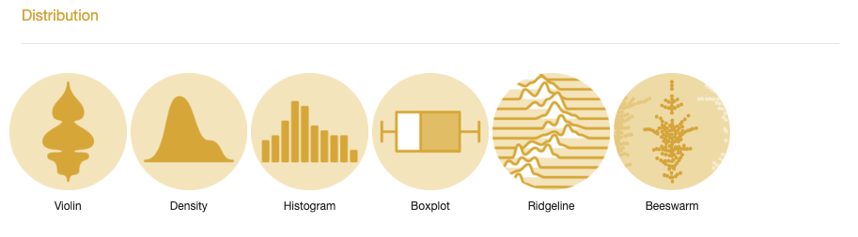

Violin plots
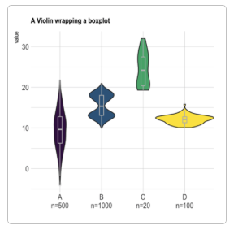
Violin plots allow to visualize the distribution of a numeric variable for one or several groups. They are very well adapted for large dataset, as stated in data-to-viz.com. They’re often used to replace boxplot.

Density plot
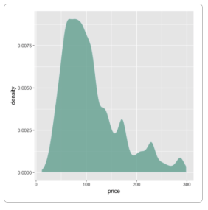
A density plot shows the distribution of a numeric variable. In ggplot2, the geom_density() function takes care of the kernel density estimation and plot the results.

Histogram
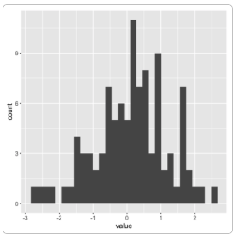
A histogram is used to study the distribution of one or several variables

Boxplot
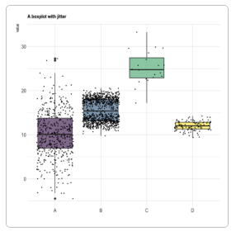
Boxplot is probably the most commonly used chart type to compare distribution of several groups. However, you should keep in mind that data distribution is hidden behind each box. For instance, a normal distribution could look exactly the same as a bimodal distribution.

Ridgeline chart
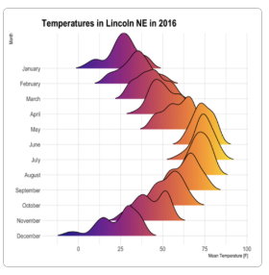
Ridgeline chart, sometimes called joyplot, this kind of chart allows to visualize the distribution of several numeric variables

Beeswarm plot
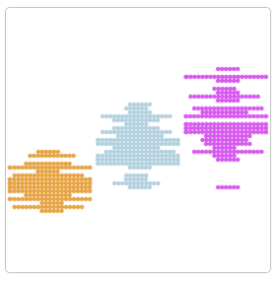
A beeswarm plot, also known as a swarmplot, is a graph type that presents individual data points without overlap, creating a distinct “swarming” effect reminiscent of a bee swarm.

Correlation
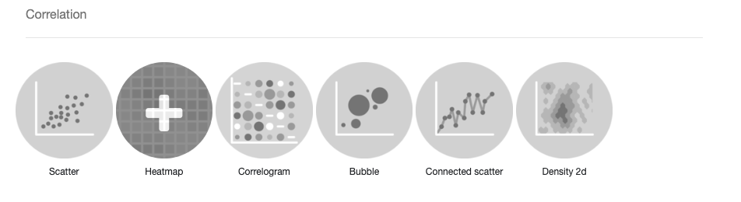

Scatter plot
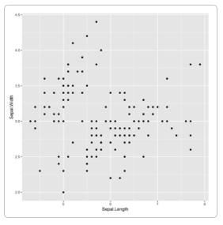
A Scatterplot displays the relationship between 2 numeric variables. Each dot represents an observation. Their position on the X (horizontal) and Y (vertical) axis represents the values of the 2 variables.

Heatmap
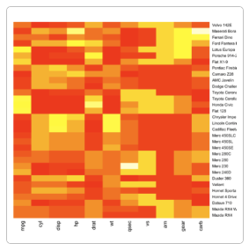
A heatmap is a graphical representation of data where the individual values contained in a matrix are represented as colors

Correlogram
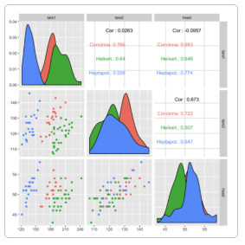
A correlogram or correlation matrix allows to analyse the relationship between each pair of numeric variables in a dataset.

Bubble plot
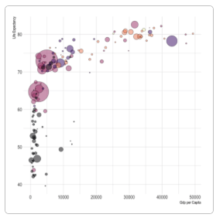
A bubble plot is a scatter plot with a third numeric variable mapped to circle size. A bubble chart is basically a scatterplot with a third numeric variable used for circle size.

Connected scatterplots
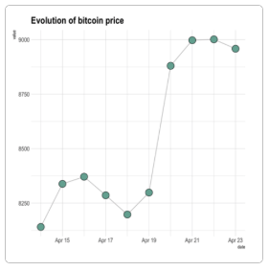
Connected scatterplots are often used for time series.

2D density chart
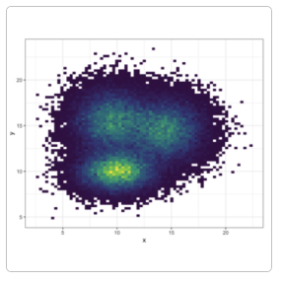
A 2d density chart displays the relationship between 2 numeric variables. One is represented on the X axis, the other on the Y axis, like for a scatterplot. Then, the number of observations within a particular area of the 2D space is counted and represented by a color gradient.

Ranking
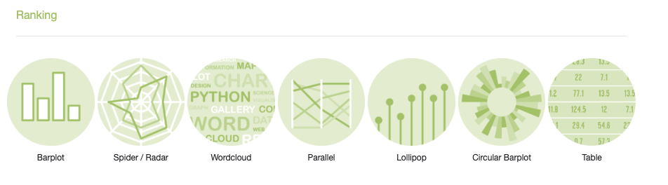

Barplot
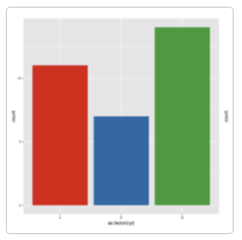
A barplot is used to display the relationship between a numeric and a categorical variable.

Radar / Spider chart
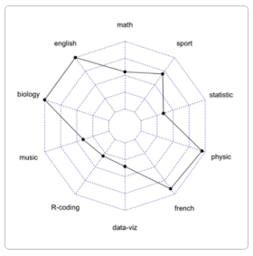
A radar or spider or web chart is a two-dimensional chart type designed to plot one or more series of values over multiple quantitative variables.

Wordcloud
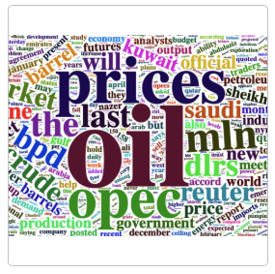
A wordcloud (or tag cloud) is a visual representation of text data. Tags are usually single words, and the importance of each tag is shown with font size or color.

Parallel
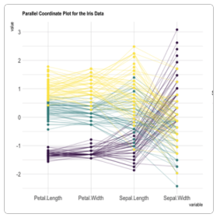
Parallel plot or parallel coordinates plot allows to compare the feature of several individual observations (series) on a set of numeric variables. Each vertical bar represents a variable and often has its own scale. (The units can even be different). Values are then plotted as series of lines connected across each axis.

A lollipop plot
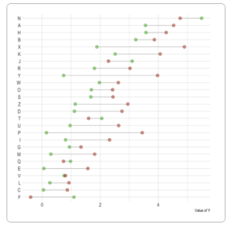
A lollipop plot is basically a barplot, where the bar is transformed in a line and a dot. It shows the relationship between a numeric and a categorical variable.

The circular barplot
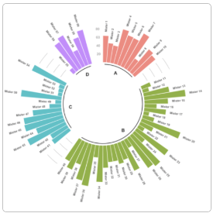
The circular barplot, a variation of the well known barplot. Note that even if visually appealing, circular barplot must be used with care since groups do not share the same Y axis. It is very adapted for cyclical data though.

Tables
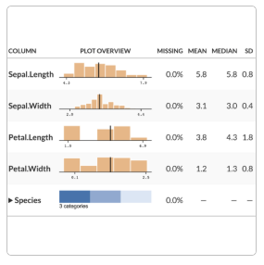
Tables are an indispensable tool in data visualization. They offer a straightforward way to present complex data in an organized, easy-to-read format.

Part of Whole
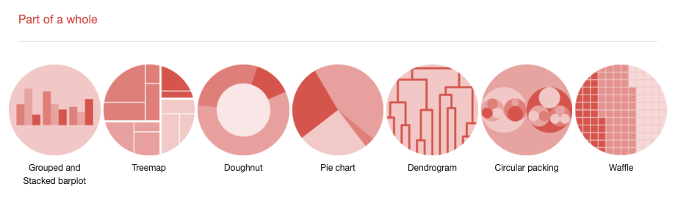

Grouped and Stacked barplot
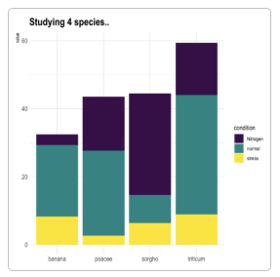
Grouped and Stacked barplot display a numeric value for several entities, organised in groups and subgroups.

Treemap
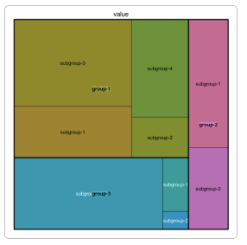
A Treemap displays hierarchical data as a set of nested rectangles. Each group is represented by a rectangle, which area is proportional to its value.

Donut chart
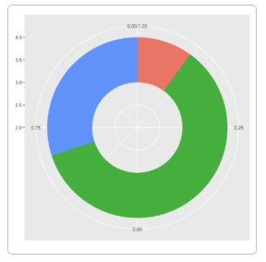
A donut or doughnut chart is a ring divided into sectors that each represent a proportion of the whole. It is very close from a pie chart and thus suffers the same problem.

Piechart
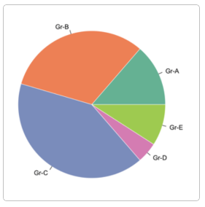
A piechart is a circle divided into sectors that each represent a proportion of the whole.

Dendrogram
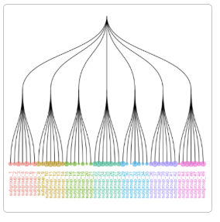
A dendrogram (or tree diagram) is a network structure. It is constituted of a root node that gives birth to several nodes connected by edges or branches. The last nodes of the hierarchy are called leaves.

Circular packing
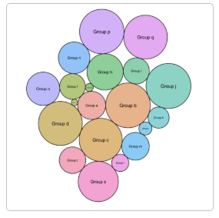
Circular packing or circular treemap allows to visualize a hierarchic organization. It is an equivalent of a treemap or a dendrogram, where each node of the tree is represented as a circle and its sub-nodes are represented as circles inside of it.

Waffle Chart
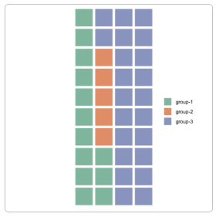
A Waffle Chart visually represents categorical data through a grid of small squares, resembling a waffle. Each category is assigned a unique color, and the number of squares allocated to each category corresponds to its proportional share of the total data count.

Evolution
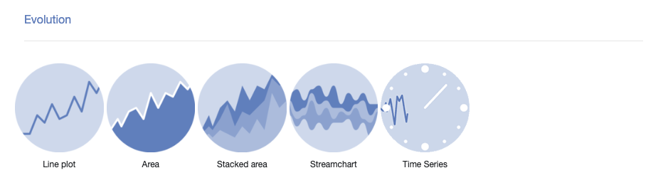

Line chart
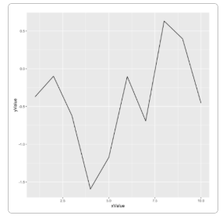
Line chart is similar to to a connected scatterplot that is almost the same thing, but each observation is represented as a dot.

Area chart
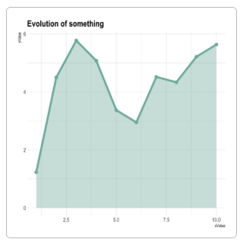
An area chart represents the evolution of a numeric variable. It is very close to a line chart. A line chart is the same but doesn’t fill the surface between the line and the X axis. A connected scatterplot is almost the same thing, but each observation is represented as a dot.

Stacked area chart
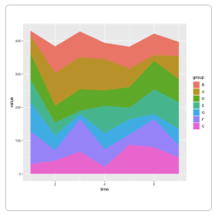
A stacked area chart displays the evolution of a numeric variable for several groups. It is very close to an area chart.

Streamgraph
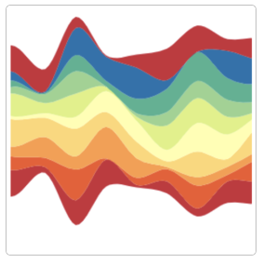
A streamgraph is a type of stacked area chart. It represents the evolution of a numeric variable for several groups. Areas are usually displayed around a central axis, and edges are rounded to give a flowing shape.

Time series
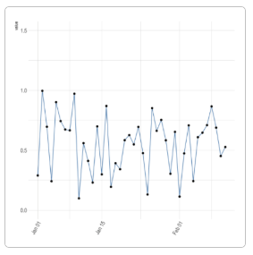
Time series aim to study the evolution of one or several variables through time.

Map
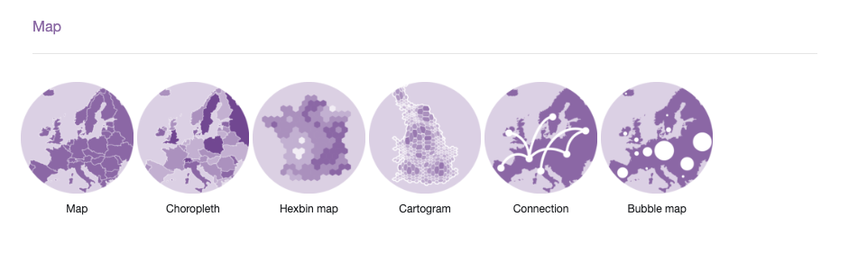

Map chart
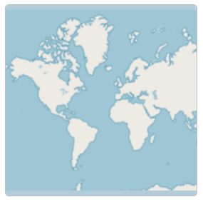
Map chart, It explains how to build static and interactive maps based on different input data, but does not explain how to plot data on it.

Choropleth map
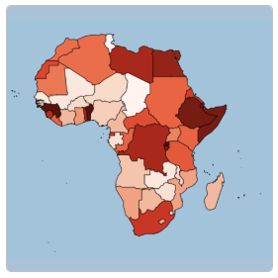
A choropleth map displays divided geographical areas or regions that are coloured in relation to a numeric variable.

Hexbin map
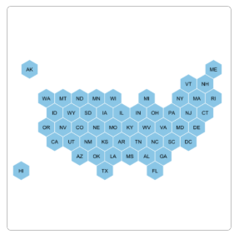
A hexbin map refers to two different concepts. It can be based on a geospatial object where all regions of the map are represented as hexagons.

Cartogram
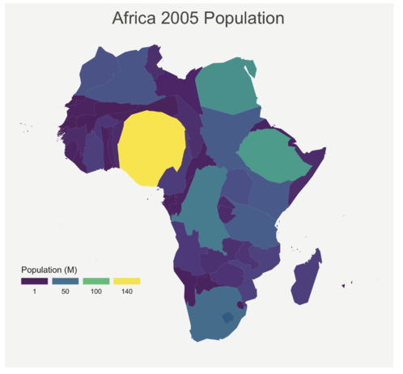
A cartogram is a map in which the geometry of regions is distorted in order to convey the information of an alternate variable. The region area will be inflated or deflated according to its numeric value.

Connection map
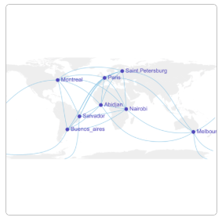
A connection map shows the connections between several positions on a map. The link between 2 locations is usually drawn using great circle: the shortest route between them. It results in a rounded line that gives a really pleasant look to the map.

Bubble map
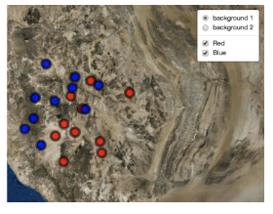
Bubble map, this section is dedicated to map with markers displayed on top of it. These markers can be circles with size proportional to a numeric value, resulting in a bubble map.

Flow
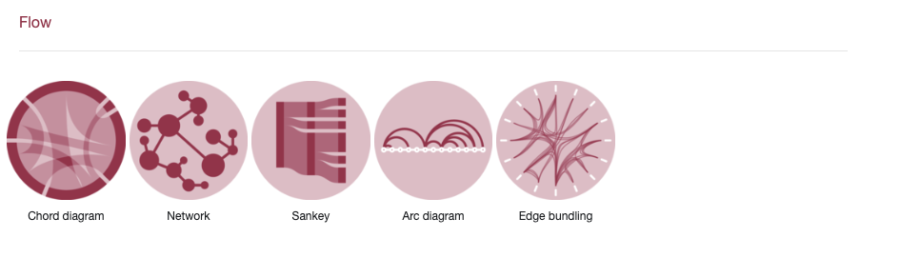

Chord diagram
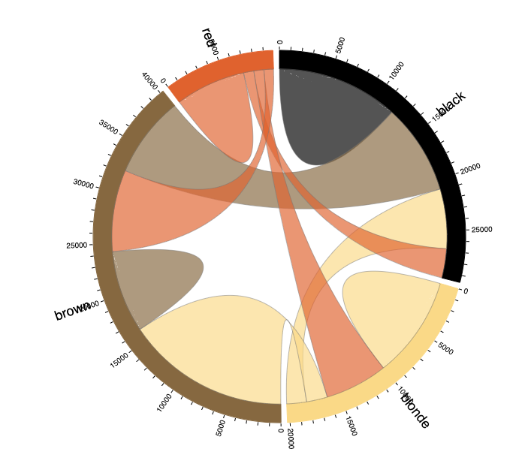
A Chord diagram allows to study flows between a set of entities. Entities (nodes) are displayed all around a circle and connected with arcs (links).

Network diagrams
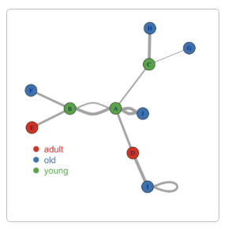
Network diagrams (or Graphs) show interconnections between a set of entities. Each entity is represented by a Node (or vertice). Connections between nodes are represented by links (or edges).

Sankey diagram
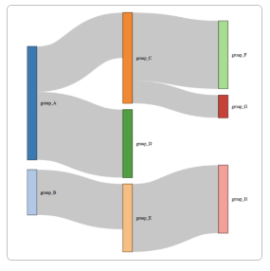
A Sankey diagram allows to study flows. Entities (nodes) are represented by rectangles or text.

Arc diagram
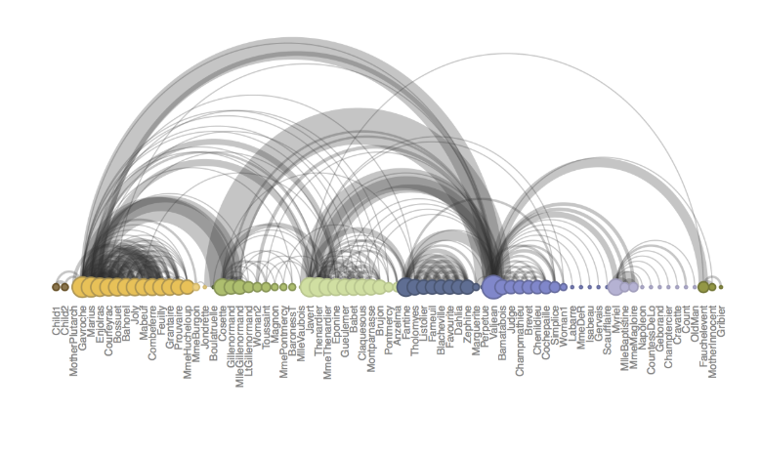
An arc diagram is a special kind of network graph. It is consituted by nodes that represent entities and by links that show relationships between entities. In arc diagrams, nodes are displayed along a single axis and links are represented with arcs.

Hierarchical edge bundling
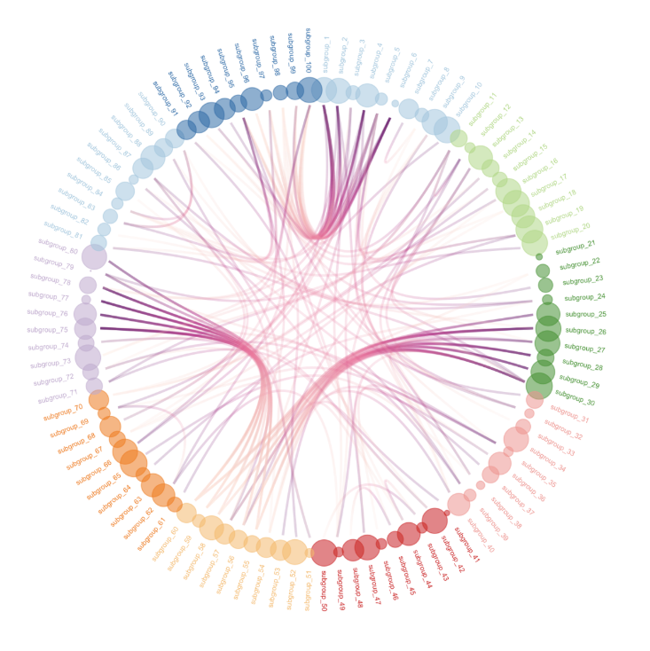
Hierarchical edge bundling allows to visualize adjacency relations between entities organized in a hierarchy. The idea is to bundle the adjacency edges together to decrease the clutter usually observed in complex networks.

House Keeping

Announcement

Assignment

Assignment1: Assignment Title
- What to do
  - A
  - B
- Format and Requirement
  - PDF format, < ?? pages
  - file name should be include your student id and name
    - stuID_name_title.pdf (e.g. 1111111_ChungilChae_SelfIntroduction.pdf)
  - APA, Double-Space, No title page, 12 points, Reference section if necessary
  - Chinese name in English, English name, Student ID, Class name and section (e.g. GE2021, W09; MGS3001, W01)
- due date
  - by Date(DAY) 11:59PM
  - NO LATE SUBMISSION ALLOWED!!!!

Reference

