[Lecture Notebook] Data Visualization
  - MGS3701 Data Mining, Spring 2025
Chad (Chungil Chae)
Tue, 27 May 2025

Table 3.2
housing.df <- read.csv("data/BostonHousing.csv")
head(housing.df, 9)
CRIM ZN INDUS CHAS NOX RM AGE DIS RAD TAX PTRATIO LSTAT MEDV
1 0.00632 18.0 2.31 0 0.538 6.575 65.2 4.0900 1 296 15.3 4.98 24.0
2 0.02731 0.0 7.07 0 0.469 6.421 78.9 4.9671 2 242 17.8 9.14 21.6
3 0.02729 0.0 7.07 0 0.469 7.185 61.1 4.9671 2 242 17.8 4.03 34.7
4 0.03237 0.0 2.18 0 0.458 6.998 45.8 6.0622 3 222 18.7 2.94 33.4
5 0.06905 0.0 2.18 0 0.458 7.147 54.2 6.0622 3 222 18.7 5.33 36.2
6 0.02985 0.0 2.18 0 0.458 6.430 58.7 6.0622 3 222 18.7 5.21 28.7
7 0.08829 12.5 7.87 0 0.524 6.012 66.6 5.5605 5 311 15.2 12.43 22.9
8 0.14455 12.5 7.87 0 0.524 6.172 96.1 5.9505 5 311 15.2 19.15 27.1
9 0.21124 12.5 7.87 0 0.524 5.631 100.0 6.0821 5 311 15.2 29.93 16.5
CAT..MEDV
1 0
2 0
3 1
4 1
5 1
6 0
7 0
8 0
9 0

Figure 3.1

Amtrack ridership by year
Amtrak.df <- read.csv("data/Amtrak data.csv")
# use time series analysis
library(forecast)
Registered S3 method overwritten by 'quantmod':
method from
as.zoo.data.frame zoo
ridership.ts <- ts(Amtrak.df$Ridership, start = c(1991, 1), end = c(2004, 3), freq = 12)
plot(ridership.ts, xlab = "Year", ylab = "Ridership (in 000s)", ylim = c(1300, 2300))
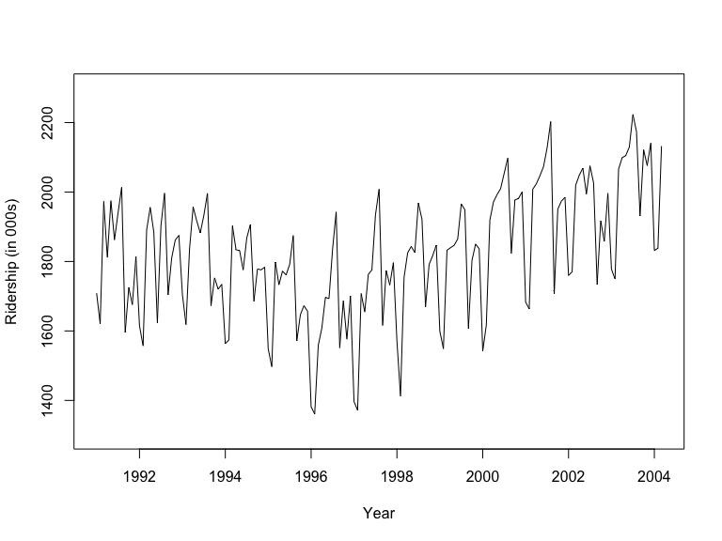

Boston housing data
housing.df <- read.csv("data/BostonHousing.csv")
## scatter plot with axes names
plot(housing.df$MEDV ~ housing.df$LSTAT, xlab = "MDEV", ylab = "LSTAT")
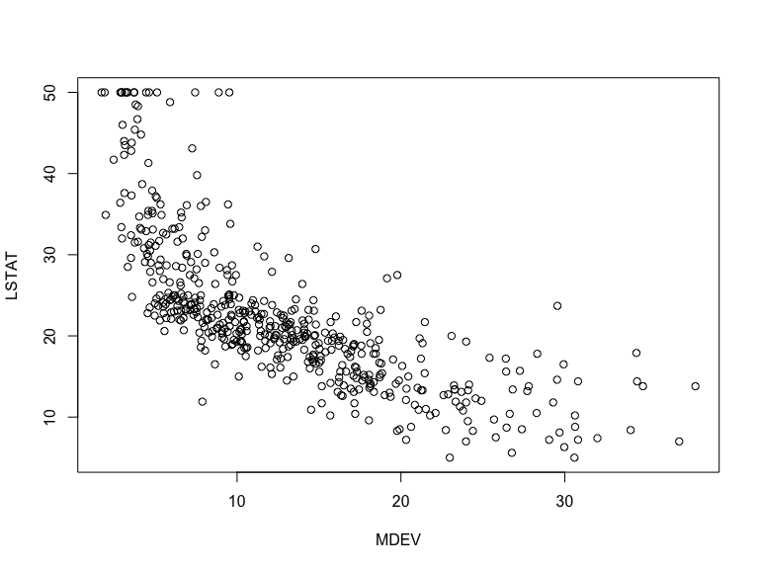
# alternative plot with ggplot
library(ggplot2)
ggplot(housing.df) + geom_point(aes(x = LSTAT, y = MEDV), colour = "navy", alpha = 0.7)
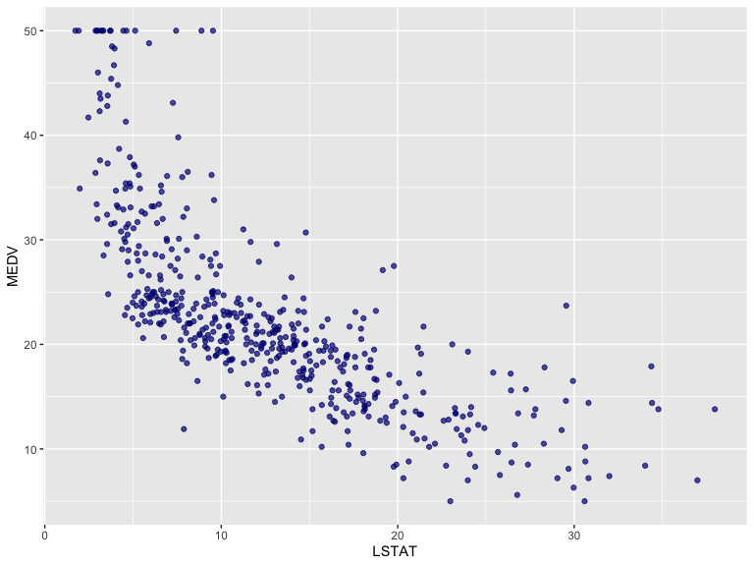

barchart of CHAS vs. mean MEDV
# compute mean MEDV per CHAS = (0, 1)
data.for.plot <- aggregate(housing.df$MEDV, by = list(housing.df$CHAS), FUN = mean)
names(data.for.plot) <- c("CHAS", "MeanMEDV")
barplot(data.for.plot$MeanMEDV, names.arg = data.for.plot$CHAS,
xlab = "CHAS", ylab = "Avg. MEDV")
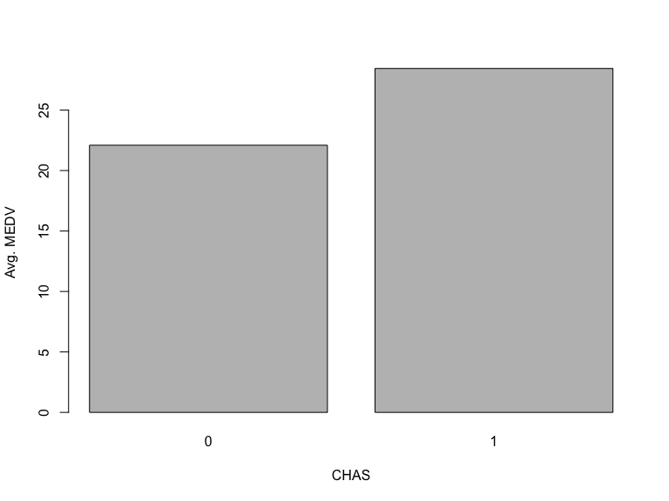
# alternative plot with ggplot
ggplot(data.for.plot) + geom_bar(aes(x = CHAS, y = MeanMEDV), stat = "identity")
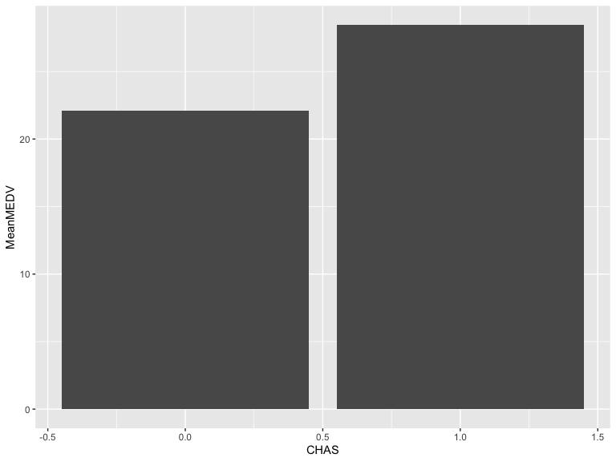

barchart of CHAS vs. % CAT.MEDV
data.for.plot <- aggregate(housing.df$CAT..MEDV, by = list(housing.df$CHAS), FUN = mean)
names(data.for.plot) <- c("CHAS", "MeanCATMEDV")
barplot(data.for.plot$MeanCATMEDV * 100, names.arg = data.for.plot$CHAS,
xlab = "CHAS", ylab = "% of CAT.MEDV")
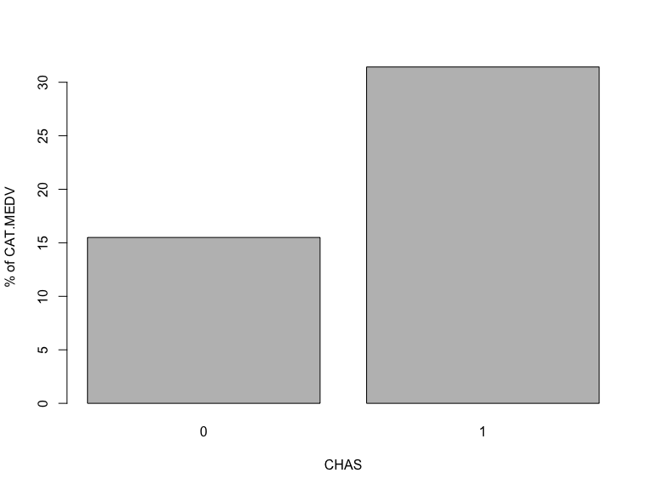

Figure 3.2

histogram of MEDV
hist(housing.df$MEDV, xlab = "MEDV")
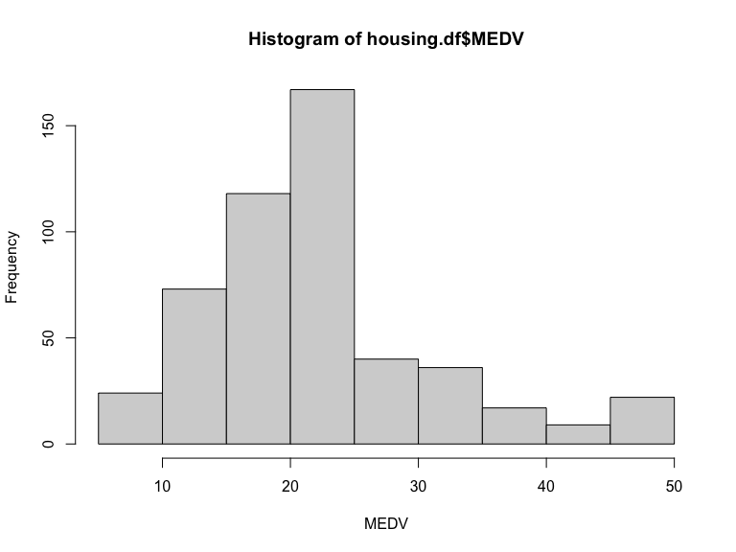

alternative plot with ggplot
library(ggplot2)
ggplot(housing.df) + geom_histogram(aes(x = MEDV), binwidth = 5)
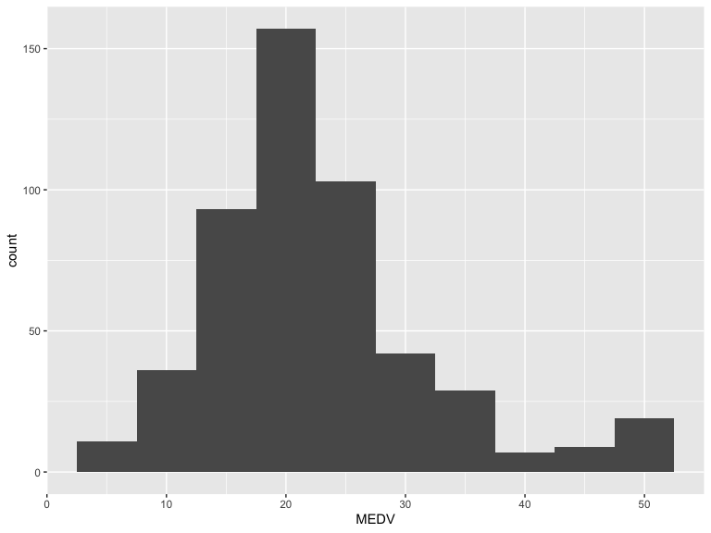

boxplot of MEDV for different values of CHAS
boxplot(housing.df$MEDV ~ housing.df$CHAS, xlab = "CHAS", ylab = "MEDV")
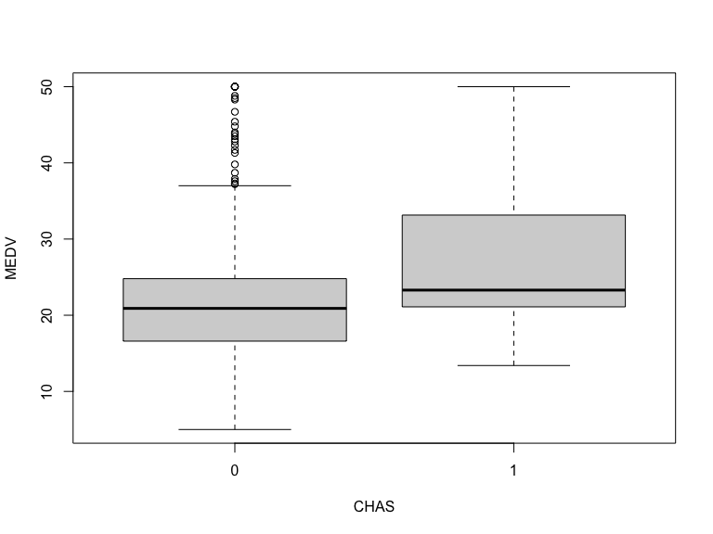
# alternative plot with ggplot
ggplot(housing.df) + geom_boxplot(aes(x = as.factor(CHAS), y = MEDV)) + xlab("CHAS")
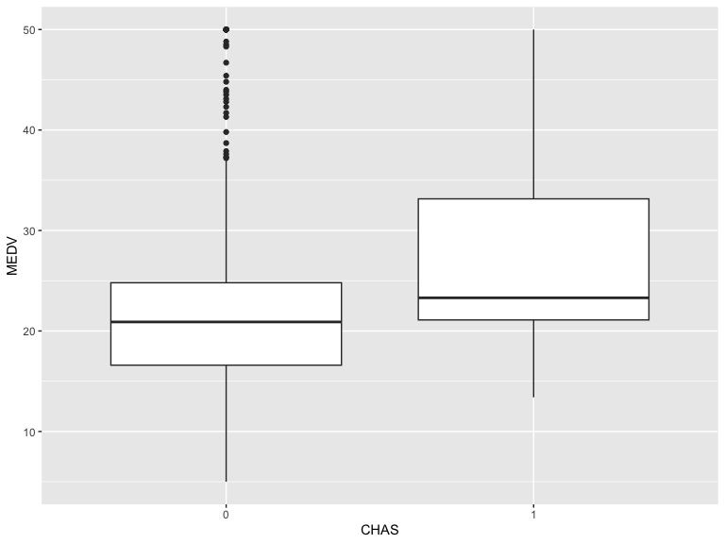

Figure 3.3

side-by-side boxplots
# use par() to split the plots into panels.
par(mfcol = c(1, 4))
boxplot(housing.df$NOX ~ housing.df$CAT..MEDV, xlab = "CAT.MEDV", ylab = "NOX")
boxplot(housing.df$LSTAT ~ housing.df$CAT..MEDV, xlab = "CAT.MEDV", ylab = "LSTAT")
boxplot(housing.df$PTRATIO ~ housing.df$CAT..MEDV, xlab = "CAT.MEDV", ylab = "PTRATIO")
boxplot(housing.df$INDUS ~ housing.df$CAT..MEDV, xlab = "CAT.MEDV", ylab = "INDUS")
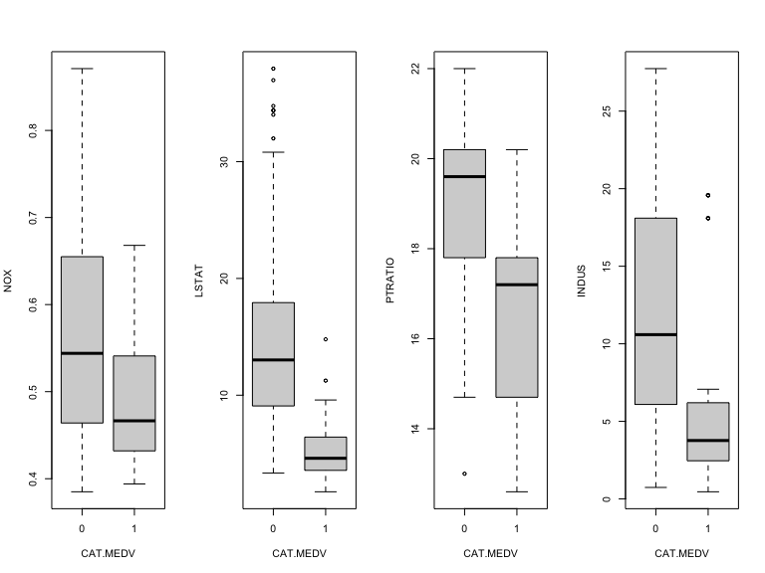

Figure 3.4

simple heatmap of correlations (without values)
heatmap(cor(housing.df), Rowv = NA, Colv = NA)
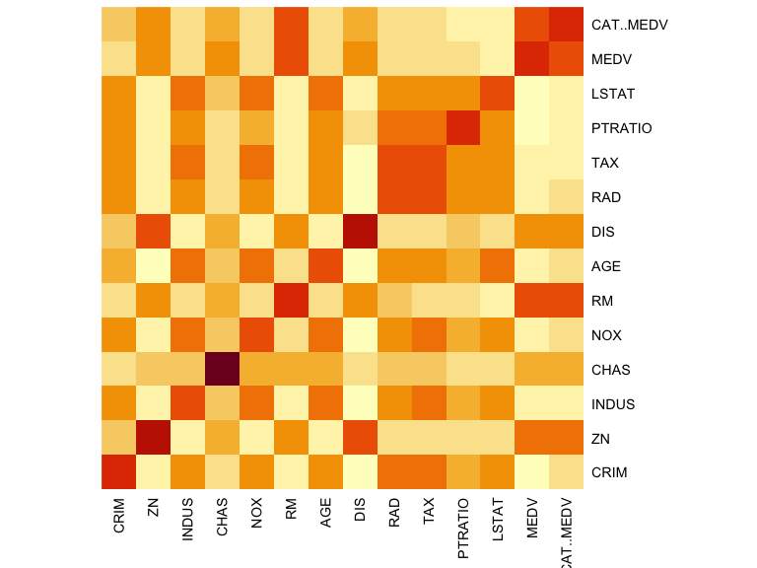

heatmap with values
library(gplots)
Attaching package: 'gplots'
The following object is masked from 'package:stats':
lowess
heatmap.2(cor(housing.df), Rowv = FALSE, Colv = FALSE, dendrogram = "none",
cellnote = round(cor(housing.df),2),
notecol = "black", key = FALSE, trace = 'none', margins = c(10,10))
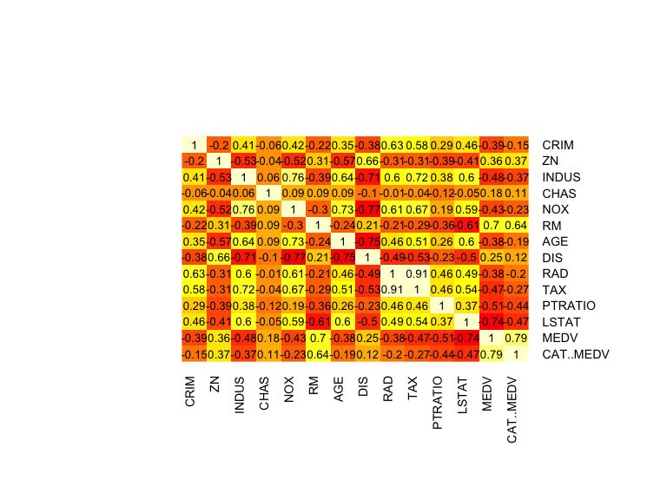

alternative plot with ggplot
library(ggplot2)
library(reshape) # to generate input for the plot
Attaching package: 'reshape'
The following object is masked from 'package:lubridate':
stamp
The following object is masked from 'package:dplyr':
rename
The following objects are masked from 'package:tidyr':
expand, smiths
cor.mat <- round(cor(housing.df),2) # rounded correlation matrix
melted.cor.mat <- melt(cor.mat)
ggplot(melted.cor.mat, aes(x = X1, y = X2, fill = value)) +
geom_tile() +
geom_text(aes(x = X1, y = X2, label = value))
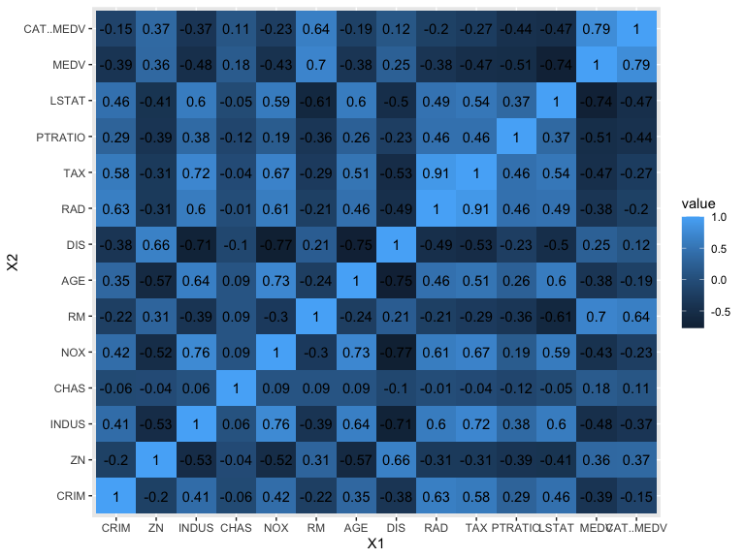

Figure 3.5
# replace dataFrame with your data.
# is.na() returns a Boolean (TRUE/FALSE) output indicating the location of missing
# values.
# multiplying the Boolean value by 1 converts the output into binary (0/1).
#heatmap(1 * is.na(dataFrame), Rowv = NA, Colv = NA)

Figure 3.6

Housing data scatter plot with color CAT..MEDV
## color plot
par(mfcol = c(1,1), xpd=TRUE) # allow legend to be displayed outside of plot area
plot(housing.df$NOX ~ housing.df$LSTAT, ylab = "NOX", xlab = "LSTAT",
col = ifelse(housing.df$CAT..MEDV == 1, "black", "gray"))
# add legend outside of plotting area
# In legend() use argument inset = to control the location of the legend relative
# to the plot.
legend("topleft", inset=c(0, -0.2),
legend = c("CAT.MEDV = 1", "CAT.MEDV = 0"), col = c("black", "gray"),
pch = 1, cex = 0.5)
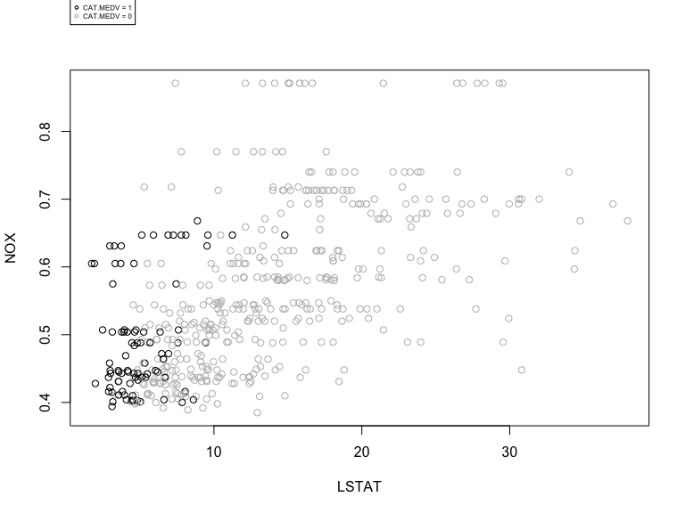
# alternative plot with ggplot
library(ggplot2)
ggplot(housing.df, aes(y = NOX, x = LSTAT, colour= CAT..MEDV)) +
geom_point(alpha = 0.6)
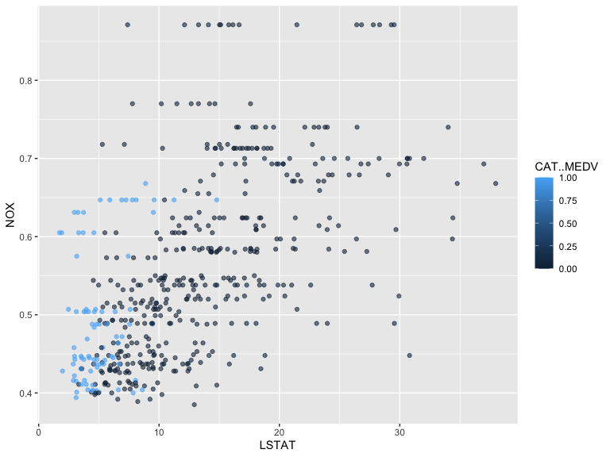

panel plots
# compute mean MEDV per RAD and CHAS
# In aggregate() use argument drop = FALSE to include all combinations
# (exiting and missing) of RAD X CHAS.
data.for.plot <- aggregate(housing.df$MEDV, by = list(housing.df$RAD, housing.df$CHAS),
FUN = mean, drop = FALSE)
names(data.for.plot) <- c("RAD", "CHAS", "meanMEDV")
# plot the data
par(mfcol = c(2,1))
barplot(height = data.for.plot$meanMEDV[data.for.plot$CHAS == 0],
names.arg = data.for.plot$RAD[data.for.plot$CHAS == 0],
xlab = "RAD", ylab = "Avg. MEDV", main = "CHAS = 0")
barplot(height = data.for.plot$meanMEDV[data.for.plot$CHAS == 1],
names.arg = data.for.plot$RAD[data.for.plot$CHAS == 1],
xlab = "RAD", ylab = "Avg. MEDV", main = "CHAS = 1")
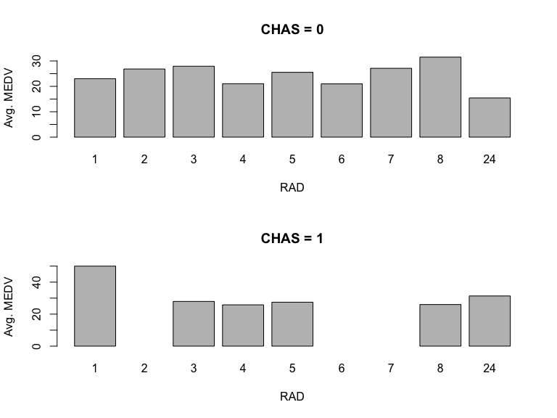
# alternative plot with ggplot
ggplot(data.for.plot) +
geom_bar(aes(x = as.factor(RAD), y = `meanMEDV`), stat = "identity") +
xlab("RAD") + facet_grid(CHAS ~ .)
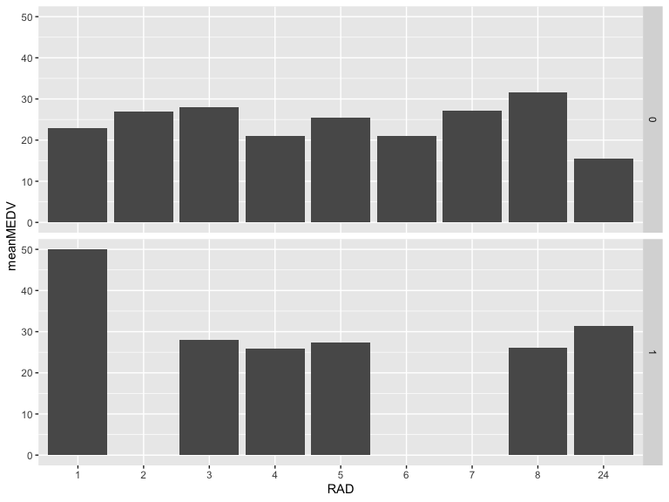

Figure 3.7

simple plot
# use plot() to generate a matrix of 4X4 panels with variable name on the diagonal,
# and scatter plots in the remaining panels.
plot(housing.df[, c(1, 3, 12, 13)])
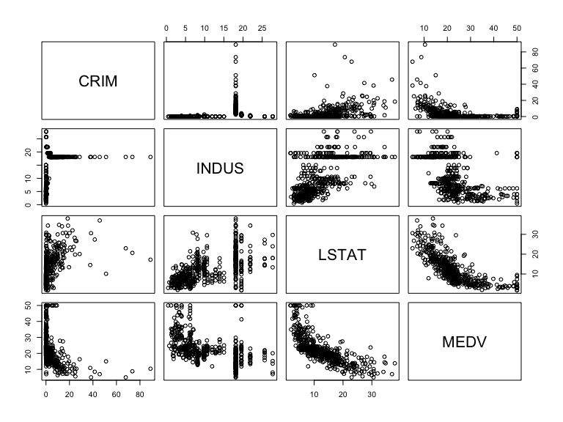

alternative, nicer plot (displayed)
library(GGally)
Registered S3 method overwritten by 'GGally':
method from
+.gg ggplot2
ggpairs(housing.df[, c(1, 3, 12, 13)])
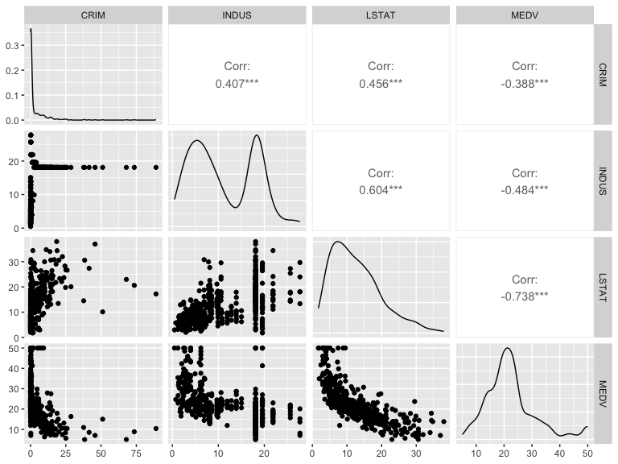

Figure 3.8

Simple plot MEDV CRIM
options(scipen=999) # avoid scientific notation
## scatter plot: regular and log scale
plot(housing.df$MEDV ~ housing.df$CRIM, xlab = "CRIM", ylab = "MEDV")
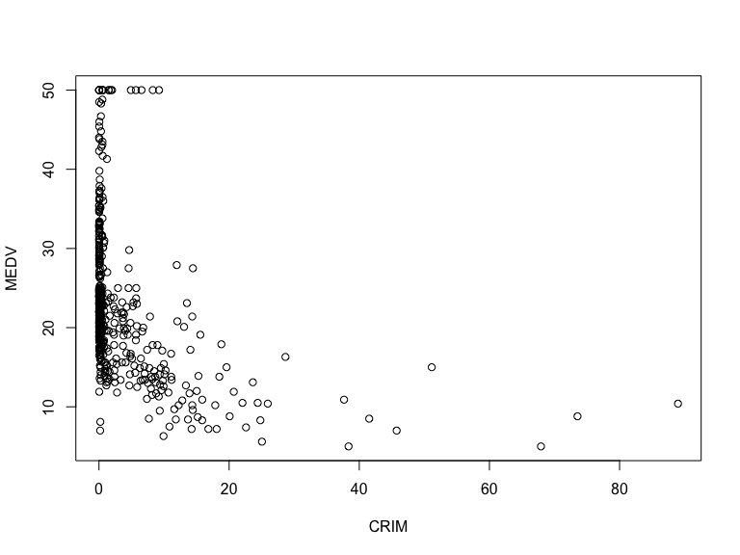

to use logarithmic scale set argument log = to either ‘x’, ‘y’, or ‘xy’.
plot(housing.df$MEDV ~ housing.df$CRIM,
xlab = "CRIM", ylab = "MEDV", log = 'xy')
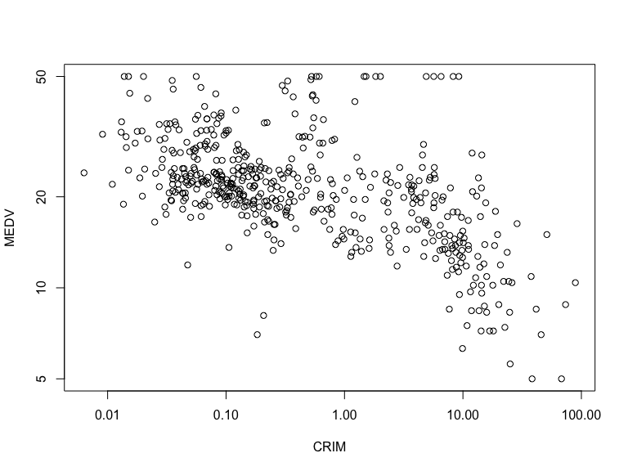

alternative log-scale plot with ggplot
library(ggplot2)
ggplot(housing.df) + geom_point(aes(x = CRIM, y = MEDV)) +
scale_x_log10(breaks = 10^(-2:2),
labels = format(10^(-2:2), scientific = FALSE, drop0trailing = TRUE)) +
scale_y_log10(breaks = c(5, 10, 20, 40))
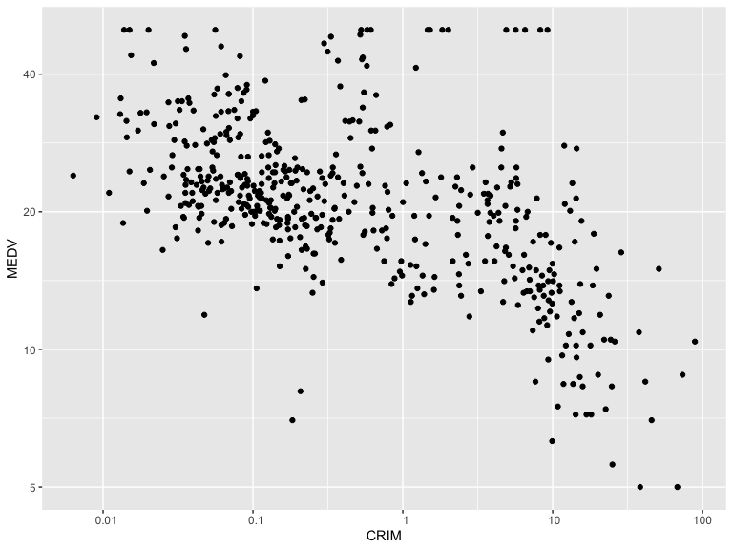

boxplot: regular and log scale
boxplot(housing.df$CRIM ~ housing.df$CAT..MEDV,
xlab = "CAT.MEDV", ylab = "CRIM")
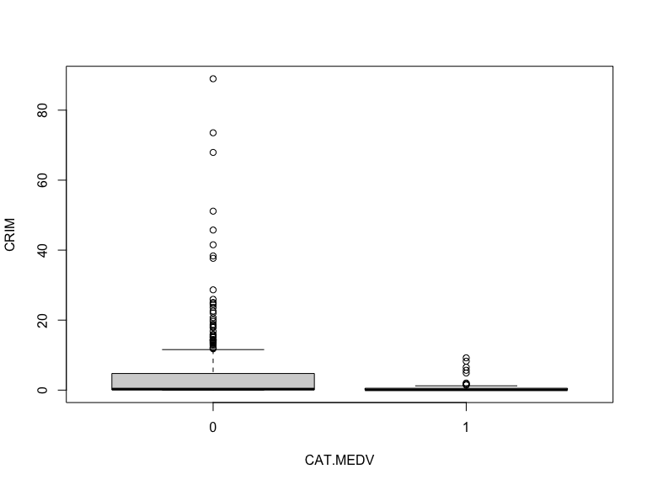
boxplot(housing.df$CRIM ~ housing.df$CAT..MEDV,
xlab = "CAT.MEDV", ylab = "CRIM", log = 'y')
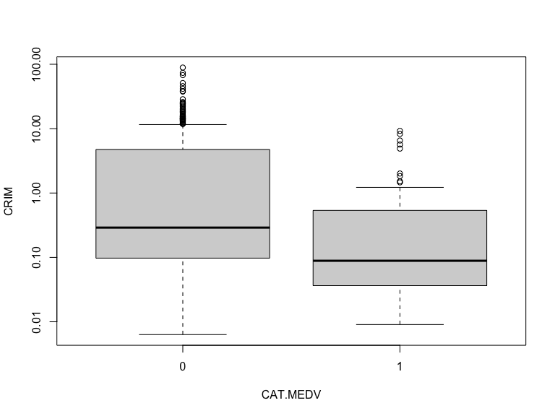

Figure 3.9
library(forecast)
Amtrak.df <- read.csv("data/Amtrak data.csv")
ridership.ts <- ts(Amtrak.df$Ridership, start = c(1991, 1), end = c(2004, 3), freq = 12)

fit curve
ridership.lm <- tslm(ridership.ts ~ trend + I(trend^2))
plot(ridership.ts, xlab = "Year", ylab = "Ridership (in 000s)", ylim = c(1300, 2300))
lines(ridership.lm$fitted, lwd = 2)
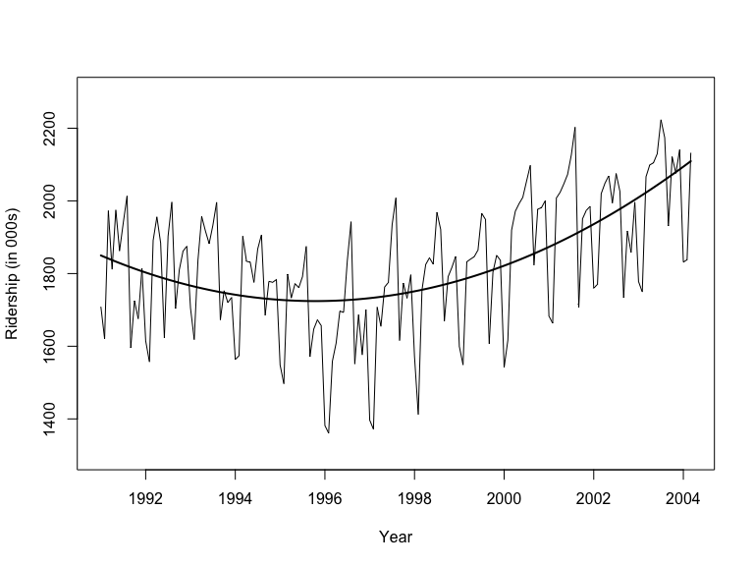

alternative plot with ggplot
library(ggplot2)
ggplot(Amtrak.df, aes(y = Ridership, x = Month, group = 12)) +
geom_line() + geom_smooth(formula = y ~ poly(x, 2), method= "lm",
colour = "navy", se = FALSE, na.rm = TRUE)
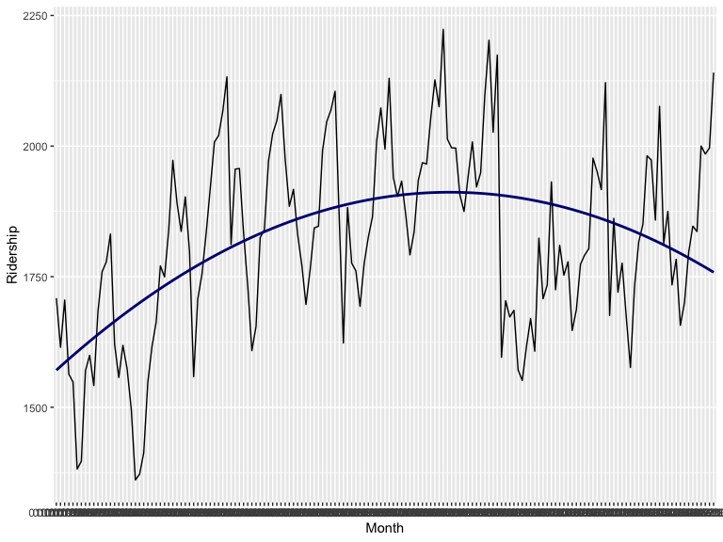

Year
ridership.2yrs <- window(ridership.ts, start = c(1991,1), end = c(1992,12))
plot(ridership.2yrs, xlab = "Year", ylab = "Ridership (in 000s)", ylim = c(1300, 2300))
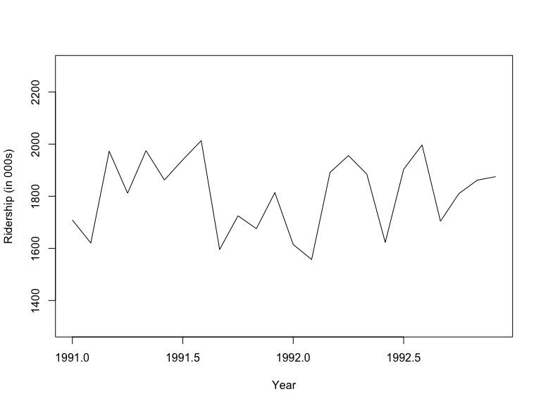

Month
monthly.ridership.ts <- tapply(ridership.ts, cycle(ridership.ts), mean)
plot(monthly.ridership.ts, xlab = "Month", ylab = "Average Ridership",
ylim = c(1300, 2300), type = "l", xaxt = 'n')
## set x labels
axis(1, at = c(1:12), labels = c("Jan","Feb","Mar", "Apr","May","Jun",
"Jul","Aug","Sep", "Oct","Nov","Dec"))
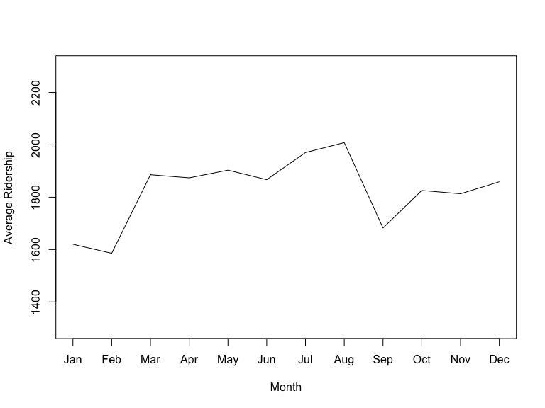

Year(aggregated)
annual.ridership.ts <- aggregate(ridership.ts, FUN = mean)
plot(annual.ridership.ts, xlab = "Year", ylab = "Average Ridership",
ylim = c(1300, 2300))
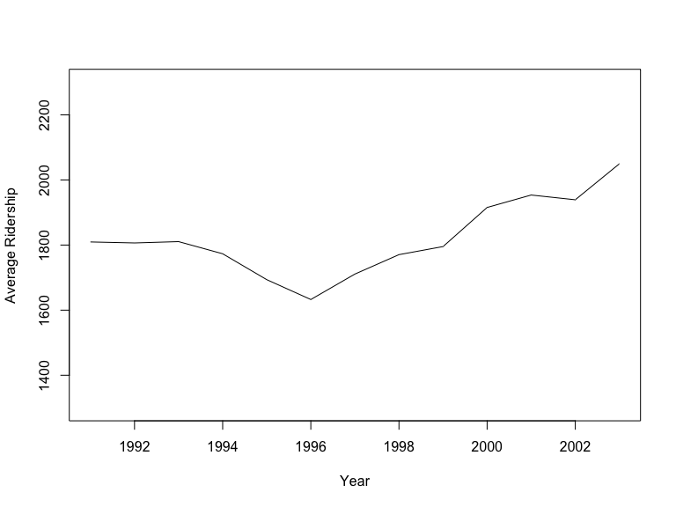

Figure 3.10

Utilities sales
utilities.df <- read.csv("data/Utilities.csv")
plot(utilities.df$Fuel_Cost ~ utilities.df$Sales,
xlab = "Sales", ylab = "Fuel Cost", xlim = c(2000, 20000))
text(x = utilities.df$Sales, y = utilities.df$Fuel_Cost,
labels = utilities.df$Company, pos = 4, cex = 0.8, srt = 20, offset = 0.2)
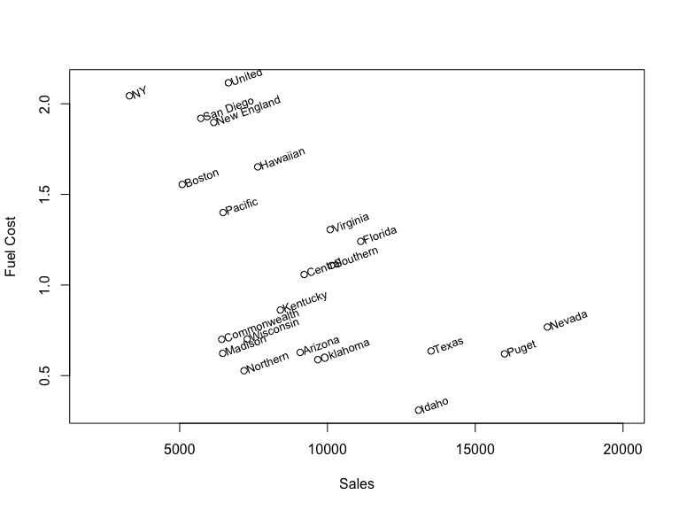

alternative with ggplot
library(ggplot2)
ggplot(utilities.df, aes(y = Fuel_Cost, x = Sales)) + geom_point() +
geom_text(aes(label = paste(" ", Company)), size = 4, hjust = 0.0, angle = 15) +
ylim(0.25, 2.25) + xlim(3000, 18000)
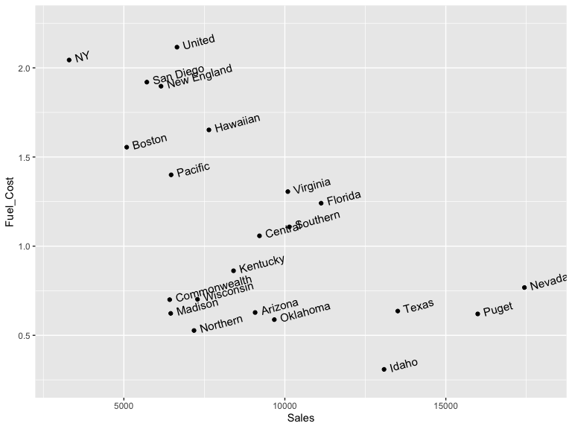

Figure 3.11

use function alpha() in library scales to add transparent colors
# use function alpha() in library scales to add transparent colors
universal.df <- read.csv("data/UniversalBank.csv")
library(scales)
Attaching package: 'scales'
The following object is masked from 'package:purrr':
discard
The following object is masked from 'package:readr':
col_factor
plot(jitter(universal.df$CCAvg, 1) ~ jitter(universal.df$Income, 1),
col = alpha(ifelse(universal.df$Securities.Account == 0, "gray", "black"), 0.4),
pch = 20, log = 'xy', ylim = c(0.1, 10),
xlab = "Income", ylab = "CCAvg")
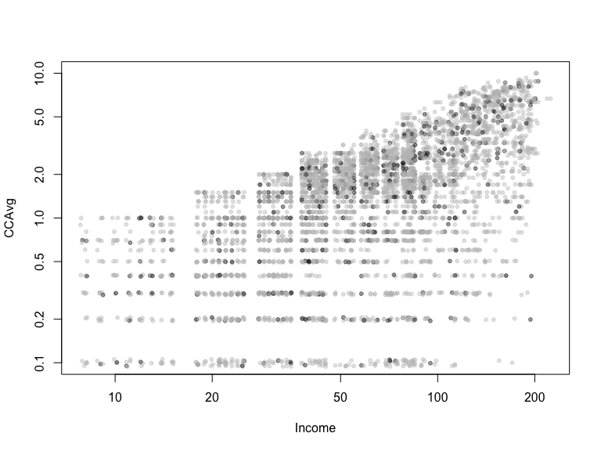

alternative with ggplot
library(ggplot2)
ggplot(universal.df) +
geom_jitter(aes(x = Income, y = CCAvg, colour = Securities.Account)) +
scale_x_log10(breaks = c(10, 20, 40, 60, 100, 200)) +
scale_y_log10(breaks = c(0.1, 0.2, 0.4, 0.6, 1.0, 2.0, 4.0, 6.0))
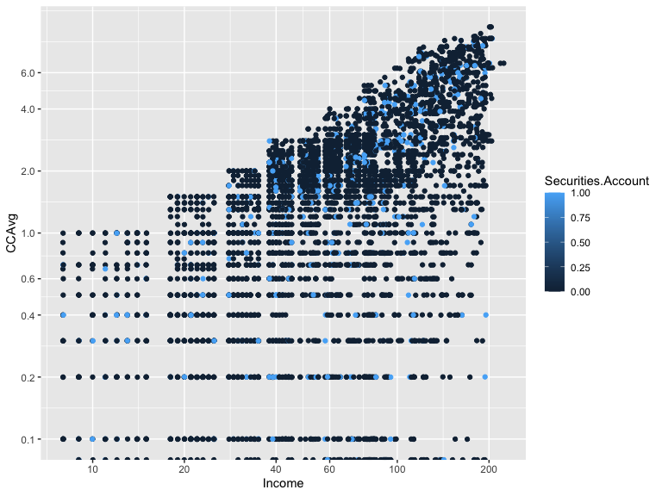

Figure 3.12

Paracoord plot
library(MASS)
Attaching package: 'MASS'
The following object is masked from 'package:dplyr':
select
par(mfcol = c(2,1))
parcoord(housing.df[housing.df$CAT..MEDV == 0, -14], main = "CAT.MEDV = 0")
parcoord(housing.df[housing.df$CAT..MEDV == 1, -14], main = "CAT.MEDV = 1")
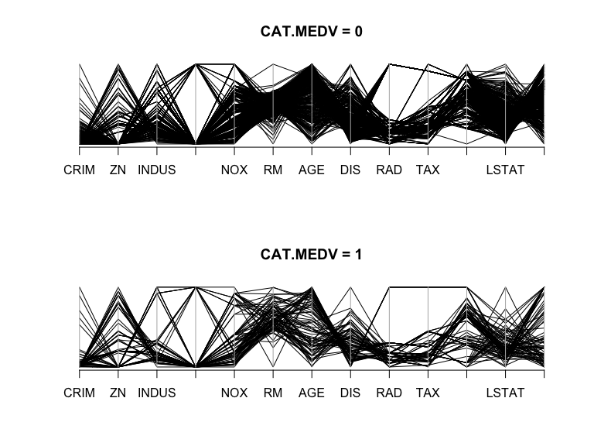

Figure 3.14

Network
library(igraph)
Attaching package: 'igraph'
The following objects are masked from 'package:lubridate':
%--%, union
The following objects are masked from 'package:dplyr':
as_data_frame, groups, union
The following objects are masked from 'package:purrr':
compose, simplify
The following object is masked from 'package:tidyr':
crossing
The following object is masked from 'package:tibble':
as_data_frame
The following objects are masked from 'package:stats':
decompose, spectrum
The following object is masked from 'package:base':
union
ebay.df <- read.csv("data/eBayNetwork.csv")
# transform node ids to factors
ebay.df[,1] <- as.factor(ebay.df[,1])
ebay.df[,2] <- as.factor(ebay.df[,2])
graph.edges <- as.matrix(ebay.df[,1:2])
g <- graph.edgelist(graph.edges, directed = FALSE)
isBuyer <- V(g)$name %in% graph.edges[,2]
plot(g, vertex.label = NA, vertex.color = ifelse(isBuyer, "gray", "black"),
vertex.size = ifelse(isBuyer, 7, 10))
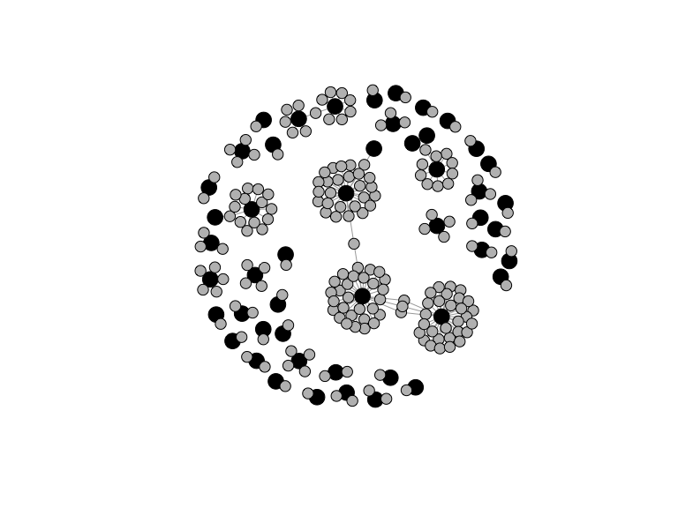

Figure 3.15

Treemap
library(treemap)
tree.df <- read.csv("data/EbayTreemap.csv")
# add column for negative feedback
tree.df$negative.feedback <- 1* (tree.df$Seller.Feedback < 0)
# draw treemap
treemap(tree.df, index = c("Category","Sub.Category", "Brand"),
vSize = "High.Bid", vColor = "negative.feedback", fun.aggregate = "mean",
align.labels = list(c("left", "top"), c("right", "bottom"), c("center", "center")),
palette = rev(gray.colors(3)), type = "manual", title = "")
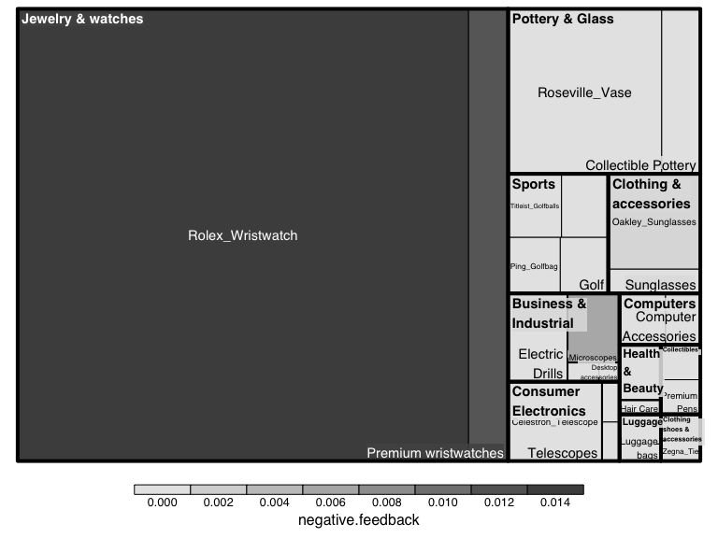

Figure 3.16

Map1
#library(ggmap)
#SCstudents <- read.csv("data/SC-US-students-GPS-data-2016.csv")
#Map <- get_map("Denver, CO", zoom = 3)
#ggmap(Map) + geom_point(aes(x = longitude, y = latitude), data = SCstudents,
# alpha = 0.4, colour = "red", size = 0.5)

Figure 3.17

Map2
#library(mosaic)
#
#gdp.df <- read.csv("data/gdp.csv", skip = 4, stringsAsFactors = FALSE)
#names(gdp.df)[5] <- "GDP2015"
#happiness.df <- read.csv("data/Veerhoven.csv")
#
# gdp map
#mWorldMap(gdp.df, key = "Country.Name", fill = "GDP2015") + coord_map()
#
# eell-being map
#mWorldMap(happiness.df, key = "Nation", fill = "Score") + coord_map() +
# scale_fill_continuous(name = "Happiness")

