[Lecture Note] Dimension Reduction
  - MGS3701 Data Mining, Spring 2025
Chad (Chungil Chae)
Tue, 27 May 2025

Learning Objectives
- The dimension of a dataset, which is the number of variables, must be reduced forthe data mining algorithms to operate efficiently.
- This process is part of the pilot/prototype phase of data mining and is done before deploying a model.
- We present and discuss several dimension reduction approaches:

    - Incorporating domain knowledge to remove or combine categories,

    - using data summaries to detect information overlap between variables (and remove or combine redundant variables or categories),

    - using data conversion techniques such as converting categorical variables into numerical variables, and

    - employing automated reduction techniques, such as principal components analysis (PCA), where a new set of variables (which are weighted averages of the original variables) is created.
- These new variables are uncorrelated and a small subset of them usually contains most of their combined information (hence, we can reduce dimension by using only a subset of the new variables).
- Finally, we mention data mining methods such as regression models and classification and regression trees, which can be used for removing redundant variables and for combining “similar” categories of categorical variables.

SHORT VIDEO INTRODUCTION
https://www.youtube.com/watch?v=eN0wFzBA4Sc

Introduction

- Large Number of Variables:
  - In data mining, large numbers of variables are common.
  - Initially small sets of variables often expand during data preparation.
- Expansion of Variables:
  - Data preparation involves creating new derived variables. Examples include:
    - Dummies for categorical variables.
    - New forms of existing variables.
- Correlation and Model Impact:
  - High correlation among subsets of variables is likely.
  - Including highly correlated variables can lead to:
    - Overfitting.
    - Reduced accuracy.
    - Reduced reliability.
- Computational Problems:
  - Large numbers of variables can cause issues for:
    - Supervised algorithms.
    - Unsupervised algorithms.
    - Other computational processes aside from correlation concerns.
- Model Deployment Costs:
  - Superfluous variables in models can lead to increased costs due to:
    - Collection.
    - Processing.

Curse of Dimensionality

- Dimensionality of a Model:
  - Definition: The number of predictors or input variables used by the model.
- Curse of Dimensionality:
  - Definition: The problems caused by adding variables to multivariate data models.
  - As variables are added, the data space becomes increasingly sparse.
  - Classification and prediction models fail due to insufficient data across many variables.
- Exponential Increase in Difficulty:
  - Difficulties increase exponentially with the addition of each variable.
  - Example for intuition:
    - A chessboard has 2 dimensions and 64 squares (choices).
    - Expanding the chessboard to a cube increases dimensions by 50% (from 2 to 3 dimensions).
    - Location options increase by 800%, to 512 (8 × 8 × 8).
- Statistical Distance and Noise:
  - Proliferation of variables means nothing is close to anything else anymore.
  - Too much noise is added, making patterns and structures indiscernible.
- Big Data and Genomics:
  - The problem is acute in Big Data applications.
  - Example: Genomics analysis might deal with values for thousands of different genes.
- Dimension Reduction:
  - Key step in data mining to reduce dimensionality with minimal accuracy sacrifice.
  - In artificial intelligence literature:
    - Often referred to as factor selection or feature extraction.

Practical Consideration

- Preference for Automated Methods:
  - Data mining prefers automated methods over domain knowledge.
- Importance of Initial Data Exploration:
  - Ensure variables measured are reasonable for the task at hand.
  - Integration of expert knowledge can lead to better results.
- Expert Knowledge Integration:
  - Discussion with data provider (or user) is beneficial.
- Practical Considerations:
  - Variable Importance:
    - Which variables are most important for the task?
    - Which variables are likely to be useless?
  - Error-Prone Variables:
    - Which variables are likely to contain much error?
  - Future Availability and Cost:
    - Which variables will be available for future measurements?
    - What will it cost to measure them?
  - Measurability Before Outcome:
    - Which variables can be measured before the outcome occurs?
- Example Scenario:
  - Predicting the closing price of an ongoing online auction:
    - Cannot use the number of bids as a predictor because it is not known until the auction closes.

Example: House Prices in Boston
- Boston Housing Example:
  - Introduced in Chapter 3.
  - For each neighborhood, several variables are given.
- Example Variables:
  - Crime rate.
  - Student/teacher ratio.
  - Median value of a housing unit in the neighborhood.
- Table Descriptions:
  - Table 4.1: Description of all 14 variables.
  - Table 4.2: The first nine records of the data.
- First Record Example:
  - Represents the first neighborhood.
  - Average per capita crime rate: 0.006.
  - 18% of the residential land zoned for lots over 25,000 ft².
  - 2.31% of the land devoted to nonretail business.
  - No border on the Charles River.
  - Additional details follow similarly.
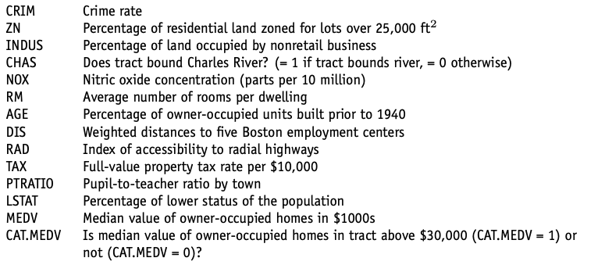

Data Summaries

- Initial Step of Data Exploration:
  - As seen in the chapter on data visualization.
  - Getting familiar with data and their characteristics using summaries and graphs.
  - This step’s importance cannot be overstated.
  - Better understanding leads to better modeling or mining results.
- Role of Numerical Summaries and Graphs:
  - Helpful for data reduction.
  - Information conveyed can assist in:
    - Combining Categories:
      - Combining categories of a categorical variable.
    - Variable Selection:
      - Choosing variables to remove.
    - Information Overlap:
      - Assessing the level of information overlap between variables.
- Strategies for Dimension Reduction:
  - Before discussing these strategies, consider useful summaries and tools.

Summary Statistics
- R Functions for Data Summarization:
  - Overview Function:
    - summary() provides an overview of all variables in the data set.
  - Characteristic Functions:
    - mean()
    - sd() (standard deviation)
    - min()
    - max()
    - median()
    - length()
    - These functions help understand the scale and type of values for each variable.
- Detecting Extreme Values:
  - min() and max() can detect extreme values that might be errors.
- Central Values and Skewness:
  - mean() and median() provide a sense of central values.
  - A large deviation between mean and median indicates skew.
  - sd() gives a sense of data dispersion relative to the mean.
- Handling Missing Values:
  - sum(is.na(variable)) counts the number of null values, indicating missing data.
- Boston Housing Example:
  - Table 4.3: Shows summary statistics and R code.
  - Observations from the table:
    - Different variables have very different ranges of values.
    - Variation in scale across variables can distort analyses if not treated.
    - Mean much larger than the median for certain variables (e.g., CRIM) indicates right skew.
    - No missing values or extreme values due to typing errors.
- Summarizing Relationships Between Variables:
  - Correlation Matrix:
    - For numerical variables, use cor() to compute a matrix of correlations between each pair.
    - Table 4.4: Shows the correlation matrix for the Boston Housing variables.
    - Most correlations are low and many are negative.
  - Visual Display:
    - Heatmap can visually display a correlation matrix (see Figure 3.4 in Chapter 3).
- Importance of Correlation Matrix:
  - Will revisit the correlation matrix in the context of correlation analysis.

Aggregation and Pivot Tables
- Aggregation for Data Exploration:
  - Aggregation by one or more variables provides valuable insights.
- Single Variable Aggregation:
  - Function:
    - table()
  - Example:
    - Table 4.5: Number of neighborhoods that bound the Charles River vs. those that do not (using CHAS as the grouping variable).
    - Observation: Majority of neighborhoods (471 of 506) do not bound the river.
- Aggregation by Multiple Variables:
  - Function:
    - aggregate() for aggregating by one or more variables.
  - Example:
    - Table 4.6: Computes average MEDV by CHAS and RM.
    - Group RM (average number of rooms per dwelling) into bins of size 1.
    - Empty values indicate no neighborhoods with those combinations (e.g., bounding the river and having on average 3 rooms).
- Pivot Tables:
  - Functions:
    - melt() and cast() in the reshape package.
    - melt() stacks a set of columns into a single column.
    - cast() reshapes the single column into multiple columns by chosen aggregating variables.
  - Example:
    - Table 4.7: Computes the average of MEDV by CHAS and RM and presents it as a pivot table.
- Exploratory Step in Classification Tasks:
  - Produce summaries for each class.
  - Assist in detecting useful predictors that show separation between two classes.
- Importance of Data Summaries:
  - Essential for almost any data mining task.
  - Important preliminary step for cleaning and understanding data before further analyses.

Correlation Analysis

- Large Datasets with Many Variables:
  - Likely to serve as predictors.
  - Usually contain much overlap in information covered by the set of variables.
- Finding Redundancies:
  - Correlation Matrix:
    - Shows all pairwise correlations between variables.
    - Identifies pairs with very strong (positive or negative) correlations.
      - Variables with high correlation have a lot of overlap in information.
      - Good candidates for data reduction by removing one of the variables.
- Avoiding Multicollinearity:
  - Removing strongly correlated variables helps prevent multicollinearity problems.
    - Definition: Multicollinearity occurs when two or more predictors share the same linear relationship with the outcome variable.
    - R handles multicollinearity automatically in regression models.
- Detecting Variable Duplications:
  - Correlation Analysis:
    - Useful for identifying duplicated variables in the dataset.
  - Duplications can occur when:
    - The same variable appears accidentally more than once under different names.
    - The dataset is merged from multiple sources.
    - The same phenomenon is measured in different units.
- Using Correlation Table Heatmaps:
  - Heatmaps make identifying strong correlations easier.
  - Visual display of correlation matrix (as shown in Chapter 3).

Reducing the Number of Categories in Categorical Variables

- Handling Categorical Variables with Many Categories:
  - When a categorical variable has many categories and is used as a predictor.
  - Dummy Variables:
    - A variable with ( m ) categories will be transformed into ( m ) or ( m-1 ) dummy variables.
    - This can greatly inflate the dimension of the dataset, even with few original categorical variables.
- Reducing Categories:
  - Combining Categories:
    - Incorporate expert knowledge and common sense.
    - Pivot tables are useful for examining the sizes of various categories and the behavior of the outcome variable in each category.
    - Categories with very few observations are good candidates for combining with other categories.
    - Label the most relevant categories for the analysis and group the rest as “other”.
- Classification Tasks:
  - In tasks with a categorical outcome variable:
    - A pivot table broken down by outcome classes can help identify categories that do not separate the classes.
    - Such categories can be included in the “other” category.
  - Example (Figure 4.1):
    - Distribution of outcome variable CAT.MEDV broken down by ZN (treated as a categorical variable).
    - Categories ZN = 17.5, 90, 95, and 100 can be combined as all neighborhoods have CAT.MEDV = 1.
    - Categories ZN = 12.5, 25, 28, 30, and 70 can similarly be combined.
- Time Series Context:
  - If a categorical variable denoting the season (month, hour of day) will serve as a predictor:
    - Reduce categories by examining the time series plot and identifying similar periods.
  - Example (Figure 4.2):
    - Time plot shows quarterly revenues of Toys “R” Us between 1992–1995.
    - Quarter 4 periods appear different, so quarters 1–3 can be combined into a single category.

Converting a Actegorical Variable to a Numerical Variable

- Categorical Variables Representing Intervals:
  - Examples include age group or income bracket.
- Known Interval Values:
  - If the values of the intervals are known:
    - Example: Category 2 represents the age interval 20–30.
- Replacing Categorical Values:
  - Replace the categorical value with the mid-interval value.
    - Example: Replace “2” with “25” (mid-interval value for the age interval 20–30).
- Resulting Numerical Variable:
  - The categorical variable becomes a numerical variable.
  - No longer requires multiple dummy variables.

Principal Components Analysis

- Principal Components Analysis (PCA):
  - A useful method for dimension reduction.
  - Especially valuable when the number of variables is large.
- Suitability:
  - Effective when subsets of measurements are:
    - Measured on the same scale.
    - Highly correlated.
- Outcome of PCA:
  - Provides a few variables (often as few as three).
  - These variables are weighted linear combinations of the original variables.
  - Retain the majority of the information from the full original set.
- Intended Use:
  - PCA is designed for use with numerical variables.
- Alternative Methods for Categorical Variables:
  - Other methods such as correspondence analysis are more suitable for categorical variables.

Example: Breakfast Cereals
- Dataset Description:
  - Data collected on the nutritional information and consumer rating of 77 breakfast cereals.
  - Consumer rating represents cereal “healthiness” for consumer information (not rated by consumers).
- Variables:
  - Includes 13 numerical variables.
  - Focus is on reducing the dimensionality.
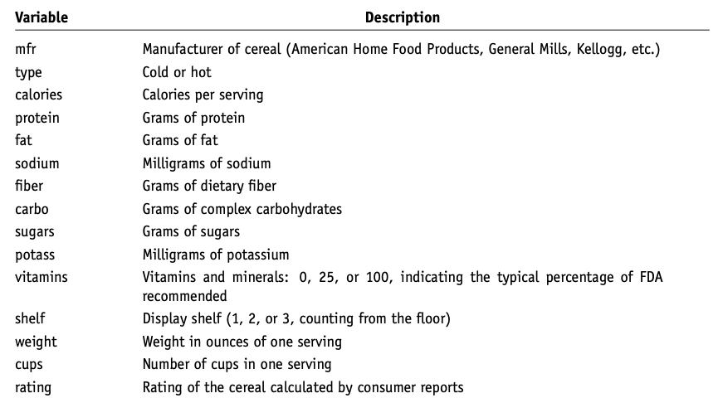
- Basis of Information:
  - Information for each cereal is based on a bowl of cereal (constant volume) rather than a serving size (varies by weight).
- Data Snapshot:
  - A snapshot of the data is shown in Figure 4.3.
  - Variable descriptions are provided in Table 4.8.
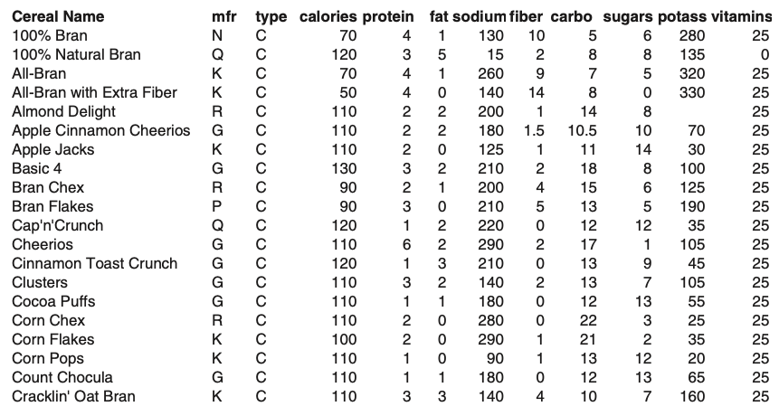
- Focus on Two Variables:
  - Calories and Consumer Rating:
    - Data for these variables are presented in Table 4.9.
    - Average calories across the 77 cereals: 106.88.
    - Average consumer rating: 42.67.
- Covariance Matrix:
  - Provides estimated covariance between the two variables:
    - Calories
    - Consumer Rating
$$S=\left[\begin{matrix}379.63 & −188.68 \\ −188.68 & 197.32\end{matrix}\right]$$
- It can be seen that the two variables are strongly correlated with a negative correlation of
$$−0.69=\frac{−188.68}{\sqrt{\left(379.63\right)\left(197.32\right)}}$$
- Total Variation and Co-variation:
  - Concept:
    - 69% of the total variation in both variables is co-variation.
    - Variation in one variable is duplicated by similar variation in the other.
- Variable Reduction:
  - Objective:
    - Reduce the number of variables while maximizing their unique contributions.
    - Possible to reduce two correlated variables to a single variable without much information loss.
- Principal Components Analysis (PCA):
  - Purpose:
    - Find a linear combination of variables that contains most information.
    - Retain the majority of the variability (information).
  - Example Calculation:
    - Total variability: 379.63 (calories) + 197.32 (rating) = 577.
    - Calories account for 66% of total variability: $\frac{379.63}{577}$.
    - Rating accounts for 34% of total variability.
- Scatter Plot and Principal Components:
  - Figure 4.4:
    - Scatter plot of rating vs. calories.
    - z1-axis: Direction with the largest variability (first principal component).
    - z2-axis: Perpendicular to z1 (second principal component).
  - z1: Line that captures the most variation.
  - Principal component: Line that minimizes the sum of squared perpendicular distances from the line.
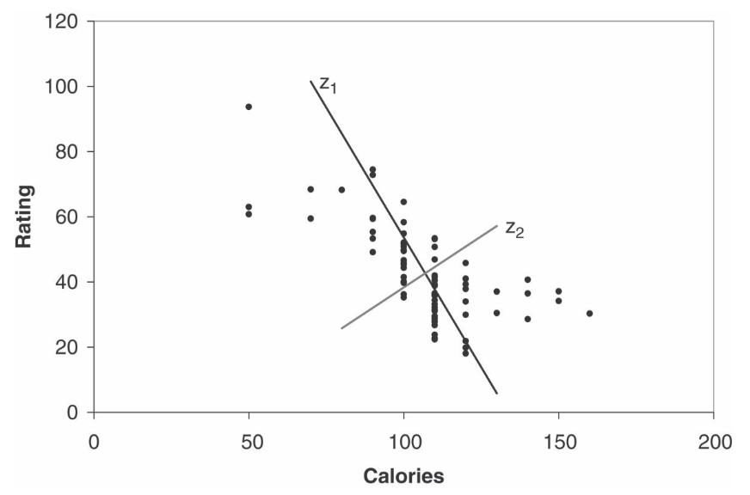
- Running PCA in R:
  - Function: prcomp()
  - Output:
    - Rotation matrix (.rot): Weights for projections.
      - Weights for z1: (0.847, -0.532)
      - Weights for z2: (0.532, 0.847)
    - Reallocated variance:
      - z1 accounts for 86% of total variability.
      - z2 accounts for 14%.
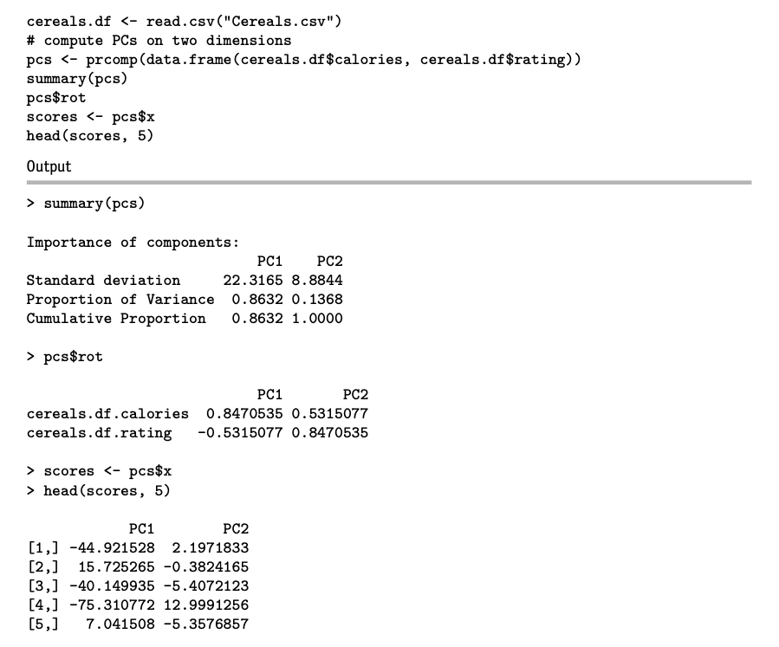
- Principal Component Scores:
  - Projected values of calories and rating onto new axes (after subtracting means).
  - Example Calculation:
    - 100% Bran cereal with 70 calories and a rating of 68.4:
      - First score: $\left(0.847\right)\left(70−106.88\right)+\left(−0.532\right)\left(68.4−42.67\right)=−44.92$.
- Properties of New Variables:
  - Means of z1 and z2 are zero (variables are mean-centered).
  - Sum of variances $\text{var}\left(z1\right)+\text{var}\left(z2\right)$ equals sum of original variances.
    - Variances:
      - var(z1) = 498
      - var(z2) = 79
    - z1 accounts for 86% of total variance.
- Conclusion:
  - First principal component, z1, captures most variability.
  - Reasonable to use z1 to represent two original variables.
  - These concepts can be generalized to more than two variables.

Principal Components

Generalizing PCA Procedure for p > 2 Variables:
- Original Variables:
  - Denote the original p variables by $ X_1, X_2, , X_p $.
- New Variables $Z_{1},Z_{2},…,Z_{p}$:
  - PCA creates new variables as weighted averages of the original variables (after mean subtraction): $Z_{i}=a_{i,1}\left(X_{1}−\overline{X_{1}}\right)+a_{i,2}\left(X_{2}−\overline{X_{2}}\right)+⋯+a_{i,p}\left(X_{p}−\overline{X_{p}}\right), i=1,…,p$
  - Each pair of $Z$ variables has a correlation of 0 (they are uncorrelated).
  - Resulting $Z$ variables are ordered by their variance:
    - $Z_{1}$ has the largest variance.
    - $Z_{p}$ has the smallest variance.
- Principal Component Scores:
  - Weights $a_{i,j}$ are computed by software and used to calculate the principal component scores.
- Advantages of Principal Components:
  - Uncorrelated (correlation coefficient = 0).
  - Using principal components as predictors in regression models prevents multicollinearity issues.
- Example with Breakfast Cereal Dataset:
  - Apply PCA to 13 numerical variables.
  - Result (Table 4.11):
    - First three components account for more than 96% of the total variation.
    - First two principal components capture 92.6% of the total variation.
  - Suggests capturing most variability with less than 25% of original dimensions.
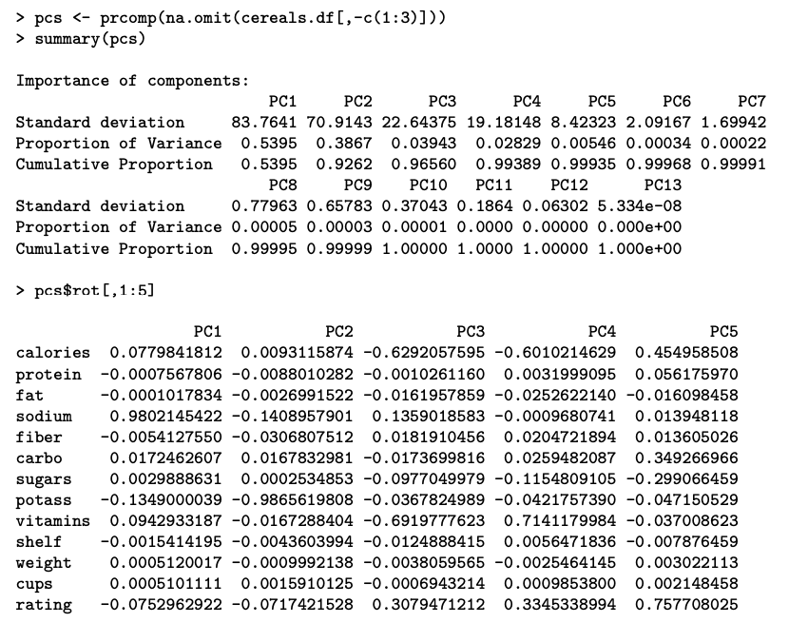
- Influence of Variable Scales:
  - Results can be influenced by the scales of the variables.

Normalizing the Data
- Understanding Data Structure with PCA:
  - Examine the weights to see how the original variables contribute to the principal components.
  - Example:
    - First principal component is dominated by sodium content (highest weight).
    - Second principal component is dominated by potassium content.
    - Due to different units of measurement leading to dominance in total variance.
- Normalization:
  - Purpose:
    - To give all variables equal importance in terms of variability.
  - Method:
    - Replace each original variable with a standardized version having unit variance.
    - Achieved by dividing each variable by its standard deviation.
  - When to Normalize:
    - Use normalization when variables are measured in different units.
    - Do not normalize if the variables’ scales reflect their importance and are common (e.g., dollars).
- Alternative to Normalization:
  - Perform PCA on the correlation matrix instead of the covariance matrix.
  - Most software programs allow this choice.
- Example with Breakfast Cereal Data:
  - Normalize 13 variables due to different scales.
  - Perform PCA on the correlation matrix.
  - Output (Table 4.12):
    - Need 7 principal components to account for more than 90% of the total variability.
    - First 2 principal components account for only 52% of the total variability.
    - Reducing to two variables would lose much information.
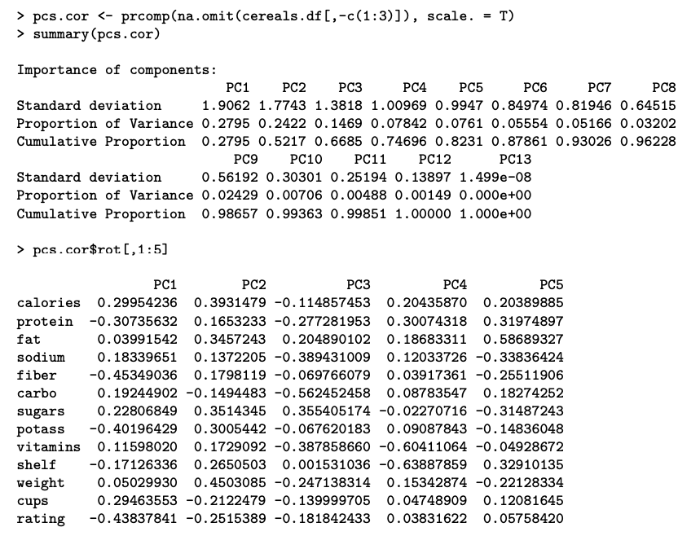
- Interpreting Principal Components:
  - First Principal Component:
    - Measures the balance between calories and cups (positive weights) vs. protein, fiber, potassium, and consumer rating (negative weights).
    - High scores indicate high calories and amount per bowl but low protein and potassium.
    - Low consumer rating associated with high scores.
  - Second Principal Component:
    - Most affected by the weight of a serving.
  - Third Principal Component:
    - Most affected by carbohydrate content.
- Scatter Plot of Principal Component Scores:
  - Useful when data can be reduced to two dimensions.
  - Figure 4.5:
    - Scatter plot of first vs. second principal component scores for breakfast cereals.
    - Observations labeled to reveal structure.
    - Moving from right to left: Cereals become less healthy.
    - Moving from bottom to top: Cereals get heavier.
    - Clusters of observations can be identified, such as children’s cereals in the middle-left part of the plot.
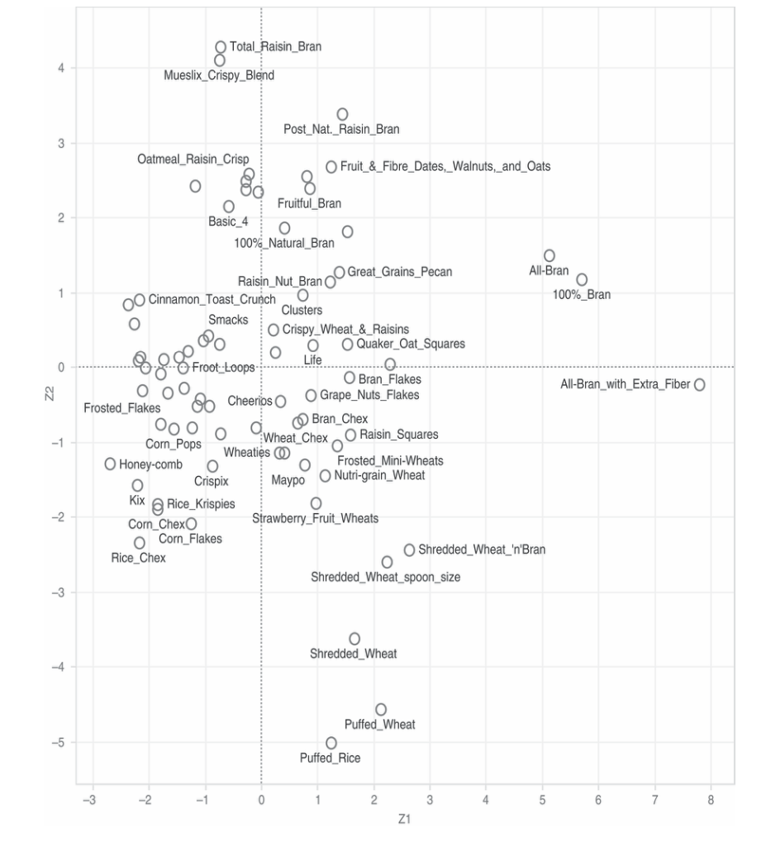

Using Principal Components for Classification and Prediction

PCA for Predictor Reduction in Supervised Learning:
- Goal:
  - Reduce the number of variables while retaining predictive power.
- Procedure:
  - Apply PCA to Predictors:
    - Use the training data to perform PCA.
  - Determine Principal Components:
    - Identify the number of principal components to retain.
  - Use Principal Scores as Predictors:
    - Model will now use the reduced number of principal scores as predictors.
  - Validation Set:
    - Compute principal scores for the validation set using weights from the training data.
    - Use these new principal scores as predictors for validation.
- Disadvantage:
  - Nonlinear Predictive Information:
    - Using a subset of principal components might result in the loss of nonlinear relationships.
    - Example: Quadratic effects or interactions between predictors may not be captured.
  - Reason:
    - PCA produces linear transformations, capturing only linear relationships between the original variables.

Dimension Reduction Using Regression Models

Methods for Reducing the Number of Columns:
- Exploratory Methods:
  - Summary Statistics and Plots:
    - Use summary statistics and data visualizations to understand and reduce data dimensions.
  - Principal Components Analysis (PCA):
    - PCA reduces dimensionality without considering the outcome variable.
- Informal Methods:
  - Incorporate the relationship between predictors and the outcome variable.
  - Example:
    - Combining similar categories based on their similar behavior concerning the outcome variable.
- Regression Models for Dimension Reduction:
  - Directly consider the predictive or classification task:
    - Linear Regression:
      - Used for prediction tasks (Refer to Chapter 6).
    - Logistic Regression:
      - Used for classification tasks (Refer to Chapter 10).
- Subset Selection Procedures:
  - Algorithmically choose a subset of predictor variables from a larger set.
  - Details provided in the relevant chapters.
- Using Fitted Regression Models for Combining Categories:
  - Statistically Insignificant Coefficients:
    - Categories with high p-values (not statistically significant) can be combined with the reference category.
    - Their distinction from the reference category has no significant effect on the outcome variable.
  - Categories with Similar Coefficient Values:
    - Categories with similar coefficients (and the same sign) can be combined.
    - Their effect on the outcome variable is similar.
- Example Illustration:
  - Chapter 10 provides an example of predicting delayed flights, illustrating how regression models are used for dimension reduction.

Dimension Reduction Using Classification and Regression Trees

Classification and Regression Trees for Dimension Reduction:
- Purpose:
  - Reduce the number of columns.
  - Combine categories of a categorical variable.
- Types of Trees:
  - Classification Trees:
    - Used for classification tasks.
  - Regression Trees:
    - Used for prediction tasks.
- Method:
  - Algorithm creates binary splits on the predictors to best classify/predict the outcome variable.
    - Example: Splitting age data into above/below age 30.
- Tree Diagram as a Tool:
  - Determine important predictors:
    - Predictors that do not appear in the tree can be removed.
    - Categories that do not appear in the tree can be combined.
- Detailed Discussion:
  - Further details and discussion are provided in Chapter 9.

House Keeping

Announcement

Assignment

Assignment1: Assignment Title
- What to do
  - A
  - B
- Format and Requirement
  - PDF format, < ?? pages
  - file name should be include your student id and name
    - stuID_name_title.pdf (e.g. 1111111_ChungilChae_SelfIntroduction.pdf)
  - APA, Double-Space, No title page, 12 points, Reference section if necessary
  - Chinese name in English, English name, Student ID, Class name and section (e.g. GE2021, W09; MGS3001, W01)
- due date
  - by Date(DAY) 11:59PM
  - NO LATE SUBMISSION ALLOWED!!!!

Reference

