[Lecture Notebook] Evaluating Predictive Performance
  - MGS3701 Data Mining, Spring 2025
Chad (Chungil Chae)
Tue, 27 May 2025

Table 5.1
# package forecast is required to evaluate performance
library(forecast)
Registered S3 method overwritten by 'quantmod':
method from
as.zoo.data.frame zoo
# load file
toyota.corolla.df <- read.csv("data/ToyotaCorolla.csv")
# randomly generate training and validation sets
training <- sample(toyota.corolla.df$Id, 600)
validation <- sample(setdiff(toyota.corolla.df$Id, training), 400)
# run linear regression model
reg <- lm(Price~., data=toyota.corolla.df[,-c(1,2,8,11)], subset=training,
na.action=na.exclude)
pred_t <- predict(reg, na.action=na.pass)
pred_v <- predict(reg, newdata=toyota.corolla.df[validation,-c(1,2,8,11)],
na.action=na.pass)
## evaluate performance
# training
accuracy(pred_t, toyota.corolla.df[training,]$Price)
ME RMSE MAE MPE MAPE
Test set -2.764938e-11 1093.729 803.959 -0.8753312 8.025352
# validation
accuracy(pred_v, toyota.corolla.df[validation,]$Price)
ME RMSE MAE MPE MAPE
Test set 0.6011947 1090.11 834.2342 -0.6821839 8.460744

Figure 5.2
# remove missing Price data
toyota.corolla.df <-
toyota.corolla.df[!is.na(toyota.corolla.df[validation,]$Price),]
# generate random Training and Validation sets
training <- sample(toyota.corolla.df$Id, 600)
validation <- sample(toyota.corolla.df$Id, 400)
# regression model based on all numerical predictors
reg <- lm(Price~., data = toyota.corolla.df[,-c(1,2,8,11)], subset = training)
# predictions
pred_v <- predict(reg, newdata = toyota.corolla.df[validation,-c(1,2,8,11)])
# load package gains, compute gains (we will use package caret for categorical y later)
library(gains)
gain <- gains(toyota.corolla.df[validation,]$Price[!is.na(pred_v)], pred_v[!is.na(pred_v)])
# cumulative lift chart
options(scipen=999) # avoid scientific notation
# we will compute the gain relative to price
price <- toyota.corolla.df[validation,]$Price[!is.na(toyota.corolla.df[validation,]$Price)]
plot(c(0,gain$cume.pct.of.total*sum(price))~c(0,gain$cume.obs),
xlab="# cases", ylab="Cumulative Price", main="Lift Chart", type="l")
# baseline
lines(c(0,sum(price))~c(0,dim(toyota.corolla.df[validation,])[1]), col="gray", lty=2)
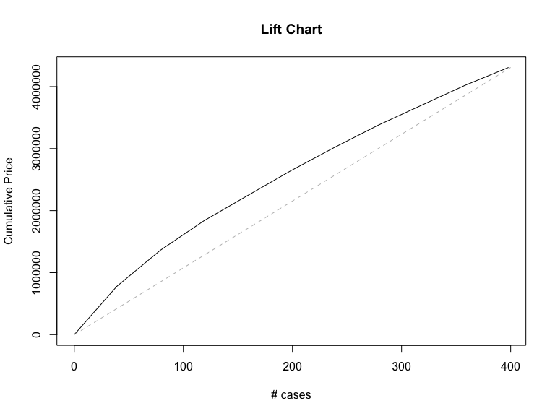
# Decile-wise lift chart
barplot(gain$mean.resp/mean(price), names.arg = gain$depth,
xlab = "Percentile", ylab = "Mean Response", main = "Decile-wise lift chart")
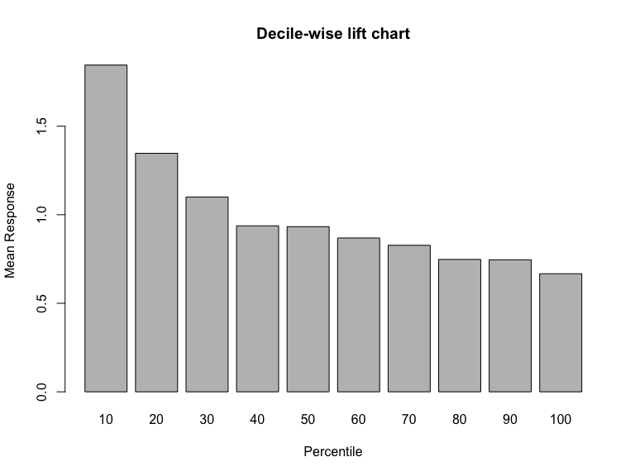

Table 5.5
library(caret)
Loading required package: lattice
Attaching package: 'caret'
The following object is masked from 'package:purrr':
lift
library(e1071)
owner.df <- read.csv("data/ownerExample.csv")
#confusionMatrix(as.factor(ifelse(owner.df$Probability>0.5, 'owner', 'nonowner')),
# owner.df$Class)
#confusionMatrix(as.factor(ifelse(owner.df$Probability>0.25, 'owner', 'nonowner')),
# owner.df$Class)
#confusionMatrix(as.factor(ifelse(owner.df$Probability>0.75, 'owner', 'nonowner')),
# owner.df$Class)

Figure 5.4
# replace data.frame with your own
df <- read.csv("data/liftExample.csv")
# create empty accuracy table
accT = c()
# compute accuracy per cutoff
for (cut in seq(0,1,0.1)){
cm <- confusionMatrix(as.factor(1 * (df$prob > cut)), as.factor(df$actual))
accT = c(accT, cm$overall[1])
}
# plot accuracy
plot(accT ~ seq(0,1,0.1), xlab = "Cutoff Value", ylab = "", type = "l", ylim = c(0, 1))
lines(1-accT ~ seq(0,1,0.1), type = "l", lty = 2)
legend("topright", c("accuracy", "overall error"), lty = c(1, 2), merge = TRUE)
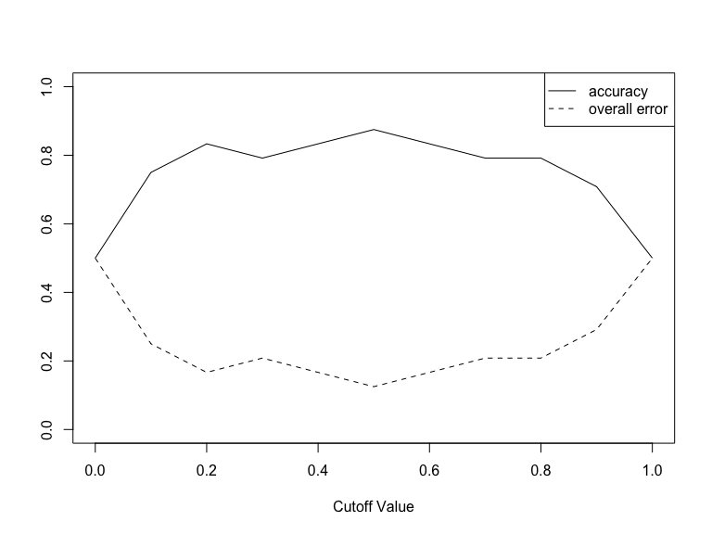

Figure 5.5
library(pROC)
Type 'citation("pROC")' for a citation.
Attaching package: 'pROC'
The following objects are masked from 'package:stats':
cov, smooth, var
r <- roc(df$actual, df$prob)
Setting levels: control = 0, case = 1
Setting direction: controls < cases
plot.roc(r)
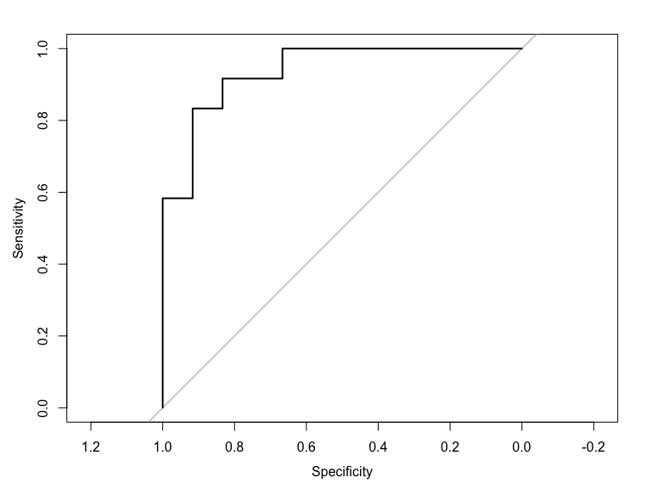
# compute auc
auc(r)
Area under the curve: 0.9375

Figure 5.6
# first option with 'caret' library:
library(caret)
lift.example <- lift(relevel(as.factor(actual), ref="1") ~ prob, data = df)
xyplot(lift.example, plot = "gain")
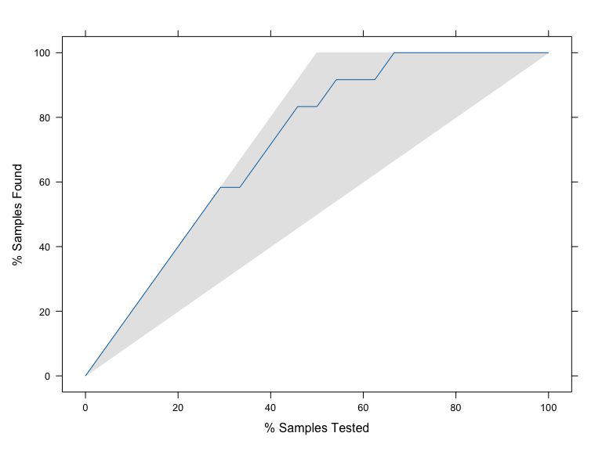
# Second option with 'gains' library:
library(gains)
df <- read.csv("data/liftExample.csv")
gain <- gains(df$actual, df$prob, groups=dim(df)[1])
plot(c(0, gain$cume.pct.of.total*sum(df$actual)) ~ c(0, gain$cume.obs),
xlab = "# cases", ylab = "Cumulative", type="l")
lines(c(0,sum(df$actual))~c(0,dim(df)[1]), col="gray", lty=2)
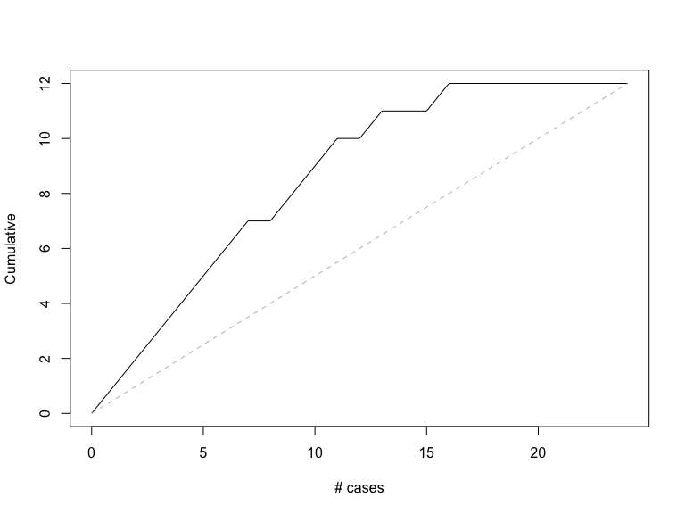

Figure 5.7
# use gains() to compute deciles.
# when using the caret package, deciles must be computed manually.
gain <- gains(df$actual, df$prob)
barplot(gain$mean.resp / mean(df$actual), names.arg = gain$depth, xlab = "Percentile",
ylab = "Mean Response", main = "Decile-wise lift chart")
