[Lecture Note] Topic Modeling: Comprehensive Explanations
  - Make up and special topic
Chad (Chungil Chae)
Tue, 27 May 2025

Learning Objectives
- Topic model concept
- Implemetation
- Topic interpretation
- Advanced model
- Application

SHORT VIDEO INTRODUCTION
https://www.youtube.com/watch?v=3mHy4OSyRf0

Introduction

What is Topic Modeling?
- Definition: Topic modeling is an unsupervised machine learning technique that discovers abstract “topics” that occur in a collection of documents. It doesn’t require pre-labeled data, making it powerful for exploratory analysis.
- Core idea: Elaborate that each document contains multiple topics in different proportions (like 30% politics, 50% economics, 20% healthcare), and each topic is characterized by a distribution over words (e.g., the “economics” topic might give high probability to words like “market,” “inflation,” “GDP”).
- Goal: Emphasize that topic modeling helps us understand large text collections by revealing underlying thematic structures. For example, analyzing thousands of news articles to understand main themes without reading each one.
- Give a concrete example: “Imagine having 10,000 customer reviews. Rather than reading each one, topic modeling might show that 30% discuss product quality, 25% discuss shipping issues, 20% discuss customer service, etc.”
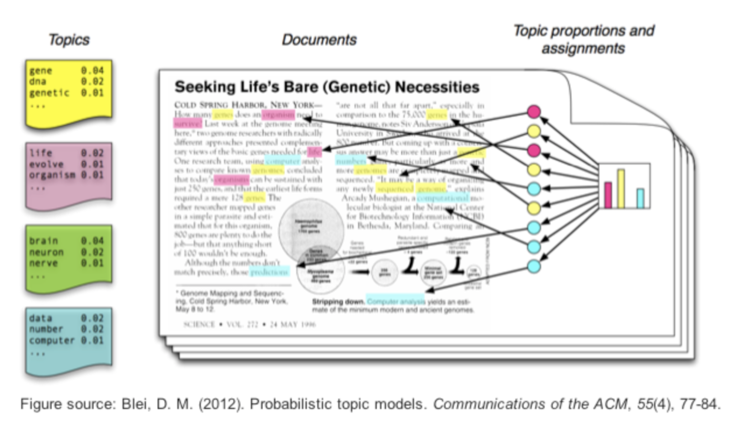

Historical Context
- Origins: Explain how information retrieval problems (like searching large document collections) led to the development of these methods.
- Milestone developments:
  - Describe LSA as the first attempt to capture semantic meaning beyond exact keyword matching using matrix factorization.
  - Explain how pLSA improved on LSA by introducing a proper probabilistic model but still had limitations with new documents.
  - Highlight LDA as the breakthrough that addressed pLSA’s limitations by adding Dirichlet priors, becoming the standard approach.
  - Mention that recent neural approaches are extending these foundations with deep learning capabilities.
- Connect this history to the broader evolution of text analytics, showing how topic modeling fits into the progression from simple keyword counting to sophisticated semantic analysis.

Why Topic Modeling Matters
- Document organization: Show examples of how digital libraries or enterprise document systems use topic modeling to automatically categorize thousands of documents.
- Information retrieval: Explain how Google Scholar might use topic modeling to improve academic paper search, allowing users to find conceptually related papers even when they use different terminology.
- Content recommendation: Describe how Netflix or Spotify might leverage topic models to understand content and user preferences at a thematic level.
- Knowledge discovery: Show examples like analyzing medical literature to discover connections between seemingly unrelated research areas.
- Dimensionality reduction: Explain the technical advantage of reducing thousands of word dimensions to a small number of topic dimensions while preserving semantic relationships.
- Include a real-world example: “Researchers used topic modeling on 17,000 New York Times articles to track how COVID-19 discourse evolved from a health crisis to an economic and political issue.”

Theoretical Foundation

Text Representation
- Bag-of-words approach: Explain that word order is discarded, and documents are represented as word frequency counts. Show a simple example converting a sentence to this representation.
- Document-term matrix: Use a visual example showing a small corpus of 3-4 documents and how they’d be represented in this matrix format.
  - For example, show how documents like “I love machine learning”, “I love deep learning”, and “Deep learning is fascinating” would be represented in a matrix.
  - Demonstrate how sparse this matrix becomes with real-world data (mostly zeros).
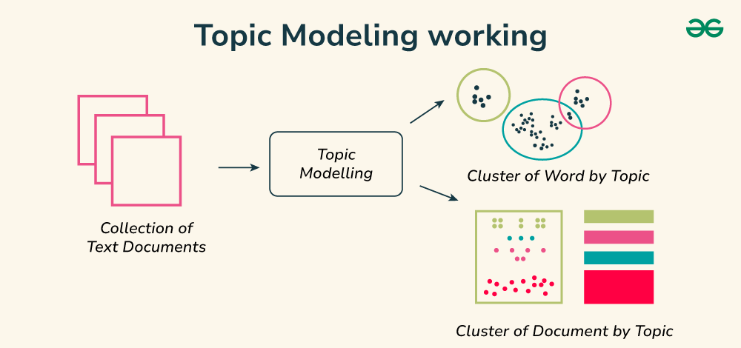
- Challenges:
  - Illustrate sparsity with statistics (e.g., “A corpus of 10,000 news articles might have 50,000 unique terms, but each document uses only 100-200 of them”).
  - Explain how high dimensionality leads to computational challenges and the “curse of dimensionality.”
  - Discuss how semantically related words like “car” and “automobile” are treated as completely different dimensions in this representation.

Probabilistic Modeling Concepts
- Generative models: Use the cooking analogy: “Imagine reverse-engineering recipes (topics) from final dishes (documents). We observe the dishes and try to figure out what ingredients (words) went into each recipe and in what proportions.”
- Latent variables: Explain that topics are hidden/latent because we don’t observe them directly in the text; we only see words and must infer the underlying topics.
- Distributions: Use visual examples showing:
  - How a document might be distributed across topics (e.g., 70% sports, 30% business)
  - How a topic might be distributed across words (e.g., the sports topic gives high probability to “team,” “player,” “game,” etc.)
- Key probability distributions :
  - Explain the multinomial distribution as a generalization of the coin flip to multiple outcomes (like rolling a die).
  - Describe the Dirichlet distribution as a “distribution over distributions” that controls how concentrated or spread out topic mixtures tend to be.
  - Show visualizations of how different Dirichlet parameters create different distribution patterns.
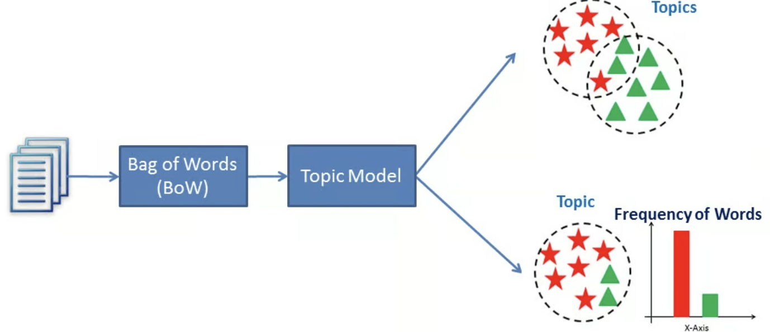
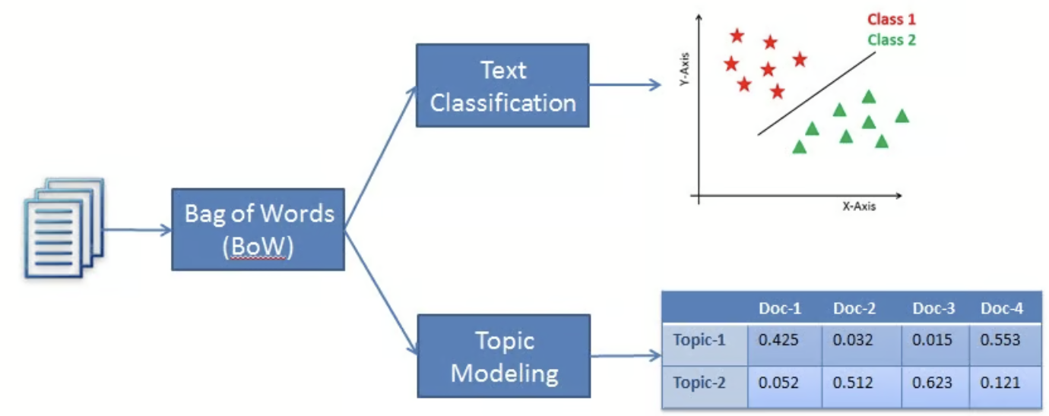

Latent Dirichlet Allocation (LDA)
- Core assumption: Elaborate on the mixed membership model - unlike hard clustering, documents aren’t assigned to single topics but have proportions of multiple topics.
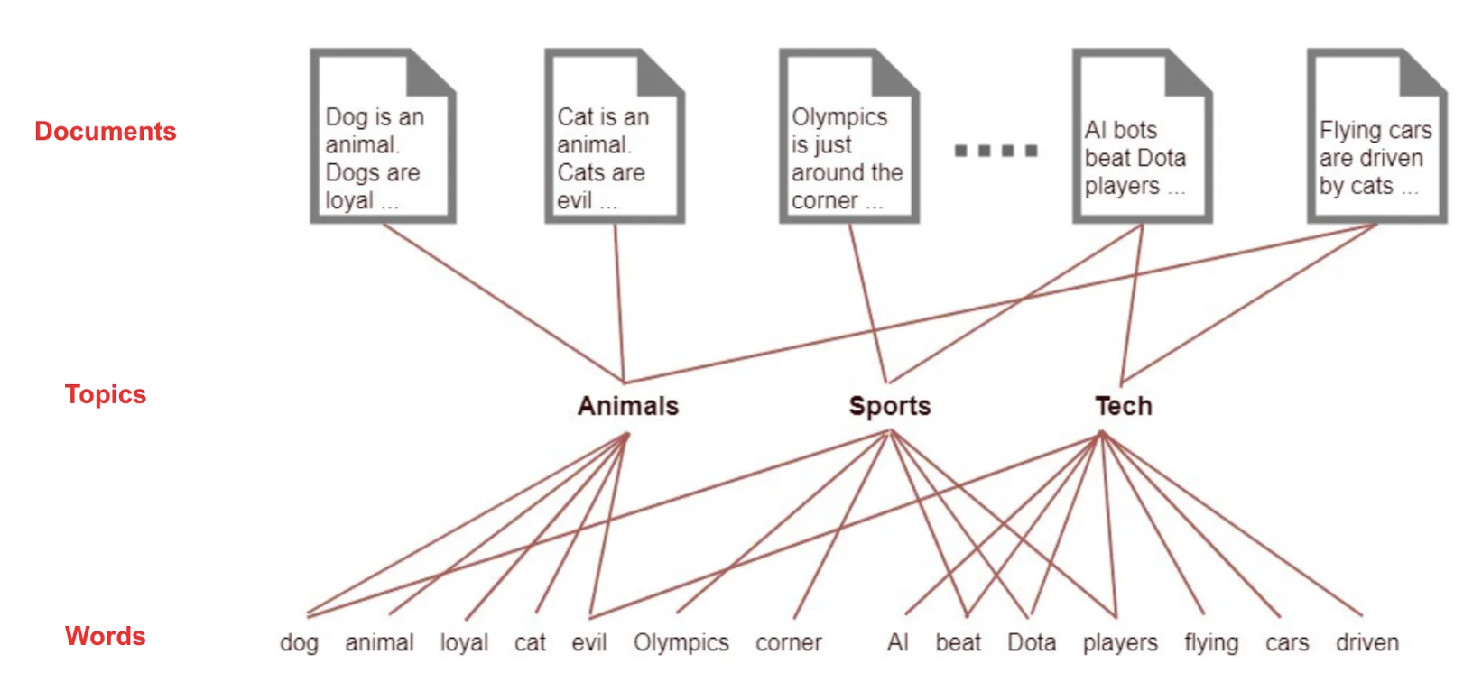
- Mathematical representation:
  - Walk through the notation carefully, explaining that P(topic|document) represents the document-topic distribution.
  - Explain that P(word|topic) represents the probability of seeing each word given a particular topic.
  - Use a simple numerical example to make this concrete.
- Plate notation diagram: Explain each node and plate in the diagram:
  - Outer plate represents M documents
  - Inner plate represents N words in each document
  - α controls document-topic distribution
  - β controls topic-word distribution
  - z represents topic assignments for each word
  - w represents observed words
- Uniqueness: Clarify that the power of LDA comes from this shared topic structure - all documents use the same set of topics, just in different proportions, which allows us to discover connections between documents.

Other Topic Modeling Approaches
- Latent Semantic Analysis (LSA):
  - Explain singular value decomposition (SVD) in intuitive terms as finding the most important dimensions of variation in the document-term matrix.
  - Show how truncating the SVD creates a low-rank approximation that captures the most important semantic patterns.
  - Use a visual example of dimensionality reduction from word space to topic space.
- Non-Negative Matrix Factorization (NMF):
  - Explain the intuition: decomposing the document-term matrix into two non-negative matrices (document-topic and topic-word).
  - Highlight why non-negativity is semantically meaningful for topic modeling (can’t have negative amounts of topics).
- Comparison table: For each method, cover:
  - Mathematical foundation (matrix factorization vs probabilistic modeling)
  - Interpretability of results
  - Computational requirements
  - Handling of new documents
  - Theoretical guarantees
  - When each might be preferred

LDA Deep Dive

LDA Intuition
- Two probability distributions:
  - Use concrete examples showing what these distributions look like in practice.
  - For θ (theta), show a bar chart of topic proportions for a specific document.
  - For φ (phi), show word clouds or probability tables for specific topics.
- Metaphor: Expand on the recipe book metaphor:
  - Topics are like recipes (instructions for combining ingredients)
  - Documents are like dishes made by mixing multiple recipes
  - Words are like ingredients that appear in various recipes
  - When we observe only the final dishes (documents), LDA helps us recover the original recipes (topics)
- Animation: When discussing the animation, walk through:
  - How topic proportions are first sampled for a document
  - How words are then generated by repeatedly sampling topics and then words from those topics
  - How this creates word co-occurrence patterns that LDA can detect

LDA Parameters
- K: Discuss the importance of choosing an appropriate number of topics:
  - Too few topics: Important distinctions get merged (e.g., “science” topic might merge physics, biology, chemistry)
  - Too many topics: Single coherent themes get fragmented (e.g., “physics” might split into multiple redundant topics)
  - Explain that this is a model selection problem, and there’s no single “correct” number
- α (alpha): Use visualizations to show:
  - Low alpha values (e.g., 0.1) create sparse document-topic distributions where documents focus on few topics
  - High alpha values (e.g., 50) create more uniform distributions where documents contain many topics
  - Explain when each setting might be appropriate (e.g., low alpha for specialized documents, high alpha for diverse documents)
- β (beta): Similarly, use visualizations to show:
  - Low beta values create topics focused on few distinctive words
  - High beta values create topics that spread probability across many words
  - Explain that most implementations use symmetric Dirichlet priors (same alpha for all topics, same beta for all words)

LDA Generative Process
- Choose θ ~ Dirichlet(α) for each document: Explain that this step determines the topic mixture for each document. Use a visual example of sampling from a Dirichlet distribution to get a topic proportion vector.
- Choose φ ~ Dirichlet(β) for each topic: Explain that this step determines the word distribution for each topic. Show visually how each topic gets its own probability distribution over the vocabulary.
- For each word position in each document:
  - Choose a topic z ~ Multinomial(θ): Explain this as picking a topic based on the document’s topic proportions (like spinning a weighted roulette wheel).
  - Choose a word w ~ Multinomial(φ_z): Explain this as picking a word from the selected topic’s word distribution (spinning another weighted roulette wheel).
- Visual representation: Walk through an animated example showing:
  - A document with 3 topics (70% science, 20% politics, 10% sports)
  - For each word position, show topic selection based on these proportions
  - Then show word selection from the chosen topic
  - Gradually build up the complete document
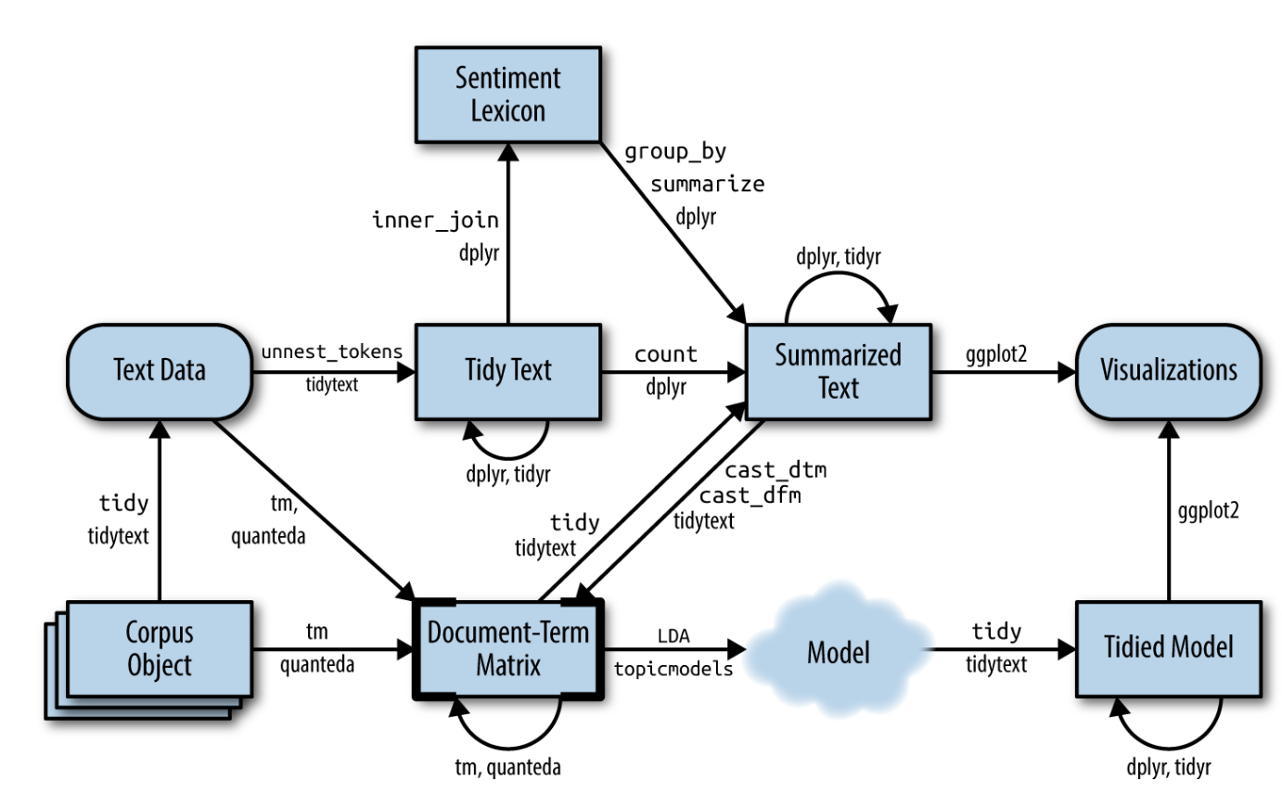

Inference Methods
- Problem: Emphasize that in practice, we observe documents (words) but not topics, so we need to work backward through the generative process (posterior inference).
- Collapsed Gibbs Sampling:
  - Explain the intuitive process: repeatedly going through each word in each document and reassigning its topic based on:
    - Which topics are common in this document (context influence)
    - Which topics commonly generate this word (semantic influence)
  - Show a simplified example of topic reassignment for a few iterations
  - Explain convergence as reaching a stable state where topic assignments rarely change
- Variational Inference:
  - Explain the core idea: approximating the complex posterior with a simpler distribution
  - Use the metaphor of finding the closest simple shape that approximates a complex shape
  - Mention that it optimizes parameters to minimize the difference between the approximation and true posterior
  - Highlight that it’s often used in large-scale applications like Google’s implementation
- Trade-offs: Discuss practical considerations:
  - Gibbs sampling: More accurate but slower, harder to scale, stochastic
  - Variational inference: Faster, deterministic, easier to scale, but potentially less accurate
  - When to choose each approach based on data size and accuracy requirements

Topic Distributions
- Topic-word distribution: Show example outputs from a real model:
  - Topic 1: economy (0.08), market (0.07), financial (0.06), growth (0.05), investment (0.04)…
  - Topic 2: disease (0.09), patient (0.08), treatment (0.07), clinical (0.06), medical (0.05)…
  - Explain how looking at top words helps interpret what each topic represents
- Document-topic distribution: Show examples for specific documents:
  - Document 1: Topic 3 (0.65), Topic 7 (0.20), Topic 12 (0.15)…
  - Document 2: Topic 5 (0.45), Topic 9 (0.30), Topic 2 (0.25)…
  - Explain how these distributions show the topical composition of each document
- Example: Use a concrete example, like a news article about “economic impacts of healthcare policy” and show:
  - Its topic distribution (e.g., 60% economics, 30% healthcare, 10% politics)
  - The top words for each of those topics
  - How this represents the mixed-topic nature of real documents
- Interpretation: Provide guidance on reading these distributions:
  - Focus on relative proportions rather than exact values
  - Look for dominant topics in documents
  - Interpret topics by examining multiple top words, not just one or two
  - Consider domain knowledge when assigning meaning to topics


Implementation Walkthrough

Preprocessing Pipeline
- Text cleaning: Demonstrate with examples:
  - Raw text: “The company’s Q3 earnings were $5.2M, up 15% year-over-year.”
  - After cleaning: “the companys q3 earnings were 5 2m up 15 year over year”
  - Explain rationale for each transformation (lowercasing, removing punctuation, etc.)
- Tokenization: Show different approaches:
  - Simple whitespace splitting: [“the”, “companys”, “q3”…]
  - More sophisticated tokenizers that handle contractions, hyphenations, etc.
  - Highlight language-specific challenges
- Stop word removal: Explain:
  - Definition of stop words (common words that don’t carry topical meaning)
  - Show examples: “the”, “is”, “and”, “of”, etc.
  - Demonstrate impact: reduces noise and focuses on content-bearing words
  - Caution about domain-specific stop words
- Stemming/Lemmatization: Compare approaches:
  - Stemming: “running”, “runs”, “runner” → “run” (rule-based, faster)
  - Lemmatization: “better” → “good” (dictionary-based, more accurate)
  - Show examples of both approaches on the same text
- N-gram consideration: Explain:
  - Unigrams miss multi-word concepts (“New York”, “machine learning”)
  - Show examples of bigrams/trigrams that preserve meaning
  - Discuss trade-offs (vocabulary explosion vs. semantic preservation)
- Code snippet: Walk through a complete preprocessing pipeline in Python, highlighting key functions and parameters

Parameter Tuning
- Number of topics (K):
  - Show examples of the same corpus modeled with different K values (e.g., 5, 20, 50)
  - Demonstrate how topics become more specific with higher K
  - Show coherence score plots for different K values
  - Discuss heuristics: sqrt(N/2) where N is number of documents
  - Explain the importance of domain expertise in this decision
- Alpha and Beta:
  - Show visualizations of different alpha values and resulting document-topic distributions
  - Similarly for beta and resulting topic-word distributions
  - Explain asymmetric priors (some topics might naturally be more common)
  - Show how to implement automatic optimization in Gensim
- Iterations/Passes:
  - Explain difference between passes (full data sweeps) and iterations (algorithm steps)
  - Show convergence plots (log-likelihood or perplexity vs. iterations)
  - Discuss diminishing returns and when to stop training
  - Provide rules of thumb for different corpus sizes

Common Challenges
- Overfitting: Explain:
  - Signs of overfitting (topics that memorize specific documents)
  - How to address it (regularization, fewer topics, more training data)
  - Show examples of overfitted vs. well-fitted topics
- Stability: Discuss:
  - Why different random initializations lead to different results
  - Techniques for improving stability (multiple runs with consensus topics)
  - How to compare topics across runs (topic alignment methods)
- Interpretability: Address:
  - The semantic gap between statistical patterns and human understanding
  - Why some topics appear as mixtures of unrelated concepts
  - Techniques for improving interpretability (anchoring, seeding)
- Evaluation: Cover:
  - The challenge of evaluating unsupervised models
  - Intrinsic measures (perplexity, coherence) vs. extrinsic measures (task performance)
  - Human evaluation approaches and best practices
- Solutions: Provide practical advice for each challenge:
  - Ensemble methods
  - Parameter sweeps with coherence metrics
  - Interactive refinement
  - Domain-specific customizations

Topic Interpretation & Visualization

Interpreting Topics
- Word lists: Explain:
  - Why we look at top N words (usually 10-20) per topic
  - The importance of examining probability values, not just rankings
  - Show examples of clear vs. ambiguous topics based on word lists
- Word clouds: Discuss:
  - How word size represents probability within a topic
  - Advantages for quick visual inspection
  - Limitations (may overemphasize visual differences)
  - Show examples of effective topic word clouds
- Topic labels: Cover:
  - Process for manually assigning meaningful labels
  - Inter-annotator agreement issues
  - Best practices (concise, descriptive, consistent)
  - Show examples of good and poor labeling
- Example: Walk through a complete example:
  - Words: “patient (0.08), hospital (0.07), doctor (0.06), treatment (0.05)…”
  - Interpretation process: identifying common theme of healthcare
  - Alternative interpretations and disambiguation
- Caution: Discuss interpretation pitfalls:
  - Cherry-picking words that fit preconceived notions
  - Ignoring contradictory evidence
  - Overinterpreting noise as signal
  - Need for validation with domain experts

LDAvis Visualization
- Interactive visualization tool: Explain the importance of interactive exploration for understanding complex models
- Components:
  - Left panel: Explain that each bubble represents a topic, size indicates corpus prevalence
  - Right panel: Explain term relevance calculation (combines probability and exclusivity)
  - Distance: Explain that it’s based on Jensen-Shannon divergence between topics
  - λ parameter: Explain how adjusting it changes the balance between probability and exclusivity
- Screenshot: Walk through each element in the visualization:
  - Global term frequency (blue bars)
  - Topic-specific term frequency (red bars)
  - How to identify distinctive vs. common terms
  - What topic similarity and distance mean
- Demonstration: Show how to use the visualization to:
  - Identify redundant topics (closely positioned)
  - Find unique, distinctive topics
  - Adjust λ to see different perspectives on topics
  - Interpret term relevance within topical context
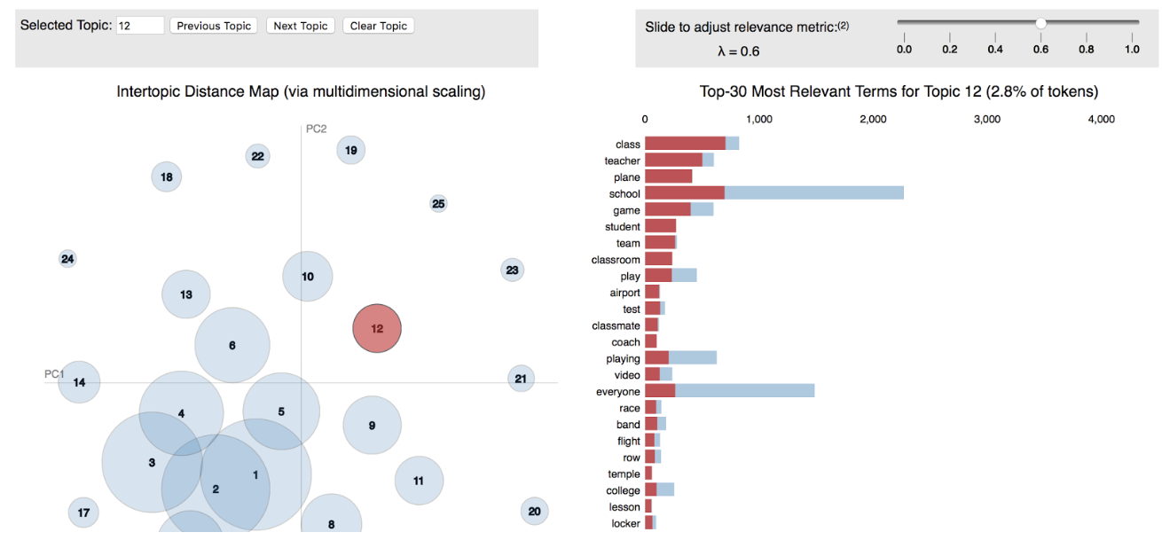

Coherence Measures
- Definition: Explain that coherence measures try to quantify the semantic consistency of words within a topic
- Types of coherence:
  - UMass coherence: Explain how it uses document co-occurrence and log conditional probability
  - CV coherence: Explain how it combines multiple approaches for more human-aligned scores
  - UCI coherence: Explain how it uses external data and pointwise mutual information
  - Compare with human judgments of coherence
- Code example: Walk through Gensim implementation:
  - How to calculate different coherence measures
  - Interpreting the output values
  - Using coherence for model selection
- Interpretation: Provide guidelines:
  - Typical score ranges for different measures
  - Relative vs. absolute interpretation
  - When to trust/distrust coherence scores
  - Complementary evaluation approaches

Interpreting Results
- Example topics from real dataset: Show a complete case study:
  - 5-6 topics from a realistic dataset (e.g., news articles)
  - Top 10 words for each topic
  - Assigned labels and justification
- Visualization of document-topic mixtures: Demonstrate:
  - Heatmap of document-topic proportions
  - Clustering documents by dominant topic
  - Identifying boundary cases (mixed-topic documents)
- Practical interpretation tips:
  - Explain how context matters (same word has different meaning in different topics)
  - Show how to use original documents to validate topic interpretations
  - Demonstrate techniques for handling polysemy and synonymy
  - Explain the importance of examining multiple related topics together
- Identify outliers or noise topics: Discuss:
  - Characteristics of “junk” topics (uniform word distributions, highly mixed topics)
  - How to handle them (filtering, retraining, parameter adjustment)
  - When they might indicate interesting edge cases

Advanced Topics & Variations

Dynamic Topic Models
- Purpose: Expand on how static topic models fail to capture evolution:
  - Terms change meaning over time (“cloud” pre/post-computing)
  - Topics emerge, evolve, merge, and disappear
  - Proportions shift with events and trends
- Key differences from standard LDA:
  - Explain the state-space model approach (topics evolve following sequential dependencies)
  - Describe how word distributions evolve over time slices
  - Explain how documents are grouped into time slices
- Applications: Provide concrete examples:
  - Tracking “artificial intelligence” as a research topic from 1980-2025
  - Analyzing how political discourse evolves during election cycles
  - Monitoring brand perception changes after major events
- Visual example: Walk through an example timeline showing:
  - Topic emergence (e.g., “social media” appearing in 2005-2008)
  - Term probability shifts within topics over time
  - Changes in topic prevalence through time periods

Hierarchical Topic Models
- Structure: Explain the conceptual model:
  - Super-topics contain sub-topics in a tree structure
  - Documents can be described at multiple levels of granularity
  - Example: “Science” → “Biology” → “Genetics” → “CRISPR”
- Methods:
  - Hierarchical Dirichlet Process (HDP): Explain non-parametric approach that automatically determines number of topics at each level
  - Pachinko Allocation Model (PAM): Explain directed acyclic graph structure allowing more complex topic relationships
  - Compare advantages/disadvantages of each approach
- Advantage: Elaborate on benefits:
  - More natural representation of concept hierarchies
  - Multi-resolution analysis of document collections
  - Better handling of large, diverse corpora
  - Improved navigation of document collections
- Visual example: Show hierarchy visualization:
  - Topic tree with word distributions at each node
  - How documents propagate through the hierarchy
  - Example of zoom-in/zoom-out navigation

Neural Topic Models
- Neural Network Approaches:
  - Variational Auto-Encoders (VAE): Explain the encoder-decoder architecture and how it relates to topic modeling
  - Neural Variational Document Model (NVDM): Explain how it learns document representations in continuous space
  - ProdLDA: Explain how it combines neural networks with LDA’s probabilistic structure
  - Discuss the relationship to word embeddings
- Advantages: Elaborate on:
  - Ability to capture semantic relationships beyond co-occurrence
  - Integration with pre-trained language models
  - Handling of larger vocabularies
  - Potentially more coherent topics
- Challenges: Discuss:
  - Increased complexity and computational requirements
  - Difficulty interpreting latent dimensions
  - Need for larger training data
  - Hyperparameter sensitivity
- Current research directions: Mention:
  - Transformer-based topic models
  - Multimodal topic modeling (text + images)
  - Zero-shot topic modeling
  - Self-supervised approaches

Supervised Topic Models
- Incorporating labels/metadata:
  - Supervised LDA (sLDA): Explain how it jointly models documents and response variables
  - Labeled LDA: Explain how it constrains topics to align with document labels
  - Compare discriminative vs. generative approaches
- Applications: Provide concrete examples:
  - Document classification: Using topic proportions as features
  - Author-topic models: Discovering author-specific themes and interests
  - Sentiment-topic models: Learning sentiment-specific word distributions for topics
  - Geographical topic models: Discovering region-specific topics
- When to use: Discuss scenarios:
  - When prediction is the primary goal
  - When metadata provides strong priors for topic structure
  - For personalization applications
  - When interpretability needs to align with existing categories

Applications & Case Studies

Content Recommendation
- Application: Expand on recommendation approaches:
  - Content-based filtering using topic proportions
  - Using topic modeling to address cold-start problems
  - Hybrid systems combining collaborative and topic-based approaches
  - Explainable recommendations through topic interpretations
- Process flow: Walk through the complete pipeline:
  - Training the topic model on content corpus (articles, products, etc.)
  - Inferring topic distributions for user history
  - Creating user profiles as aggregated topic vectors
  - Computing similarity between user profiles and candidate content
  - Ranking and presenting recommendations
- Real-world examples: Discuss implemented systems:
  - News aggregators like Google News using topics for personalization
  - Academic paper recommenders like Semantic Scholar
  - Content streaming services categorizing content
  - E-commerce product recommendation
- Advantages: Highlight key benefits:
  - Ability to explain “why” items are recommended
  - Discovery of cross-category connections
  - Privacy advantages (local processing of user preferences)
  - Addressing popularity bias in collaborative filtering

Document Organization & Search
- Applications: Elaborate on use cases:
  - Automatic tagging: How topics can become document metadata
  - Topic-based search: Enhancing keyword search with semantic topics
  - Document summarization: Using topic proportions to identify key content
  - Faceted browsing: Using topics as navigation dimensions
- Case study: Walk through digital library implementation:
  - Initial corpus preparation and modeling
  - Integration with existing metadata
  - User interface for topic-based exploration
  - Evaluation of user experience improvements
  - Metrics showing increased engagement
- Visualization: Explain document map visualization:
  - 2D projection of documents based on topic similarity
  - Clustering and color-coding by dominant topic
  - Interactive exploration capabilities
  - How it reveals thematic structure
- Benefits: Discuss concrete improvements:
  - Quantitative metrics of improved document discovery
  - Reduced search time for information retrieval
  - Better handling of synonymy and polysemy
  - Support for exploratory search behaviors

Trend Analysis
- Application: Expand on trend detection:
  - Early identification of emerging topics
  - Tracking topic proportion changes over time
  - Connecting topic shifts to external events
  - Predictive models based on topic trajectories
- Process: Detail the methodology:
  - Creating appropriate time slices (daily, weekly, monthly)
  - Training separate models or dynamic topic models
  - Aligning topics across time periods
  - Measuring changes in topic prevalence and content
  - Statistical testing for significant shifts
  - Visualizing and reporting findings
- Case study: Present COVID-19 discourse analysis:
  - Data collection from news and social media
  - Topic evolution from medical to economic to political focus
  - Correlation with pandemic timeline events
  - Regional variations in topic emphasis
  - Policy implications of the analysis
- Visual example: Walk through visualization:
  - Line graph showing topic proportion changes
  - Annotation of key events affecting discourse
  - Topic content evolution display
  - Predictive projections of future trends

Academic Literature Mapping
- Application: Elaborate on research landscape analysis:
  - Understanding interdisciplinary connections
  - Tracking evolution of research fields
  - Identifying emergent research themes
  - Supporting literature review processes
  - Discovering potential collaborations
- Process: Explain methodology:
  - Corpus creation from abstracts, full-texts, or citations
  - Specialized preprocessing for academic text
  - Topic modeling with field-specific adjustments
  - Connecting topics to citation networks
  - Temporal analysis of research evolution
- Case study: Present computer science literature map:
  - Data from major conferences and journals
  - Identified major research areas
  - Discovered bridges between traditionally separate fields
  - Predicted emerging research frontiers
  - Usage by researchers and funding agencies
- Visual example: Explain network visualization:
  - Topics as nodes sized by publication volume
  - Edges representing topical overlap
  - Clusters indicating research communities
  - Temporal color-coding showing evolution
  - Interactive elements for exploration

Conclusion & Resources

Key Takeaways
- Core concepts: Reinforce fundamental principles:
  - The mixed-membership nature of documents across topics
  - The probabilistic foundations of topic modeling
  - The unsupervised nature of discovery
  - The balance between statistical and human interpretability
- LDA fundamentals: Summarize essential components:
  - The generative story and its relationship to the model
  - Critical parameters and their effects
  - Inference challenges and approaches
  - Limitations and assumptions
- Practical considerations: Highlight implementation advice:
  - Importance of preprocessing decisions
  - Parameter selection strategies
  - Evaluation approaches
  - Common pitfalls and solutions
- Applications: Remind students of the breadth of applications:
  - From social media analysis to scientific discovery
  - From content organization to trend prediction
  - Emphasize interdisciplinary nature

Further Learning Resources
- Books: Provide context for each recommendation:
  - “Probabilistic Topic Models” by David Blei: Foundational mathematical treatment
  - “Mining the Social Web” by Matthew Russell: Practical implementation focus
  - Mention specific chapters most relevant to topic modeling
- Libraries: Compare available implementations:
  - Gensim: Python library specialized for topic modeling
  - scikit-learn: General ML library with LDA/NMF implementations
  - BERTopic: Modern neural approach combining BERT with clustering
  - Top2Vec: Embedding-based topic discovery
  - Discuss strengths and use cases for each

Questions?
- Prepare for common questions:
  - “How many topics should I choose for my project?”
  - “How can I evaluate if my topics are good?”
  - “Can topic modeling handle short texts like tweets?”
  - “How does topic modeling compare to clustering?”
- Include contact information for further discussion
- Suggest project ideas for students to apply topic modeling
- Preview related concepts that might be covered in future sessions

Reference

