[Lecture Note] The Purpose of Research
  - GE2021 Research Technology, Fall 2026
Chad (Chungil Chae)
Tue, 15 September 2026

Learning Objectives
- Describe the purpose of scientific research
- Describe two theories of knowledge: falsifiability and the scientific revolution
- Compare and contrast qualitative, quantitative, and mixed methods
- Explain the importance of ethics and objectivity in research Pajo (2022)

What is reserach?
https://www.youtube.com/embed/mV0bUQpz468?si=VaKxq2yZmsG4kiFH

I. Scientific Research and Its Purpose
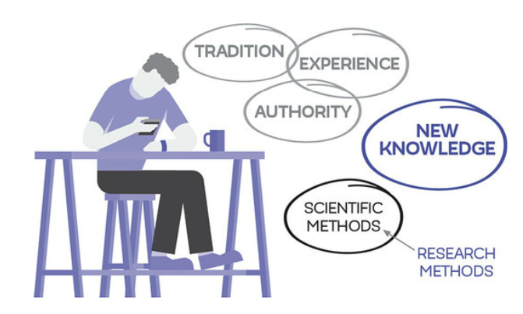

Not a Scientific Knowledge
- Traditional Knowledge: a form of knowledge inherited from the culture one grew up in
- Authority: a form of knowledge believed to be true because its source is authoritative, such as parents or teachers.
- Experiential knowledge: a form of knowledge gained through experiences

Scientific Knowledge
- Scientific knowledge: a form of knowledge based on studies conducted by researchers; knowledge that can be trusted.
- New scientific knowledge is produced by systematic research
- Reality and knowledge are two different things
- Research is generated by following sets of rules, embodying skills, and following a framework to analyze results.

II. Theories of Knowledge
Karl Popper’s Falsifiability

https://plato.stanford.edu/entries/popper/
Thomas Kuhn’s Structure of Scientific Revolution

https://plato.stanford.edu/entries/thomas-kuhn/

Karl Popper’s Falsifiability
- Systematic attempts to prove things wrong advance scientific knowledge
- Empirical evidence: acquiring data or information by systematically observing people or events, i.e. practical experience.
- Falsified: proven an established theory wrong.

- PS1 is a problem situation or issue
- To explain this problem, there are a number of tentative theories, or TT1.
- If we try to falsify these tentative theories by error of elimination,
- EE1, we find that most of our tentative theories are incorrect and there is a new explanation for the first problem we started on.
- Through this natural selection process, we build new knowledge and end up with a new problem situation, PS2.

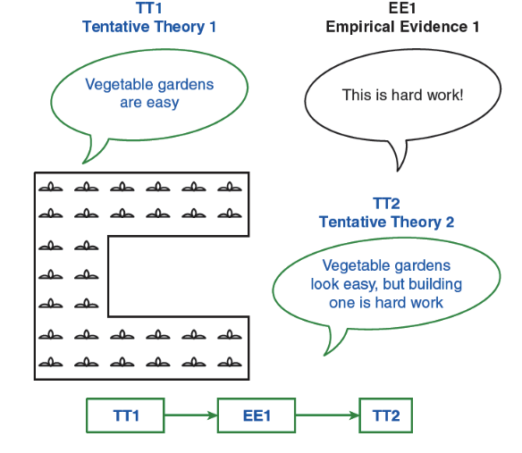
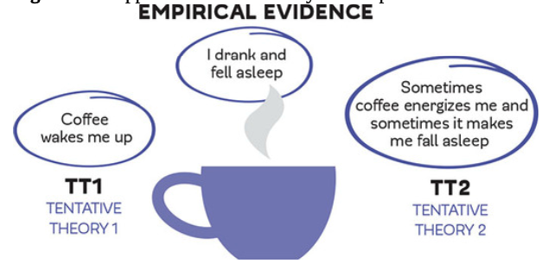
PS1 -> TT1 -> EE1 -> PS2

Thomas Kuhn’s Structure of Scientific Revolution
- Normal science: general rules, laws and paradigms accepted as truths; does not aim to explore new ideas or build on scientific knowledge, experiment, or risk.
- Paradigm: an unchangeable pattern used over and over again; widely accepted by the scientific community.
- Anomalies: things that do not fit into the paradigms of normal science; happens once or twice and does not fit into commonly accepted patterns.
- Crisis: the accumulation of many anomalies against an accepted truth of normal science; encountered when normal science does not fit with reality anymore.
- Revolution: after a crisis, the revolution replaces the old paradigm with a new paradigm.
- Paradigm shift: when the widely accepted paradigm encounters many anomalies, leading to crisis, then revolution, and settles into a new paradigm, which becomes accepted and the new normal science.

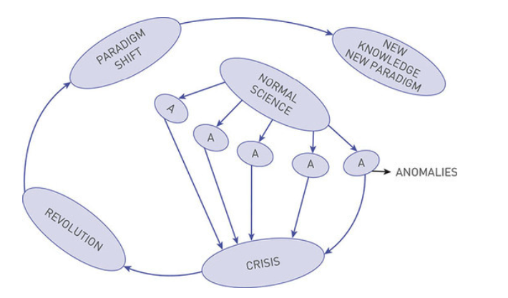

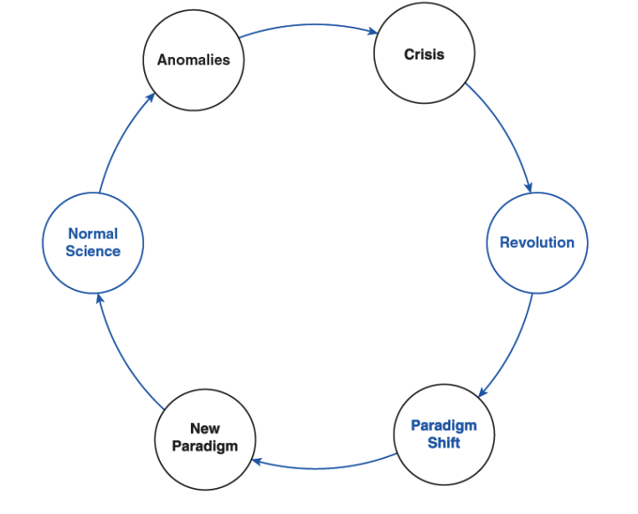

III. A Quick Look at Qualitative, Quantitative, and Mixed Methods

Qualitative Research
- Qualitative research aims at gaining insight and depth; not just simple facts, but insights, emotions, perspectives, and so on about the topic of research
 Inductive reasoning
Inductive reasoning: begins with specific observations and moves to a broader understanding of a topic or problem; often leads to creating new theories of science; allows researchers to become immersed in their study without preconceived notions or assumptions.

Quantitative Research
- Quantitative Research requires a good grasp of the topic of study and research conducted in that topic before data collection; the design of study is essential and their work is based on the systematic calculation of data
Deductive reasoning
Deductive reasoning begins with a broad theory that can lead to a specific idea or concept that is ready to be tested; data collection is straightforward with no digressions.

Mixed Methods
- Mixed methods is a research design combine the best features of qualitative and quantitative methodologies.
- Mixed-method design is useful in studies when traditional qualitative or quantitative methods will leave the study with significant limitations.
- There are four most widely used types of mixed-methods:
  - Convergent design is used when the qualitative and quantitative data are collected simultaneously; the data is analyzed separately and only brought together when compiling results.
  - Explanatory sequential design
    - Quantitative lead design is a two-phase process that starts with quantitative data collection, followed by qualitative collection of cases important to the study.
    - Qualitative lead design is a two-phase data collection that starts with qualitative and then is followed by quantitative methods.
  - Embedded design is when one qualitative or quantitative study is ongoing and collects different types of data before, during, or after the study.

IV. Ethical Research

Ethics and Research Ethics
- Ethics: the group of morals and values that govern behaviors and decisions
- Research ethics: research ethics use rules and regulations concerned with protecting the rights of people who participate in research studies.

Ethical Rules
- Informed consent provides participants with information about the study, particularly about any risks involved.
- Confidentiality is the promise not to disclose identifiable information about the participant to any third party.
- It is unethical to coerce people into taking part in a study
- Conflict of interest is also a concern; it refers to the possibility that the study may be part of an outside agenda.

A Violation of Ethics
The Tuskegee syphilis study is an infamous case of ethics violation in research.
- It started with…
  - Between 1932 and 1972, the United States Public Health Service and the Tuskegee Institute conducted a study on the effects of syphilis on the human body.

- What happened?
  - The researchers recruited 600 African American men to participate, but did not disclose the focus of their study to their participants, who were simply told they were being treated for “bad blood.”
  - Many believed they were receiving free health services from the government.
  - Two-thirds of the participating men had syphilis, and despite the fact that penicillin was validated as an effective treatment in 1942, not one of the men in the Tuskegee study received treatment.
  - This continued for an additional 30 years, and was finally revealed through a leak to the newspapers in the early 1970s.

- What impact?
  - Only 74 participants survived. Around 40 of their wives were also infected and 19 children were born with syphilis (U.S. Public Health Service Syphilis Study at Tuskegee, 2013).
  - The tragedy of the Tuskegee study is measured not only in numbers directly affected, but in the lasting resentment it caused within the African American community.

Researchers’ Biases
- Objectivity: perceiving something from different angles without personal preferences or judgements.
- Subjective thinking: based on personal emotions, experiences, and prejudices.
- Selective observation: a common type of bias, when one is focused on a specific occurrence or group of people instead of including an entire sample of the observation; that is, focuses on what interests the researcher and failing to notice things that may contradict their theory.
- Overconfidence bias: when a researcher feels overconfident in their own abilities and does not consider additional details or aspect that could need more attention.
- Overgeneralization: using a small number of cases to draw conclusions about the entire population.

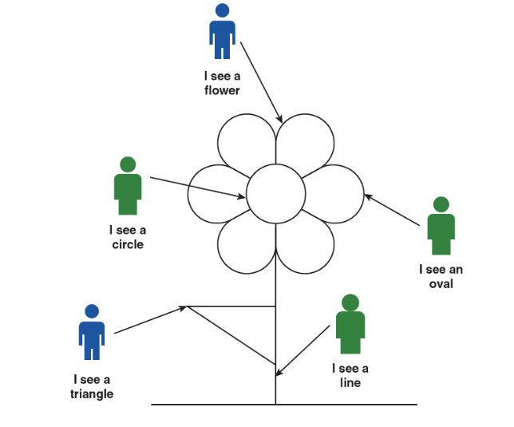



Summary and Terms
- Scientific research seeks to produce reliable knowledge through systematic investigation, distinguishing it from traditional, authoritative, or experiential forms of knowledge. Unlike these forms, scientific knowledge is trusted because it is created using structured methods, clear rules, and rigorous analysis. Researchers aim to uncover objective truths, acknowledging that knowledge evolves over time as new insights emerge.
- Two key theories guide the advancement of scientific knowledge. Karl Popper’s principle of falsifiability argues that progress occurs when theories are systematically tested and proven wrong, relying on empirical evidence to refine or replace existing ideas. Meanwhile, Thomas Kuhn’s concept of scientific revolutions explains that science operates within established paradigms until anomalies accumulate, leading to a crisis and a paradigm shift. Over time, the new paradigm becomes the foundation for normal science, illustrating the dynamic nature of scientific progress.
- Research methods involve three primary approaches: qualitative, quantitative, and mixed methods. Qualitative research emphasizes depth, seeking to explore emotions and perspectives using inductive reasoning. Quantitative research is more structured, employing deductive reasoning to test specific hypotheses using measurable data. Mixed methods combine the strengths of both, offering flexibility through designs like convergent or sequential approaches to address complex research questions.
- Ethics play a crucial role in research. Researchers must prioritize participant rights through informed consent, confidentiality, and avoidance of coercion or conflicts of interest. Historical cases like the Tuskegee syphilis study highlight the consequences of ethical violations. To maintain objectivity, researchers should avoid biases such as selective observation, overconfidence, and overgeneralization, striving for an unbiased pursuit of knowledge.
- Ultimately, scientific research thrives on ethics, objectivity, and the willingness to challenge established ideas. By adhering to these principles, researchers contribute to a constantly evolving body of knowledge that advances understanding and benefits society.

Terms
- Anomaly: something that does not fit into the paradigms of normal science.
- Authority: a form of knowledge we believe to be true because it comes from authoritative sources, such as parents, teachers, and professional figures.
- Crisis: an accumulation of many anomalies against an accepted truth.
- Deductive reasoning: reasoning that begins with a broad theory that leads to a specific idea or concept to be tested.
- Empirical evidence: acquiring information by systematically observing people or events.
- Ethics: a set of guidelines that are primarily concerned with protecting the rights of study participants and are mandatory for the researcher.
- Experiential knowledge: a form of knowledge that we learn through pleasant or unpleasant experiences.
- Falsify: prove that a theory is incorrect.
- Inductive reasoning: reasoning that begins with specific observations and moves to a broader understanding of a topic or problem.

- Mixed methods: research studies that combine the best features of qualitative and quantitative methodologies.
- Normal science: the work of scientists using the general rules, laws, and paradigms that are accepted as truths. It does not explore new ideas or build on scientific knowledge.
- Objectivity: perceiving something from different angles without personal preferences or judgments.
- Overgeneralization: a type of bias that occurs when a researcher uses a small number of cases to draw conclusions about an entire population.
- Paradigm: an unchangeable pattern that is used over and over again.
- Paradigm shift: occurs when a widely accepted paradigm encounters many anomalies that lead to a crisis, then a revolution, and then a new paradigm.
- Qualitative research: research that seeks to gain insight and depth on a topic.
- Quantitative research: research based on the systematic calculation of data.
- Revolution: when an old paradigm is replaced with a new paradigm.
- Scientific knowledge: a form of knowledge based on studies conducted by researchers.
- Selective observation: a type of bias that occurs when a researcher is focused on a specific occurrence or group of people instead of including an entire sample.
- Subjective thinking: thinking based on personal emotions, experiences, and prejudices.
- Traditional knowledge: a form of knowledge we inherit from our culture that includes information that we learned as children that is now part of who we are and how we behave.

Discussion
- What is the difference between reality and knowledge?
- What is research methodology and what do we need it for?
- Can you think of examples that can illustrate Popper’s falsifiability?
- How does inductive reasoning differ from deductive reasoning?
- What are some examples that can illustrate Kuhn’s paradigm shift?
- How does traditional knowledge differ from subjective thinking?

Class Activity
- A university researcher is interested in conducting research to assess the effectiveness of an obesity prevention intervention in an urban community. The intervention targets men of color. Once enrolled, researchers ask each participant to participate in a 12-week educational and behavioral intervention with both an individual and a group component. Researchers also request participants to provide clinical data (e.g., cholesterol finger prick) and behavioral data (e.g., fruit and vegetable consumption). In a small group of two to three students, brainstorm the following:

    - What are some potential ethical concerns study participants may raise when considering participating in this study?

    - As a researcher, what concrete steps can you take to ensure men that you will protect their rights as human subjects in this research study?
- You are a researcher at a community-based research institute. You are interested in learning more about alcohol abuse among adolescents in your community, through a mixed-methods study. You intend to both distribute a survey to adolescents in all the local schools and conduct focus groups with a subsample of adolescents. In a small group, develop three quantitative questions to include on the survey and develop three qualitative questions you will use during the focus group. Discuss the benefits and limitations to learning more about alcohol abuse using each strategy (qualitative vs. quantitative).
- In a small group, think back to the events of the past 24 hr. Think specifically about decisions you made during this time period related to (a) what you chose to eat, (b) how many hours you slept, and (c) how you dressed. Discuss what prompted you to make these decisions, namely to what extent (a) traditional knowledge, (b) knowledge from authority, and (c) experiential knowledge influenced your decision-making.

Futher Issue

More to Read
- Chalmers, A. F. (1999). What Is This Thing Called Science? (3rd Edition)
  - This book provides a foundational understanding of science and scientific inquiry. It delves into the nature of scientific knowledge, exploring ideas like falsifiability, paradigms, and how science progresses.
- Popper, K. (2002). The Logic of Scientific Discovery
  - Karl Popper’s seminal work focuses on the philosophy of science, particularly his principle of falsifiability. It offers insights into how scientific theories are tested and improved through empirical evidence.
- Kuhn, T. S. (2012). The Structure of Scientific Revolutions
  - One of the most influential texts on how science evolves, Kuhn discusses the concepts of paradigms, crises, and revolutionary shifts in scientific thought.
- Creswell, J. W., & Creswell, J. D. (2017). Research Design: Qualitative, Quantitative, and Mixed Methods Approaches
  - This book is an excellent guide for understanding the different research methodologies and how to design and conduct studies following scientific principles.
- Ziman, J. (2000). Real Science: What It Is, and What It Means
  - This book examines how modern science operates, including its methodologies, ethics, and societal implications. It provides a philosophical and practical analysis of scientific research.

Chapter Infographic
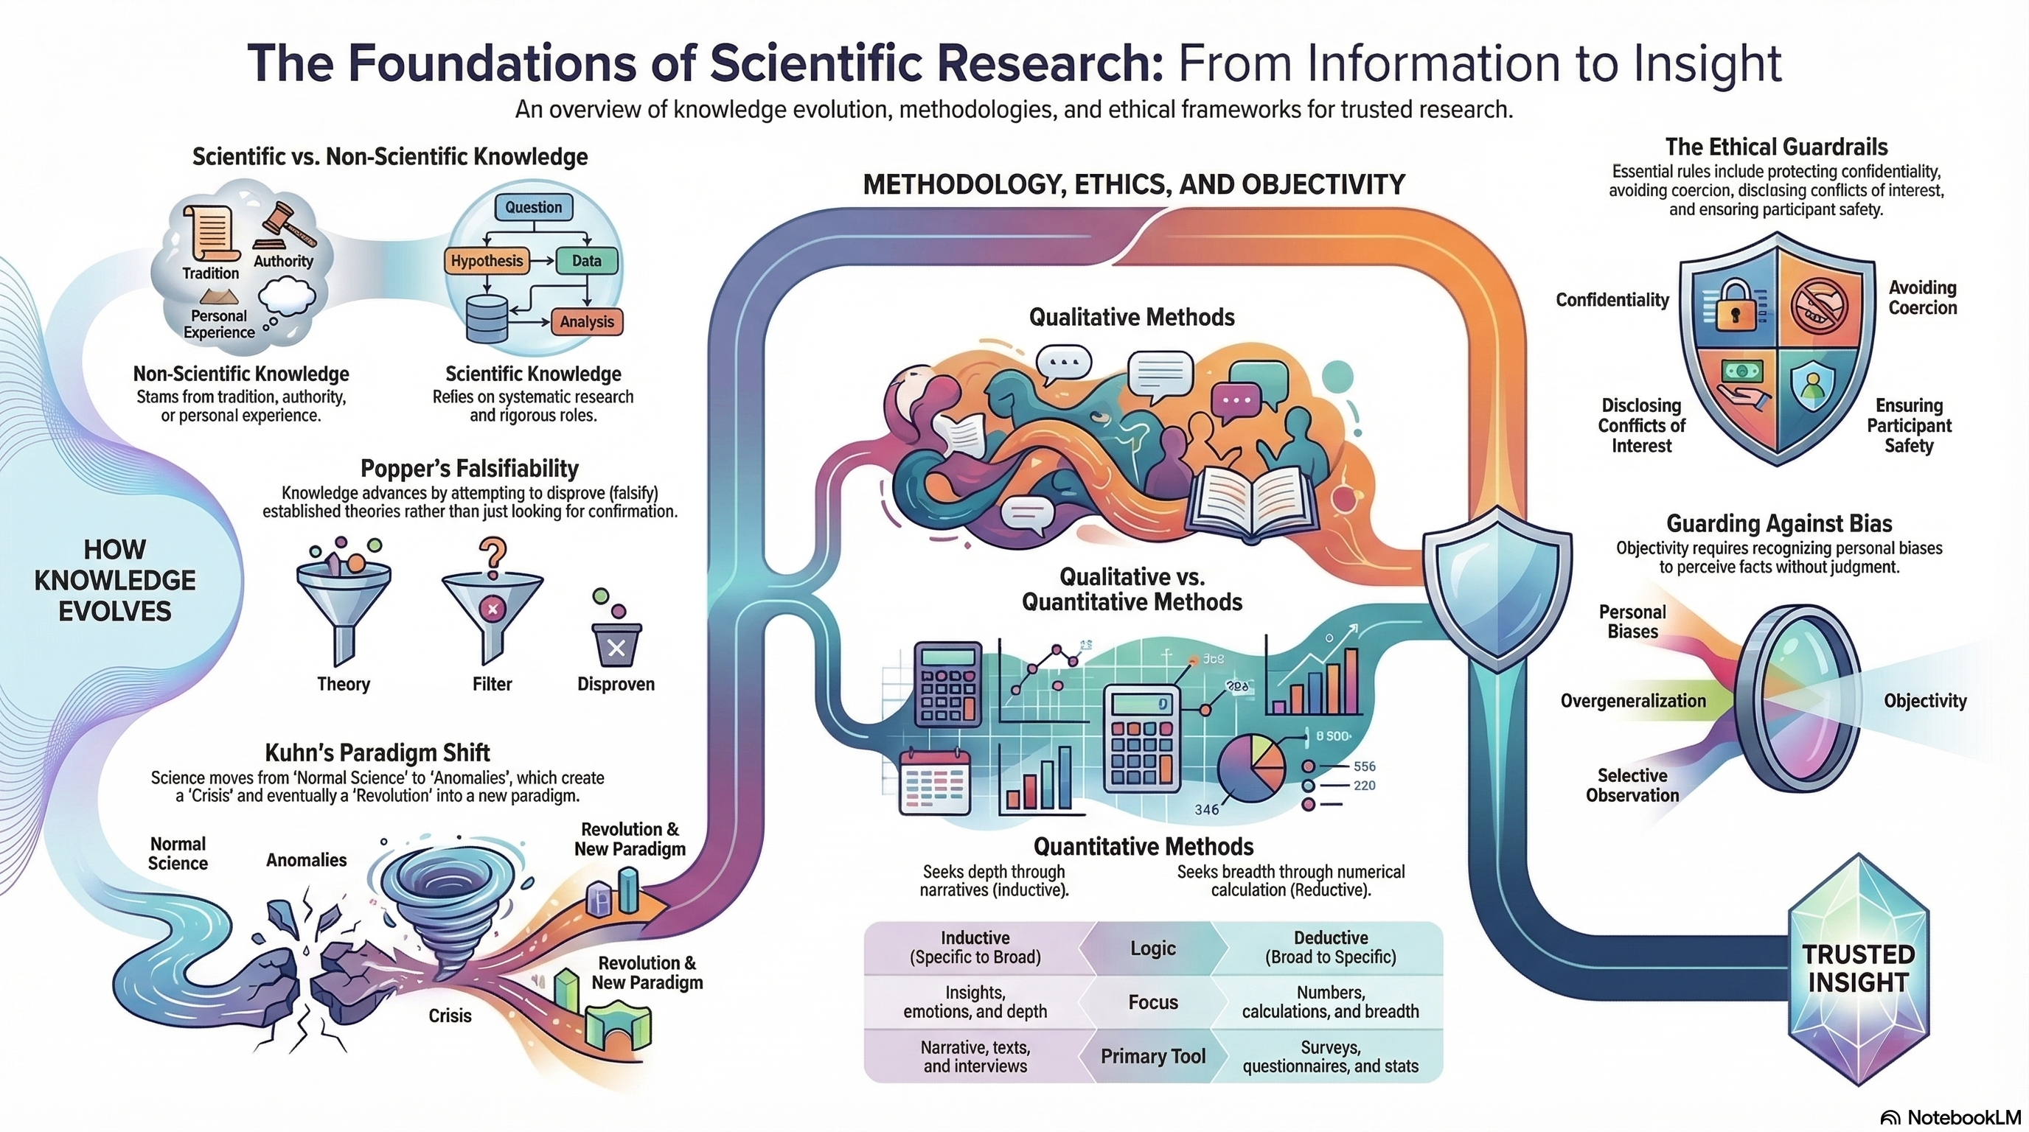
NotebookLM 생성 요약 인포그래픽. 해설 영상·팟캐스트는 resource/ 참조.

Quiz
출처: 02_Assets/assessment/GE2021_TestBank.xlsx (chapter=1) · 5문항

Q1. Scientific knowledge is considered the most trustworthy form of knowledge because it follows strict rules of discovery.
- A. TRUE
- B. FALSE
정답 보기
정답: A
Scientific knowledge follows strict scientific rules of discovery, making it the most trusted form of knowledge.

Q2. Which type of knowledge do we inherit from our culture, including rules and behaviors we learned as children?
- A. Traditional knowledge
- B. Experiential knowledge
- C. Scientific knowledge
- D. Authoritative knowledge
정답 보기
정답: A
Traditional knowledge comes from cultural inheritance, rules, and behaviors learned as children.

Q3. According to Popper’s falsifiability principle, how is a stronger theory created?
- A. By building empirical evidence that contradicts an established theory
- B. By proving the current theory is correct
- C. By collecting more data supporting the theory
- D. By conducting qualitative interviews
정답 보기
정답: A
Popper believed we advance knowledge by falsifying existing theories, leading to stronger replacements.

Q4. What did Thomas Kuhn call the accumulation of many anomalies against an accepted truth?
- A. A paradigm
- B. A revolution
- C. A crisis
- D. Normal science
정답 보기
정답: C
According to Kuhn, many anomalies lead to a crisis, then a revolution and paradigm shift.

Q5. A film studio sponsors a study on the likability of its own movie. This situation is best described as:
- A. Coercion
- B. Selective observation
- C. Informed consent
- D. Conflict of interest
정답 보기
정답: D
When a sponsor has a vested interest in specific results, it is a conflict of interest.

Reference
Pajo, B. (2022). Introduction to research methods: A hands-on approach. Sage.

