[Lecture Note] Analyzing Quantitative Data
  - GE2021 Research Technology, Fall 2026
Chad (Chungil Chae)
Tue, 15 September 2026

Learning Objectives
- 10-1 Summarize why statistics are used in research methods
- 10-2 Conduct univariate analysis
- 10-3 Explain the measures of central tendency
- 10-4 Define measures of variability and dispersion
- 10-5 Describe the various ways to graphically represent data
- 10-6 Conduct bivariate analysis

SHORT VIDEO INTRODUCTION
https://www.youtube.com/watch?v=nHpf5V1SpNc

https://www.youtube.com/watch?v=EUeQRE5UJpg

Analyzing Quantitative Data

- Statistics: a branch of mathematics that uses mathematical logic to interpret phenomena and draw conclusions from the accumulated data.
- It establishes relationships between and among variables and can even attempt to predict future behaviors or relationships.

Univariate Analysis

- Univariate analysis: the analysis of only one variable.
- Descriptive analysis: allows researchers to sketch the details of variables and gain familiarity with the sample; gives an idea of the descriptive characteristics of variables.
  - Descriptive statistics describe the first impressions of a variable.
- Inferential analysis/statistics: provide a deeper understanding of the variables because it draws conclusions about the population from the sample at hand.
  - This type of analysis goes beyond the description of the data available and attempts to draw relationships or associations between variables.
  - Once a relationship is detected between variables, inferential statistics attempts to predict the possibility of applying the same relationship to the entire population of the study.

- Inferential statistics operate by trying to calculate the random error that occurs during collection and analysis.
- Random error: associated with the type of common mistakes or errors that happen by chance when data are collected or entered into a spreadsheet or during analysis.
- Sampling error: a random error that occurs during the process of data collection.
  - Inferential statistics only investigates the sampling error that can happen randomly; it is unable to identify a systematic sampling error.
Univariate analysis is the first step researchers take to familiarize themselves with the population sample.

- Frequency Distributions
  - Constructing a frequency distribution with data is a simple procedure that can illustrate key characteristics of participants in the sample.
  - The first indicator is absolute frequency, which reflects the number of times an event or instance has been repeated.
  - Assigning percentages to each category adds another layer of valuable information.
    - Percentages are capable of zooming out from the raw numbers because it compares the raw numbers to the entire sampling population.
  - Cumulative percent: another descriptive measure of frequency; shows the collective percentage of categories together.
    - It is sensitive to the order of organization.

Measure of Central Tendency

Measures of central tendency: summarize an entire variable or category in a single value that is numerically representative of it.
- Mean: the mathematical average of a set of numbers; all numbers in a variable category are added together and then divided by n, which is the total number of entries in that data set.
  - The mean is useful for comparing two or more groups.
  - The mean takes into account every single point in the variable, and it is very sensitive to outliers.
  - Outlier: a data point that is much higher or lower than the majority of other points.
- Median: represents the center point in a set of numbers that have been arranged in ascending or descending order.
  - The median is useful in statistics because it gives an understanding about the distribution of a variable.
- Mode: the most frequently used number in a data set; which number is most commonly encountered in a specific set of numbers.
  - The mode can provide additional information that can potentially clarify any misleading information from the mean or median.
  - One variable can have more than one mode.
    - Unimodal: only one mode
    - Bimodal: two modes
    - Multimodal: three or more modes

Measures of Variability and Dispersion

- Measures of central tendency tell about the middle scores in a distribution, but they tell very little about how they are spread out.
- Measures of variability and dispersion are the ones that give information about how far apart or close by the values are in a distribution.
- Variability expresses the degree to which data in a data set spreads out, or deviates, from the center.

- Homogenous: sets that have little variability
- Heterogenous: sets with a lot of variability
  - Pose a higher level of complexity in approaching analysis.
- Range: the difference between the largest and smallest numbers in the set.
  - Interquartile range (IQR) is another measure of the middle 50% of the scores in a variable
- Variance: represents each datapoint’s average deviation from the mean; the average sum of the squared distance of every single point in the data set from the mean.
- Standard deviation: the square root of the variance; also represents each data point’s average deviation from the mean.

Normal Distribution
- The normal distribution is a theoretical perfect distribution where the mean, mode, and median are equal to one another.
  - It is symmetrical; the mean divides the distribution into equal halves.
  - It is used to compare against the actual distribution.
- Standard scores: also called z scores; indicate the number of standard deviations in a distribution and what proportion of the scores fall within this range.
- The proportion of z scores that fall between z scores in any normal distribution, regardless of its means or standard deviations, are defined by the following rules:
  - The area between z scores 0 and −1 and between 0 and 1 always equal 0.3413.
  - The area between z scores 1 and 2 and between −1 and −2 always equal 0.136.
  - The area between z scores 2 and 3 and between −2 and −3 always equal .0215.
  - The proportion of scores greater than z score 3 or smaller than z score −3 is 0.0013.
- These rules mean that approximately 68% of the data points fall between one standard deviation below and above the means.
  - 99% fall between 2 standard deviations below and above the mean.

Skewness and Kurtosis
- Skewness: when a distribution lacks the symmetry created when the mean, median, and mode are in the center; its shape is asymmetric when viewed in a histogram.
  - The term used to note that a distribution is clustered on the right or the left.
  - A distribution with a long tail on the left side and a majority of data on the right is called left-skew, left-tailed, or negatively skewed distribution.
  - A distribution with a long tail on the right but a majority of points of the left is called a right-skew, right-tailed, or positively skewed distribution.
  - In right/positively skewed distributions, the mode will be on the left of the distribution where the highest peak is, the median will have a greater value than the mode, and the mean will have a higher value than the median and mode.
  - The opposite occurs in left/negatively skewed distributions; the mean will have the smallest value, followed by the median, and then the mode, which will be at the highest peak.
- Kurtosis: refers to the flatness of the distribution and the flatness of its tails.
  - The two characteristics work together; a high peak in the distribution also has long flat tails.
    - Leptokurtic: distribution with a high peak and long flat tails
    - Platykurtic: distribution with a flat peak and short tails.
  - Kurtosis is an indication that some problematic outliers are present in the distribution.
  - If kurtosis is noted during analysis, the researcher will often take another look at the distribution to possibly remove outliers and bring the distribution to a shape closer to normal distribution.

Continuous and Discrete Variables
- Discrete variables: categorical variables that can only take whole numbers and do not have any continuity in terms of measurement.
  - Example: number of employees in an institution
- Continuous variable: a type of numerical variable that can take all possible units
  - Examples: income, height, weight

V. Graphical Representation of Data
A graphic representation of information can have a powerful impact on a broader audience, visually depicting relationships and patterns among variables.

- Bar graphs: use vertical bars that represent each variable in a study.
  - The viewer can easily distinguish not only which category occurs most frequently, but how it compares to the other categories.
- Histograms: often used for quantitative variables where the categories are related to one another.
  - Presents the frequency of a variable in the form of distinct but connected bars.
- Line graph: a line connecting points in a distribution.
  - Useful in depicting two or more categories simultaneously, or if there are multiple distributions in the same category.
  - A line graph is an effective way to demonstrate relationships between variables.
- Pie charts: a visual representation of the distribution of one variable.
  - Work best with categorical variables that have a small number of categories.
  - The main advantage of a pie chart is its visual impact on the audience.

VI. Bivariate Analysis

- Bivariate analysis: used to investigate the relationship between two variables; particularly, to understand whether the changes in one variable are reflected by changes in another.
- Correlation: used to determine the extent to which two quantitative variables approximate a linear relationship.
- Regression: used to identify the line that best describes this relationship.
- The Linear Model

    - A linear relationship between variables is a perfect relationship between two variables that, when graphed, resembles a straight line.

    - In a linear relationship, the changes in units of one variable are reflected in specific interval changes in the other variable.

    - They are rare in research findings because most of the variables collected from participants will have variability in the answers.

Correlation
- When all the data are cleaned and entered in a software program, scientists will typically run an analysis using a Pearson correlation coefficient, called r—an index that determines the level of correlation between two variables
- Pearson correlation coefficient r can range in value from −1 to 1, indicating the level of linearity between two variables.
  - The closer this coefficient, r, is to −1 or 1, the more likely it is that the relationship resembles a linear relationship.
  - The closer this coefficient is to 0, the less likely it is that these two variables are correlated to each other.
  - Correlations of 1 or −1 are perfect positive and negative relationships, respectively, while a correlation coefficient of 0 indicates no relationship between variables.

Causation
- The fact that two variables are strongly correlated with one another does not mean that one variable causes changes in the other variable.
- A spurious relationship happens when the correlation between two variables is affected by a third variable that interferes with the relationship we are studying.

Regression
- Regression/best fitting line: represents the closest possible linear relationship between two variables.
- Regression is used to predict future behaviors of the variables as much as to explain current behaviors.
  - The best fitting line of the relationship between variables also tells us the direction of a relationship

Scatterplots
- Scatterplots visually depict a bivariate relationship.
- Scatterplots are dots on a graph that represent a relationship between two quantitative variables: dependent and independent.
  - Each single dot represents one case.
  - The dependent variable is on the vertical axis (or y-axis) and the independent variable on the horizontal axis (or x-axis).

Chapter Infographic
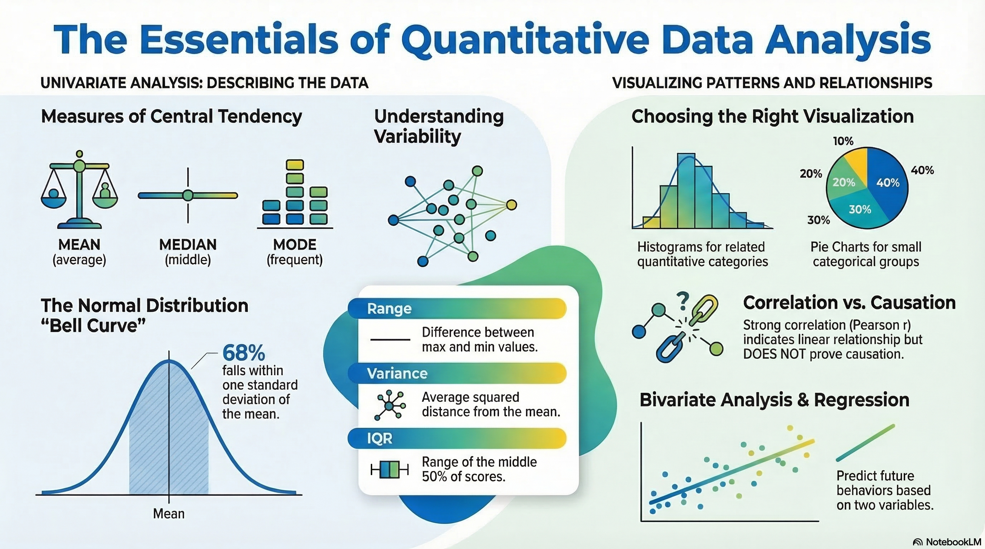
NotebookLM 생성 요약 인포그래픽. 해설 영상·팟캐스트는 resource/ 참조.

Quiz
출처: 02_Assets/assessment/GE2021_TestBank.xlsx (chapter=10) · 5문항

Q1. Univariate analysis examines only one variable at a time.
- A. TRUE
- B. FALSE
 정답 보기
정답: A
Univariate analysis focuses on a single variable, while bivariate analysis examines the relationship between two variables.

Q2. Statistics is BEST defined as:
- A. A branch of biology that studies populations
- B. A type of qualitative coding system
- C. A branch of mathematics that uses logic to interpret phenomena and draw conclusions from accumulated data
- D. A scale used in surveys
정답 보기
정답: C
Statistics is the mathematical discipline used to interpret data and draw conclusions about variables and relationships.

Q3. Which statement BEST distinguishes descriptive from inferential statistics?
- A. Descriptive analyzes the population; inferential only the sample
- B. Descriptive uses no math; inferential uses no math
- C. Descriptive is qualitative only; inferential is quantitative only
- D. Descriptive describes the sample at hand; inferential draws conclusions about the population from the sample
정답 보기
정답: D
Descriptive statistics summarize the sample, while inferential statistics generalize to the broader population.

Q4. “Absolute frequency” in a frequency distribution refers to:
- A. The percentage of cases that fall in a category
- B. A cumulative percentage
- C. The raw count of how many times an event or category occurs
- D. The standard deviation of the distribution
정답 보기
정답: C
Absolute frequency is the raw number of times something occurs (e.g., 34 high-school graduates).

Q5. For the dataset 2, 4, 6, 8, 20, 24, 30, 32, 34, 40, the median is:
- A. 20
- B. 22
- C. 24
- D. 30
정답 보기
정답: B
With an even number of values, the median is the average of the two middle numbers (20 + 24)/2 = 22.

Reference

