[Lecture Note] Qualitative Designs and Data Collection
  - GE2021 Research Technology, Fall 2026
Chad (Chungil Chae)
Wed, 16 September 2026

Learning Objectives
- 11-1 Plan a qualitative study in a community that is not well known or understood.
- 11-2 Understand that qualitative research and quantitative research are not opposed.
- 11-3 Do participant observation, write field notes, and manage them in a database.
- 11-4 Collect other data, like artifacts, photos, and videos; texts can also be collected.

SHORT VIDEO INTRODUCTION
https://www.youtube.com/watch?v=JjwJ_PiA19A

Qualitative Research

- Some research questions cannot be answered reliably through survey questionnaires and require different methods.
- When researchers want to know what people do, not just what they say they do, researchers have to spend time observing them.
- When researchers want to know how people think, not just how many think in the expected way, researchers have to spend time interviewing them.
  - The qualitative approach presents interviewees with a shorter list of questions that allows them to give longer answers with variable content.
  - Qualitative research allows the researcher to capture lots of data that would be missed if participants are required to select one of two answer choices on a survey.
- Qualitative research can be used to establish categories in lesser known populations; it is important to establish categories before counting how many people fit in each one.

Research Design
- Two situations to consider for the basic rationale for qualitative research:
  - To do research in a community you know very little about (explanatory).
  - To do research in a community you know a lot about (confirmatory).

Ethnographic Designs
- Ethnographic designs are perhaps the most prominent among the qualitative designs, and typically one of the first things social scientists associate with qualitative research; they deal with people’s views and values.
- When studying an unknown community, it is only unknown to you.
  - You might experience stress when living in another culture, which we refer to as culture shock.
- You can also do research in a known community to learn more about it.

Experimental Designs
- An experiment in a lab gives the researcher a lot of control over the variables, in contrast to ethnographic fieldwork, where lots and lots of things intervene in everyday life, without the researcher being able to know all of the variables, let alone control them.
- But even in fieldwork, there are field experiments.
  - Natural experiments happen all around us all the time and you can learn to discover and evaluate them.
  - Naturalistic experiments can be made to happen in the real world; they seek to balance the benefits of retaining real-world complexity with the benefits of structure in experimental designs.

Comparative Designs
- Experiments are comparative by design, because pretest and posttest data are compared, and so are the two groups, including the control group.
- When it comes to nonexperimental designs, there are even more possible comparisons, which is why nonexperimental researchers call their designs comparative.
- Some designs compare cases, and others construct comparisons within cases.

Process and Theory
- Researchers can collect qualitative data before they collect quantitative data, so that they construct a better questionnaire, or they could start with a questionnaire, and then continue with a subsample of informants for some follow-up in-depth interviews.
  - It is highly recommended to add a qualitative component even if it is mostly quantitative research and to add some quantitative components even if it is mostly qualitative research.
- Even though it is necessary to distinguish between the two research methods, it is also important to examine how qualitative and quantitative approaches intersect, and how we should cycle through both.
- In the qualitative design, you are allowing yourself to be informed by the participants in the study about the categories.

Differences in Setting and Design
- There are some principal differences in setting and design between qualitative and quantitative studies.
  - In field research, there is a more realistic picture, but less control.
  - The field can be inexpensive, but costly in terms of time.
- There is a continuum in design: more structure to less structure.
  - You can build structure into the research, such as in experiments or comparisons, which means you spend more time designing and less time collecting data that is already structured.
  - Or you choose a more flexible design, which means you don’t have to spend as much time on it and can start collecting data without all the details planned out, but that data will have less structure, so you will have to put more effort and structure into the analysis.

Data Collection
In the field, researchers will encounter things they never have before, and details of such encounters need to be observed and recorded.
- Humans can fail to notice things and think about their own perception; memory fades and details are lost or invented.
- To tackle these issues, researchers should to become aware of things that can interfere with recording qualitative data.
- Some researchers prefer to work in teams so that the records of multiple observers can be compared and reconciled; cross-referencing our notes and recollections with others—called intersubjectivity—is the best shot at objectivity.
- There are three types of ethnographic data: what people do, what they say about what they do, and what they think.
  - Researchers should aim to collect all three types of data rather than relying on one and jumping to conclusions.
- Qualitative data can be collected in many ways, and two of the most prominent are participant observation and ethnographic interviews.

Participant Observation
- Participant observation: a strategic method developed by social scientists that considers the position of the researcher in relation to his or her research subjects.
- The participant observer tries to maintain a position between participation and observation.
  - If the balance is lost and the researcher drifts towards one extreme, turning into a participant without much observation, we fear that they are going native, which means that the researcher is too accepting of cultural norms and not distant enough from the social norms and cultural values of the community.
  - If the researcher drifts toward the other extreme, observing without much participation, we fear that the true dynamics of the people and culture being studied is being missed by the researcher.
- Researchers should refrain from judging people and traditions during the process of participant observation; the scientific process requires them to evaluate with as little bias as possible.
- Experiences and insights gained during participant observation should be documented in field notes, which are descriptive and analytical at once.

Ethnographic Interviews
- Qualitative interviews require three basic things: interviewer, interviewee (sometimes called an informant), and an interview schedule (or outline) to guide the process.
- Ethnographic interviews are also called in-depth interviews.
- They are neither structured nor unstructured; we call them semistructured because we do have our outline of prepared questions, but those questions are open-ended and flexible, and informants can respond in their own words and varying length.
- Other interviews are considered informal, meaning they are casual conversations without a guiding list of questions but that may be informative and can be remembered and written down later.
- Take written notes during the interview, but if you have consent, also audio or video record the interview.
  - After the interview, transcribe voice to text, so that you can keyword-search the original interview data as well as the notes taken during the interview and jump right into the qualitative analysis.
- The number of informants needed depends on the research design.
  - If the purpose of interviews is to learn about a culture, or an organization, or the attributes of a group of people, you could gain a lot of information from relatively few key informants who happen to very knowledgeable about the community.
  - In other cases, research requires interviews with a group of cultural experts, who will guide the researcher through the interview.

Consider Variations
- Interviews can be conducted with individuals or with groups of individuals; group interviews promise to yield additional data to put individual data in perspective.
- It could make sense to collect individual data and cultural data, so that attributes of individuals can be understood in the context of the attributes of a culture.
- Focus group: an interview of a group of people who don’t know each other but occupy the same position, led in a discussion by the researcher.

Data Management
- It makes sense to digitize materials as soon as you collect them and associate them with keywords that are searchable.
- It is better to store the data in universal formats (such as .txt for words, .csv for numbers, .jpgs for images) and stay informed on best practices for archiving data.

Other Kinds of Qualitative Data
In some settings, data collection through direct contact with humans may be impossible or deemed unnecessary, and data can be recorded through other means.

Artifacts
- Artifacts are everything people created: arts and crafts, tools, tech, trash, to name some examples.
- They could be common and used daily, or they could be special and used in rituals.
- Objects can tell researchers that it existed in a particular place and time and that it was used by a group of people.
- Objects can tell researchers about the social structure, either in the past or present, and if they have objects from across time, about social and cultural change.
- Some objects can be collected, but many cannot be brought back from the field, and must be recorded in detail or through images to be studied later.

Images
- One reason to photograph people and objects, their actions and interactions, is to document their existence and their variety.
- Another reason is to record details that might escape the researcher in the field but be studied back in the lab when there is more time and more context has been gained, to make sense of the details experienced in the field
- Researchers can, but do not have to take the photos themselves; they can collect images such as magazine covers, or whatever visual materials exists on the research subject
  - In projects examining areas of people’s lives that are difficult to do participant observation in, researchers might ask informants to take and submit photos of themselves and their surroundings.
- Indirect observations are all these other types of observations that come from the environment such as photographs, videos, and artifacts, but not directly from the participants.

Video
- In lab or field settings, video recordings can lead to important insights that might be missed otherwise.
- Researchers can capture more data in a video than a photo, but they have to think about where to place the camera.
- Video recordings are also helpful in collaborate research, when not everyone will be on site to do direct observation.

Documents
- Qualitative research also takes place in archives.
- Newspapers archives, many of which are digital or being digitized and made accessible through research libraries, might prove a useful source of such records.
- A clearly defined, comprehensive, and well-maintained digital archive allows for good control in sampling as well as for replication.

Mixed Methods
- Combining methods of direct observation (such as participant observation and ethnographic interviews) with unobtrusive collection of objects, images, and more is fun but is also a powerful tool.
- Research projects that use mixed methods can generate more robust data and can also be used to correct impressions gained from single viewpoints.

Chapter Infographic
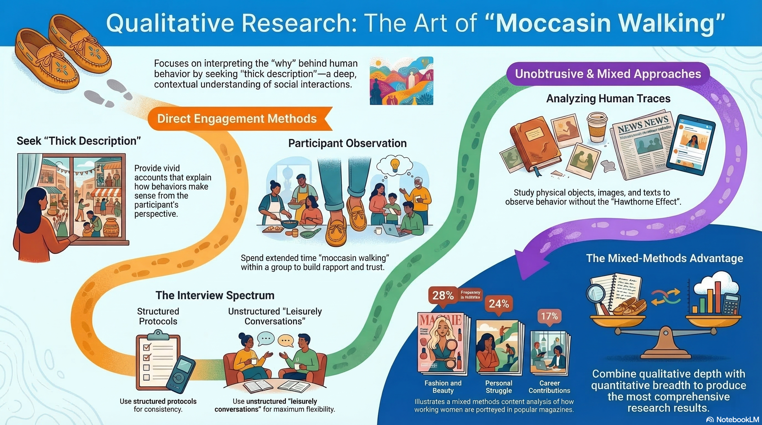
NotebookLM 생성 요약 인포그래픽. 해설 영상·팟캐스트는 resource/ 참조.

Quiz
출처: 02_Assets/assessment/GE2021_TestBank.xlsx (chapter=11) · 5문항

Q1. Qualitative research relies heavily on descriptive language to convey findings, while quantitative research presents results in numerical form.
- A. TRUE
- B. FALSE
 정답 보기
정답: A
Qualitative research uses rich description to interpret behavior; quantitative research expresses findings numerically.

Q2. According to Chapter 11, the primary goal of qualitative research is to:
- A. Test hypotheses with statistical significance
- B. Provide a “thick description” of behavior within its cultural context
- C. Maximize sample size for generalization
- D. Use only numerical data
정답 보기
정답: B
Geertz’s thick description aims to interpret behavior in its broader cultural context.

Q3. Compared with quantitative research, qualitative research tends to be:
- A. More inductive, allowing theory to emerge from data
- B. More deductive, starting from a theoretical hypothesis
- C. Identical in approach
- D. Strictly mathematical
정답 보기
정답: A
Qualitative designs typically build theory inductively from data; quantitative designs deduce hypotheses ahead of time.

Q4. Most qualitative fieldworkers adopt the role of:
- A. Complete observer only
- B. Complete participant only
- C. Participant-observer, combining elements of both
- D. External statistician
정답 보기
정답: C
The participant-observer role balances insider experience with analytic distance.

Q5. A complete-participant fieldworker who becomes so immersed that they lose analytic distance is said to be:
- A. Practicing thick description
- B. Using the extended case method
- C. Conducting unobtrusive research
- D. “Going native”
정답 보기
정답: D
Anthropologists call this “going native” — the danger of losing objectivity through over-identification with the group.

Reference

