[Lecture Note] Entering, Coding, and Analyzing Qualitative Data
  - GE2021 Research Technology, Fall 2026
Chad (Chungil Chae)
Wed, 16 September 2026

Learning Objectives
- 12-1 Describe how to enter, clean, and organize qualitative data.
- 12-2 Examine and code raw data.
- 12-3 Analyze qualitative data.

SHORT VIDEO INTRODUCTION
https://www.youtube.com/watch?v=lYzhgMZii3o

https://www.youtube.com/watch?v=Wj45MVxHWOA

https://www.youtube.com/watch?v=rvMf1cbctYM

https://www.youtube.com/watch?v=eT-EDgwRvRU

https://www.youtube.com/watch?v=95hHHIW6k6Q

Enter, Clean, and Organize Qualitative Data

- Conceptually, qualitative information is handled in the same way as quantitative information, but some adjustments must be made because the data are delivered in immediately quantifiable form.
- By its very nature, qualitative information will seldom be represented by numbers, but it can still be systematic and well organized.
- In addition to the raw information accumulated when conducting a study, it is essential to create a separate file of various records, including how many interviews, case studies, or observations were conducted, when and where the data collection took place, and other information about the participants in the study.
  - Basic information like the date, time, location, duration of the event, and participant characteristics should be logged.

Transcription
- Transcribing: the process where the recording of an interview or a focus group or any other recorded material is turned into written words.
- There are various dictation applications and software that can help with transcription process.
- A researcher needs to include everything that is heard, from grammatical errors and mispronunciations to background noise.

Memoing
- Taking notes on what you are thinking as you read and reread the transcribed interviews is called memoing, which facilitates later analysis by bringing you closer to the written material.
- The researcher relies on these memos or written impressions that were collected during the analysis to see for consistencies or repeated thoughts and ideas.
- Classification of memos is a process that happens after the memos are written in free-thinking style.
  - Theoretical memos: These memos relate to a theory or make connections between the narrative and theoretical concepts.
  - Self-reflection memos: These memos connect the narrative with past experiences or simply note how the researcher perceives the written information.
  - Hypothetical memos: These memos propose or predict a relationship between different parts of the narrative, though it is still too early to come to a conclusion.

Diagrams
- Diagrams are not only useful for record keeping but can also lend a systematic and organized view of the data.
- Various software programs allow researchers to create a range of diagrams, from simple to complex.

Coding Qualitative Data

- Coding is one way of bringing order to this written information by labelling and categorizing data.
- A code is a word or a few words that capture common meaning or categorization.

- The process of coding involves aggregating the text or visual data into small categories of information, seeking evidence for the code from different databases being used in a study, and then assigning a label to the code.
  - In vivo coding: code word per word as written in text.
  - Preexisting codes: codes taken from the literature.
  - Theoretical coding: a set of structured codes, usually from the theoretical perspective of the study, and the text is further examined with little flexibility to add other interpretations.
  - Content analysis: a type of qualitative analysis where frequencies of certain words used in a text are examined.
  - Patterns: the identification and grouping of similarities or differences of codes.
  - Interpretation: the process of going from simple codes to patterns and themes in the text.
  - Themes: broader groups into which categories of memos are gathered.

Analyzing Qualitative Data

While researchers have attempted to come up with many systematic ways to handle qualitative data, the analytical process can still be fraught with difficulty because each researcher is as unique as their study. However, qualitative analysis, when conducted correctly, should correct for those individual differences and bring out the best possible interpretation.

- Recognizing Patterns
  - Looking for similarities in actions, words, events, or feelings is one way of investigating qualitative work.
- Creating Categories
  - At the start, coding involves removing extraneous information while keeping the information of value.
  - Then, in the analysis phase, we assemble similarly coded information and organize it into larger categories so we can see how different participants approached the same topic of interest.

- Searching for Frequency
  - Frequency plays an important role in qualitative analysis, because the repetition of a topic or concept may be meaningful.
- Considering Diversity
  - Since diversity is part of the world we live in, our continued awareness of it will result in better studies, better investigation, and much better results and discussions.
- Remembering the Past
  - There are many cases when past experiences, personal history, or other types of background will influence participants and impact their responses.
  - Taking into account as many elements as we can when analyzing data will result in a higher quality of data analysis and a stronger study.

- Thinking Theoretically
  - Considering theories while analyzing data can help researchers interpret information in a meaningful way and make necessary connections between their material and the larger theoretical context.
- Thinking Critically
  - Critical thinking is the ability to look at something from multiple perspectives and to challenge our usual ways of thinking.

Chapter Infographic
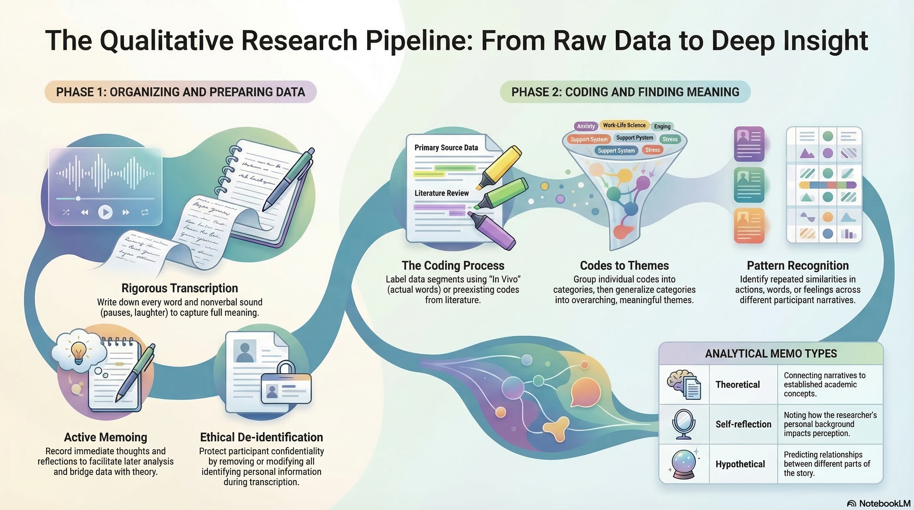
NotebookLM 생성 요약 인포그래픽. 해설 영상·팟캐스트는 resource/ 참조.

Quiz
출처: 02_Assets/assessment/GE2021_TestBank.xlsx (chapter=12) · 5문항

Q1. When transcribing a qualitative interview, the researcher should write down everything heard, including grammatical errors, pauses, and background noise.
- A. TRUE
- B. FALSE
 정답 보기
정답: A
Correcting grammar or omitting non-verbal cues during transcription can transform meaning; full fidelity is required.

Q2. In qualitative research, transcription refers to:
- A. Statistically summarizing interview data
- B. Writing down everything heard from the recorded interview, including verbal and non-verbal sounds
- C. Translating interviews into another language
- D. Compressing audio files to save disk space
정답 보기
정답: B
Transcription is the verbatim writing of audio recordings, including pauses, fillers, and non-verbal cues.

Q3. Roughly how much time can a 1-hour interview take to transcribe?
- A. Less than 30 minutes
- B. Approximately the same as the interview length
- C. Up to 8 hours, depending on typing speed and audio quality
- D. Always exactly 24 hours
정답 보기
정답: C
A 1-hour interview can take up to 8 hours to transcribe — researchers should plan accordingly.

Q4. A theoretical memo is one that:
- A. Connects parts of the narrative to a theory or theoretical concept
- B. Connects the narrative to the researcher’s personal past
- C. Predicts a relationship between parts of the narrative
- D. Records demographic data
정답 보기
정답: A
Theoretical memos link narrative content to theoretical frameworks (e.g., feminist theory, functionalism).

Q5. Which notation is commonly used to indicate non-verbal sounds like laughter or coughing in a transcript?
- A. Double parentheses (( ))
- B. Single quotes ’ ’
- C. Curly braces { }
- D. Brackets [ ]
정답 보기
정답: A
Per Research Workshop 12.1, double parentheses (( )) are used to indicate non-verbal sounds.

Reference

