[Lecture Note] Results and Discussion
  - GE2021 Research Technology, Fall 2026
Chad (Chungil Chae)
Wed, 16 September 2026

Learning Objectives
- 13-1 Write a results section.
- 13-2 Describe how to present results in quantitative studies.
- 13-3 Explain how to present results in qualitative studies.
- 13-4 Prepare visual representations of results.
- 13-5 Compose a discussion section.
- 13-6 Develop a recommendations section based on methodology or topic.

SHORT VIDEO INTRODUCTION
https://www.youtube.com/watch?v=6J4m0gLddog

Reporting Results

- The best way to write is by starting with the section that feels most comfortable. Then, the researcher can expand, think, analyze, converse, and edit as well as add to the other sections as the work progresses.
- It is helpful to think about organization before diving in.

Demographic Section
- The results section for both qualitative and quantitative designs generally begins with the demographics of the sample.
- Basic characteristics of the population, such as gender, race and ethnicity, age, height, weight, marital status, sexual orientation, religious affiliation, employment status, and income are included, as well as the number of participants in the study.
- The demographic information is important, even if the focus of research is somewhere else, seemingly unrelated to demographics.

Findings Section
- After reporting demographics, the results section reports the findings of the study.
- In quantitative studies, researchers typically provide general information about the variables using measures such as frequency, averages, or percentages to give a broader picture of what the researcher found to be of interest.
- In qualitative studies, the results will list and discuss the codes, patterns, and themes found in the study.

Results in Quantitative Studies

- A straightforward statement of findings is customary, written in a direct and matter-of-fact style.
- Tables and figures are strongly recommended because they allow a visual presentation of detailed data.

Rejecting the Null Hypothesis
- Being able to reject the null hypothesis may not mean that we have proven the alternative hypothesis.
  - There are often scenarios in which we reject both the null hypothesis and the alternative hypothesis, because the relationship between variables is different than predicted.

Failing to Reject the Null Hypothesis
- Failing to reject the null hypothesis still contributes to the advancement of science, because it means that the null hypothesis stands as an explanation for the relationship between variables of interest.
- When we fail to reject the null, we are sometimes able to identify new relationships between variables or discover other unexpected associations.

Results in Qualitative Studies

- Results in qualitative research follow a similar format to those in quantitative studies, providing an overview of demographics and then pointing out patterns from the analysis.
- The most straightforward way to report results is to rank them in order of importance and then combine results where patterns exist.
- To support their point, researchers use quotations directly from the text, illustrate the findings with excerpts from the data, and write a complex narrative as their results.

Visually Presenting Results

- Data visualization: visually telling story through data; a growing discipline in its own right that cuts across all other fields.
- They bring meaning, show dynamics, depict details, and ultimately illuminate the key relationships researchers and readers should be focusing on.
- The most widely used types of visual presentations are tables and figures.

Tables
- Tables can deliver a large amount of information at one time.
- They work best when the information is extensive and providing it in narrative form can be inefficient.
- A good rule of thumb is to present the information in a table when it occupies less space than a written rendition of the same information.
- Refrain from repeating the outcomes in a table and in the narrative; discuss the results and their implications, but do not repeat the points that have been made visually.

Figures
- Some common types of figures are charts, graphs, plots, and path diagrams.
- Path diagrams: a basic model that depicts the relationship between variables by using arrows or other types of connectors.
- It is important to consider the type of figure to use and its purpose.
- It is then helpful to consider other stylistic guidelines, such as labels, colors, amount of information, and clarity.
- Having a good numbering or labeling system will keep figures in order and ensure the reader can reference them.

Discussion

- The discussion is where you write about your interpretation of the results and what comes next.
- The discussion should begin with a clear outline of what will be included and how, such as delineating the limitations of the study.
- Limitations explore the factors that could have improved the effectiveness, such as a bigger sample for more reliable results or a more diverse sample.
- One way of organizing the discussion of findings would be by order of importance.
- The interpretation of results is the researcher’s opinion of the findings, but it is most often based on the literature or the theories previously researched.

Recommendations

- Toward the end of the discussion, most researchers anticipate how the study might be followed up with other studies to reveal even more knowledge and insight.
- Two common types of recommendations:
  - Recommendations on the methodology of future studies.
  - Recommendations on topics.

Chapter Infographic
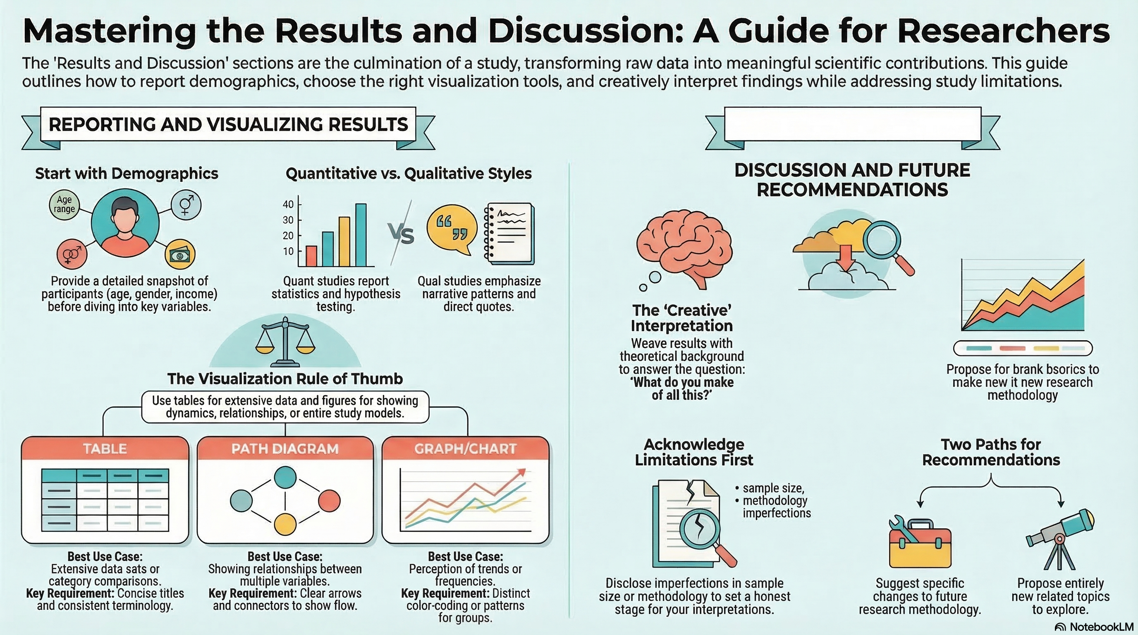
NotebookLM 생성 요약 인포그래픽. 해설 영상·팟캐스트는 resource/ 참조.

Quiz
출처: 02_Assets/assessment/GE2021_TestBank.xlsx (chapter=13) · 5문항

Q1. The results section typically begins by reporting the demographic characteristics of the sample.
- A. TRUE
- B. FALSE
 정답 보기
정답: A
Describing the sample’s basic demographics helps readers understand who participated before the findings are presented.

Q2. The results section of a research paper is BEST described as:
- A. A creative interpretation of the findings
- B. A list of recommendations for future studies
- C. A summary of the literature review
- D. A complete, descriptive, and detailed report of the findings
정답 보기
정답: D
The results section reports the findings as descriptively, exactly, and clearly as possible — interpretation is left for the discussion.

Q3. Rejecting the null hypothesis means that:
- A. The alternative hypothesis is automatically proven true
- B. The study was a complete failure
- C. A relationship between variables was found, though it may not match the predicted direction
- D. No findings will be reported
정답 보기
정답: C
Rejecting the null indicates a relationship exists, but doesn’t guarantee the predicted alternative was confirmed.

Q4. Failing to reject the null hypothesis is BEST described as:
- A. A worthless outcome with nothing to report
- B. A valid scientific contribution that still advances knowledge and may reveal unexpected relationships
- C. Proof of researcher incompetence
- D. A reason to discard the data
정답 보기
정답: B
Studies that fail to reject the null still build knowledge and sometimes uncover unanticipated patterns.

Q5. When reporting demographic distributions, the chapter recommends using:
- A. Raw numbers only
- B. Random anecdotes
- C. Names of individual participants
- D. Percentages, often alongside raw counts, because they communicate context more effectively
정답 보기
정답: D
Percentages allow readers to grasp distribution at a glance, whereas raw numbers force readers to do mental math.

Reference

