[Lecture Note] Formulating a Research Question
  - GE2021 Research Technology, Fall 2026
Chad (Chungil Chae)
Tue, 15 September 2026

Learning Objectives
- Choose a research topic.
- Explain how to operationalize research constructs
- Describe the different types of variables
- Formulate the various types of hypotheses
- Create a visualization of a research question (Pajo, 2022)

SHORT VIDEO INTRODUCTION
https://www.youtube.com/watch?v=mrWeLJZydUU

Selecting Your Research Topic

Topic Choice
What is the anatomy of a topic? (Colquitt & George, 2011)
- Significance: Taking on “Grand Challenges”
- Novelty: Changing the Conversation
- Curiosity: Catching and Holding Attention
- Scope: Casting a Wider Net
- Actionability: Insights for Practice

Fundamental vs Applied Research
- Fundamental research: looks at the world at large and tries to generate new ideas or explanation about how the world works and why; may not have application in everyday life in the immediate sense.
- Applied research: seeks to solve a specific societal problem or uncover more information about a particular issue; has direct implications in practice.

Narrowing the Research Topic
- Two features of a broader topic can lead to the research question: the constructs and the population of interest.
  - Construct: a concept that is possible to measure in a form.
  - The population of interest: group of subject that share simialr charateristics or tied in a similar context that researcher have interested in
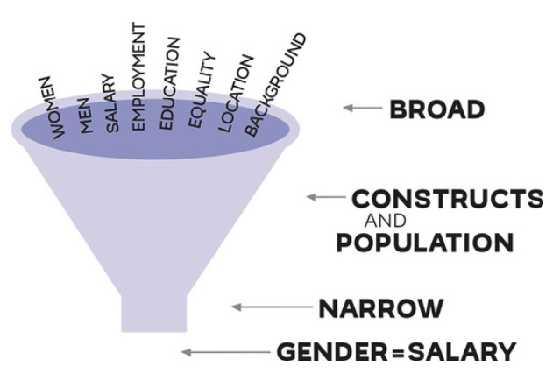

Operationalization of Constructions

Operationalization is nothing more than our ability to transform constructs into measurement pieces. The best researcher is able to measrue all the characteristics of a construct.
- Operationalization: turning constructs into actual variables to measure
- Variable: a specific feature or aspect of the construct that can take different values for each participant in a study.
- Conceptualization: the process of breaking down constructs into smaller pieces and clarifying to know the precise meaning of each.

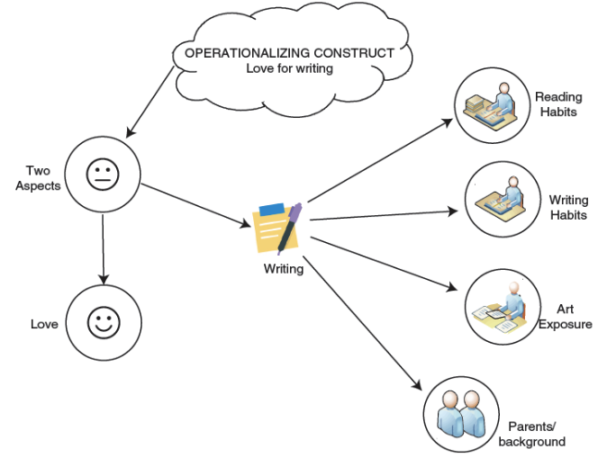

Types of Variables: Collecting Information

Independent and Dependent Variables
- Independent variable: the explanatory or predicting variable that explains the variation in the dependent variable; often constant/doesn’t change for the participant
- Dependent variable: the outcome; what researchers want to find out from a study and what they hope is influenced by the independent variable.
- Variables are unique to each study; a variable can be dependent in one study and independent in another.

Control Variables
- Control variables: any variables that are used to control the results; not directly related to the focus of the study but crucial for understanding the relationship between the variables of focus.
- They help minimize biases and provide more accurate findings.

Confounding and Disturbance Variables
- Confounding variables: influence the independent variable in such a way that the results from the dependent variable become untrustworthy; could not have been controlled or predicted during the study’s design; only become apparent during data collection or analysis.
- Disturbance variable: lurks in the background and disturbs the findings of the dependent variable; common characteristics of participants mislead the findings of the study without the researchers’ awareness.

Moderators and Mediators
- Moderators: variables that can strengthen or weaken an already established relationship between the independent and dependent variables.
- Mediators: intervening variables that interfere with the relationship between the main variables; when a mediator is present, the relationship between the independent and dependent variables may not even exist anymore.

Types of Hypotheses
- Hypothesis: a statement that predicts a specific phenomenon or behavior.
- They are usually present in a quantitative study but not a qualitative one.

Alternative Hypothesis and Null Hypothesis
- Alternative hypothesis: the prediction based on literature and theory about what the testing results will be; that is, what the variables are expected to look like once the data is collected.
- Null hypothesis: claims there is no relationship between the variables of interest in the study; this is the hypothesis researchers are actually testing with their findings.
- Research outcomes have two options: reject the null hypothesis in favor of the alternative hypothesis, or fail to reject the null hypothesis.

Directional Hypothesis and Nondirectional Hypothesis
- Directional hypothesis: predicts a specific course for the variables
- Nondirectional hypothesis: has no direction and simply predicts a relationship between two or more variables; rather than making assumptions on how the variables will behaving, researchers are investigating the possible relationship between variables.

Open-Ended Question
- For qualitative studies rather than quantitative; that is, when the researcher has many constructs but is not attempting to measure them
- A qualitative study asks different types of research questions and has a different methodology to collect data.

Visualizing a Research Question

Diagram
- Try drawing the reserach question
- It can be helpful to make a drawing of the research question to help visualize it.
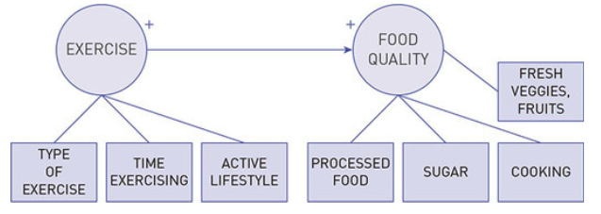

Closing

Discussion
- A researcher is focused on how sleep (measured in hours) influences academic performance (measured in GPA).
- A researcher wants to find whether academic performance (measured in GPA) influences self-esteem (measured on a 1 to 10 scale).
- A researcher is studying the influence of television watching (measured in hours) on speech onset of toddlers (measured in number of words spoken by age of 2).
- A researcher is attempting to see whether self-esteem (measured on a scale of 1 to 10) relates to and/or influences substance abuse (measured in frequency of substance use and abuse) among adolescents.
- A researcher is interested in understanding whether exposure to a large variety of food (measured in the number of different food textures and food types) influences the level of pickiness among children younger than 6 years old (measured on a scale of 1 to 10).
- Find the dependent and the independent variables in these examples:
- What is the difference between the null and alternative hypotheses?
- What is the purpose of the null hypothesis?
- How can we distinguish between disturbance and confounding variables? Illustrate with an example.
- What are some ways to operationalize constructs, such as sleep, time, and anxiety?
- What is the purpose of having a direction when we design an alternative hypothesis?
- What do directional and nondirectional hypotheses tell us?

Summary
This chapter introduced the concepts of fundamental and applied research. We consider fundamental research those broad theories that attempt to explain how life works and can be applied to many different things rather than one specific problem.
Applied research refers to studies that investigate one particular issue or problem. Once we have a topic of interest and have expressed this topic in the form of a question or a simple sentence, we are ready to operationalize our research. Operationalization means identifying the constructs of the study and expressing them in variables.
Constructs are broad or general terms that cannot be measured straightforwardly, but need to be broken down to simpler measurements. Variables are simple, specific measures of one characteristic. A construct can have one variable or many variables. There are a few types of variables. Some basic variables are independent and dependent variables.
An independent variable attempts to predict the changes in the dependent variable. A dependent variable changes, or we expect it to change, as a result of the presence of the independent variable. Independent variables are known as predictors, whereas dependent variables are known as outcomes. Besides the main types of variables in our study, we also include other variables to make sure that our results are appropriate.
Control variables, for example, are often not related to the main focus of the study, but they can influence the independent and dependent variables. To avoid biases and aim for higher accuracy in our work, we measure additional control variables. Confounding or intervening variables may influence the independent variable and question the findings of our study. In our attempt to protect the study from confounding or intervening variables, we look out for possible variables that may influence our results.
Disturbance or extraneous variables are more difficult to distinguish and take measures before the start of the study. These are variables that are not related to the independent variable, but they can potentially create a problem for the dependent variable, leading us to false results.
Moderators and mediators can also influence the independent and dependent variables. Moderators are variables that can strengthen or weaken a relationship between the independent and dependent variable. These are powerful variables that can make results much stronger or weaker, but the relationship between the main variables is still present. Mediators are even stronger. Mediators can cause the relationship between the independent and dependent variable to completely disappear.
This chapter also discussed the concept of hypothesis and its types. A hypothesis is a statement that predicts the relationship between variables. Some hypotheses can have a direction and make specific predictions about how the variables will change. These are called directional hypotheses.
Other types of hypotheses do not make specific assumptions about how the change in variables will be reflected—they just state the possibility of an association between variables. These are called nondirectional hypotheses or simply research questions, if stated in the form of a question.
Another categorization of hypotheses divides them into alternative and null. Alternative hypotheses are statements that predict some form of relationship between variables, either directional or nondirectional. Null hypotheses are the statements that claim no relationship between variables. Null hypotheses are the hypotheses we test in the study. Even though it seems like we are trying to prove the alternative hypotheses, we are in fact simply testing the null hypotheses or the possibility that there is no relationship between variables.

Terms
- Alternative hypothesis: the hypothesis that attempts to predict how the variables will relate to each other after the data are collected.
- Applied research: research that seeks to solve a specific societal problem or uncover more information about a particular issue.
- Conceptualization: the process of breaking a construct into smaller pieces and clarifying its specific meaning in our study.
- Confounding (intervening) variable: variable that influences that independent variable in a way that causes results from the dependent variable to become untrustworthy.

- Construct: an abstract term that is difficult to measure and can be understood differently by different people.
- Control variable: variable that minimizes biases and provides more accurate findings by removing characteristics that could affect the relationship between the independent and dependent variables.
- Dependent variable: the outcome or surprise variable that is influenced by the independent variable.
- Directional hypothesis: a hypothesis that predicts a specific course for variables.

- Disturbance (extraneous) variable: variable that can disturb the findings of the dependent variable, which cannot be controlled.
- Fundamental research: by collecting information about large groups of people, research that tries to generate new ideas about how the world works and why.
- Hypothesis: a statement that predicts a specific phenomenon or behavior.

- Independent variable: the explanatory or predicting variable that explains the variation in the dependent variable.
- Mediator: a variable that interferes with the relationship between the independent and dependent variables to the point where the relationship may be destroyed altogether.
- Moderator: a variable that can strengthen or weaken an established relationship between the independent and dependent variables.
- Nondirectional hypothesis: a hypothesis that has no direction, but predicts a relationship between two or more variables.

- Null hypothesis: a hypothesis that claims there is no relationship between the variables of interest in a study.
- Operationalization: the process of turning constructs into measurable variables.
- Variable: measures a specific feature or aspect of a construct and can take different values.

Chapter Infographic
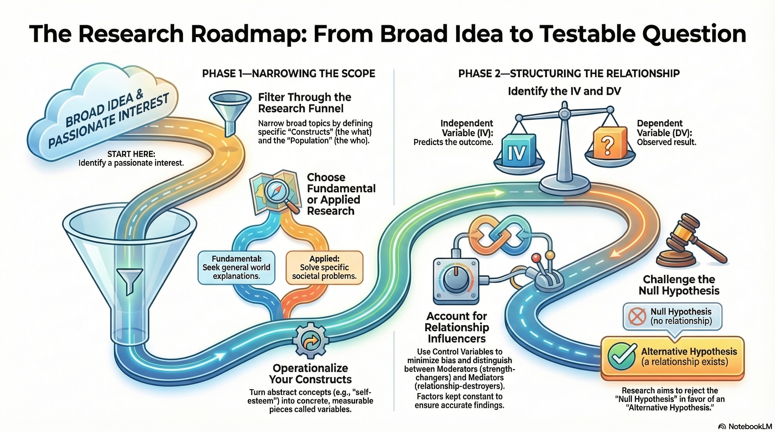
NotebookLM 생성 요약 인포그래픽. 해설 영상·팟캐스트는 resource/ 참조.

Quiz
출처: 02_Assets/assessment/GE2021_TestBank.xlsx (chapter=2) · 5문항

Q1. Applied research looks at the world at large and tries to generate new ideas about how the world works and why.
- A. TRUE
- B. FALSE
 정답 보기
정답: B
This describes fundamental research. Applied research seeks to solve a specific societal problem.

Q2. Which type of research seeks to solve a specific societal problem or uncover information about a particular issue?
- A. Fundamental research
- B. Applied research
- C. Mixed methods
- D. Qualitative research
정답 보기
정답: B
Applied research seeks to solve specific societal problems with practical implications.

Q3. A study examining theories of migration to understand why people move between countries is an example of:
- A. Applied research
- B. Descriptive research
- C. Exploratory research
- D. Fundamental research
정답 보기
정답: D
Studying broad theories without immediate practical application characterizes fundamental research.

Q4. Two features that help narrow a broad topic into a research question are:
- A. Theory and methodology
- B. Constructs of interest and population of interest
- C. Hypothesis and variables
- D. Sample size and design
정답 보기
정답: B
Narrowing involves identifying (1) constructs of interest and (2) population of interest.

Q5. A researcher finds that girls have higher self-esteem than boys but did not control for socioeconomic status. The finding may be inaccurate because:
- A. The sample was too small
- B. The study was longitudinal
- C. The hypothesis was directional
- D. Socioeconomic status could influence self-esteem independently of gender
정답 보기
정답: D
Without controlling for SES, the gender-self-esteem finding could be confounded by socioeconomic differences.

Reference
Colquitt, J. A., & George, G. (2011). Publishing in AMJ—part 1: Topic choice. Academy of management journal. Academy of Management Briarcliff Manor, NY.
Pajo, B. (2022). Introduction to research methods: A hands-on approach. Sage.

