[Lecture Note] Researching and Writing the Literature Review
  - GE2021 Research Technology, Fall 2026
Chad (Chungil Chae)
Tue, 15 September 2026

Learning Objectives(Pajo, 2022)
- Describe the purpose of a literature review
- Learn about online databases as resources
- Examine different ways of organizing a literature review
- Discuss how to think critically and analyze studies
- Identify the correct placement of study hypotheses
- Compare and contrast a systematic review of the literature and a literature review

SHORT VIDEO INTRODUCTION
https://www.youtube.com/watch?v=rk_jgtdJOD0

Defining a Literature Review

Literature Review and Its Purpose
- Literature review: the synthesis of the entire body of all the original research studies in a specific topic of interest; not just reporting them but engaging, discussing, and synthesizing the body of work in its entirety.
- Its purpose is to demonstrate the researcher’s grasp on the topic of interest and to support their argument for the necessity of the proposed study

Literature Review as Research Method (Snyder, 2019)

The Importance of Literature Reviews
The author emphasizes that knowledge production in many fields (such as business research) is growing quickly and becoming ever more interdisciplinary, making it challenging to remain current. Literature reviews play a critical role in synthesizing existing knowledge so researchers can identify the state of the art, pinpoint research gaps, and generate research questions.

Three Broad Approaches to Literature Reviews
- Systematic Reviews: A method originating in medical science, designed to locate, appraise, and synthesize all empirical evidence relevant to a clearly formulated question.
  - Key Features: Highly structured and transparent (e.g., PRISMA guidelines). Often relies on statistical methods (like meta-analysis) to combine findings from different studies. Suitable when the research question is specific (e.g., “What is the effect of factor X on Y?”).
  - Advantages: Rigor and replicability: clearly documented steps and inclusion/exclusion criteria. Can inform evidence-based practice or policy by summarizing overall effects.
- Semi-Systematic (or Narrative) Reviews: Useful when a topic has been studied across diverse disciplines under various conceptualizations, making a fully systematic approach difficult.
  - Key Features: Often broader in scope than systematic reviews. May use qualitative and/or quantitative methods to map themes, theoretical perspectives, or historical trends.
  - Advantages: Can capture a wide variety of theoretical perspectives. Good for identifying knowledge gaps or mapping how research on a topic has developed over time.
- Integrative Reviews: Aims to critically review, synthesize, and “integrate” literature on a topic in order to advance theoretical frameworks or create new conceptual models.
  - Key Features: Often used for mature or emerging topics. Requires careful selection of literature and a high level of conceptual thinking. More flexible but must still be transparent about methods.
  - Advantages: Can lead to significant theoretical contributions by reconceptualizing or building new frameworks.

The Review Process: Four Phases
- Designing the Review: Articulate why the review is needed.
  - Develop a clear research question aligned with the purpose of the review.
  - Select an appropriate approach (systematic, semi-systematic, or integrative).
  - Determine search strategy, databases, and inclusion/exclusion criteria.
- Conducting the Review: Pilot-test the search terms and inclusion criteria.
  - Screen articles (e.g., by title, abstract, full text) to arrive at the final sample.
  - Document decisions throughout to ensure transparency.
- Analysis: Extract relevant data and code it systematically (e.g., study characteristics, results, theoretical perspectives).
  - Use an analysis method that fits your review approach (e.g., meta-analysis, thematic analysis).
- Writing Up the Review: Clearly present methods so readers can assess trustworthiness.
  - Organize findings coherently (e.g., by themes, chronological development, or theoretical frameworks).
  - Highlight contributions, implications, limitations, and future research directions.

Evaluating a Literature Review
The author stresses the importance of transparency, depth, rigor, and usefulness.
A well-executed review should:
- Clearly define its purpose and scope.
- Explain and justify the methodology.
- Demonstrate that the chosen method and inclusion criteria were appropriate for the research question.
- Make a meaningful contribution (e.g., identifying research gaps, providing theoretical or practical insights, introducing a conceptual model).

Common Pitfalls
- Failing to describe the review’s methodology in detail (e.g., insufficient information about how articles were chosen).
- Restricting the search scope too narrowly (e.g., only certain journals or brief time spans) without a clear rationale.
- Offering only descriptive findings (e.g., listing how many articles there are on a topic) without deeper analysis.
- Not translating the findings into a valuable contribution (e.g., new theory, framework, or clear research agenda).

Discussion Points
- Purpose and Value of Literature Reviews
  - Why are literature reviews a cornerstone of rigorous academic research?
  - How do they help researchers avoid “reinventing the wheel”?
- Choosing the Right Approach
  - Under which circumstances might a systematic review be most suitable?
  - When might a semi-systematic or an integrative review be preferable?
- Ensuring Rigor and Transparency
  - What are the consequences of non-transparency (e.g., failing to detail how you selected articles)?
  - Why is it essential for other scholars to replicate or verify your review method?
- Quality vs. Quantity
  - How do inclusion and exclusion criteria affect the results of a review?
  - Why is it better to refine the research question carefully rather than arbitrarily exclude large sets of studies?
- Making a Theoretical Contribution
  - How can a literature review go beyond summarizing existing work and actually build or refine theory?
  - In what ways can a review pave the way for new empirical research?
- Ethical Dimensions
  - How might bias (intentional or unintentional) creep into the selection or interpretation of studies?
  - What steps can researchers take to mitigate bias?

Summary
- Literature reviews are a rigorous research methodology that requires clear purpose, methodical searching, transparent selection criteria, and an appropriate analysis technique.
- Researchers can adopt systematic, semi-systematic, or integrative reviews based on their specific goals—e.g., evidence of effect, mapping of themes, or building new theory.
- Thorough documentation, transparency, and a strong conceptual or theoretical contribution can make a review more likely to be useful, impactful, and publishable.

Exploring the Literature

Using Libraries and Online Databases
- Access online databases through a library’s website
- Schools often have librarians for specific fields to help navigate databases in a specific area of inquiry.

Using Search Engines
- Most databases have similar search engines that are easy to navigate
- Use “advanced search” rather than quick searches
- Boolean operators: using AND, OR, NOT to combine keywords in searching

Using Interlibrary Loan
- Interlibrary loan: the ability to access inventory of books and articles available in a library other than your own.
- WKU Interlibrary Loan
  - https://library.wku.edu.cn/en/interlibrary-loan-request-form


Writing Annotated Bibliographies
- Annotated bibliography: a brief summary of the article or book read, including explanations and comments on the citations.

Understanding and Organizing the Literature

Creating a Guiding Table
- Creating a table helps to understand the studies better and grasp what information needs to go into the literature review.
- Assigning each study an ID number can help organize them and can be the first column of the table.
- Other columns include author names, publication and study dates, locations, theories used, information on the participants, and so on.
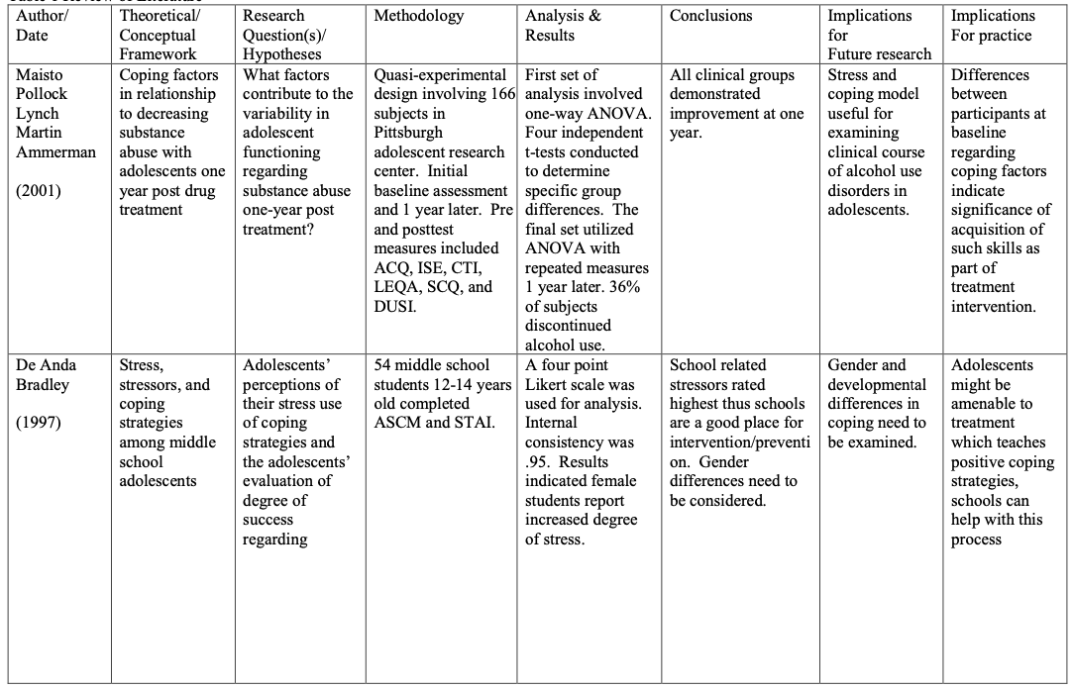

Using the Conceptual Graph
- Reviewing the literature can cause adjustments to be made on the conceptual graph of constructs and variables.
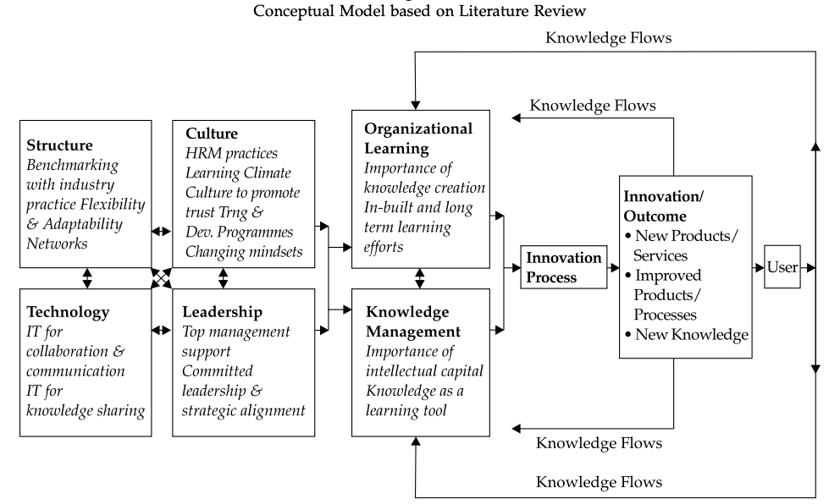

Organizing Your Work
- Researchers have their own styles of organizing literature.
- No matter the style, one should organize the literature logically
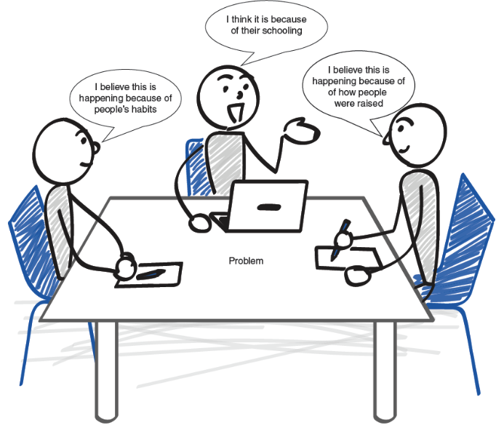

Conceptualizing the Literature: Patterns
- Finding patterns in the literature is a simple and effective way to organize a literature review

Thinking Critically

Exploring different venues regarding how to design your literature review is always recommended, but one important principle should be kept in mind: employing critical thinking. Using critical thinking is one of the reasons students go to school in the first place. Reading books and learning new information can help to gain knowledge. Some of that knowledge is retained and some is forgotten. Being critical, on the other hand, is a skill that can be applied to various aspects of life. But how can one be critical and what does critical thinking really mean?

Reading Critically
- Active reading, where one reads the information on the page while simultaneously considering the information given and coming up with additional ideas, leads to critical thinking.

Analyzing Studies
- First look at the concepts, theories, and perspectives the researchers are using; ask questions regarding their intentions and if they considered other ideas.
- Next look closely at the methodologies employed

Important questions to consider in each step of the review(Snyder, 2019).
- Phase 1: design
  - Is this review needed and what is the contribution of conducting this review?
  - What is the potential audience of this review?
  - What is the speci c purpose and research question(s) this review will be addressing?
  - What is an appropriate method to use of this review’s specific purpose?
  - What is the search strategy for this speci c review? (including search terms, databases, inclusion and exclusion criteria etc.)

- Phase 2: conduct
  - Does the search plan developed in phase one work to produce an appropriate sample or does it need adjustment?
  - What is the practical plan for selecting articles?
  - How will the search process and selection be documented?
  - How will the quality of the search process and selection be assessed?

- Phase 3: analysis
  - What type of information needs to be abstracted to fulfill the purpose of the specific review?
  - What type of information is needed to conduct the specific analysis?
  - How will reviewers be trained to ensure the quality of this process?
  - How will this process be documented and reported?

- Phase 4: structuring and writing the review
  - Are the motivation and the need for this review clearly communicated?
  - What standards of reporting are appropriate for this specific review?
  - What information needs to be included in the review?
  - Is the level of information provided enough and appropriate to allow for transparency so readers can judge the quality of the review?
  - The results clearly presented and explained?
  - Is the contribution of the review clearly communicated?

Hypotheses or Research Questions
- Can end with either a research question or a hypothesis to make the argument that there are still unanswered questions worth investigating.
- A research question is broader while a hypothesis includes an understanding of the possible answer.
The hypotheses of your study need to be included at the end of your literature review. After all, that is why you wrote the entire argument with the literature. You needed to prove how important your hypotheses are and why this particular study is worth investigating. Often, the alternative and null hypotheses are placed in a separate paragraph. Remember our discussion from Chapter 2 where we always try to reject the null hypothesis. In a nutshell, that is the focus of our study, so we need to state these hypotheses at the end of the literature review.
For example, I am interested in conducting a mixed-methods study about the ways that psychiatrists diagnose their patients. My goal is to find out the process of how a person is diagnosed with any disorder or mental problem, as well as the percentage of people who walk in the door of a psychiatrist’s office, but are mentally healthy and leave without a diagnosis. Once the literature is explored and it shows that there is a disagreement among researchers on whether some diagnoses are truly mental problems as well as the increasing number of people being diagnosed in our society, the literature review clearly shows the need to explore this topic further. At the end of it are the hypotheses. The following is an illustration of this example:
H1: There is a relationship between the number of complaints people express at the psychiatrist’s office when they walk in for the first time and whether they leave with a diagnosis. The relationship is one- directional, so the higher the number of complaints, the higher the number of diagnoses the patient receives.
H01: There is no relationship or trend between the number of complaints from people who walk in to a psychiatrist’s office for the first time and the number of diagnoses they receive.
H2: There is a relationship between the number of complaints people express at the psychiatrist’s office when they walk in for the first time and whether they leave with a prescription for psychotropic medications. The relationship is one-directional, so the higher the number of complaints, the higher the number of prescriptions.
H02: There is no relationship between the number of complaints of people who walk in to a psychiatrist’s office for the first time and the number of prescriptions they receive.

Systematic Reviews of Literature
- Systematic review: is different from a literature review; it is a form of scientific study that brings together every study on a specific topic and draws conclusions from it.

Systematic Reviews Versus Narrative Literature Reviews
- There are four major factors that make a systematic review different from a literature review:
  - the focus is different;
  - selection bias is reduced;
  - rigorous steps and procedures are followed, and
  - assessment and analyses of studies are involved.
- Selection bias: the researcher’s tendency to look closely at scientific work that aligns with their ideas and overlooks work that may oppose them.
- Methodology: how data are collected
- Meta-analyses: statistically recalculate the data from original studies based on standard criteria.

14 Types of ReviewGrant & Booth (2009)
- Critical review
- Literature review
- Mapping review/systematic map
- Meta-analysis
- Mixed studies review/mixed methods review
- Overview
- Qualitative systematic review / Qualitative evidence synthesis
- Rapid review
- Scoping review
- State-of-the-art review
- Systematic review
- Systematic search and review
- Systematized review
- Umbrella review

Discussion
- What type of information is commonly included when writing an annotated bibliography? (Name all that apply.)
- How is the systematic review different from a literature review?
- What distinguishes meta-analyses from all other types of reviews?
- What is the role of hypotheses on our literature review?
- How can we start our literature review?
- What is selection bias and what types of reviews are more prone to include selection bias?

Closing

Summary
- Writing a literature review is a rewarding task with added perks, such as

    - painting a picture on what the scientific literature in your topic really looks like;

    - pulling out studies that are relevant to your topic and showing your organizational skills in making sense of them;

    - displaying your creativity in designing the literature review that best supports and complements your study;

    - exercising critical thinking by looking at the studies from various perspectives; and

    - writing a logical, critical, and analytical literature review that supports your proposed study and naturally ends with your research question(s) or hypotheses.
- Writing a literature review is a rewarding task with added perks, such as

    - painting a picture on what the scientific literature in your topic really looks like;

    - pulling out studies that are relevant to your topic and showing your organizational skills in making sense of them;

    - displaying your creativity in designing the literature review that best supports and complements your study;

    - exercising critical thinking by looking at the studies from various perspectives; and

    - writing a logical, critical, and analytical literature review that supports your proposed study and naturally ends with your research question(s) or hypotheses.
- In this chapter, you were introduced to some helpful tips on how to organize the literature and, most importantly, how to initially conceptualize the tasks. This organization is unique to each researcher, but some helpful tips were provided in how to look for patterns, similarities in methodologies or findings, as well as distinctive differences or opposing results from studies.
- Your literature review will culminate with the hypotheses or research questions you have formulated. For every alternative hypothesis, we include a null hypothesis because the null hypothesis is the one we will eventually try to reject. This chapter also introduced systematic reviews of literature and how they are different from the traditional literature reviews.
- A systematic review of literature tends to be protected from selection biases—biases related to how we choose studies to include in our review. A systematic review also follows rigorous steps and procedures compared to the traditional review. After all, a systematic review of literature is best conceptualized as a research design rather than a literature review.
- It usually has its own traditional literature review. Systematic reviews are also more organized and full of details on the studies they have investigated. This allows researchers to paint a complete picture on the literature of a specific topic. Meta-analyses are similar to systematic reviews with an added feature of statistically recalculating the data from original studies.

Terms
- Annotated bibliography: a brief summary of the article or book you read, including the focus of the study, the methodology used, the findings, and any other important information that directly relates to your research topic.
- Boolean operators: operators that are used to conduct searches in the library and other databases (i.e., AND, OR, NOT).
- Interlibrary loan: the possibility of borrowing articles and books from other libraries that may not be available in your local or university library.
- Literature review: the body of literature surrounding a specific topic of interest to the researcher.

- Meta-analyses: the type of systematic reviews that statistically recalculate the data from the original studies based on standard criteria. Meta-analyses are a rigorous way of conducting systematic reviews.
- Methodology of the systematic reviews: answers the question about how the articles and books (and other media) included in the systematic review were collected, what keywords were used, what techniques were used to narrow down the number of published records, and what rules were followed for selecting the final sample of articles and books.

- Selection bias: biases that surround the way we select and decide which articles to use for our literature review. To avoid selection bias, we often conduct a systematic review of the literature on the topic.
- Systematic review: a review of the literature that follows specific guidelines in collecting studies on a topic. It is usually less prone to biases.

Chapter Infographic
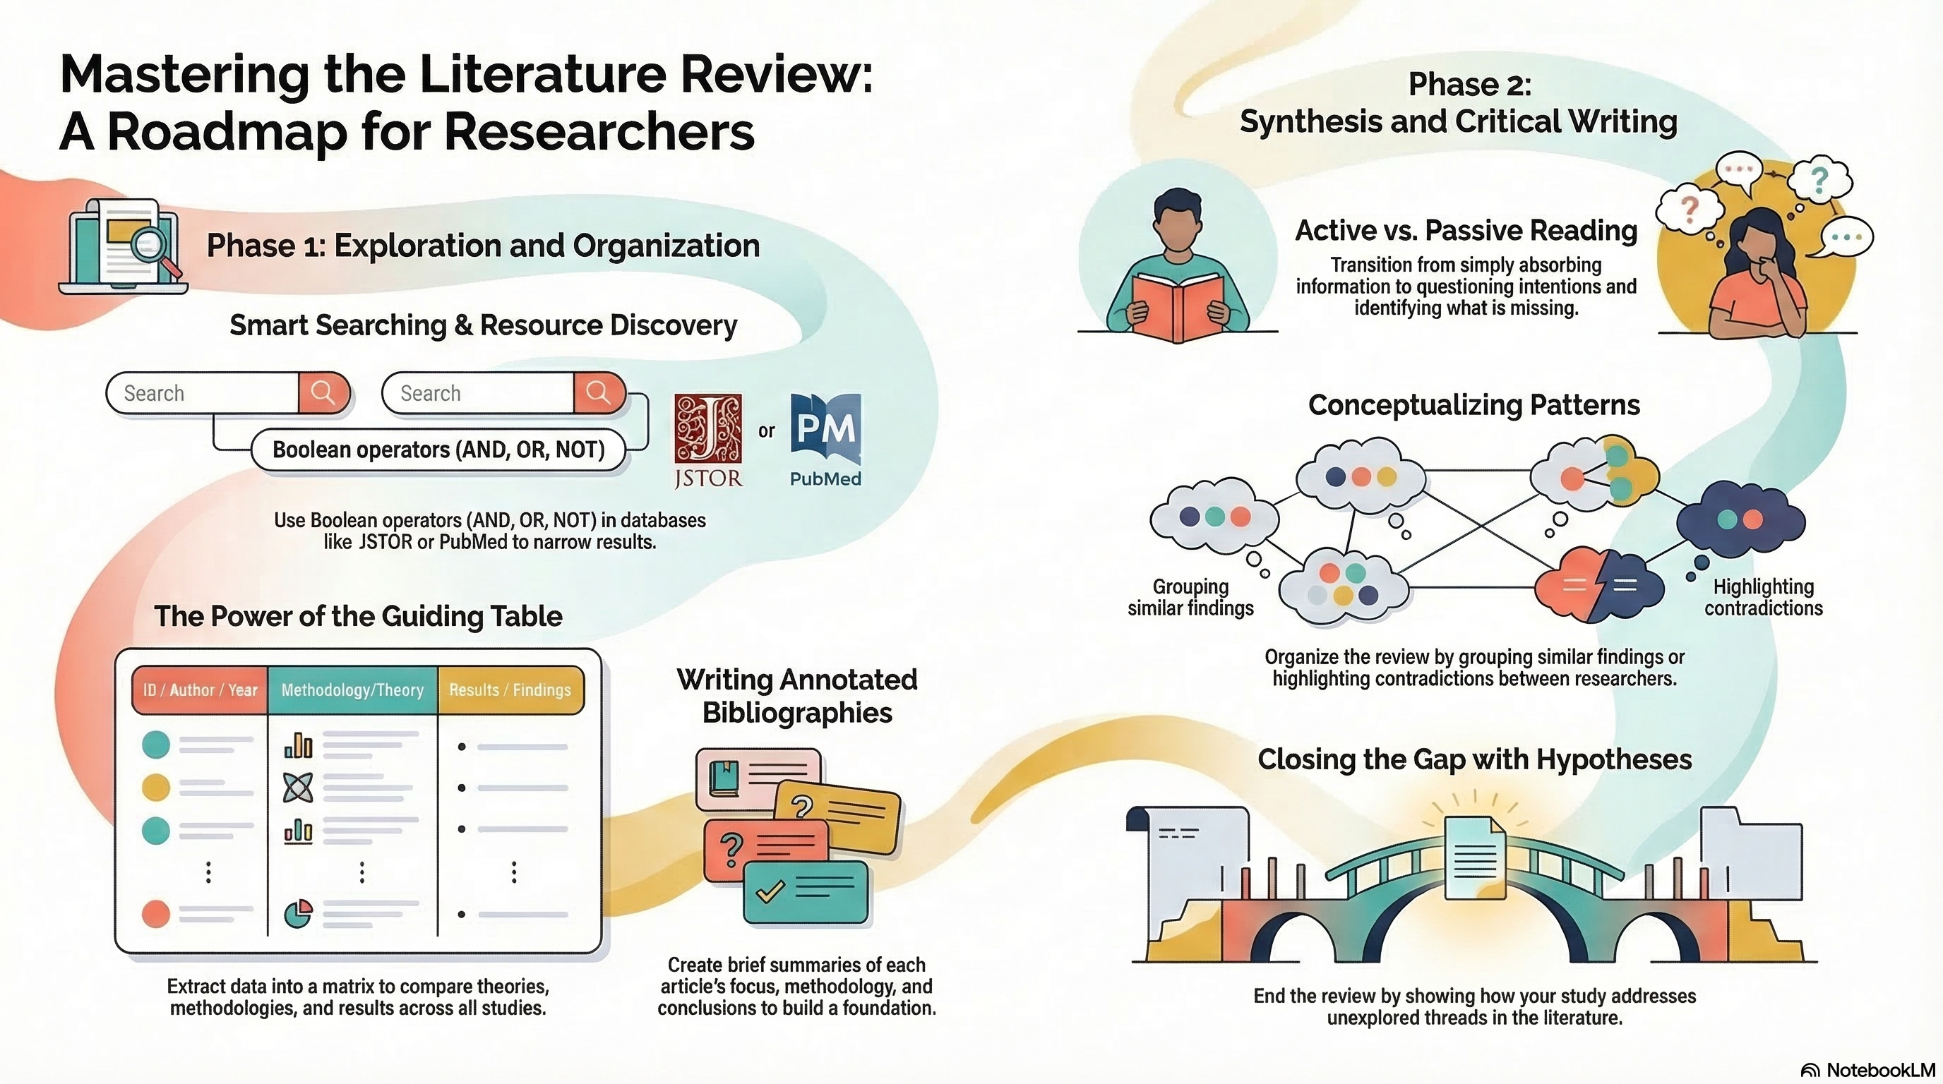
NotebookLM 생성 요약 인포그래픽. 해설 영상·팟캐스트는 resource/ 참조.

Quiz
출처: 02_Assets/assessment/GE2021_TestBank.xlsx (chapter=3) · 5문항

Q1. A literature review is simply a summary of previously published research articles.
- A. TRUE
- B. FALSE
 정답 보기
정답: B
A literature review is not just a summary; it is a critical analysis that builds an argument for why the study is needed.

Q2. The primary purpose of a literature review is to:
- A. Show familiarity with the body of research and build an argument for the study’s importance
- B. Collect original data
- C. Replace the methodology section
- D. Prove the null hypothesis
정답 보기
정답: A
A literature review demonstrates knowledge of existing research and argues why the new study matters.

Q3. During a formal defense, the scientific community evaluates two main things:
- A. Sample size and budget
- B. The hypothesis and the conclusion
- C. Whether the researcher knows the literature AND whether the study is feasible
- D. The independent and dependent variables
정답 보기
정답: C
Reviewers evaluate the researcher’s familiarity with literature and the feasibility of the proposed study.

Q4. When searching a database, which Boolean operator should you use to include ALL keywords in the results?
- A. AND
- B. OR
- C. NOT
- D. NEAR
정답 보기
정답: A
AND requires all keywords to be present in the search results, narrowing the search.

Q5. A novice researcher finds that most studies on diabetic children’s parents only surveyed mothers. This finding suggests:
- A. The literature is missing the perspective of fathers, creating a gap to fill
- B. The literature is complete
- C. Mothers are the only relevant population
- D. More quantitative studies are needed
정답 보기
정답: A
Identifying that fathers’ perspectives are missing reveals a gap in the literature that justifies new research.

Reference
Grant, M. J., & Booth, A. (2009). A typology of reviews: An analysis of 14 review types and associated methodologies. Health Information & Libraries Journal, 26(2), 91–108.
Pajo, B. (2022). Introduction to research methods: A hands-on approach. Sage.
Snyder, H. (2019). Literature review as a research methodology: An overview and guidelines. Journal of Business Research, 104, 333–339.

