[Lecture Note] Quantitative Designs
  - GE2021 Research Technology, Fall 2026
Chad (Chungil Chae)
Tue, 15 September 2026

Learning Objectives(Pajo, 2022)
- Describe the purpose of exploratory, descriptive, and explanatory studies.
- Compare and contrast cross-sectional and longitudinal studies.
- Explain the differences between nomothetic research and idiographic research.
- Discuss each type of experimental design and its advantages and disadvantages.

SHORT VIDEO INTRODUCTION
https://www.youtube.com/watch?v=VQbkw-SI8c4

Categorizations of Research Studies

Major decisions for designing a study.
- Visualize and conceptualize the study.
- Determine the practical details of the study.
- Learn about the possible errors that could occur.
- Finally, begin working.

The first characteristic of research design involves what we are trying to accomplish in this study.
- Exploring a new relationship between variables? Describing a phenomenon in detail? Explaining an established relationship?
- Common distinctions of studies are based on trying to explore, explain, or describe something.

Quantitative or Qualitative
- Quantitative.
  - Small samples; in-depth explorations; tends to construct a new theory.
  - Less design work, more data analysis.
  - Text, audio, image, and object analyses.
- Qualitative.
  - Large samples; clean measures to test hypothesis; tests an established theory.
  - Intensive design work, less data analysis.
  - Statistical analyses.

Exploratory Studies—Answering “What?”
- Exploratory studies are often used to investigate a new topic of research, a new thread of previously established relationships, a new methodology, a new instrument of data collection, or to gain a deeper understanding on a specific population.
- Useful as initiators for larger, complex studies. Aim at investigating, exploring, or figuring out a new, innovative thread of knowledge.

Descriptive Studies—Answering “How?”
- Descriptive studies allow researchers to focus on describing a phenomenon or understanding the details about people’s experiences of a particular event.
- Awareness of the difficulties that a specific group of people is experiencing may reveal possible ways of intervening to help the group in need.
- Generally qualitative as it is often necessary to gather in-depth data and allow participants the flexibility of expressing their feelings and situations in detail.

Explanatory Studies—Answering “Why?”
- Explanatory studies are reinforcing studies. They focus on explaining the reasons behind a phenomenon, relationship, or event.
- Seek to explain the reasons behind an already known and/or established relationship.
- May be quantitative or qualitative depending on the researcher, but are usually quantitative.

Cross-Sectional Versus Longitudinal Studies

Cross-Sectional Studies
- Cross-sectional is the name for studies that collect data only once, a simple snapshot of data collected at one point in time.
  - For example, collecting information from participants who have purchased an expensive car in the last year.
- Refers to one shot of data collection, without any follow-up questions; useful when collecting data from a large number of participants.
- Difficult to establish any cause-effect relationships because all the variables are collected at the same time.

Longitudinal Studies
- Longitudinal studies collect data at different points in time, which helps the data to be more accurate and avoid or minimize errors like inaccurate responses.
  - For example, we may want to know the long-term effects of a specific medication given to children.
- These different data collection points are called waves. The first data collection is often called base wave or wave I, typically continuing with wave II, wave III, and so on.
- Desirable for various topics as they are known for their accuracy.
- Types of longitudinal studies:
  - Panel studies follow and accumulate data from the same participants over a period of time.
  - Trend studies collect data at different points in time from different participants of the same population.
  - Cohort studies follows the same cohort of people over time. Includes a broader definition (such as being born, married, or giving birth in the same year) and are not the same people.

Causality in Research
- An important feature of design is determining the type of relationship the study will investigate.
- Researchers often attempt to establish a causal relationship between variables of interest, which refers to attempts to determine that one or more variables (the independent variables), have caused the changes in another variable (the dependent variable).

Nomothetic Research
- Nomothetic research aims at arriving at causal relationships that are easily applied to the population at large. Often quantitative because of its large scope.
  - Such as establishing that people with a higher education level will likely earn a higher salary.
- To establish nomothetic causality, a research study needs to establish three criteria:
  - Correlation: variables we are studying are related to each other; the changes in our independent variable should go hand in hand with changes in the dependent variable.
  - Time order: determines the actual order of changes from one variable to another; changes in the independent variable happen first in time and are accompanied by changes in the dependent variable happening later in time.
  - Non-spuriousness: A spurious relationship is explained away by a third variable that may have not been considered. Claiming nomothetic causality requires a non-spurious relationship.

Idiographic Research
- Idiographic research attempts to explain the entire realm of influences and every possible detail that has influenced a particular phenomenon or event for an individual. Often qualitative in nature.
- It is time-consuming because it can investigate only one individual or event at a time because of its depth in truly capturing the information.
- Fuels later nomothetic research, but it is an important tool used to investigate a problem at an individual level before generalizing society at large.

Experimental Designs
- An experimental design is a study that includes an experiment and then analyzes the results.

Classic Experimental Design
- Experimental design refers to the presence of a test, experiment, intervention, or some form of manipulation happening at the time of data collection.
- Three requirements must be fulfilled in order to conduct an experimental design:

    - the presence of a control group and an experimental group, (2) randomly assigning participants to the control and experimental groups, and (3) collecting data before and after the experiment, also known as pre- and posttesting.
- Experimental and Control Groups
  - The experimental group is undergoing some form of experimentation, such as training, taking a test or a drug, or some other form of intervention.
  - The control group do everything the participants in the experimental group do, but are not given any test, drug, intervention, or manipulation, although they may be told that they are.
  - The control group controls for confounding or disturbing variables, giving researchers confidence that findings are accurate and the outcome was a consequence of the experiment rather than extraneous reasons.
- Random Assignment
  - When ready to collect data, first one should randomly place the participants into the experimental group and the control group.
  - Minimizes the potential of characteristics to be the determining factor.
  - Random select can be accomplished in a number of ways including drawing numbers or using a computer number generator.
  - The researcher is usually aware of which group participants are assigned, whereas the participants are not aware. In instances where neither is aware, the studies are known as double-blind studies.
- Pre- and Posttesting
  - Researchers need to pretest the participants and posttest them to figure out the actual results of our study, otherwise they may not notice any changes.
  - The pretest and the posttest cannot be different or it may manipulate the outcome.

Solomon Four-Group Experimental Design
- The Solomon four-group experimental design is a type of experimental design that helps to minimize measurement errors.
  - Protects the study from the biases of pretest.
  - Uses two experimental groups and two control groups.
  - One experimental and one control group take the pretest, the other two groups are subjected only to the intervention or the placebo and do not take the pretest.
  - The differences in results can clearly show whether the pretest is influencing the results of the study.

Quasi-Experimental Designs
- Quasi-experimental designs conduct some form of intervention, testing, modification, or manipulation and examine the results.
- These studies are more relaxed in terms experimental design requirements such as randomly selecting participants for the control and the experimental groups or conducting a pretest and a posttest.
- Common quasi-experimental designs:
  - Randomized One-Group Posttest-Only.
  - Randomized Posttest-Only Control Group.
  - Non-Random Posttest-Only Control Group.
  - Non-Random Pretest Posttest Control Group.
  - Non-Random One-Group Pretest Posttest.

Non-Experimental or Pre-Experimental Designs
- Non-experimental designs do not include any manipulation, such as training, intervention, or drug taking.
  - Crucial for researchers who are exploring something innovative and will then move into conducting experiments later.
  - Common designs include the Non-Random Cross-Sectional Survey and the Longitudinal Cohort Study.
- The term pre-experimental implies that these types of studies are conducted before the researcher establishes the need for an experiment.

Chapter Infographic
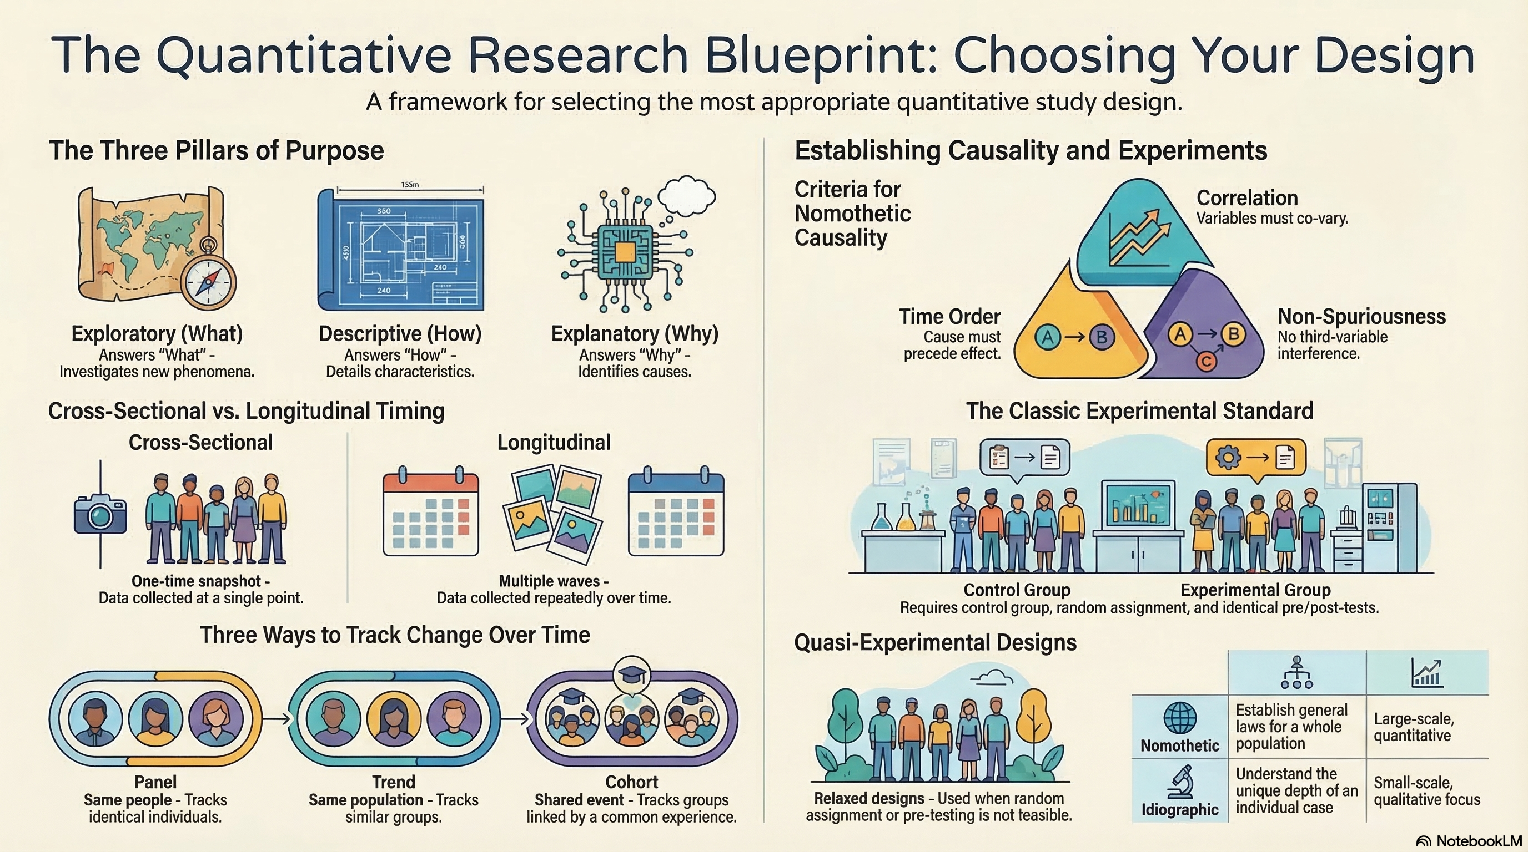
NotebookLM 생성 요약 인포그래픽. 해설 영상·팟캐스트는 resource/ 참조.

Quiz
출처: 02_Assets/assessment/GE2021_TestBank.xlsx (chapter=4) · 5문항

Q1. Exploratory studies are used to investigate established relationships that have been widely studied.
- A. TRUE
- B. FALSE
 정답 보기
정답: B
Exploratory studies investigate new topics, new relationships, or existing relationships in new populations.

Q2. Which type of study answers the question ‘What?’ and investigates new topics or relationships?
- A. Descriptive
- B. Explanatory
- C. Exploratory
- D. Longitudinal
정답 보기
정답: C
Exploratory studies answer ‘What?’ by investigating new or previously unstudied topics and relationships.

Q3. The main advantage of cross-sectional designs is their:
- A. Ability to show causation
- B. Elimination of disturbing variables
- C. High accuracy over time
- D. Cost-effectiveness and speed of data collection
정답 보기
정답: D
Cross-sectional designs are inexpensive and quick, collecting data once from many participants.

Q4. A major limitation of cross-sectional studies is that:
- A. They cannot establish cause-and-effect relationships
- B. They are too expensive
- C. They require too many participants
- D. They must use qualitative methods
정답 보기
정답: A
Since all data are collected at once, it is impossible to determine which variable caused changes in another.

Q5. The Solomon four-group design is used to:
- A. Reduce the sample size
- B. Control for the effects that pre-testing itself might have on participants
- C. Eliminate the need for post-testing
- D. Replace random assignment
정답 보기
정답: B
The Solomon design adds groups without pre-tests to determine if the pre-test itself influenced results.

Reference
Pajo, B. (2022). Introduction to research methods: A hands-on approach. Sage.

