[Lecture Note] Measurement Errors, Reliability, Validity
  - GE2021 Research Technology, Fall 2026
Chad (Chungil Chae)
Tue, 15 September 2026

Learning Objectives
- 5-1 Recognize measurement errors and describe how to categorize them.
- 5-2 Compare and contrast the interrater reliability, test-retest reliability, and internal consistency reliability.
- 5-3 Analyze the different types of validity: face validity, content validity, construct validity, criterion validity, concurrent validity, and predictive validity.

SHORT VIDEO INTRODUCTION
https://www.youtube.com/watch?v=oE71Onl5K-s

Defining Measurement Error
- Measurement error: when the data collected does not represent reality because of the way it was measured.
- Exclusive to quantitative design

Types of Measurement Errors
- Random Error: when the measurement error in the collected data is inconsistent and has no pattern.
  - When measurement error is small and random, there still may be high-quality data available.
- Systematic Error: when data collected indicates that the measure is not accurately measuring the concept.
  - Far more problematic than random error
  - Can be related to the measurement being used, the way the data is being collected, or other environmental factors unrelated to the measurement.

Reliability
- Reliability in quantitative design: the consistency in a measurement; data collection is reliable if it yields the same results when used on different subjects, populations, or settings.
- Reliability in qualitative design: the study’s replicability, dependability, and consistency.
- Accuracy: participants’ answers about a topic and whether or not the answers are free from error.
- Reliability does not mean accuracy.

Inter-Observer or Inter-Rater Reliability
- There is more than one researcher present in data collection, and all observers keep separate ratings of the data to then compare responses to determine a degree of consistency.
- More common in qualitative studies

Test-Retest Reliability
- Associated exclusively with quantitative design
- Ensures data collection tool consistently yields the same results regardless of the passing of time.

Internal Consistency Reliability
- Often used in surveys and questionnaires and associated with quantitative designs
- Including multiple questions that measure the same variable to make sure the participant’s answer was not due to error.

Validity
- Validity: the ability or potential of a data collection tool to capture and measure the construct or phenomenon that the researcher is interested in measuring.
- In quantitative design, it is tightly related to the measurement of a concept, whereas in qualitative design it relates to how a concept is being captured through texts, images, or sounds.

Face Validity
- When researchers decide to classify the measurement instrument or tool as an accurate measurement of the construct in question.
- A subjective assessment of the validity of a measurement instrument
- Does not imply the measurement is valid, but implies that for the sake of the researcher’s discussion, the measurement is considered valid.
- Often used because measurement tools cannot always be confirmed as valid

Content Validity
- How well a measurement tool captures all aspects of the construct that is being tested or measured.

Construct Validity
- How well a measurement is able to truly measure the construct in question; how accurately researchers have operationalized a construct.

Criterion Validity, Concurrent Validity, and Predictive Validity
- Criterion validity: for cases when researchers are not satisfied with the way the construct has been measured and decide to create a new measurement for a construct that has already been measured.
- Criterion validity needs to establish both concurrent validity and predictive validity.
- Concurrent validity: occurs when comparing a new test with an established measurement tool and examining the matching results
- Predictive validity: occurs when a measurement test produces the same results over time.
- Difference Between Reliability and Validity of the Measurement Instrument

Chapter Infographic
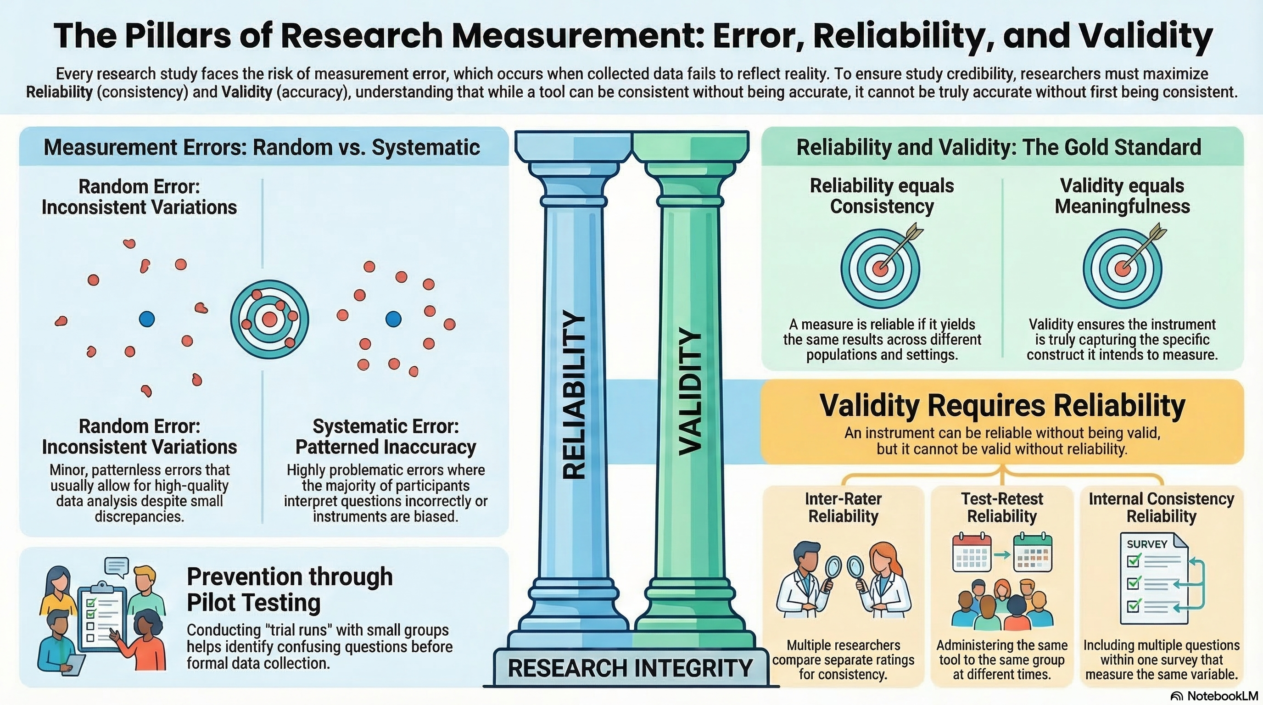
NotebookLM 생성 요약 인포그래픽. 해설 영상·팟캐스트는 resource/ 참조.

Quiz
출처: 02_Assets/assessment/GE2021_TestBank.xlsx (chapter=5) · 5문항

Q1. A carefully designed study can usually eliminate measurement errors entirely.
- A. TRUE
- B. FALSE
 정답 보기
정답: B
Measurement errors are present in any design; the realistic goal is to minimize them, not eliminate them.

Q2. Which of the following BEST defines a measurement error?
- A. A discrepancy between collected data and reality due to how the construct was measured
- B. A statistical mistake made during data analysis
- C. An ethical violation in the data collection process
- D. A typographical error in the final research report
정답 보기
정답: A
A measurement error occurs when data do not represent reality because of the way the construct was measured.

Q3. What is the KEY characteristic that distinguishes random error from systematic error?
- A. Random error is always larger in magnitude
- B. Random error always invalidates the entire dataset
- C. Random error only occurs in qualitative studies
- D. Random error has no consistent pattern
정답 보기
정답: D
Random error is inconsistent and has no pattern, while systematic error shows a consistent pattern across participants.

Q4. Asking participants “How often do you feel anxious?” with options Never/Rarely/Sometimes/Often is likely to introduce which problem?
- A. Random error caused by vague qualifiers interpreted differently by participants
- B. Systematic error from a flawed instrument
- C. Predictive validity issues
- D. Inter-rater reliability conflicts
정답 보기
정답: A
Words like “often” are interpreted differently by people (Barnes et al., 2003), creating random error with no consistent pattern.

Q5. A study in a Muslim and Jewish neighborhood asks “How often do you go to church?” to measure religiosity. The resulting data would suffer from:
- A. Random error due to vague terms
- B. High predictive validity
- C. Systematic error caused by a flawed measurement instrument
- D. Inter-rater reliability problems
정답 보기
정답: C
The question systematically misrepresents religiosity for non-Christian populations, producing a consistent error pattern across most participants.

Reference

