[Lecture Note] Sampling
  - GE2021 Research Technology, Fall 2026
Chad (Chungil Chae)
Tue, 15 September 2026

Learning Objectives
- 6-1 Explain the purpose of sampling.
- 6-2 Compare and contrast probability and nonprobability sampling.
- 6-3 Describe the types of nonprobability sampling.
- 6-4 Summarize the types of probability sampling.
- 6-5 Understand sampling error, confidence interval, and saturation.

SHORT VIDEO INTRODUCTION
https://www.youtube.com/watch?v=pTuj57uXWlk

Sampling

- Sampling: the procedure used by researchers to select a subset of the population that can be used to conduct scientific study.
- Sample: the subset of the population used in sampling.
  - By following sampling procedures, researchers increase the likelihood of getting a representative subset of the population as their sample.
- Population: the entire group of people that are the focus of the study.
- Representative sample: one that reflects the same features of interest as the entire population.
- The first step toward finding the best sampling technique is to determine the population of interest and develop a sampling frame.
  - Sampling frame: a list of the entire population of the study.
  - Researchers have developed different ways to sample from a population even if a sampling frame is not possible.

Probability and Nonprobability Sampling

- Probability: participants are randomly selected and a sampling frame is often used.
- Nonprobability: participants are often not randomly selected and a sampling frame may not be available.
- Randomization for sampling means everyone in the population has an equal chance of participating in the study.
- It is common for qualitative studies to use nonprobability sampling types and for quantitative studies to use probability sampling types.
- Probability sampling often results in a larger sample size while nonprobability sampling results in a smaller sample size.

Types of Nonprobability Sampling
Nonprobability sampling includes various techniques that do not include an equal change of participation. They often involve populations that are difficult to reach or where a sampling frame does not exist.

Convenience Sampling
- Convenience sampling: technique that allows the researcher to select any participants who are available to participate in a study, even if they are not representative of a population.
- Their participation happens by availability and accident, so this is often also called accidental sampling.
- Pilot studies: initial inquiries that pave the way for larger studies.
  - Helps avoid badly conducted larger studies.
  - Cost-effective way to test aspects of a study.

Snowball Sampling
- Snowball sampling: technique in which participants are selected by word of mouth.
  - One or a few participants are willing to help find more participants.
  - May not be representative of the entire population because the researcher selects only participants who know each other.
- A researcher can start with convenience sampling and continue with snowball.
- A researcher should try to introduce as much participant variety as possible by encouraging participants to recommend people with specific characteristics to participate.

Purposive Sampling
- Purposive sampling: technique that allows the researcher to select participants of interest for the study; also called judgmental sampling.
- Homogenous sampling: type of purposive sampling technique in which participants are chosen based on a trait of characteristic of interest.
  - Each participant must have the specific characteristic the researcher is looking for.
- Deviant case sampling: focuses on unusual or very specific cases.
- Purposive sampling allows a researcher to pick participants according to the characteristic under the study, but that means the results of the study cannot be generalized to the greater population and offer low external validity.

Quota Sampling
- Quota sampling: technique that compares different groups within the population of interest; found in both qualitative and quantitative designs.
  - The researcher needs a sample of predetermined quota or proportions.
- Proportional quota sampling: the sample’s representation of the same proportion as it exists in the entire population of interest.
- Non-proportional quota sampling: uses a different quota from the one found in the population of interest because the study’s aim is to compare two or more different groups of interest.

Types of Probability Sampling
All types of probability sampling use randomization, but they vary in the methodology used to choose participants, which depends on the aim of the study.

Simple Random Sampling
- Simple random sampling: sampling procedure that relies on complete randomization without any specific boundaries.
- Conducted in one step using techniques such as random number generation.
- Every member has an equal chance of participating and it ensures representation of the population.
- It requires a complete list of the population from which the sample is drawn.

Systematic Random Sampling
- Systematic random sampling: same technique as simple random sampling but has a level of organization embedded in it.
- A systematic way of randomly selecting participants from a sampling frame.
- Operates under the assumption that participants are randomly order in a sampling frame so everyone in the list has the same chance of participating in the study.

Stratified Random Sampling
- Stratified random sampling: a technique that become valuable when the study is focused on understanding, comparing, or analyzing different groups of a population.
  - Requires equal numbers of participants from each group.
- Strata: lists of different groups to choose participants from.
- Proportionate stratified sampling: type of sampling that follows the proportions of the population but also creates specific strata that are of interest to the study.
- Disproportionate stratified sampling: a sample in which the proportions are not equivalent to the proportions in the entire population.

Cluster Random Sampling
- Cluster random sampling: useful technique for when the population of interest is widely spread out.
- Researcher follows two steps:
  - Clusters are randomly defined.
  - A cluster is a group of population in a specific geographical area.
  - Participants are randomly selected from each participating cluster.

Sampling Assessment

Sampling Error
- Sampling error is a statistical measurement that broadly represents how different the sample size is from the population of interest.
- Used in quantitative studies.
- Helps to determine whether the sample is sufficiently representative to the entire population.
- A small sampling size indicates a good match between the sample and entire population, which allows researchers to generalize their findings beyond the sample.
- Sampling error is measured for any different parameters of the population that are the focus of the study.

Confidence Interval
- Confidence interval (CI) measures the confidence of lack of confidence in the sample size and sampling method.
- One of the first indexes looked at in a quantitative study.
- Higher sample sizes lead to higher confidence.

Saturation
- Saturation is the measure used to estimate the right sample size in qualitative work.
- Saturation refers to the moment in qualitative data collection where no new information is coming in.
- Reaching saturation means the sample size is sufficient and data collection can stop.

Chapter Infographic
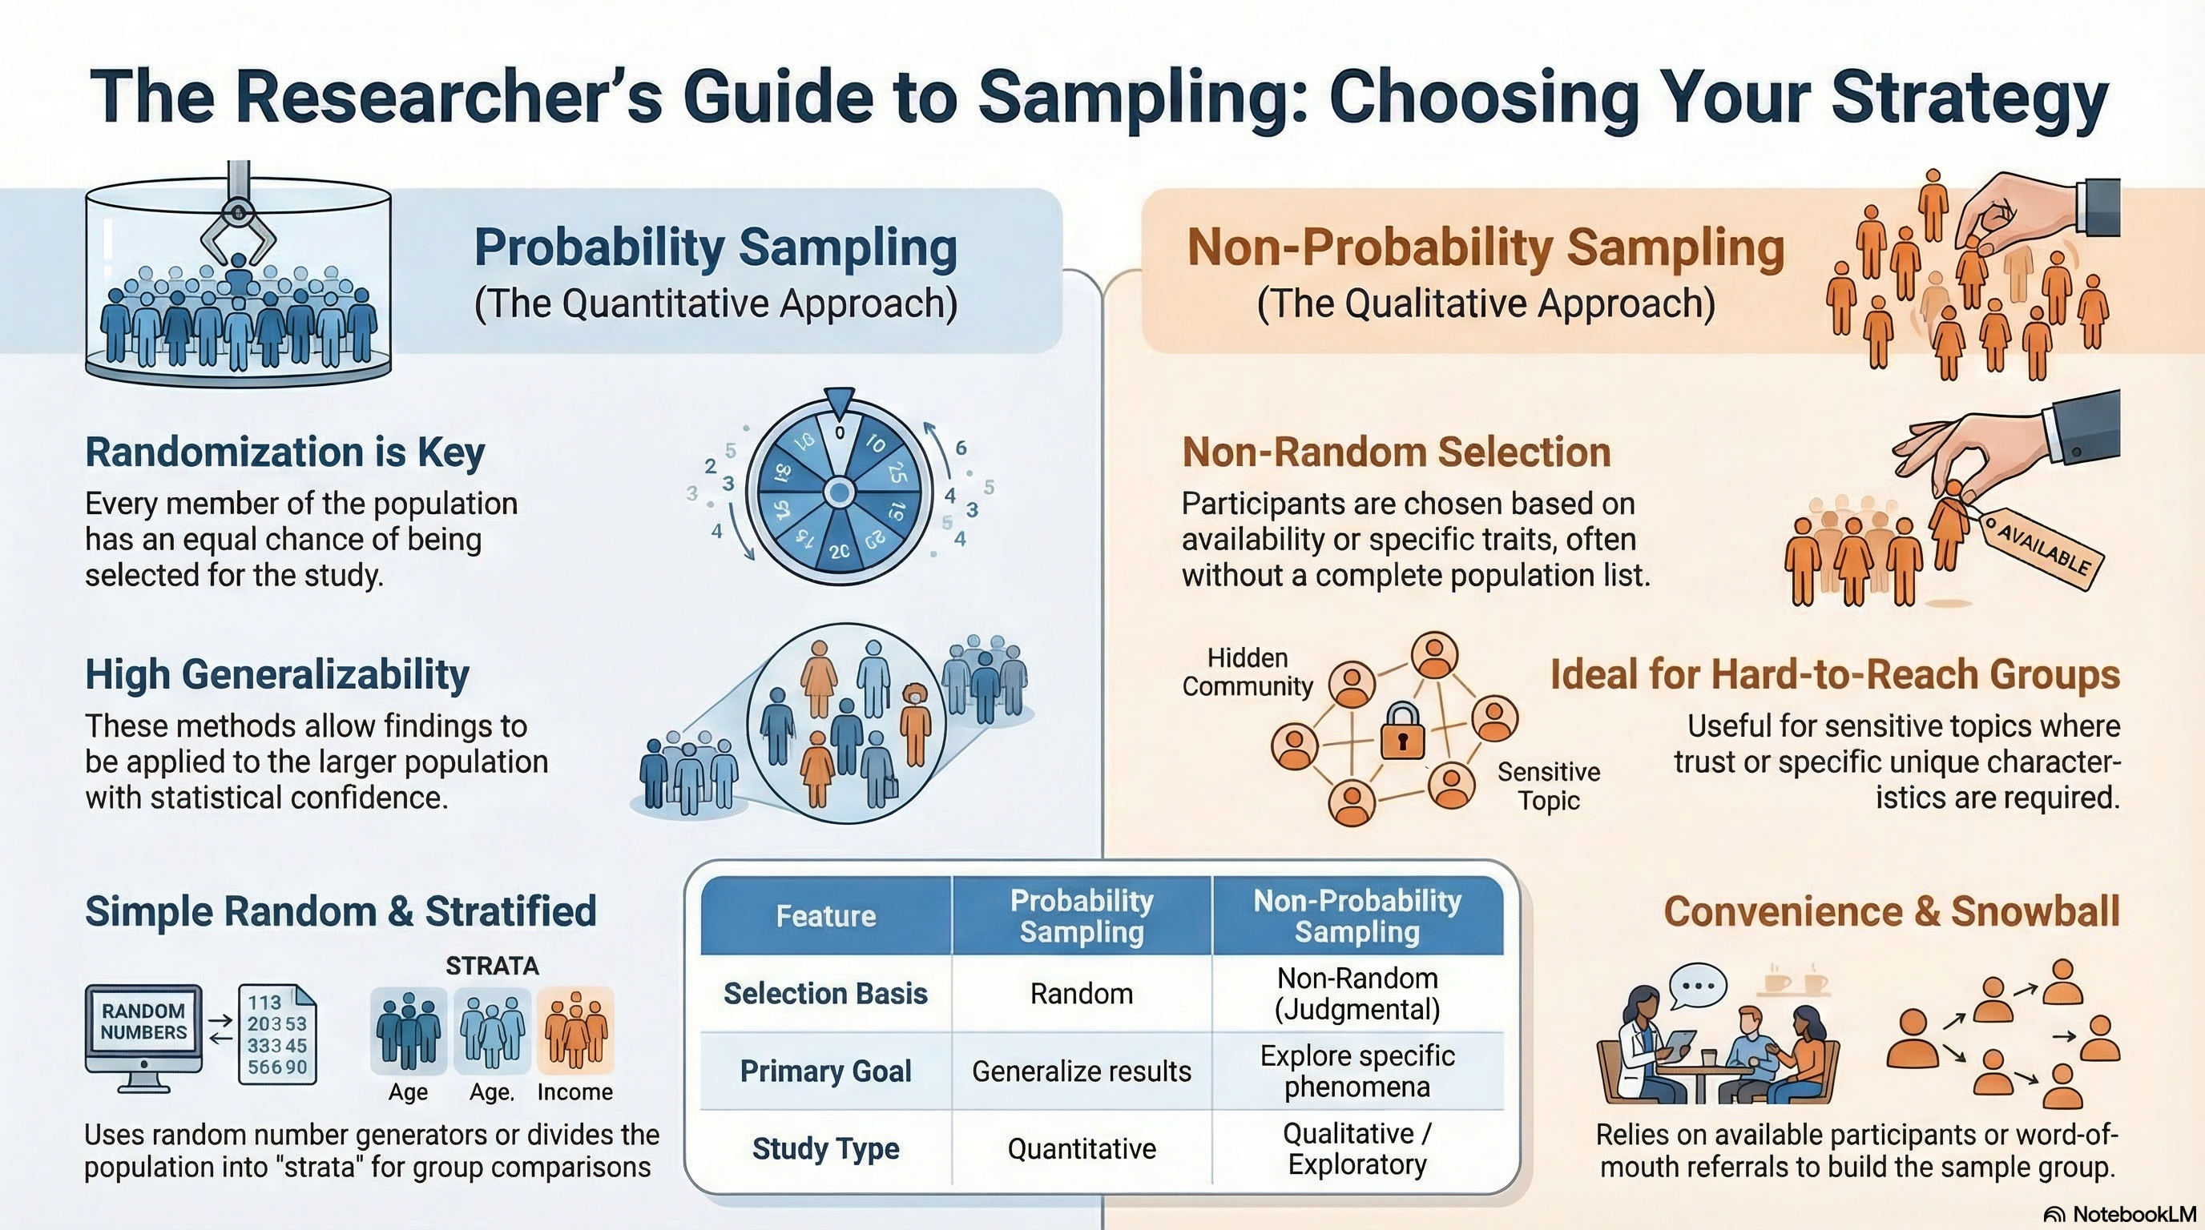
NotebookLM 생성 요약 인포그래픽. 해설 영상·팟캐스트는 resource/ 참조.

Quiz
출처: 02_Assets/assessment/GE2021_TestBank.xlsx (chapter=6) · 5문항

Q1. A sampling frame is a complete list of the entire population of interest in a study.
- A. TRUE
- B. FALSE
 정답 보기
정답: A
A sampling frame is defined as a list of the entire population of a study.

Q2. Which of the following BEST defines “sampling”?
- A. The process of analyzing collected data
- B. The act of writing the literature review
- C. A statistical test of significance
- D. The procedure used to select a subset of the population for a scientific study
정답 보기
정답: D
Sampling is the procedure researchers use to select a subset of the population (a sample) to conduct the study.

Q3. A researcher studying students at a specific university visits the registrar to obtain a roster of all enrolled students. This roster serves as the:
- A. Sample
- B. Strata
- C. Sampling frame
- D. Pilot study
정답 보기
정답: C
A complete list of the population from which a sample is drawn is called the sampling frame.

Q4. The MAIN distinction between probability and non-probability sampling lies in:
- A. Sample size
- B. Cost of the study
- C. Random selection of participants and use of a sampling frame
- D. The qualitative or quantitative nature of the analysis
정답 보기
정답: C
Probability sampling uses random selection (and usually a sampling frame); non-probability sampling does not.

Q5. A researcher studying HIV risk behaviors among newly arrived undocumented immigrants will most likely use which type of sampling?
- A. Simple random sampling
- B. Stratified random sampling
- C. Non-probability sampling, because participants are sensitive and hard to reach
- D. Systematic random sampling
정답 보기
정답: C
Sensitive topics with hard-to-reach populations call for non-probability sampling so the researcher can build trust before recruitment.

Reference

