[Lecture Note] Data Collection for Quantitative Research
  - GE2021 Research Technology, Fall 2026
Chad (Chungil Chae)
Tue, 15 September 2026

Learning Objectives
- 7-1 Familiarize yourself with the details of experimental design.
- 7-2 Familiarize yourself with the details of quasi-experimental design.
- 7-3 Understand the steps of designing a survey study.
- 7-4 Consider additional data collection sources.

SHORT VIDEO INTRODUCTION
https://www.youtube.com/watch?v=Vwtxlgudc4s

https://www.youtube.com/watch?v=mUfYXr4VKgI

Data Collection in Experimental Design

- Experimental designs are unique quantitative studies that include specific details.
- They attempt to investigate the possibility of how variable may affect each other in a controlled setting.

Review of Experimental Design
- Quantitative studies collect information in the form of numbers to standardize information so that it can be processed through statistical tests.
- Experimental research: conducting an experiment or intervention on one of the randomly assigned groups in the study while controlling finding with a second group.
  - The experimental group is exposed to a variable of study, while the control group experiences the same conditions, except they do not undergo any manipulation.
  - For an experiment, the researcher needs to:
    - Randomly assign participants into control and experimental groups
    - Conduct a pretest and posttest to measure the expected areas of change
    - Protect findings from other external explanations

Collecting Data in Experimental Design
- The data collected in the experimental design is the standardized information collected at the beginning and end of the study.
  - In classical experimental design, both the control and intervention groups take pretests and posttests.
  - The pretest is identical to the posttest, and if there is a statistically significant difference between them, the null hypothesis can be rejected.

Data Collection in Quasi-Experimental Design

- A classic experimental design is not always feasible for various reasons
  - Impossibility of randomization, non-equivalent groups available, and so on.
- Quasi-experimental studies allow the researcher to conduct some form of intervention, training, or other experiment and measure the impact, without fulfilling all the required conditions for the classic experimental study.

Data Collection in Surveys

- Survey: refers to the method of data collection
- Questionnaire: the instrument containing the questions
- Non-standardized survey questionnaire: a questionnaire that was never tested for reliability and validity.
- Standardized survey questionnaire: a questionnaire that has been tested and is a reliable and valid form of data collection.

Steps to Develop Survey
- Step 1. Develop a list of constructs
- Step 2. Determine constructs
- Step 3. Create the first variables
- Step 4. Turn constructs into variables
- Step 5. Tips and ideas on crafting the best possible questions
- Step 6. Organize in a manner that attracts and holds participant attention
- Step 7. Create an answer scale
- Step 8. Conduct a pilot study to evaluate the instrument

Details in the Steps
- Step 1. Develop a list of constructs
  - Developing a complete list of all the items and constructs to be measured in a questionnaire stimulates thinking about ways to measure them.
- Step 2. Determine constructs
  - From the list, figure out which ones are constructs and which ones are items to measure.
- Step 3. Create the first variables
  - For items to be measured, it is best to look around for established survey instruments that may be related to the study.
  - Some potential sources to find questions are U.S. Census data and questionnaires from organizations such as the Department of Education, Centers for Disease Control and Prevention, and so on.

- Step 4. Turn constructs into variables
  - Researchers can consult the literature to look for scientific possibilities and enumerate them on the questionnaire, or create a brief, open-ended question.
  - Closed variables have predefined answers or multiple-choice options that the participant can select from.
    - More specific and can distinguish between categories
  - Open variables are where a participant supplies their own answer in their own words.
    - Not specific and best used to capture opinions, views, and attitudes, especially about sensitive topics.

- Step 5. Tips and ideas on crafting the best possible questions
  - Clarity: the wording of questions needs to be clear and grammatically correct.
  - Simplicity: participants donate their time to fill out a survey, and they should not need to struggle to understand what is being asked in a question.
  - Unbiased: avoid guiding participants’ answers.
  - Intelligible: use of technical terms can confuse participants.
  - Avoid Social Desirability: social desirability is the tendency where participants want to look good and avoid the truth.
  - Avoid double-barreled questions: double-vision or double-barreled question ask about more than one concept but only allow one answer from the respondent.
  - Avoid double-negatives: Questions with two negative statements can be unclear.
  - Contingency questions: contingency questions are follow-up questions at the end of a questionnaire; often a respondent’s answer to a question triggers another question.
  - Avoid dangling alternatives: dangling alternatives are when alternatives are put in a question before introducing the topic.
  - Avoid hypothetical questions: they are difficult to capture and may be understood differently by different people.

- Step 6. Organize in a manner that attracts and holds participant attention
  - When questions bore participants, it can change their attitude towards the entire questionnaire.
  - Their attention may decrease as they answer each question, and they are less willing to respond accurately.
  - It is best practice to ask demographic questions at the end, after the attention-requiring questions.
    - Participants may also be willing to answer more accurately if they have not yet exposed their identity.
  - Questions should also follow a logical sequence.
  - Researchers should be wary of using only scale measurements, because participants may start skipping questions or selecting the same rating repetitively.

- Step 7. Create an answer scale
  - A scale needs to range from the maximum of a concept to the minimum of the same concept.
  - Depending on the purpose of the question, consider having an odd or even number of response options.
    - If you are looking to force respondents to take a stand, have an even number of options.
  - Answers should be inclusive of all options and gradually progress from one to another.

- Step 8. Conduct a pilot study to evaluate the instrument
  - Pilot study: a way of testing an instrument with a small group of participants that allows the researcher to get feedback on the instrument from them.
    - It can give the researcher a sense of how much time respondents need to complete it, making recruiting easier.
    - The researcher can determine any issues in understanding questions, their sequence, of it any questions caused discomfort.
    - Participants may volunteer suggestions about certain terms or language that will best convey accurate information.
    - The researcher can test data entry and correct any problems caused during the data collection phase.

Methods of Data Collection

- The method of data collection is focused on the process of transforming raw information from participants into measurable units that can later be analyzed.
- Researchers are actively involved in data collection and should follow specific rules on best practices to systematically and professionally collect the information.

- Personally Collecting Questionnaires
  - Researchers may approach people individually and ask them the questions or have them read and answer them on their own; alternatively, they could distribute written questionnaires and collect them after completion.
  - Advantages to in-person data collection:
    - The researcher can observe body language, record impressions, and keep records of additional information not included in the questionnaire.
    - It is more likely that a participant will fully complete the questionnaire.
    - A longer questionnaire is easier to complete face-to-face, since participants are more likely to talk at length to another person rather than focus on a long, written questionnaire.
  - Disadvantages:
    - Cost limitations
    - Time limitations

- Computer-Assisted Telephone Interviewing
  - Computer-assisted telephone interviewing (CATI) is used to find the right respondents and sometimes to conduct the interview electronically.
  - If CATI redirects the respondent to an interviewer, all interviewers must be trained.
    - They should be familiar with the content of the study, set a comfortable tone, and use neutral language to avoid hinting at preferred answers.

- Virtual Data Collection
  - Online surveys have become very popular.
  - Vast numbers of participants can be recruited in a matter of minutes, with higher response rates.
    - Sample sizes have grown immensely because of this.
  - Drawbacks include:
    - A substantial portion of the population does not have access to the internet.
    - Participants who feel strongly about an issue are more likely to participate, capturing more positive and negative extremes while missing responses tending toward the middle.
    - The researcher cannot guarantee the identity of the respondent in an online setting.

Chapter Infographic
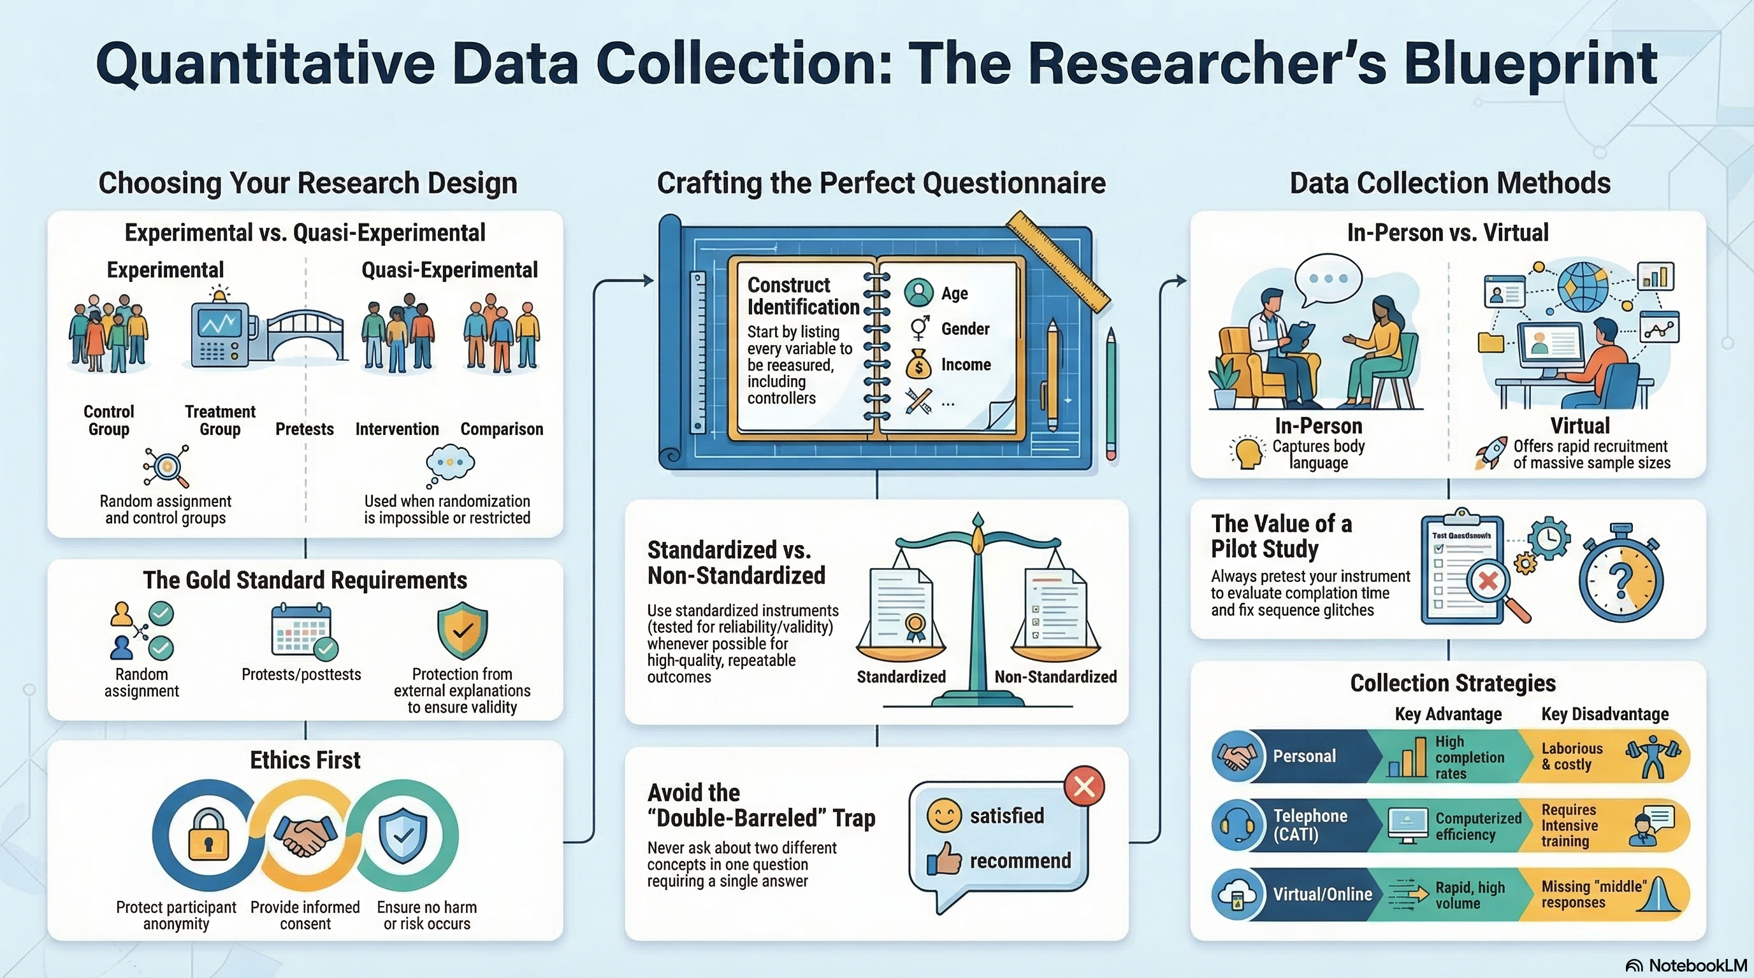
NotebookLM 생성 요약 인포그래픽. 해설 영상·팟캐스트는 resource/ 참조.

Quiz
출처: 02_Assets/assessment/GE2021_TestBank.xlsx (chapter=7) · 5문항

Q1. A classic experimental design requires random assignment of participants into experimental and control groups.
- A. TRUE
- B. FALSE
 정답 보기
정답: A
Random assignment of participants into experimental and control groups is a basic requirement of classic experimental design.

Q2. Which of the following is NOT one of the three basic requirements of experimental research listed in Chapter 7?
- A. Randomly assign participants to control and experimental groups
- B. Conduct a pretest and a posttest to measure expected change
- C. Protect findings from other external explanations
- D. Use a non-probability convenience sample only
정답 보기
정답: D
The three requirements are random assignment, pretest/posttest, and protection from external explanations. Convenience-only sampling is not required.

Q3. In an ideal experimental design, the control group is treated identically to the experimental group EXCEPT that:
- A. It is given a different pretest
- B. It is not exposed to the variable being manipulated
- C. It uses different demographic criteria
- D. It receives a different posttest
정답 보기
정답: B
Control groups are kept under identical conditions but are not exposed to the manipulation/variable of interest.

Q4. Quasi-experimental research is typically chosen when:
- A. Random assignment is impossible or when pretest data or equivalent groups are unavailable
- B. The study has unlimited time and budget
- C. Researchers want to avoid using any participants
- D. A standardized questionnaire is being used
정답 보기
정답: A
Quasi-experimental designs are used when classic experimental conditions (e.g., randomization, pretests, equivalent groups) cannot be met.

Q5. A study compares students who play a poverty-simulation game with students who watch a romantic movie. The romantic-movie group serves as the:
- A. Experimental group
- B. Pilot sample
- C. Control group
- D. Stratified subgroup
정답 보기
정답: C
The group that does not receive the experimental manipulation (romantic movie group) is the control group.

Reference

