[Lecture Note] Secondary Data
  - GE2021 Research Technology, Fall 2026
Chad (Chungil Chae)
Tue, 15 September 2026

Learning Objectives
- 8-1 Describe the benefits of using secondary data.
- 8-2 Identify the major sources of secondary data.
- 8-3 Explain the drawbacks of using secondary data.

SHORT VIDEO INTRODUCTION
https://www.youtube.com/watch?v=CPQ95B95bWE&t=101s

Benefits of Using Secondary Data

- Secondary data: data or raw information collected by other researchers.
- Primary data: data collected for a specific purpose by the researcher.

Availability of Data
- Researchers may be interested in data or information that has become impossible to collect.
- Accessing secondary data allows the researcher to have information that would have never been directly available to them.

Availability of Design and Sampling Information
- When data is available from a previous study, the researcher also has all the details on how the study was conducted, designed, and what sampling type was selected.
- This frees the researcher from having to make such decisions, but it is still important that they become familiar with the design, sampling, and data collection process, because the design is related to the data analysis.

Opportunities for Replication
- Replication of a study can happen in two ways:
  - Collect primary data that are exactly like the original study, but in a different population or location to see whether the findings hold true
  - Use secondary data by collecting additional information that may be missing from the original study.
  - Draw on the original study to learn additional information from the population
  - Data can be collected from the same participants or from the same type of population.

Protection of Participants
- Secondary data can be useful with sensitive populations of interest.
- Interviewing a participant and asking them to recall difficult events can cause emotional and psychological harm, so using secondary data such as police reports, medical examinations, and so on, can protect the participants.

Time Effectiveness
- Collecting primary data requires a great deal of time, especially for larger studies.
- Analyzing already-collected data is much easier, and the researcher is able to move directly to cleaning, coding, and analyzing the data.
  - Often secondary data is already clean, without missing values or other issues researchers must resolve when working with primary data. ## Cost Effectiveness
- Primary data collection requires a large budget that may not always be available.

Large Data Sets
- Secondary data allows the researcher to use a large amount of data that would not have been otherwise possible.
- Larger data sets allow the researcher to analyze huge amounts of data, which make it easier to generalize their findings to the general population.
- Data scraping: the process of extracting large amounts of information from social media, business sites, or any other websites of interest into a readable spreadsheet.

Major Sources of Secondary Data

- Although there is an abundant amount of secondary data available, it is important to carefully examine the secondary sources by looking at their methodologies.
- The researcher also needs information on data availability, such as the possibility of using the data for their own analysis and whether there are applicable terms and conditions.

Government Statistics
- All governments collect various forms of information about their citizens.
- These large databases are available to researchers in raw form and include basic information.
- Government statistics are some of the most comprehensive and oldest data available for most populations.
- Data sets are available from government agencies such as the Census Bureau, the Centers for Disease Control and Prevention, the National Archives, the Department of Education, and so on.

Research University Data
- Research universities often create institutes dedicated to data collection in a specific field that make valuable longitudinal data available to other researchers.
- One of the largest resources of data sets available to students is the Inter-university Consortium for Political and Social Research (ICPSR)
  - The ICPSR is hosted by the University of Michigan and is a collaboration of 776 institutions, mostly academic, but also government agencies and others.
- Another such resource is the General Social Survey (GSS), which has been collecting data since 1972 and has sister branches internationally.
- Another option is the data collected by a specific researcher at a research university.
  - Many researchers want other researchers to analyze their data and are eager to provide all the information needed if they are asked, but this remains their prerogative.

Institutional Data
- Any large organization, such as schools, hospitals, large businesses, and so on, collects information about their clients and employees.
- Their data are often in raw form and not collected for research purposes, but they are still a potential source of data for researchers.

Online Sources
- Social media hubs have demographic data and data pertaining to specific issues.
- Online reviews of products, procedures, events, and so on, can also provide information.

Disadvantages of Secondary Data

Uncertainty of Constructs
- New studies and findings continually improve previous construct measurements, so using secondary data can limit a study to the results of an older or possibly outdated data collection method.
- The original study may have had a different focus, so some constructs may have been more important to the original researchers than it is to the new researcher.
- Researchers must consider whether the original construct fits the focus of their current study; uncertainty about the measurement of the original construct can cause flaws in the new study’s results.

Ambiguity of Measurement Error
- When a researcher is highly involved in the process of data collection, they are aware of every aspect of the process, which is crucial to data analysis.
- In using secondary data, researcher often take the information at face validity because there is a lack of good sense of measurement error.

Passage of Time
- There is a possibility that secondary data is outdated.
- Depending on the study’s focus, some information becomes old quite quickly, whereas other information may remain relevant.
- However, the passage of time can be beneficial if the researcher is interested in longitudinal studies and wants to see how a concept has changed over time.

Chapter Infographic
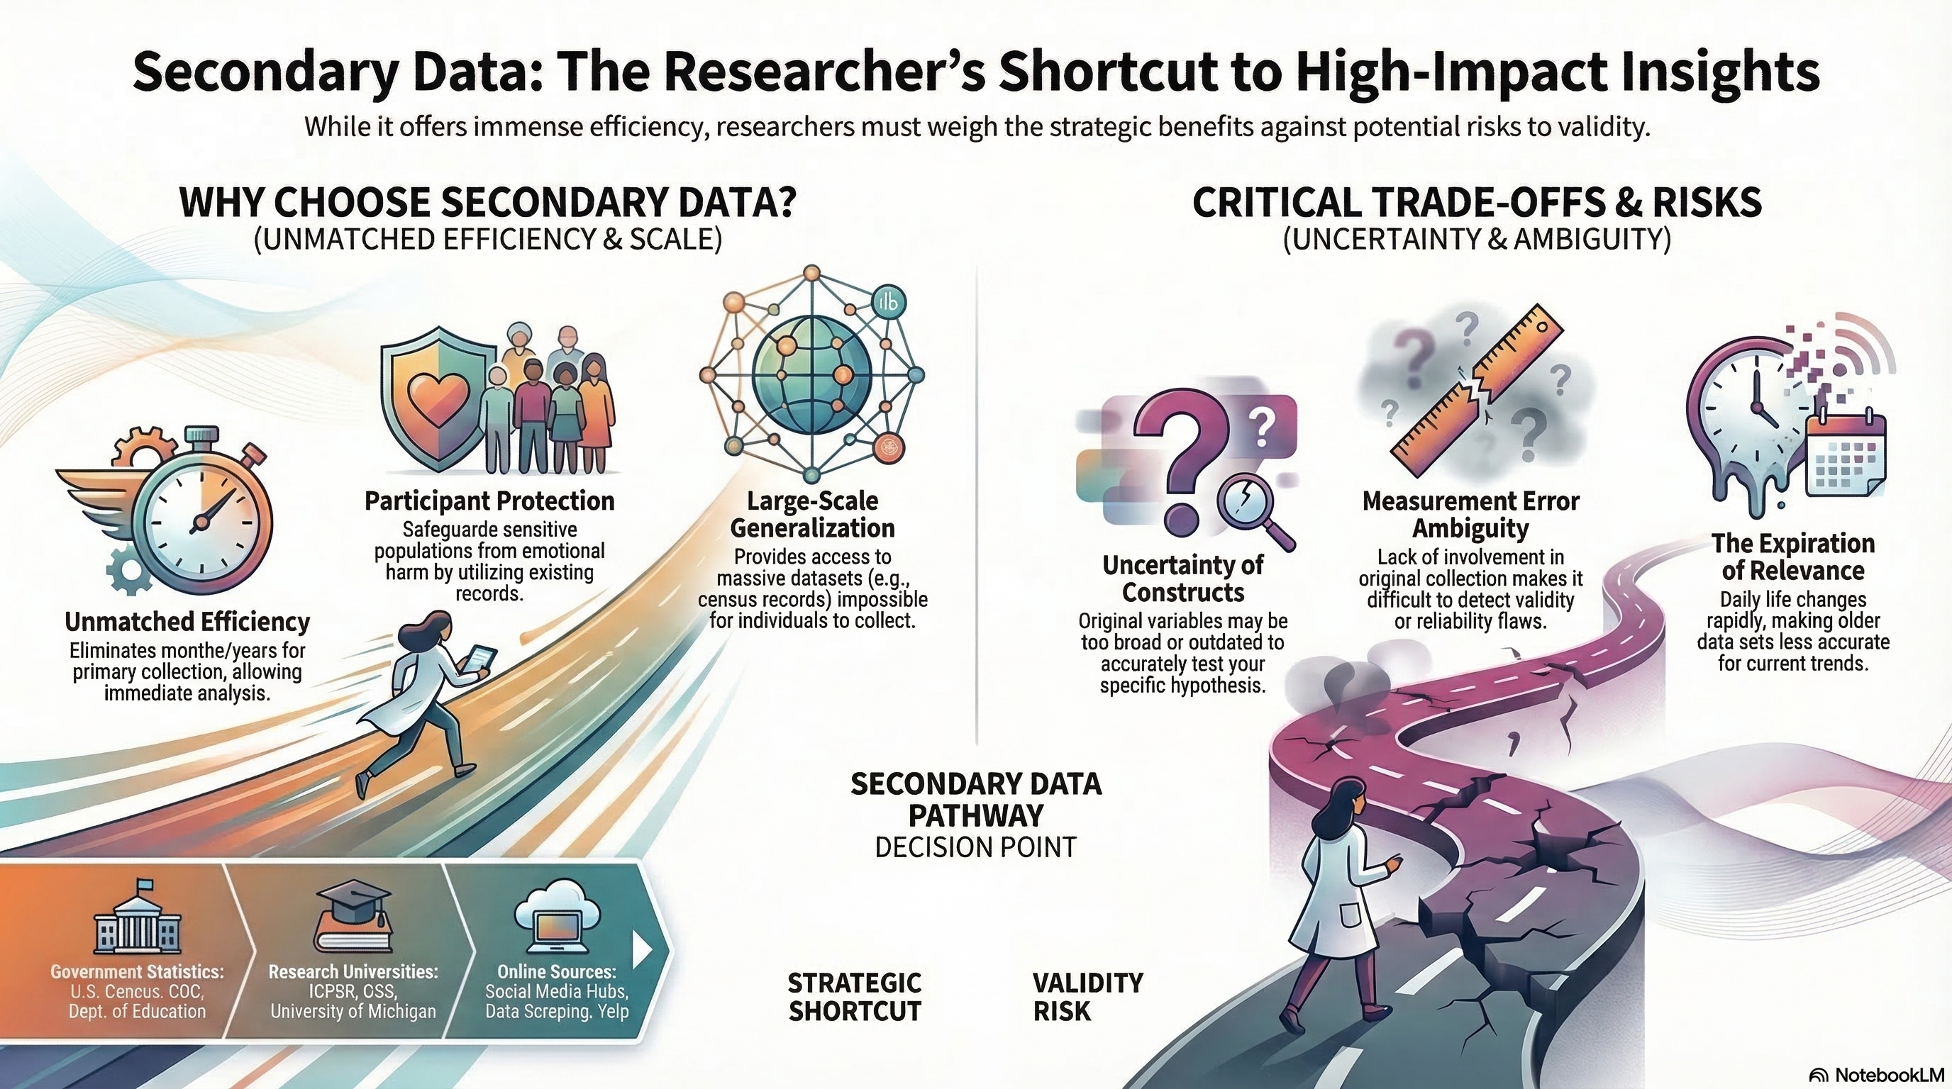
NotebookLM 생성 요약 인포그래픽. 해설 영상·팟캐스트는 resource/ 참조.

Quiz
출처: 02_Assets/assessment/GE2021_TestBank.xlsx (chapter=8) · 5문항

Q1. Primary data are data collected directly by the researcher or research team for a specific study.
- A. TRUE
- B. FALSE
 정답 보기
정답: A
Primary data are gathered firsthand by the researcher; secondary data come from other researchers or institutions.

Q2. Which of the following BEST defines secondary data?
- A. Raw information that was originally collected by other researchers or institutions and is used by a new researcher for analysis
- B. Data the researcher collects firsthand for the current study
- C. Data published only in newspapers
- D. Data that have not yet been analyzed by anyone
정답 보기
정답: A
Secondary data are data originally collected by others and reused by a new researcher for analysis.

Q3. According to Chapter 8, replication of a study can occur in which TWO ways?
- A. Collecting brand-new primary data only / hiring a new team only
- B. Translating the data into another language only
- C. Re-publishing the original article / changing the journal
- D. Collecting fresh primary data on a different population OR using the existing secondary data and adding missing information
정답 보기
정답: D
Replication can mean (1) gathering new primary data in a different population/location or (2) using the existing secondary data and adding new information.

Q4. Why is secondary data considered time-effective?
- A. It always produces statistically significant results
- B. It is published faster than primary data
- C. It eliminates the lengthy data-collection phase, letting researchers move directly to cleaning and analysis
- D. It does not require ethical review of any kind
정답 보기
정답: C
Because the data already exist, the researcher skips the long collection phase and proceeds straight to analysis.

Q5. Émile Durkheim’s use of government suicide statistics across countries is a classic example of which benefit of secondary data?
- A. Availability of information that the researcher could not have collected directly
- B. Cost effectiveness only
- C. Protection of participants
- D. Replication
정답 보기
정답: A
Durkheim could never have collected national suicide data himself; secondary government statistics made the analysis possible.

Reference

