[Lecture Note] Entering and Organizing Quantitative Data
  - GE2021 Research Technology, Fall 2026
Chad (Chungil Chae)
Tue, 15 September 2026

Learning Objectives
- 9-1 Explain the purpose of entering and organizing data logically.
- 9-2 Summarize the steps needed to prepare to enter data.
- 9-3 Describe how to organize and input variables and their information.

SHORT VIDEO INTRODUCTION
https://www.youtube.com/watch?v=hQ5rSzTP1uY

The Purpose of Entering and Organizing Quantitative Data

- There are two principles involved in organizing data:
  - Place the results in various categories where they belong
  - Remove or fix any information that has the potential to intrude into the study or analysis.
- The first step in organizing data is to enter them in a readable and meaningful form.

Preparing for Data Entry

- The task of entering data. Can be repetitive and time-consuming, but it is crucial, and even a small mistake can impact the outcome.
- Logical Formatting
  - Take a critical look at the survey questions before beginning data entry to save time and frustration.
  - Determine how the variables can best be organized to ensure the data analysis phase is simple and straightforward.

Software Packages
- Data will be organized into a spreadsheet, and researchers often enter their data directly into their software of choice to avoid file corruption.
- Common programs for entering and analyzing data are Excel, Statistical Pack for Social Science (SPSS), Statistical Analysis System (SAS), Stata, R, Minitab, JMP, and more.
- Some software programs are better for analyzing rather than entering data; it is wise to examine the options before starting.
  - Different pieces of software have different strengths and weaknesses in data analysis.
  - It may be useful to do some internet research and determine which type of spreadsheet, like Excel, is the most easily imported into the analysis software of choice.

Unique Identification
- Assign a unique identification number to every participant or case in the study.
- Each complete questionnaire requires an identification number, which should be listed in the first column of the spreadsheet.
  - Each column represents a variable, and the first variable must be the identification numbers.
  - Every row will represent one participant or one case.

Missing Data
- It is common for people to leave at least one question of a questionnaire unanswered.
- Missing information can be important for analysis because it can signal an underlying problem with a specific question.
- When recording missing information, one possibility is to leave the variable blank, or another is to put an eye-catching, specific number that is not included in the standardized variable code.

Organizing and Inputting Variables

Coding and Codebooks
- A number of other minor decisions need to be made before data entry can begin.
- First, the researcher will need to determine how the responses to specific questions will be represented on the spreadsheet.
- By coding the information, the researcher can simplify raw information in a way that is easier to analyze.
- Nominable variable: also called qualitative variable; variables where answers are not mathematically related to each other.
  - Nominal variables are one of two subtypes of categorical variables.
  - Examples: gender, race, religion, and so on.
- Categorical variables: variables with answers that can be organized around various, often limited, categories.
- Ordinal variable: the other type of categorical variable; responses do not have a numeric value, but instead represent an ordered sequence of responses.
  - Example: Strongly agree, somewhat agree, somewhat disagree, strongly disagree.
- Numerical variable: also known as quantitative variables; expressed with numerical values in the original data
  - Examples: age, income, height, and so on.
  - The dataset must be consistent for analyzing information, and determining how to represent every single variable in a numeric fashion is a fundamental part of coding.
  - There are two types of numerical variables:
    - Interval: cannot express a ratio between numbers because of the lack of a true zero.
      - Example: Temperature
    - Ratio: has a true zero point.
      - Example: number of children a person has.
- Codebook: the key to the codes in the study and how they correlate with participant responses.
  - Keep in a separate, secure file.
  - Include as much detail as possible about the coding process, such as the original coding decisions and the reasoning behind them.

Variable Names
- Each variable needs to be identified because it can be easily confused with the variable next to it.
- Best practices for naming variables in a dataset to ensure the spreadsheet is compatible with various analytical software packages:
  - Names should typically be letters from the alphabet, avoiding special symbols or characters.
  - The variable name should be a single word, but may represent a combination of words.
    - Example: “raceethnic” for race and ethnicity
  - Numbers may be a part of the variable name, but ideally they should be incorporated into a single word.
    - Example: “employm1” for primary employment position
    - The length of the variable should be short; maximum of 30-40 characters.

Variable Descriptions
- Data entry in SPSS or SAS will have boxes designated for short descriptions of variables, but if using Excel, the researcher may want to use an additional Word document to log descriptive records.
- The description should include information on how the variable was measured, a list of response choices, and other significant notes.

Notations for Responses
- Before data entry begins, the researcher needs to identify the notation for each answer choice.
- Many statistical software packages have a place to store information about answer choices, but if using Excel, it is a good idea to store notations separately.
- The notations reminds the researcher at any given moment what the numbers in the variable column stand for; however, it is not a substitute for the codebook.

Scales
- Psychometric scales are a universally accepted measure that ensures accuracy and avoids subjectivity.
- All scales should be consistent, even if the concepts are unrelated.
  - Example: making sure all question answers go from “strongly agree” to “strongly disagree” instead of the opposite order.
- Make sure to repeatedly save and back up data.

Chapter Infographic
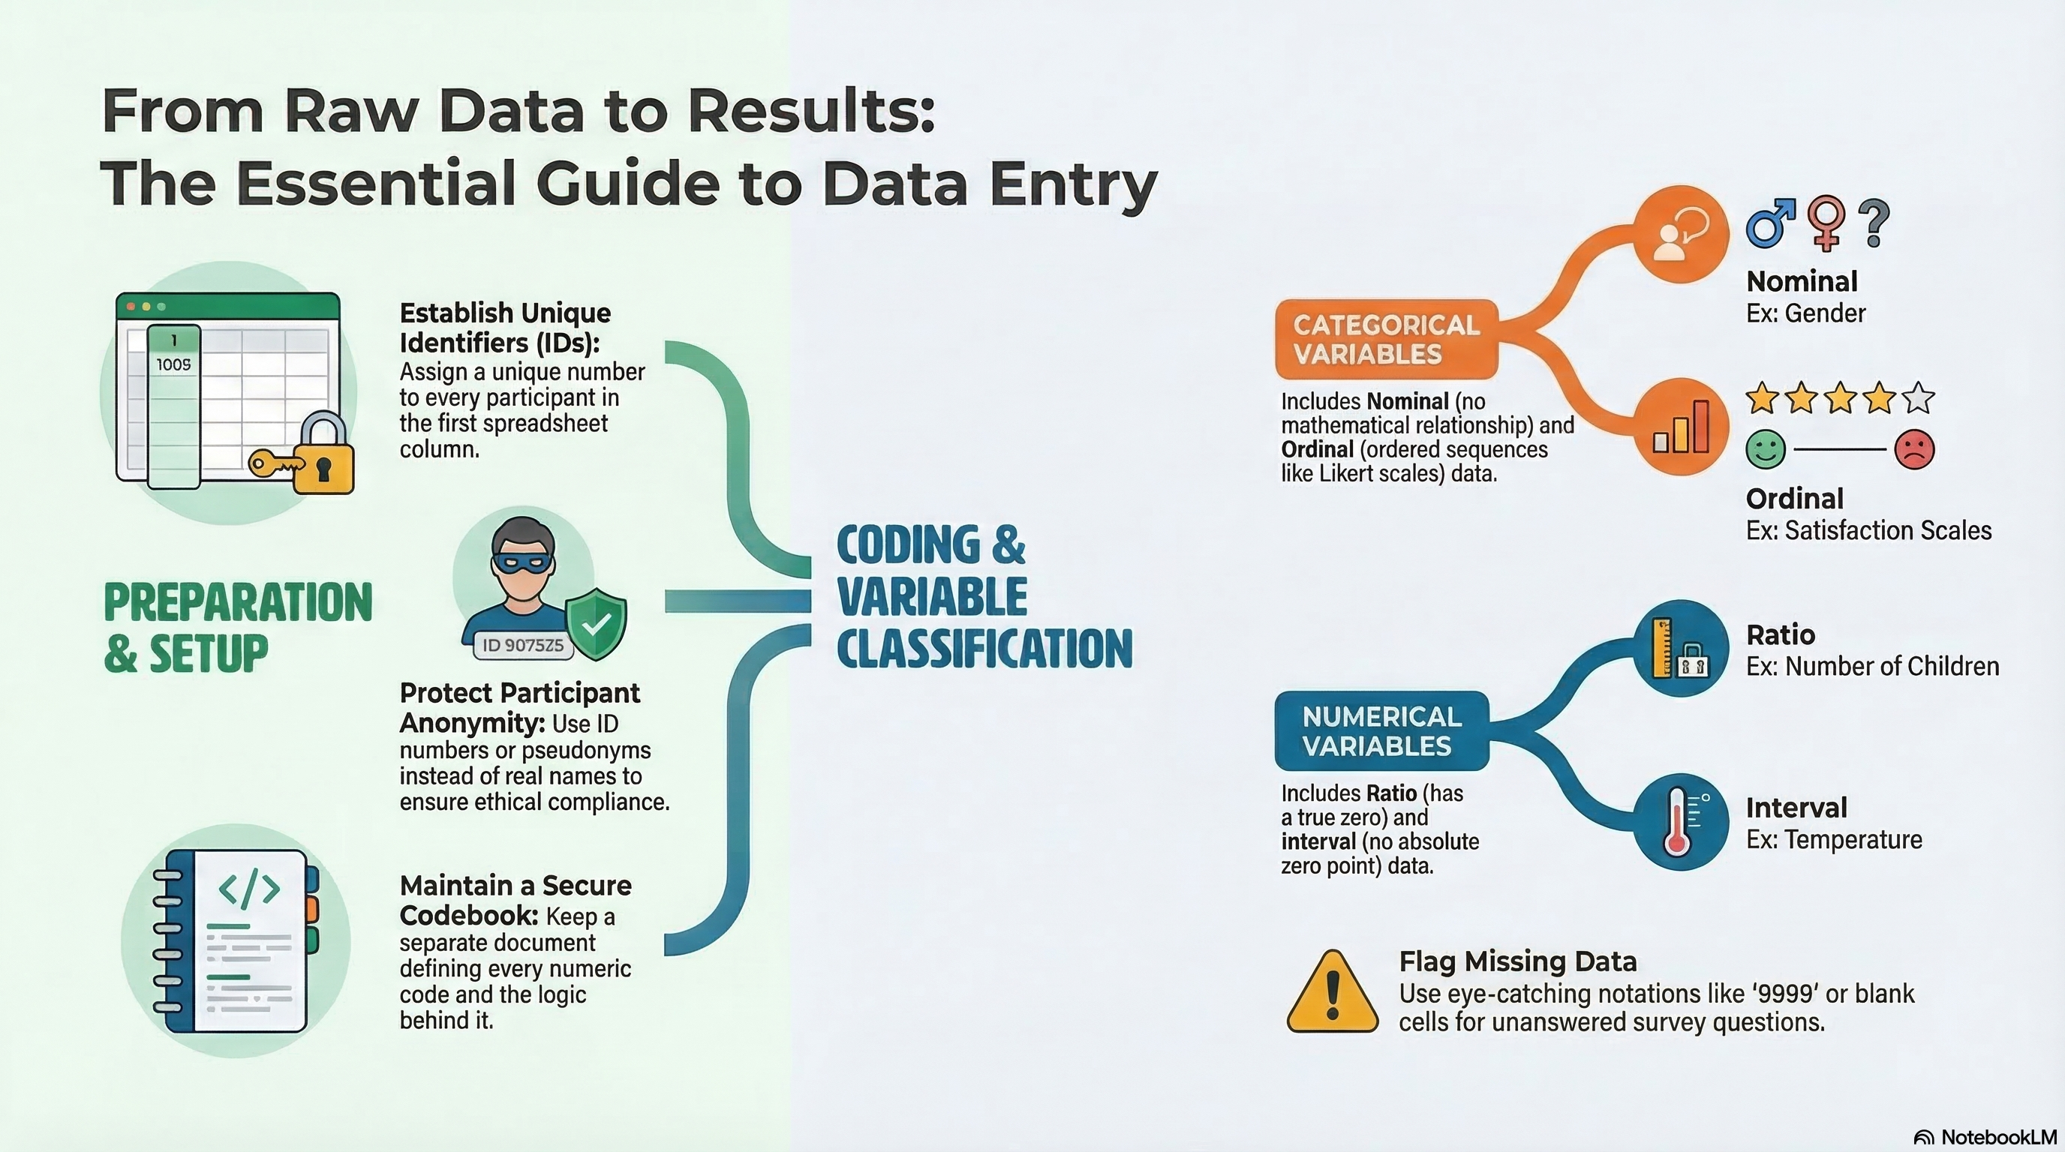
NotebookLM 생성 요약 인포그래픽. 해설 영상·팟캐스트는 resource/ 참조.

Quiz
출처: 02_Assets/assessment/GE2021_TestBank.xlsx (chapter=9) · 5문항

Q1. In a properly organized data spreadsheet, each row represents one participant (case) and each column represents one variable.
- A. TRUE
- B. FALSE
 정답 보기
정답: A
The standard convention is rows = cases/participants, columns = variables.

Q2. According to Chapter 9, the two basic principles of cleaning and organizing data are analogous to:
- A. Painting and decorating a room
- B. Grouping items into categories AND removing unnecessary items
- C. Buying new furniture and selling old ones
- D. Building and demolishing structures
정답 보기
정답: B
The chapter compares data organization to cleaning a room: (1) group items by category and (2) remove unnecessary items.

Q3. Before entering data, the researcher should critically review the questionnaire to determine:
- A. How variables can be best organized for the upcoming analysis phase
- B. Whether to delete the data
- C. Whether to abandon the study
- D. Whether to translate the data into another language
정답 보기
정답: A
Logical formatting means deciding the most analysis-friendly column order, not just copying the questionnaire order.

Q4. When using online survey platforms like SurveyMonkey or Qualtrics, the data entry phase is largely:
- A. Eliminated because data are automatically formatted into a downloadable file
- B. Twice as long as paper surveys
- C. Done only by hand
- D. Done by participants themselves
정답 보기
정답: A
Online tools deliver pre-formatted data files; the researcher proceeds directly to cleaning.

Q5. When entering data, even seemingly innocuous information (e.g., number of drinks consumed) should be treated carefully because:
- A. It is irrelevant to research
- B. Disclosure could still harm participants in unexpected ways
- C. It increases sample size
- D. It must be deleted by law
정답 보기
정답: B
Researchers cannot reliably judge harm; all identifying information must be protected as promised.

Reference

