Corporate Purpose

working

Chungil Chae

Sun, 1 December 2024

Table of contents

# Project Details

## Citation

## Abstract

tba

## Planning

### Schedule

* tba

### Progress

* Progress

## Authorship and Authors

### Author Contribution

* Supervision:
* Project administration:
  + Chungil (Chad) Chae
* Conceptualization:
  + Chungil (Chad) Chae
* Data accusation:
* Chungil (Chad) Chae
* Data curation:
* Chungil (Chad) Chae
* Formal analysis:
* Chungil (Chad) Chae
* Investigation:
* Methodology:
  + Chungil (Chad) Chae
* Resources:
* Validation:
* Visualization:
* Writing – original draft:
  + Chungil (Chad) Chae
* Writing – review & editing:
  + Chungil (Chad) Chae

### Authors

#### Chungil Chae, Ph.D., M.S.

* chadchae@gmail.com
* orcid: [000-0002-7364-1525](https://orcid.org/0000-0002-7364-1525)
* [Google Scholar](https://scholar.google.com/citations?user=c4lRBrkAAAAJ&hl=en)
* Chae (2024)

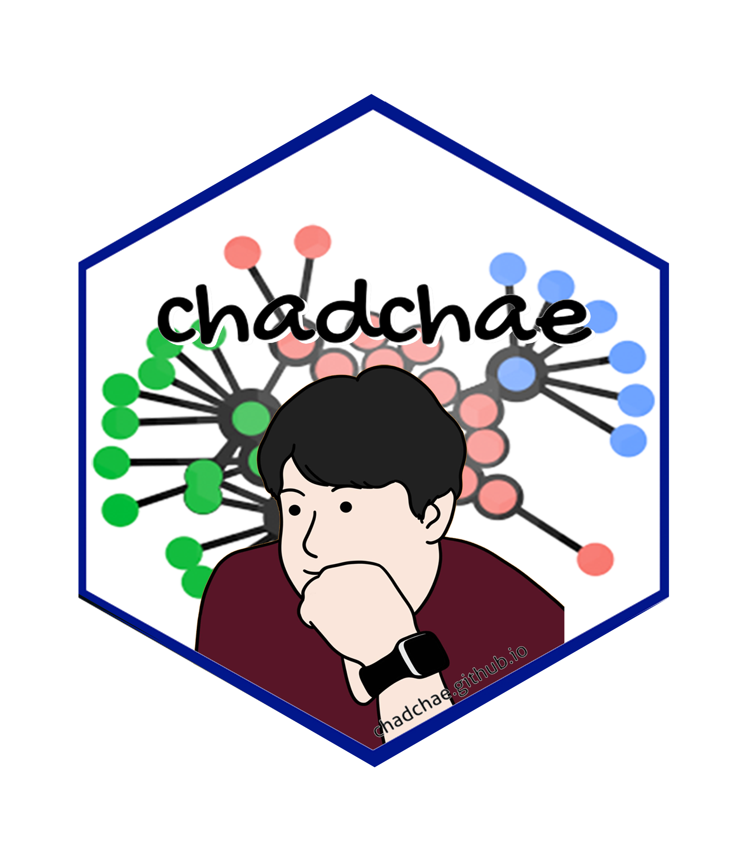

Chungil Chae Chae (2024) is an assistant professor in the field of business analytics, with a distinguished track record in organizational behavior, human resource development (HRD), learning, and development. With a prolific publication record that spans various dimensions of HRD and organizational studies, Dr. Chae has made significant contributions to understanding the dynamics of organizational support on knowledge sharing, virtual team leadership, and the structural determinants of HRD research collaboration networks. And his work embodies a deep commitment to enhancing understanding and practices in organizational behavior, HRD, learning, and development. His interdisciplinary research not only contributes to academic discourse but also offers tangible strategies for organizational improvement and individual development.

#### Author Bio 1

* tba

image or logo

bio here

### Acknowledgement

* tba

## Declearation

### IRB

### Funding

### AI

# Research Log

## 2024-06-11

* [v] 1st biblio report completed

# Meeting Log

## xxxx-xx-xx

* ☒ 10:00-10:30: Kick-off meeting

# Analysis Version

## Version 0.0.1

* Starting draft

# Draft Version

## Ver 0.0.1

* Starting draft

# Ideas and Thoughts

# Research Q & A

# Procedures

# Related Theories

# Theortical Relationship

# Theoritical Framework

## Hypothesis

# Methdology

# Method

# Data Collection

# Data

# Searching and Inclusion & Exclusion

# Round 1

## Search kewwords and category

## keywords combination

# Round 2

## Search kewwords and category

## keywords combination

# Round 3

## Search kewwords and category

## keywords combination

# PRISMA

# Reference List

Category, Classification and Decision Note for Selected Literature in Rounds

## Round 1

## Round 2

## Round 3

## Additional (during and after writing)

# Reserach Problems

# Key References

# Quotes and Paraphrases

# Products

# References

Chae, C. (2024). *Introduction to chad (chungil) chae*. <https://chadchae.github.io>