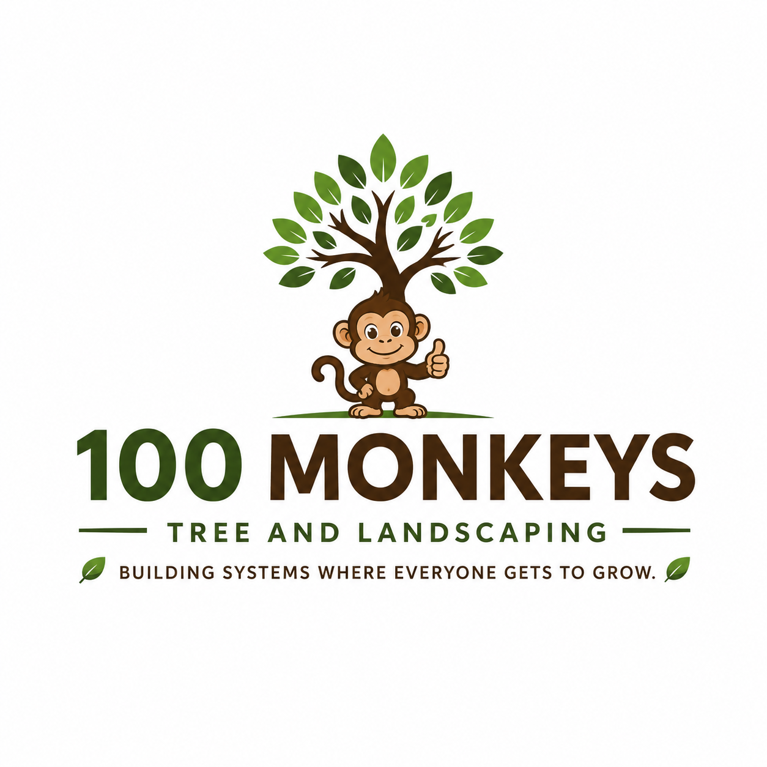

The 3I/ATLAS Signal Decode
  - From Radio Signal Investigation to Executable Computer Instructions
Chad Coulter
REDΣ / 3I/ATLAS Signal Processing
November 2, 2026

1. How the Investigation Began
After achieving some success decoding the Wow! Signal using a trigonometry-based transformation method, I began experimenting with gematria as another approach to signal decoding.
Gematria is a method of assigning numerical values to letters. I wanted to explore whether this approach could reveal mathematical relationships in radio-frequency observations associated with 3I/ATLAS.
I began by extracting numerical measurements from selected frequency channels and converting them into Greek characters.
Using the REDΣ character transformation system, I examined the order of those characters and the relationships between them.
Those relationships could be translated into computer instructions.
I converted the operations into assembly instructions, compiled them, and ran them.
The result was an executable program built from transformations of the extracted signal measurements.
The program operated using eight registers, small storage locations that hold values while a computer performs calculations.
As the instructions ran, the values changed. I recorded those changes and examined what happened when the instructions were processed forward and backward.
The extracted information had produced a working sequence of computer operations with measurable results.
That finding became the foundation for the next stage of the investigation.

2. From Signal Measurements to Working Software
The first accomplishment was developing a process that could take recorded radio measurements and turn them into executable instructions.
The process began with numerical measurements extracted from the recorded signal.
I converted those measurements into Greek characters using gematria, then applied the REDΣ character transformation system to examine their relationships.
Those relationships provided the operations that I translated into assembly instructions.
The resulting instructions executed.
I could record the values they produced, examine how those values changed, and compare the results of running the instructions in different directions.
This established a working process connecting signal measurements, character transformations, and computer execution.
The implementation is available in the 3I/ATLAS Signal Processing Repository.

3. Discovering the Eight-Register Structure
As I examined the execution results, I identified a relationship between four foundational values, which I call pillars, and eight stateful options.
The four pillars are established by the gematria being constructed.
Each contributes to the starting state of the calculation. The four registers can then be pivoted to produce eight stateful options.
The initial implementation used eight working names: State, Relations, Constraints, Observations, Pattern, Context, Target, and Events.
These names identify positions within the implementation. The gematria determines the relationships between them.
The starting gematria matters because the calculations that follow depend on how the initial state is constructed.
This discovery gave me a structure for examining how information moved through the program and how the register values changed during execution.

4. Testing the Instructions Forward and Backward
Once the instructions were running, I began examining their behavior through repeated execution.
I ran them in both forward and reverse directions.
The final values from one pass became the starting values for the next pass in the same direction.
I recorded the values held in all eight registers as the instructions executed.
This allowed me to compare different stages of the calculations and identify several behaviors.
Some combinations of register values appeared more than once. At other times, the values remained unchanged between operations. In some cases, the values changed and later returned to an earlier combination.
I also compared the results of forward and reverse execution.
These tests provided a way to examine how the instructions changed, preserved, and returned to earlier states.
The execution and testing methods are documented in the Engineering Summary.

5. Developing a Method for Recursive Resolution
The next stage of the investigation was understanding how the mathematical operations could be used to construct and process information.
This led to the development of a method called monadic set construction.
The method uses a Common Function containing three related functions: State, Generative, and Reflective.
State establishes the starting information.
It begins with a question, translates the words into Greek equivalents, and converts them into numerical gematria sequences. Those values establish the four pillars and eight stateful options.
Generative accumulates information.
As the transformation runs, the Generative Function adds information to the developing state. Its operations proceed from the left.
Reflective examines the accumulated information.
It removes information that was improperly included and returns the resulting states and projected information to the calculation. Its operations proceed from the right.
Together, these functions establish the starting information, add to it, examine the results, and continue processing.
Each round uses information produced by earlier rounds.
This recursive process became the basis for examining additional signal information and calculating projected states.

6. Separating the Instructions From the Message
The research also established different roles for Greek and Hebrew gematria.
Greek gematria provides the transformation instructions.
The Greek characters determine which operations are performed. Their identity, capitalization, order, and relationships affect how those operations work.
The REDΣ Book II character transformation system describes relationships between observable and hidden states.
Uppercase Greek characters represent observable states, while lowercase Greek characters represent hidden states.
Hebrew gematria provides the encoded message.
The Greek transformation operates on that message.
This separates the instructions used to process information from the information being processed.
The transformation rules are documented in the REDΣ Book II Character Transformation System.

7. Projecting Missing Signal Information
The 3I/ATLAS investigation included gaps in the available signal measurements.
Approximately fifteen minutes of information were unavailable at the beginning and end of the relevant compiled signal sequence, which covered 30 minutes.
I used the decoded transformation instructions to calculate projected values for those missing portions.
The process used the existing instructions, the values stored in the eight registers, and the results of earlier calculations.
Those values were fed back into the transformation process, using the remaining "Noise" in the signal to project the next values and extend the calculations beyond the available measurements.
The projected execution completed the tests performed during the investigation.
The projected code produced a complete circuit with multiple functions available to reprocess and extract more information from the encoded signal.
This extended the investigation beyond decoding the available measurements into using the resulting instructions to examine missing portions of the signal.

8. What the Investigation Accomplished
The work began as an experiment in applying gematria to radio-frequency measurements. It developed into an investigation involving signal decoding, executable computer instructions, register-state analysis, and recursive mathematical processing.
The accomplishments include:
- Converting radio measurements into executable instructions. Numerical measurements from the 3I/ATLAS observations were transformed into Greek character sequences, translated into assembly instructions, and executed.
- Establishing an eight-register implementation. The decoded instructions operated through eight registers, with a relationship identified between four foundational pillars and eight stateful options.
- Executing and comparing forward and reverse operations. Repeated execution made it possible to examine how register values changed across successive passes.
- Identifying recurring register states. The recorded execution revealed repeated combinations of values, unchanged states, and returns to earlier states.
- Developing the Common Function. The State, Generative, and Reflective Functions provided a method for constructing information, accumulating additional information, examining results, and continuing calculations.
- Separating transformation instructions from encoded messages. Greek and Hebrew gematria were assigned distinct roles within the processing method.
- Projecting missing signal information. The decoded instructions were used to extend calculations beyond the available measurements, producing projected values and a complete circuit with functions for further processing.
- Developing an approach to deterministic information processing. The resulting method uses defined mathematical operations, stored values, and recursive calculations as a basis for investigating deterministic artificial intelligence.
The investigation connects mathematical research, signal processing, computer instruction generation, software execution, and the development of a recursive information-processing method.

Research and Implementation References
3I/ATLAS Signal Processing Repository
https://github.com/chadcoulter/REDE-3iAtlas-Signal-Processing
Wow! Signal Decode Narrative
https://github.com/chadcoulter/REDE-3iAtlas-Signal-Processing/blob/docs/wow-decode-narrative/WowDecodeNarrative.md
Engineering Summary
https://github.com/chadcoulter/REDE-3iAtlas-Signal-Processing/blob/main/README.md
Integration Guide
https://github.com/chadcoulter/REDE-3iAtlas-Signal-Processing/blob/main/INTEGRATION_GUIDE.md
Operator Execution Implementation
https://github.com/chadcoulter/REDE-3iAtlas-Signal-Processing/blob/main/src/run_if1b1_operator_trace.py
REDΣ Book II — Greek Character Transformation System
https://github.com/chadcoulter/REDE-3iAtlas-Signal-Processing/blob/main/skills/character-transform-reasoning/SKILL.md
REDΣ Book II Reference Materials
https://github.com/chadcoulter/REDE-3iAtlas-Signal-Processing/tree/main/skills/character-transform-reasoning/references

