copyright GBL rev t 5/20

**MIS Global Depth-First-SearchBack-TrackingDesign  
*[Use ourDisciplined PD/AD Algorithm Top-Down Design Technique!]***

The required gs-dfs/bt (global search depth-ﬁrst-search with backtracking) by definition searches the entire MIS search space implicitly or explicitly. The dfs process searches iteratively or recursively by traversing from one partial solution state space candidate to another until maximal solutions are found. It executes backtracking to find**all** maximal/maximum (or minimal/minimum) solutions.

1. **General discussion of graph MIS problem domain:**

*“The maximal (maximum) independent set problem –*[*MIS*](https://en.wikipedia.org/wiki/Maximal_independent_set)*”*

*The MIS problem is the following: given a graph G = (V;E) and an independent set in G*

*of maximal cardinality. In the weighted case, each node v in V has an associated non-negative weight w(v) and the goal is to find maximal weight independent sets S. {v is in S and the neighborhood of v intersecting with S is not empty. This problem is NP-complete and thus it is natural to look for MIS/Cliqueapproximation algorithms.*

-MIS informal description: (Christoﬁdes, p30-31 [1]) “internally stable set,”   
 (cliques of complementary graph) – a NP-Complete problem (NP-Hard)

-MIS formal model with n is the number of vertices: (Christoﬁdes, p31) ;   
-solution space: O(3n/3) (Christoﬁdes, p53; Reingold, Nievergelt and Deo, p353)   
-graph search space: O(2n), power set of possible vertex partialcombinations

-applications: NPC, constrainted resource task scheduling, communica­tions, clique, vertex cover, ... *(note that one should be able to map in order of (p(n)) from any of theseproblems to and from the MIS formulation - NPC)*

**Proof that MIS is NP-Complete:**

First, we need to show that the MIS problem is in **NP**. We can show that a set |S| = k is may be an independent set or not in polynomial time.Second,the data structure of the 3-SAT problem (NP-Complete) can be reduced in polynomial time to the MIS problem, Thus, the 3-SAT can be solved using the MIS problem and therefore MIS is **NP-Complete**(GJ)**.**

**MIS Algorithm Domain (gs-dfs/bt)Development**

- selected algorithm: gs-bfs/bt search (Christoﬁdes, p33-35);set operations needed

The standard problem domain requirements analysis and generation of the high level design can be approached in the general pattern as indicated in the previous lecture notes. Mapping the global gs-dfs/bt algorithm to the design of a MIS search algorithm results in a tree search control structure (Christoﬁdes, pp33-35). The algorithmic design philosophy of Talbi [4] and Michaelewicz and Fogel [5] are also followed throughout this development. What are “good” heuristics?

* *Comment:* we design and analyze the MIS problem and study in detail the graph search (tree search) algorithm (Christoﬁdes) using the gs-dfs/bt search algorithm template. Individually you can study other algorithm implementation and applications for solving the MIS problem based upon other selected graph data structures (see references). *Observe that ADT(D,F,A) needed for sets in this algorithmic design*.Fordetailed MIS discussions try MIS on wikipedia. Also consider complementary[Clique problem](https://en.wikipedia.org/wiki/Clique_problem) description! Or a [Clique graph theory](https://en.wikipedia.org/wiki/Clique_(graph_theory)) description.

**MIS Problem Domain& Algorithm Domain Formal Development**

1. Problem Domain Requirements Specification form: (Christofides, p31)

-domains, D

input Di -Graph G(X,Γ), X:vertices. Γ:vertex link set (adjacency)

output Do -Maximal (Maximum) Independent setsper Christofides

-I(x); input conditions on input domain satisﬁed; x in X, link in Γ

-O(x,z); output conditions on output/input domain satisﬁed; i.e.,

a feasible/optimal solution with respect to the input domain   
-- S intersection Γ(S) = φ; independent set S in X (PD eqn 3.1 Christofides)  
-- H intersection Γ(H)not = φ for all H set in S; maximal independent set z,   
(PD eqn 3.2 Christofides)  
-- max |S| of maximal independent sets is maximum independent set(s)  
(PD eqn 3.3 Christofides)

1. Problem Domain/Algorithm Domain Integration Specification  
     
   *”Integrate MIS problem domain with gs-dfs/bt algorithm domain”*

* **Basic search constructs**for gs-dfs/bt (a tree search by construction!)
* *next-state-generator* (Di) − >x in X; I(x)
* *selection* (Di) − >x; x in X (usually from an ordered/sorted set based   
  explicitly/implicitly MIS criteria-desire terminal nodes to be MIS

(call the set Qk= Xfor each level/search-stage k of search tree!)

* *feasibility* (x, Dp) − >boolean (if true union (x, S)), S intersection Γ(S) = φ; independent set S in X
* *solution* O(x,z) “maximal “; (Dp) − >boolean; z = Dp, i.e., can no longer   
   augment Swith an x in X;
* *objective (*Dp*) ->*Do*“ordered set/*[*well founded set*](https://en.wikipedia.org/wiki/Well-founded_relation) *of MI sets is regt’d”*
* **Delay Termination** from gs-dfs/bt
* *Find all* maximal independent solutions within tbd designed *loop*
* *Generate* via gs-dfs/bt all MIS solutions without duplication!
* imports: ADT( set, set-of-sets):DiDpDo; Boolean; integer

-*Comment:*  
A) need aspeciﬁc function/algorithm (unknown) that maps input domain to output domain

B) can explicitly deﬁne axioms, A; i.e., deﬁne input/output general requirements logically for testing algorithm (including exceptions)

C) consider “better” ordering in the set of candidates based upon the # of vertex connections, …. (vertex ordering)

3. Algorithm Domain Design Speciﬁcation Refinement

* *Possibly Sort a priori nodes/vertices in* the set of candidates *Qkbased upon # of connections to other nodes? How to handle (store, process) PDs with very large number of nodes? Distributed or parallel computation?*
* *Creative data structure augmentation* of the set of candidates Qkinto Q+k and Q-kin gs-dfs/btthat provides for *generating sets without duplication*; a search tree vs. search graph (Christofides, pp 33-34;“Bron-Kerbosch Algorithm”)
* Observe thatk is the stage index (level in gs-dfs/bt search tree):S = Sk is defined as the independent set of PD graph vertices at stage k in the tree search; Sk is a partial MIS solution.
* ***Next-State Generator and Selection:***(CREATIVE!)
  + Q+k: set of vertices not selected previously at state (level) k or higher in search tree to augment Sk : updated with forward search *selecting* xik from Q+k; Q+k+1 = Q+k–Γ(xik)- {xik},*(AD eqn 3.6 from PD eqn 3.1*- Christofides)

***Additional Heuristic1: add discussion of “vertex ordering” with some math/symbols***

Vertex ordering involves forgoing pivoting at the outermost level of recursion, and instead choosing the ordering of the recursive calls carefully in order to minimize the sizes of the sets P of candidate vertices within each recursive call. To do this, we can use the degeneracy ordering, an ordering of the vertices such that each vertex has d or fewer [neighbors](https://en.wikipedia.org/wiki/Neighborhood_(graph_theory)) that come later in the ordering. Every graph has a degeneracy ordering. The degeneracy ordering can be found in  [linear time](https://en.wikipedia.org/wiki/Linear_time) by repeatedly selecting the vertex of minimum degree among the remaining vertices. Heuristics help backtracking but have polynomial time calculation to each search node.

Next state generator: Q+k+1 = min rho of Q+k

***Additional Heuristic2: add discussion of “pivoting” with some math/symbols***

The normal algorithm makes a recursive call for every clique. This is inefficient for graphs with many non maximal cliques. Pivoting allows us to save time and allow the algorithm to backtrack more quickly in branches of the search that contain no maximal clique. The pivot is picked to minimize the number of recursive calls made by the algorithm. The pivot vertex is chosen from P union X. Any maximal clique must include either *u* or one of its non-neighbors. So, only *u* and its non-neighbors need to be tested as the choices for the vertex. Pivoting is interesting because provides opportunity to do backtracking as soon as possible to generate extra search nodes, but this comes with a price. Heuristics help backtracking but have polynomial time calculation to each search node

Next state generator: ; Q+k+1 = P U X

* ***Feasibility***(CREATIVE!)
  + Q-k set of vertices which have been selected previously at state k –1 or higher in search tree to augment Sk; removal of Γ(xik ) and xikaddedwhen backtracking from Q−k (Q-k+1 = Q-k – Γ(xik)) where Γ(xik) = vertices adjacent to xik).*This is a very creative selection of a “reﬁned” data structure. (updated with equation3.5 - Christofides with backward search when deselecting xik from Q+k; addition of xik to Q-kand minus Γ(xik ).WHY?!Generates sets without duplication!*
* ***Solution:*** if Q+k = Q-k = : a set Skis a MISsolutionif it cannot be augmented further, and since sets are generated without duplication, Skis a MIS solution if and only if Q+k = Q-k =  *“again a very creative insight from AD to PD!” – (indirectly from PD eqn 3.2; see Christofides for more discussion details)*

[*One can add new gs-dfs/bt heuristics:*data structures, search constructs and algorithmic operational process refinements (improved program design in a programname: MIS gs-dfs/bt program?)]

*(Improved search = fewer search nodes/branches?)*[*NFL Thm*](https://ti.arc.nasa.gov/m/profile/dhw/papers/78.pdf) *impact!?*

* Continuing program development by instantiating more gs-dfs/bt search elements for backtracking loop:
* *initialize*sets Sk = Q-k = , Q+k = X, k = 0.
* *loop*
* *next-state-generator* (Di) − >xik in Q+k; I(x)
* *selection* (Di) − >xik; xik in Q+k (usually from an ordered* set based explicitly/implicitly MIS criteria-desire terminal nodes to be MIS)

update Q+k+1 = Q+k–Γ(xik) - xik, ; Γ(xik) = vertices adjacent to xik

* *feasibility*Q-k+1 = Q-k – Γ(xik); (xik inDp) − >boolean (if true union (xik, Sk)), Sk  
  intersection Γ(Sk) = φ; independent set Sk in Dpwith Qkconstruction, only   
  feasible sets are generated!
* *solution* O(xik,z); (xikin Dp) − >boolean; z = Dp, i.e., can no longer   
  augment Sk with an xik in X; Q+k = Q-k = 
* *ﬁnd all* maximal independent solutions within *loop* by *backtracking*

*Could be lexigraphical (Christofides); input/output degrees sorted, …

* imports: integer/real/character, BOOLEAN, ADT (Set, Set-of-Sets), ...

(list of other design speciﬁcations, ADTs-algebraic specs

* data dictionary (dfs local decision creativity!)

1. Algorithm Domain Design Continuing Refinement

* Design Speciﬁcation Name: (list of parameter speciﬁcations) domains: Di,Do“MIS gs-dfs/bt Program”  
  *[Christofides algorithm does not use a priori sorting or consider # of nodes]*
* *Creative*logic data structures Q+kand Q-kregarding backtracking condition
* ***Creative*** *early backtracking*If x in Q-k so that Γ(x) Q+k = ; i.e., if for some x in Q-k exists for which Γ(x)  Q+k = , then regardless of which x vertex is taken from Q+k to augment Sk forward, x can never be removed from Q-k (*creative equation 3.8!*)
* gs-dfs search constructs and algorithmic operational process *(continuerefinement)*
* *imports:* integer/real/character, BOOLEAN, ADT (SET, SET-OF-SETS, graph), ...

(list of other design speciﬁcations, ADTs-algebraic specs,

data dictionary (dfs local decision creativity!)

* *initialize*sets Sk = Q-k = , Q+k = X, k = 0.

*loop*

* *next-state-generator* (Di) − >xik in Q+k; I(x)
* *selection* (Di) − >xik; xik in Q+k (usually from an ordered set based explicitly/implicitly MIS criteria-desire terminal nodes to be MIS)

update Q+k = Q+k - Γ(xik) - xik, ;Γ(xik) = vertices adjacent to xik

* *feasibility*Q-k = Q-k – Γ(xik);(xik inDp)− >boolean (if true union (xik, Sk)), Sk  
   intersection Γ(Sk) =φ; independent set Sk in Dpwith Qkconstruction, only   
   feasible sets are generated!   
  If xik in Q-k so that Γ(xik) Q+k = , then backtrack
* *solution* O(xik,z); (xikin Dp) − >boolean; z = Dp, i.e., can no longer   
  augment Skwith an xik in X; Q+k = Q-k = 
* *backtrack to loop* until all possible combinations (states) are check implicitly or explicitly; backtrack to previous level k-1 search tree level   
   and loop; if all PD vertices have been used at the k = 0 level; i.e.,   
  Q+k =  for k = 0, then STOP.
* *axioms*: tbd (list of axioms relating parameters, types, imports, and operations) for all x in Di, if I(x) then there exists a function Fn(x) = z with z in Do that satisﬁes O(x,z); desired to find a specific function(x)/operational mapping.
* ***Comments:***  
  ***a***. Could put search construct flow in a table form for ease of understanding.

***b***.Observe that at this design level, the details of the functional implementa­tion are yet to be deﬁned; i.e., one must reﬁne the AD into a gs-dfs/bt low level design for mapping to agiven computer language.   
  
***c.***Also, the maximum independent set(s) of vertices may be required which would need a max set operation.

1. Functional Algorithm Speciﬁcation for MIS gs-dfs/bt:

*”Top-Down Design ﬂow into the Bron and Kerbosch Algorithm(Christoﬁdes)  
MIS dfs-bt search graph algorithm,gs-dfs/bt (page 35) [1,2]”*

“Functional MIS gs-dfs/bt Algorithm Psuedocodefound in Christofides;  
**Note:**algorithmic step-by-step math/symbolic notation!”  
*****  
Name: **MIS gs-dfs/btAlgorithm** *(Christofides, Bron and Kerbosch)*  
*Declaration and Initialization*Step 0*declaration: i*nteger/real/character, Boolean, ADT (set, set-of-sets), …

**Step 1***Initiation*: Set Sk = Q-k = , Q+k = X, k = 0.  
*Forward Step*(dfs loop)   
**Step 2***Selection:*Choose a vertex xikin Q+k, Sk+1 = Sk xik, k = k + 1   
 Update Q+k+1 = Q+k - Γ(xik) - xik,where Γ(xik)= vertices adjacent to xik*Test*  
**Step 3***Feasibility:*Q-k+1 = Q-k – Γ(xik). If xik in Q-k so that Γ(xik) Q+k = , goto Step 5,   
else go to step 4  
**Step 4***Solution:*If (Q+k = Q-k = ) then PRINT MIS Sk, goto Step 5, If Q+k =  and   
 Q-k not =  goto Step 5, else goto Step 2.  
*Backtrack* **Step 5***Loop Backtrack:* Set *k = k - 1*. Sk = Sk+1 - xik, Q+k = Q+k - xik, Q-k = Q-k + xik,   
 if k = 0 and Q+k = , STOP, else goto step 3(dfs loop).

***Additional Heuristic1: add “vertex ordering” with math/symbols and complete algorithmic process in proper position.***

Pseudocode:

VertexOrdering(G)

P = V(G) *Initiation*

R = X = empty

for each vertex v in a degeneracy ordering of G *Selection*

Vertexordering({v}, P ⋂ N(v), X ⋂ N(v)) *Loop Backtrack*

P := P \ {v} *Feasibility*

X := X ⋃ {v} *Solution*

***Additional Heuristic2: add “pivoting” with math/symbols and complete algorithmic process in proper position.***

Pseudocode:

Pivoting(R, P, X)

if P and X are both empty then

R as a maximal clique *Initiation*

choose a pivot vertex u in P ⋃ X *Selection*

for each vertex v in P \ N(u) *Feasibility*

Pivoting(R ⋃ {v}, P ⋂ N(v), X ⋂ N(v)) *Loop Backtrack*

P := P \ {v}

X := X ⋃ {v} *Solution*

*****  
6. Mapping to chosen computer language

Python was chosen to implement MIS.

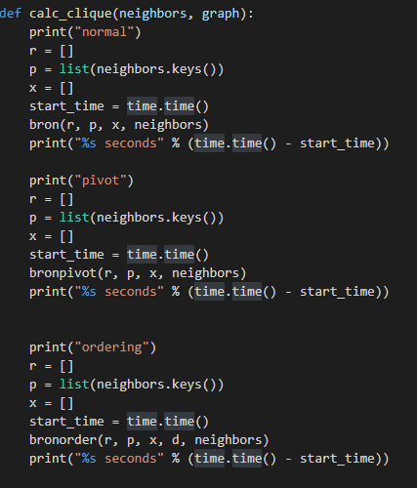

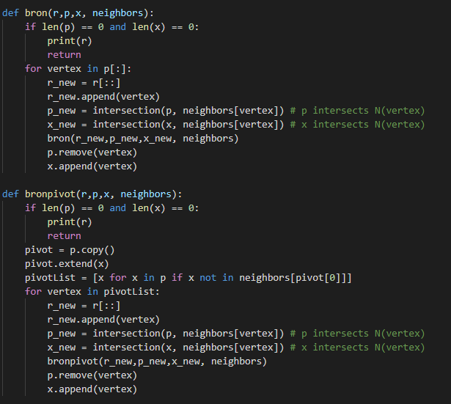

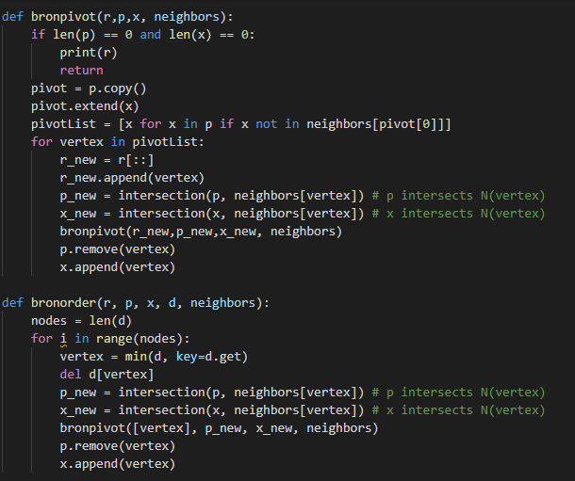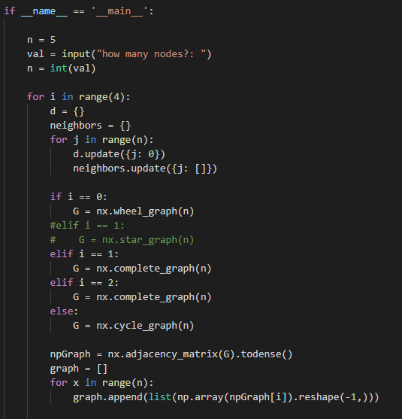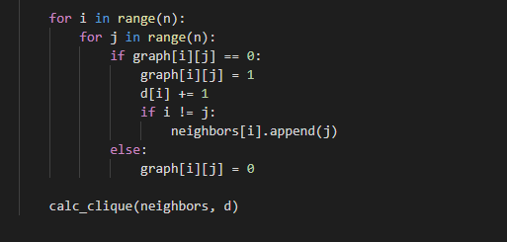

1. Test and Evaluation Report of Software Execution

Experimental Design  
  
The goal is to test and compare MIS results with/without Heuristics over some relatively small, medium and large graphs. The program being tested is written in python and being run a 4 core machine. We will test random graphs with 10, 20, and 30 nodes. For each size graph, we will test 4 different graphs: 1 wheel graph, 2 complete graphs, and 1 cycle graph. For each of those graphs, we will test with no heuristics, then with vertex pivoting, and then with degeneracy ordering. The run times for each heuristic will averaged between all of the types of graphs.

Measurement

The program is run for 10 nodes, 20 nodes, and 30 nodes for no heuristics, vertex pivoting, and ordering.

Results are shown starting by size, and for each size, normal, pivot, and ordering are shown in that order starting with wheel graph, complete graphs, complete graph, and cycle graph. For sake of simplicity, a line graph showing the trends is included in the reporting section.

10 nodes

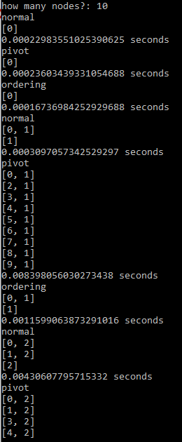

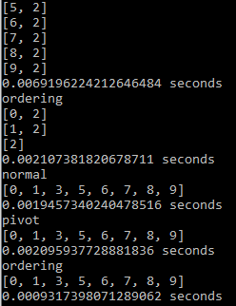

Normal (no heuristics)  
.000230  
.000310  
.00431  
.00195  
Avg: .0017  
  
Pivoting  
.000236  
.00839  
.00692  
.00210  
Avg: .00441  
  
Ordering  
.000167  
.00839  
.00692  
.00210  
Avg: .00109  
  
  
  
  
  
  
  
  
  
  
  
  
  
  
  
  
  
  
  
  
  
  
  
  
  
  
  
  
  
20 nodes

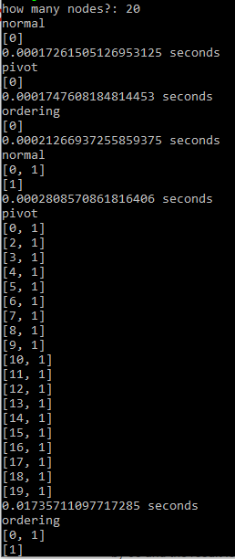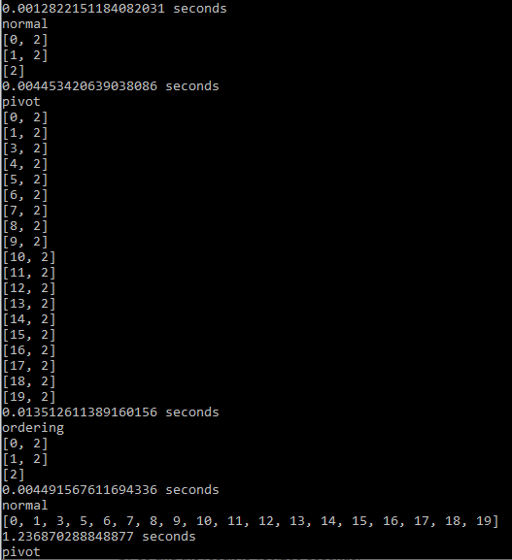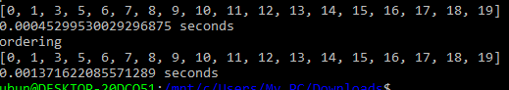

Normal (no heuristics)   
.00173  
.000281  
.00445  
1.24  
Avg: .311  
  
Pivoting  
.000175  
.0173  
.0135  
.000453  
Avg: .0122  
  
Ordering  
.000212  
.00128  
.00449  
.00137  
Avg: .00186

30 nodes

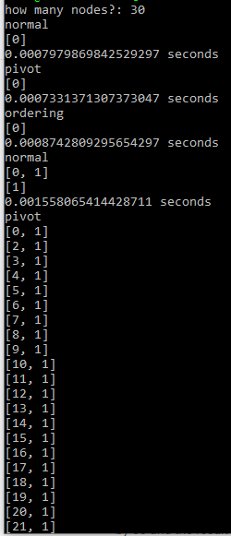

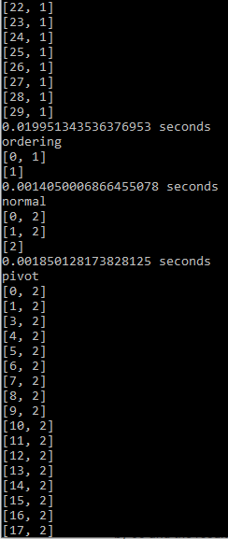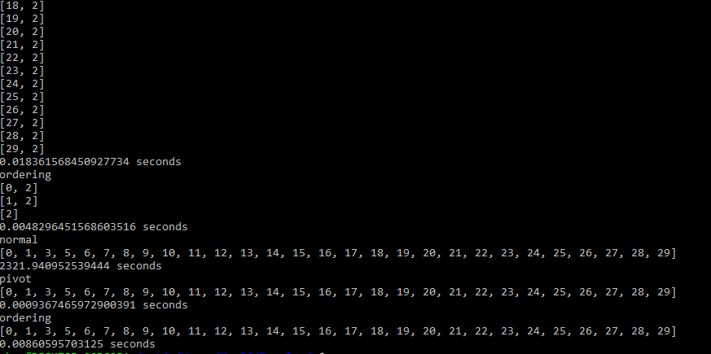

Normal (no heuristics)  
.000798  
.00156  
.00185  
2320  
Avg: 580  
  
Pivoting  
.000733  
.0199  
.0184  
.000937  
Avg: .00999  
  
Ordering  
.000874  
.00141  
.00483  
.00861  
Avg: .00393

Percent change calculations from the averages in running time for each graph size and algorithm used  
  
Normal   
10 to 20 nodes: 18194% increase   
20 to 30 nodes: 186395% increase  
  
Pivoting  
10 to 20 nodes: 176% increase  
20 to 30 nodes: 18% decrease  
  
Ordering  
10 to 20 nodes: 70% increase  
20 to 30 nodes: 111% increase

Reporting  
  
The Bron Kerbosch algorithm for MIS was successfully implemented in python with the added heuristics of degeneracy ordering and vertex pivoting. The program was tested to show the run time speeds with multiple graphs of different sizes. The results show that the heuristics do speed up the program when it comes to larger graphs. As shown the graphs below, with no heuristics, the graph of 30 nodes took over 30 minutes to run, but with the heuristics, it took no time at all.   
  
  
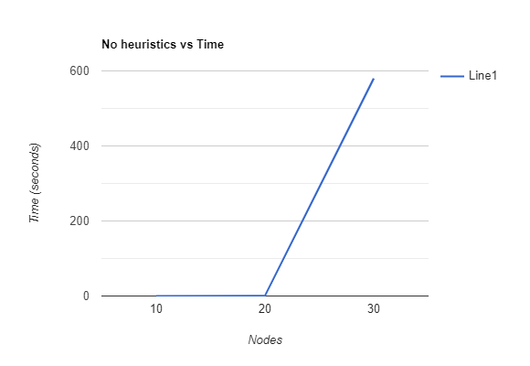

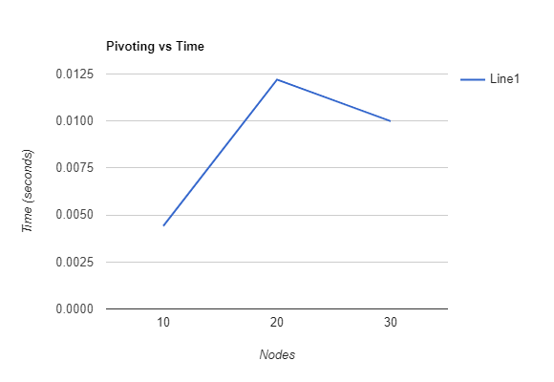

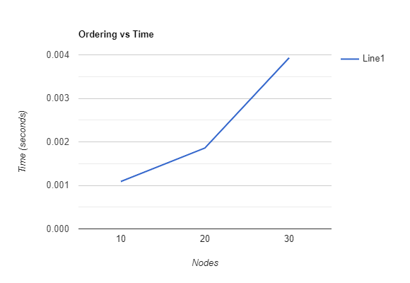

***“ Analyze design flow mapping into AFIT “graphprogram” coded in C++?Search Control Structures indicated with comments using standard search elements? Or map to a Java object-oriented implementation? Or other programming language, or parallelize algorithm?” Are there any special MIS PD cases? (planar graphs, Interval graphs, …)*** *\*\*\*\*\*\*\*\*\*\*\*\*\** ***- Comments:***

1. We have attempted for complete design documentation to explicitly reflect each symbolic algorithmic step leading to the functional low-level de­sign; this structure is more in the form of the functional decomposition design paradigm, could also define an object-oriented structure. Algorithm Complexity is of order (n22n) per code documentation? Check!Or is it of order (n23n/3)?NO!

2) Redesign gs-dfs/bt algorithm for the MIS/Clique using the suggested a priori sorting routine. Also consider appropriate data structures and processing for a large number of nodes?

3)Also, could output the search process per each search tree node for pedagogical insight. In addition, what are the restrictions to be placed on graph size in given programming language implementation? Define test objectives of MIS gs-bfs/bt program (Use Axioms?).

4) Mapping to the low-level algorithm design. Note that the integration of the Qks could be inside or outside the objects depending upon the designers con­straints/creativity. Also, the graph input process could be embedded in the graph-ADT object or designed as a separate module as the AFIT case. What are some other MIS object-oriented design possibilities? Discuss Approximation algorithms for MIS/Clique problem solutions – DFS.

5) Select another gs-dfs/bt algorithmic design for the maximal/maximum MIS or Clique problem and indicate the creative design data structures and control structures used. [ For example, [kiyama et al. (1977](http://en.wikipedia.org/wiki/Clique_problem#CITEREFTsukiyamaIdeAriyoshiShirakawa1977)) [Chiba & Nishizeki (1985](http://en.wikipedia.org/wiki/Clique_problem#CITEREFChibaNishizeki1985))[Johnson & Yannakakis (1988](http://en.wikipedia.org/wiki/Clique_problem#CITEREFJohnsonYannakakis1988)) ]. Also, consider specializedMIS/Clique problems as listed previously using gs-dfs/bt. [wikipedia]

6) Test MIS/Clique algorithms and compare over various MIS/Clique graphs ([DIMACS](http://dimacs.rutgers.edu/),[Dimacs(clique)](http://iridia.ulb.ac.be/~fmascia/maximum_clique/DIMACS-benchmark), [BHOSLIB](http://iridia.ulb.ac.be/~fmascia/maximum_clique/BHOSLIB-benchmark), Conte’s BK paper in 2013, …)

7) Add an algorithm to implement Christofides Equation 3.9, page 34. This is defined as “pivoting” in some descriptions of the [BK algorithm](https://en.wikipedia.org/wiki/Bron%E2%80%93Kerbosch_algorithm) (see Wikipedia and other references). “Heuristic impact?” [complexity?]

8) Also, add the “simple” implementation of “vertex ordering” based upon vertex degree.That is, select those nodes with “smaller degrees” first (*degeneracy ordering*) in the DFS/BT search process.“Heuristic impact?” [complexity?]

9) What would be a good approximation algorithm for the MIS problem?

Maybe some backtracking but how as to how much that’s up to us.

10) Present pseudo code also in Talbi’s algorithmic form.

***\*\*\*\*\*\*\*\*\*\*\*\*\*\****

**A view of a gs-bfs/bt refinement(pseudo code) using a stack***(from literature – How was it designed? – difficult to understand design!)*

Input G(V,E) *[a connected graph]*

*v[start vertex]*

Algorithm Depth-First Search/Backtracking

visit *v*

*V′*← {*v*} *[V′ is the set of vertices already visited]*

Put *v* on *S[S is a stack – set of candidates?]*

*u ← v*

repeat while *S*not empty;

if *A(u)* − *V′* is not empty ;

then Choose *w*ε*A(u) − V′*

visit *w*

*V′*= *V′*union {*w*}

Put *w* on stack*S[what if we want to consider each S element directly?]*

*u ← w*

else *u ← top(S)[Pop the stack – careful with ADT!]*

endif

endrepeat

DFS uses backtracking

• Go as far as you can until you get stuck(?)

• Then go back to the first point you had an untried choice*[quite general!]*

*“Now embed our standard search element functions into this gs-dfs/bt algorithm – yet another example of binding too early to a specific data structure –justify stack”*

***Some References:****(also consider papers in MIS_Clique paper directory)*

[1] Nicos Christofides. *Graph theory: An algorithmic approach (Computer science and applied mathematics)*. Academic Press, Inc., Orlando, FL, USA, 1975.

[2] Alessio Conte, [*Review of the Bron-Kerbosch algorithm and variations*](http://www.dcs.gla.ac.uk/~pat/jchoco/clique/enumeration/report.pdf), Univ of Glasgow,   
School of Computing Science, May, 2013

[3] Edward Reingold, Jurg Nieverelt, and Narsing Deo. *Combinatorial Algorithms: Theory and Practice*. PrenticeHall, 1977.

[4] Etsuji Tomita, Akira Tanaka, and Haruhisa Takahashi. *The worst-case time complexity for generating all maximal cliques and computational experiments.***Theor. Comput. Sci.,** 363:28–42, October 2006.

[5] El-Ghazali Talbi. *Metaheurisics From Design to Implementation*. Wiley and Sons, 2009

[6]Michaelewicz and Fogel, *How to Solve it: Modern Heuristics*, 2ed,Springer, ‘04

[7] Wikipedia, MIS and Clique

[8] Robson, [*Algorithms for Maximum Independent Sets*](https://www.cs.umd.edu/~gasarch/TOPICS/sat/robson.pdf), Journal of Algorithms 7, pp 425-440, 1986

*[9] Geeksforgeeks* <https://www.geeksforgeeks.org/maximal-clique-problem-recursive-solution/>

***Some MIS/Clique Software:****(see CSCE686 MIS_Clique Software directory)*

* *C++:* [*https://www.sanfoundry.com/cpp-program-find-maximum-size-clique-graph/*](https://www.sanfoundry.com/cpp-program-find-maximum-size-clique-graph/)
* *JAVA:* Prosser, Patrick, *Exact Algorithms for Maximum Clique, a Computational Study*, TR-2012-33, Glasgow University, Scotland, 2012
* *Python:* [*https://networkx.github.io/documentation/networkx-1.9.1/reference/algorithms.clique.html*](https://networkx.github.io/documentation/networkx-1.9.1/reference/algorithms.clique.html)
* *JAVA:* [*https://sites.google.com/site/indy256/algo/bron_kerbosh*](https://sites.google.com/site/indy256/algo/bron_kerbosh)