Project Proposal – CSCE686

Chad Willis

Problem Selection / Problem Domain Details

The real world problem combining two NP-Complete problems that I came up with has to do with a internet service provider (ISP) laying cables underground in a new neighborhood. This piece of the problem contains the minimum spanning tree (MST) problem. The problem of laying cables underground in this neighborhood also deals with a maximum power or bandwidth that the neighborhood is allotted before the internet slows down. This part of the problem contains the knapsack problem.

The minimum spanning tree problem can be defined as:  
Given a weighted, connected, and undirected graph, a spanning tree of a graph is a subgraph that is a tree and connects all the vertices together. The goal is to minimize the total weight of the edges of the MST. A MST has V – 1 edges, where v are the edges.   
 In the case of ISP laying cables underground, the goal is have to lay the least expensive cables from node to node, or in this case house to house. How long the cable needs to be and how deep the cable needs to be buried determines the weight, or how expensive the edge is. In the figure below, the nodes can be thought of houses, and the edges are the cables with the corresponding weights.

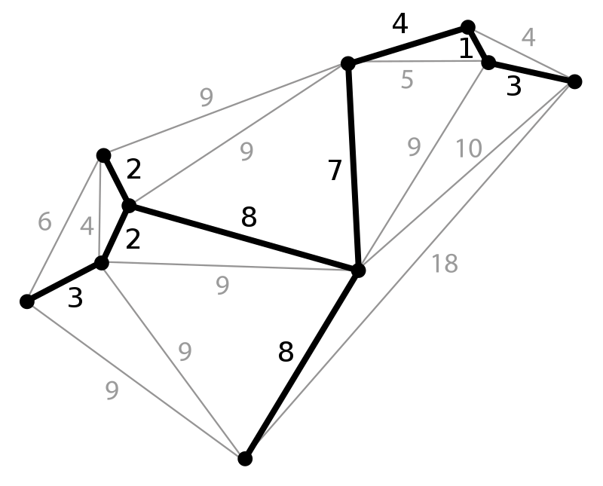

A basic summary of the algorithm is as follows:  
**1.** Sort all the edges in non-decreasing order of their weight.  
**2.** Pick the smallest edge. Check if it forms a cycle with the spanning tree formed so far. If cycle is not formed, include this edge. Else, discard it.  
**3.** Repeat step#2 until there are (V-1) edges in the spanning tree.

The knsapsack problem can be defined as:  
Given weights and values of n items, put the items into a knapsack of capacity W to get the max total value in knapsack. Basically, you want to find the maximum value such that the weights of the items put into the bag are smaller than or equal to W. An item cannot be broken into smaller pieces; this is called the 0-1 property.   
In the case of the ISP laying cables, the Knapsack is analogous to the amount of bandwidth that the ISP can handle in the neighborhood. The n items are the individual bandwidths for each new home. The goal is to have the highest value, which is the money the house is paying for the bandwidth, while not going over the maximum weight of bandwidth for the total neighborhood.

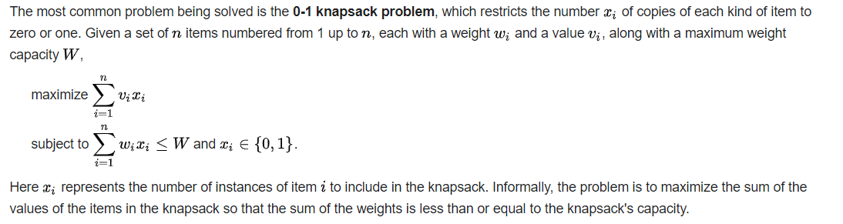

References

<https://www.geeksforgeeks.org/0-1-knapsack-problem-dp-10/>

<https://en.wikipedia.org/wiki/Knapsack_problem>

<https://www.geeksforgeeks.org/kruskals-minimum-spanning-tree-algorithm-greedy-algo-2/>

<https://en.wikipedia.org/wiki/Minimum_spanning_tree>