For the past two decades, researchers of “school choice” have focused intensively on racial segregation patterns. They worry that, when given a choice, white families will move to residences near schools with majority white kids or else pay for a private school with “desirable” racial properties. Some claim these parents “buy their way out” of racial and ethnic heterogeneity (Smith and Meier 1995). Similar arguments have been extended to non-white families as well (Cookson 1991, Wells and Crain 1991, Schneider, Teske, and Marschall 2000, Charles 2003).

While these are important questions to ask, all of the rhetoric associated with this line of research sometimes obscures a rather powerful and disturbing reality: many of our public schools cannot undergo further segregation. They are already racially and ethnically homogenous. For example, more than half[[1]](#footnote-1) of Philadelphia public schools have student bodies of near-homogenous racial-ethnic backgrounds. If researchers are worried about segregation, perhaps it is too late. It is already here.

While this kind of information can be disheartening, the problem can be framed in a better light. In some schools, integration is happening. In fact, in a 1985 nationally representative survey, 91% of respondents agreed that black and white children should, at least in principle, attend school together (Erikson and Tedin 2003). Furthermore, research has shown that there is “little evidence” that whites, or any other racial or ethnic group, prefer sending their children to a school with racial majorities of their own background (Tedin and Weiher 2004). This all seems supportive of the claim that parents are open to the possibly of sending their children to a diverse and integrated school.

In searching for clarity, some scholars have argued that segregation and integration relate to the digital divide. Parents of higher income levels or cultural capital have better access to information (like internet). In turn, they use it to identify the best schools and secure a seat their for their children there (Schneider, Teske and Marschall 2002). The correlation of income with race, then, would explain the residential and school patterns we observe.

I find this to be a very powerful argument and, further, it has important corollaries that merit closer consideration. If white, middle-class parents are using the Internet to evaluate schools and, if racial diversity is viewed as a positive school feature, then communicating this information effectively is very important. Doing so would help keep diverse schools diverse and, potentially, be a mechanism for the integration of schools with high concentrations of a single racial/ethnic group.

Exploring the impact of the many mediums of communication is clearly beyond the scope of this paper. However, it is within my means to compare two forms of communication. My hope, then, would be to pave the way for future work on communication and how these mediums, more broadly, affect peoples’ perceptions of diversity and evaluations of schools. My choice of medium for this project is the pie chart, which the Philadelphia School District currently uses, and an alternative method to promote diversity—a photograph of multicultural students.

H1: Communicating a school’s ethnic and racial diversity in a photograph (rather than a pie chart) will improve parents’ evaluation of a school.

It is my prediction that parents will view a school more favorably when diversity is communicated in a photograph. This is based on Zillman’s Exemplification Theory, which states that abstractions can prove to be more cumbersome than exemplars when making judgments of populations. Pie charts, as abstract conceptual models, will challenge parents, relative to a photograph of multicultural children. The photograph, by contrast, will serve as an efficient “representativeness heuristic,” thereby aiding study subjects in their favorable evaluation of a good school.

A second important research question relates to the effect of diversity information when communicated with other demographic characteristics of a school (as it often is). For example, districts often report the percentage of economically disadvantaged students in a school. This practice is problematic, however, as schools with high levels of poverty are potentially stigmatized due to associations (correlations) with discipline problems, antisocial behavior and sometimes violence. It would be interesting to know whether communicating diversity in the form of a photograph lessens the deleterious effects of reporting higher levels of school poverty.

H2: Advantages of communicating a school’s ethnic and racial diversity in a photograph (rather than a pie graph) will diminish with increasing numbers of economically disadvantaged students in the school.

I make this prediction, once again, drawing on Zillman’s theory. I expect exemplars to help people process diversity information and, therefore, help a good school earn its favorable review. However, I also predict that they will serve as exemplars of poverty once poverty level is revealed. It follows then, that the effect of the photograph will attenuate at the highest levels of poverty. There will be, in other words, an interaction effect between medium of communicating diversity an level of poverty in the school.

While urban public schools are sometimes caricatured as bad schools in the media, there is a lot of variance in academic quality and many of these schools are quite “good,” in fact. “Good” public schools represent important opportunities for integrating diversity, however, it is not clear how to best achieve this goal. Knowing how to “market” a school’s diversity online would be important to know in these cases, not just for the school or “society,” but also for parents who identify diversity as an attribute they look for in a school. Furthermore, the findings from this study should be generalizable to other forms of information schools provide and there seem to be extensions to other social institutions as well.

**Research Design**

These research questions will be answered by means of a survey experiment. This promises to be a particularly effective approach, given the traditional problems associated with data collection. Social desirability bias is concern. If research subjects were asked explicitly on a conventional survey “which medium of diversity gives you the best feeling towards a school?,” they would probably choose the photograph, as people are expected to look favorably of children. Similarly, who would admit to poverty being an important deterrent to schools they consider. By issuing these treatments to different research participants, they will be less likely to “guess the hypothesis” or bias their response due to the researcher. In fact, it is unlikely that subjects will even be able to perceive that the instrument is an experiment.

Using a survey experiment is also advantageous as, by randomization of treatment, it rules out the traditional “confounding factors” that bias observational data. This project, then, does not need to worry about parent involvement or mobility rate or any of the hundreds of other correlates of school poverty that may bias our causal estimates. By random assignment, we know that the experimental conditions will have approximately the same distributions of participant—even more true as the sample size increases.

The experimental design for this project was a 2x3 fully-crossed factorial design. The factor with two conditions is the “medium communicating diversity” variable where participants were exposed to either a pie chart or a photograph. The factor with three conditions is the “poverty level” variable. The three levels were low poverty, medium poverty and high poverty (specifically 45%, 65% and 85%). The central weakness of this design is that, with six cells, it needs a fairly large sample size in order to detect differences between conditions.

The weaknesses of the design are more than balanced out by its strengths. For one, it is a very efficient way to study the effects of medium and poverty. A questionnaire only needs to be collected once and, by crossing the factors, it extracts more information per subject than if the factors had been studied independently. Secondly, this design allows for a test of whether there is an interaction between factor levels. This will be important in order to test the second hypothesis of this study.

Participants were recruited from Mechanical Turk, a division of Amazon.com. This was an excellent convenience sample for this study. According to Huber et. al., M-Turk workers tend to be young, white, and political liberal. This is precisely the demographic we expect to be most likely to integrate their children into quality, diverse schools. After a pre-test confirmed that our instrument functioned properly, we collected surveys from 95 individuals. We then filtered the sample so that our analysis only included white people who were 56 years old or younger and lived in an urban area. By virtue of completing the online survey, we know that these subjects are also internet-users. The goal of this process was to make the “MTurk” sample look as representative as possible to the demographic we expect makes choices about schools online. After applying filters, our study consisted of 34 subjects—a small number that consequently limited the findings of this study.

Titled “Urban School Choice Survey,” the survey experiment was implemented using Qualtrics software. The instrument is available [here](https://sasupenn.qualtrics.com/SE/?SID=SV_5v9tQVQRewsgG0J). The goal was to make respondents feel as if they were evaluating a potential school for their child. For those with children (62%), this was probably a natural exercise. For individuals without children, we asked them to consider their “hypothetical child.” Keeping childless individuals in the study was necessary, as the sample size was already so low. Future research should probably exclude these individuals.

We told participants early on that they would need to rate the school at the end of the survey. We then

In the survey, we described and simulated a school using text and photos. We called the school Parkside. Parkside was a “good” school. The kind of school white, urban parents would seriously consider for their children. Its standardized test scores were climbing. It had an active parent group who managed the school library. Parkside has received grants funding playground equipment and made investments in school infrastructure. In addition to effectively modeling a “good” school for participants, it also allowed me to, quite effectively, disguise the key experimental conditions. This likely helped keep participants from “guessing the hypothesis.”

During the course of the survey, I asked a few questions so that the respondent’s would know that they would be accountable for understanding the information in the survey (and couldn’t just click through it). I also made it clear, early on, that the respondents would need to rate the school on a 1-10 scale at the end. This kept them in an evaluative state during the course of the instrument.

Around the midpoint of the survey, Qualtrics randomly assigned participants to experimental conditions. First, subjects were given one of two conditions pertaining to “medium communicating diversity.” This took the form of a pie chart (how the Philadelphia School District currently communicates this information) or a set of two photographs containing in total 12 children of diverse racial and ethnic backgrounds. Four of these children were Latino (33%), three were White (26%), three were Black (24%), one was Asian (8%) and one was unknown (9%). The racial/ethnic distribution of students in the photographs was the same as reported in the pie chart, essentially controlling for race/ethnicity. This, in effect isolated the independent variable of interest—medium of communication.

Subsequently, participants were randomly assigned to one of three conditions in the second experimental factor “level of poverty.” This was done by means of a pie chart, once again the method currently utilized by the Philadelphia School District. Participants either learned that the percentage of economically disadvantaged students was 45%, 65%, or 85%. In my analysis, I referred to this as low, medium and high poverty and coded the variable as an ordered factor. To summarize the treatment sequence, then, considering both experimental factors, there were six unique pathways in the survey instrument. These pathways constituted the six cells of the 2 x 3 factorial design.

The dependent variable was the participants’ evaluations of the school. This was collected after participants had been “introduced” to the school through photos and description and after they had received an experimental sequence. Specifically, the question asked: “On a zero-to-ten scale, what is the likelihood that you would consider sending one of your children to a school like Parkside? Zero means you "definitely would not consider it" and ten means you "would very seriously consider it." You can choose any number in between.” This wording and scale was taken from Tedin and Weiher (2004). For more information on instruments measuring independent or dependent variables, see the appendix.

At the end of the instrument, participants were issued questions that would allow for a manipulation check on each of the experimental factors. With a p-value of <0.001, “level of poverty” had been successfully issued. Medium of communication, however, was more complicated. At first, an index (arithmetic mean) of four variables was used, but the model advised dropping one of the variables to produce higher reliability. The final index had and acceptable Cronbach’s alpha of .77. Measuring “medium of diversity,” however, it failed the manipulation check. This essentially invalidated the experiment, however, it may only be the consequence of having used such a small sample size.

**Findings**

Cell Sizes



Macintosh HD:Users:chadgevans:Documents:Chad's documents:Graduate School:UPenn:Coursework:Spring2013:Experiments:Final_Experiment:Project:Charts_and_Graphs:LikelyToConsider.pdf

There are no findings to report, except for the fact that both null hypotheses were retained. Even the main effect “level of poverty” showed up as statistically insignificant, despite findings to the contrary in other research. Potentially (probably), this is a problem of statistical power. Several of the cells in this study had as few as four study subjects in them. With so few of subjects, degrees of freedom were low in the analysis of variance and this has an effect of pushing down the F-value (causing an insignificant result).

With that possibility acknowledged, the results are still disappointing. The means in all conditions are about the same (8.5). Furthermore, there does not seem to be a trend or pattern in means that would make it likely for a significant finding to be reached any time soon. This makes me question whether this line of theory, at least how I have applied it, would be generalizable to other mediums of communication or social institutions. But, again, it is really too early to say. The cell sizes are just too small at this point.

I did some exploratory work I would like to report, although researchers should be careful when doing post-hoc comparisons. In addition, best practice would be to adjust alpha values so that there is less chance of type one error. Given the clear exploratory nature of this work (my sample size was likely too small to even detect many important effects), I feel comfortable exploring relationships that turned up in my analysis.

The first I call “Diversity Recall.” As the end of the survey experiment, participants were asked to recall what the percentage of non-white minority students was in the school. Because I controlled on race in the “mediums of communication” the school at all time was composed of 75% minority students. As the tables below reveal, there was a statistically significant effect of both “medium of diversity” and poverty level. In addition, looking at the table of means, we see that those issued the pie chart consistently reported a close figure to what the true ethnicity of the school actually. Those in the “photograph” treatment, on the other hand, made diversity recalls that were significantly lower than the true diversity of the school. This was particularly the case for individuals in the low poverty condition (although there was no statistically significant interaction). Given the small sample size, the fact that these effects showed up means that they are probably quite powerful. The abstract pie chart, not the photograph of exemplars, seem to have communicated diversity more accurately. If in fact true (and not a type one error), this finding would be significant and have implications across a wide range of subjects and discipline. More than likely, however, a more thorough literature review would reveal that someone has already discovered this.

**Diversity Recall**

Two-way Analysis of Variance

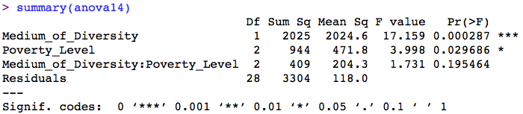

Table of Means

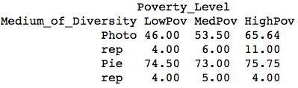

The second exploratory item this project “revealed” related to how respondents ranked diversity after exposure to different treatment conditions. There was no main effect of either “medium of communication” or poverty level on where school diversity was ranked, however, there was a significant interaction recorded. This finding may only be a chance occurrence, however, the topic merits further research. Potentially, mediums have different consequences at different levels of poverty for how people rank diversity amongst other school characteristics. If the table of means is correct, at higher levels of poverty, communicating diversity with a photograph becomes a more effective tool of promoting diversity as a positive school characteristic.

**Ranking of Diversity**

Two-Way Analysis of Variance

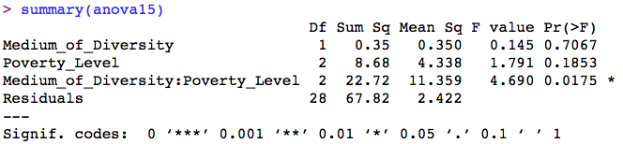

Table of Means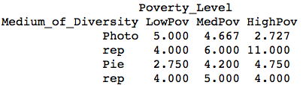

**Conclusion**

In conclusion, this project revealed the importance of sample size. Fortunately, this problem is not an insurmountable flaw. Mechanical Turk enables researchers to launch survey again and collect more data. In addition, a second wave would not likely bias results in any significant way. This fact is yet another advantage of the methodology I employed in this research.

Going forward, there are some suggestions I would recommend for future research. For one, we do not know how reliable the survey experiment is for parents actually sending their children to a diverse school. They can say that they would “strongly consider” it, however, it is unclear whether this treatment effectively resembles what actually happens in school choice. By this, I mean that, in the real world, parents actually enroll their children in schools. It would be useful to know whether the instrument can effectively replicate that important decision. More work like Tedin and Wieher’s, where they follow-up with parents to observe their actual choices, would be useful in answering this question.

Secondly, future research should investigate alternative ways parents acquire school information (in church, from friends) and compare those methods with online approaches. That would help determine how the internet, as a new resource, is affecting school choice patterns. Finally, researchers would be wise to investigate more intensively the digital divide. Schneider et. al.’s work clearly paved the way in this area, but there are many questions in this area that would be useful for understanding how information or lack of it affects school choice decisions.

Humanity will not be better on account of my findings, however, hopefully this work inspires the author and other researchers to pursue these questions and experimental methods going forward.

**Appendix**

Factor 1: Medium Communicating Diversity

Photograph

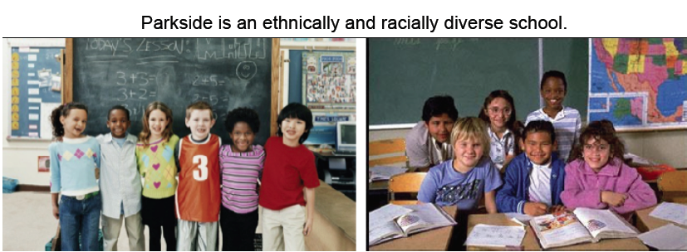

Pie Chart

Or 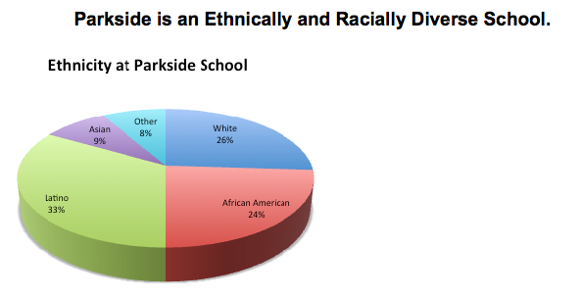

Factor 2: Level of Poverty

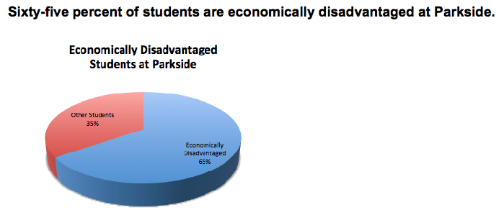

\* 1 of 3 poverty levels (45%, 65%, and 85%) were presented this way

Outcome Variable

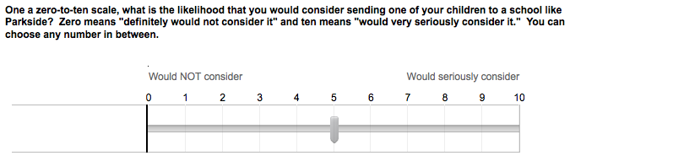

Two-Way Analysis of Variance

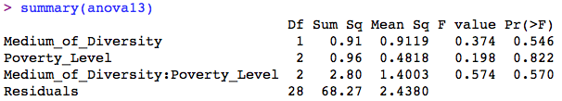

1. Estimate made by author, drawn from sample of Philadelphia public schools. [↑](#footnote-ref-1)