This

**CERTIFICATE OF COMPLETION**

is given to

«Name»

for completing 8 training hours of

**The Ethical Compass: A Seminar on RA 6713**

**and RA 11032**

conducted by this Office on July 24, 2024 via Microsoft Teams.

Given this 26th day of July 2024.

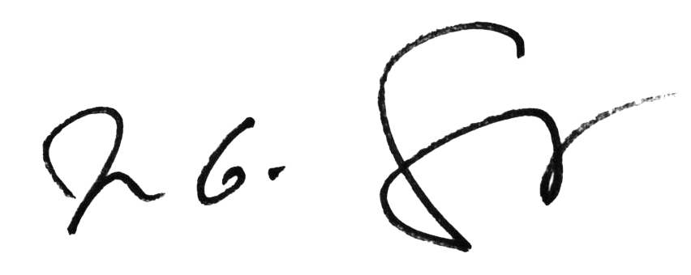

**NELSON G. SARMIENTO**

Director IV