Instructions for building ART753 Game project from Source

Our system architecture implies that our Game should be built from source using freeware tools (MTASC in particular). So that Flash IDE users are not orphaned from the project, this document will walk you through the build procedure for our Game. There’s no assumed knowledge about using “command-line” tools.

Step 1 – Copy MTASC to your local machine.

The MTASC compiler has been placed into the shared workspace, in the “\mtasc” folder. Copy this folder to some handy location on your machine (I think C:/Program Files, in an “mtasc” subfolder, is a good location. See Figure 1).

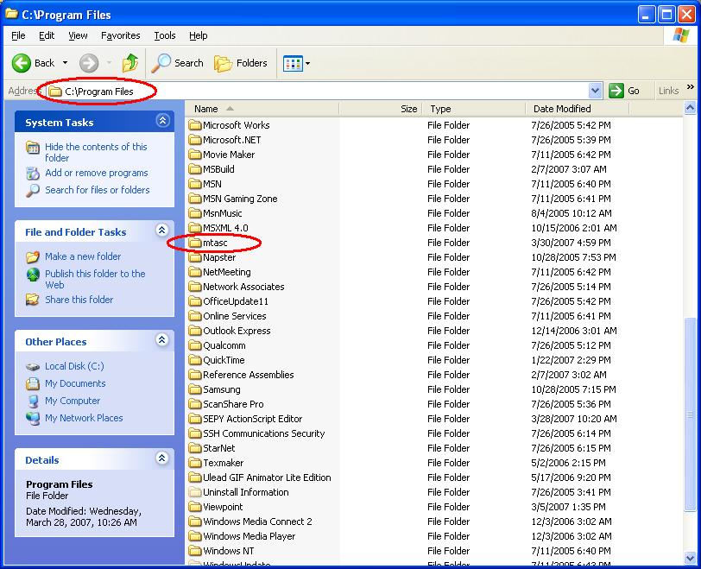

Figure 1: A new home for mtasc on the “Program Files” folder.

Step 2 – Setting your PATH to include MTASC.

Browse to Start, Control Panel, System in Windows XP (Figure 2). Double click System.

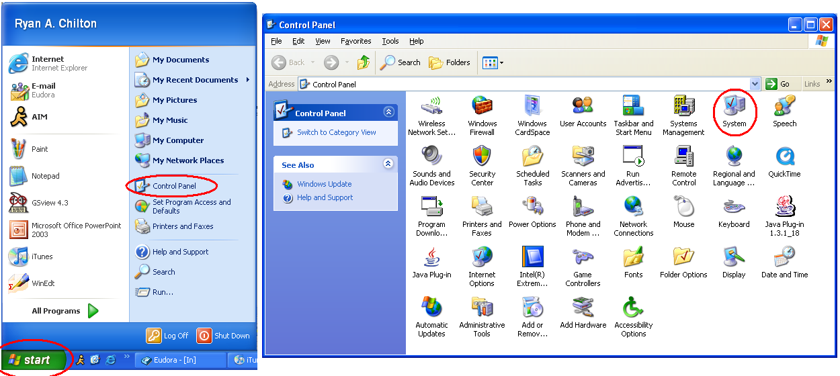
Figure 2: Navigating to Control Panel / System.

In the System dialog box, click the “Advanced” tab, and then the “Environment variables” button. It will pop up the dialog box of Figure 3. You should already have a path variable. Edit it.

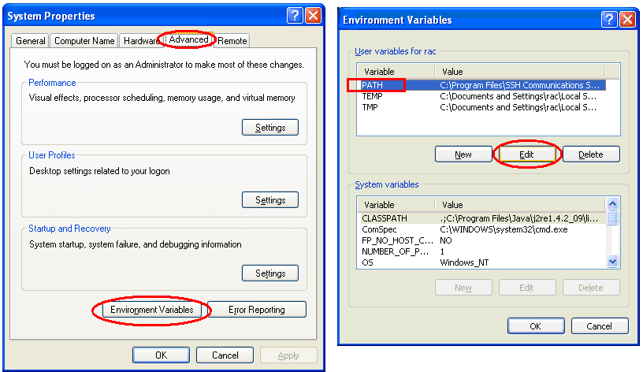

Figure 3: Environment variables dialog box.

Append the new MTASC directory:

;C:\Program Files\mtasc

To this variable. The semicolon separates it from what is already in your path.

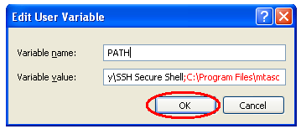

Figure 4: Type the red text. Then click OK.

Step 3 – Copying and building the project.

Copy the entire source code directory from the shared workspace, into a new folder on your machine (a folder on your desktop is fine). Currently, it is a jumble of ActionScript objects (in plaintext .AS files). To build the project into a working .SWF, double click the “Make.bat” batch file. It will generate a new SWF in the same directory (Figure 5).

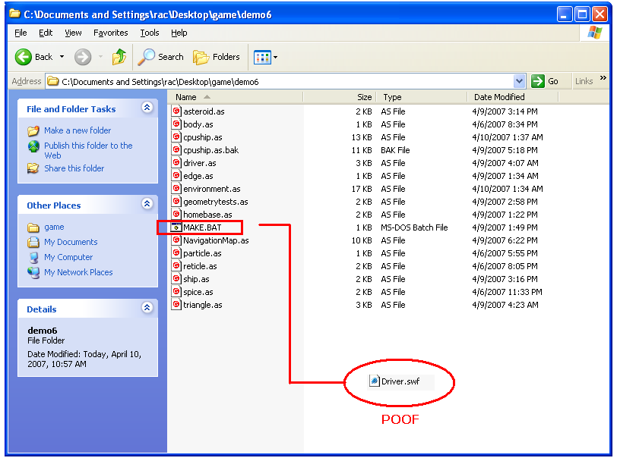
Figure 5: Generating a new SWF file using the MAKE.BAT batch file.

You will need to rebuild your SWF every time you change the source code, by running MAKE.BAT.
Step 4 – Running the SWF file.

Right click on the driver.SWF file. Select “Open With…”

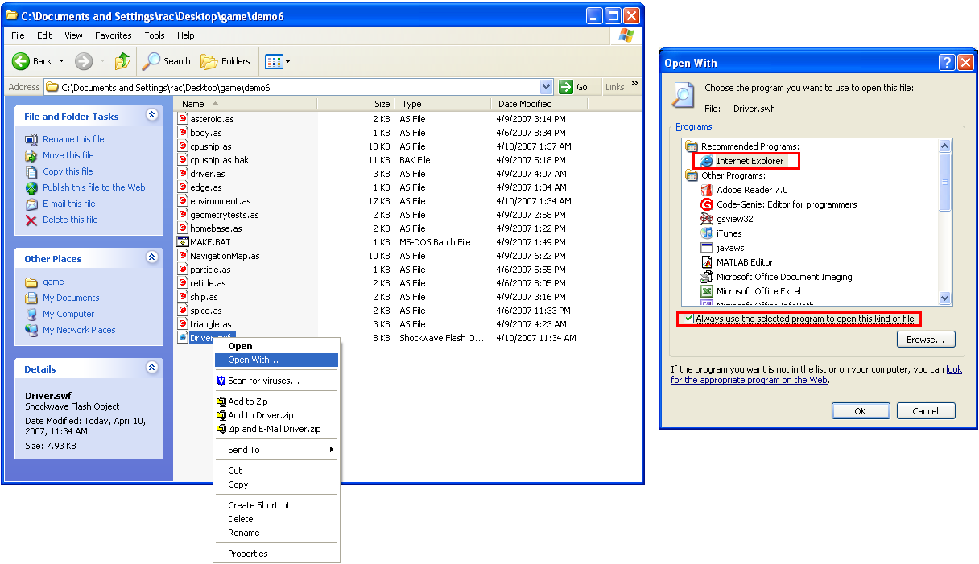

Figure 6: Opening the SWF file in Internet Explorer. As long as the Flash player is installed in your web browser this should work fine.

Choose “Internet Explorer” and check the “Always use the selected program…” checkbox. You can always use the Flash IDE to read SWFs (I think, I’ve never used it before) but running it inside a web browser imitates the final target platform.

Step 5 – Running local content in Internet Explorer and bypassing Popup Blocker.

Security settings on your machine might prohibit you from running a SWF without confirming it as a friendly application (Figure 7)

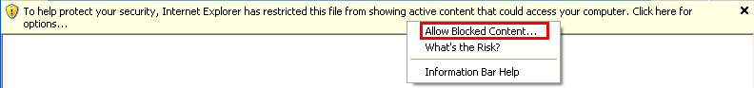
Figure 7: Internet Explorer goes for the block.

You can either click to allow it every time, or disable the warning as follows:

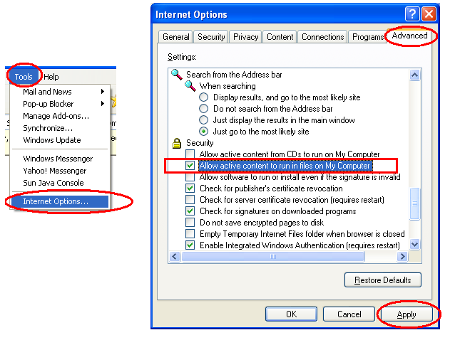
Figure 8: Disabling the warning of Figure 7.

Click “Tools” menu, select “Internet Options”. Select the “Advanced” tab. Scroll down to the “Security” section. Click “Allow active content to run in files on My Computer”. Click apply.

Step 6 – When something goes wrong.

MAKE.BAT will grab focus if compilation fails. If your PATH variable is messed up, you’ll get Figure 9. (mtasc is not recognized as a command)

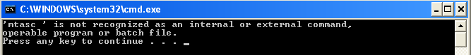
Figure 9: Fix your path setting.

Of course, programming errors will also cause compilation to fail (this is a GOOD thing – you don’t want to compile code which has unclear meaning). The compiler gives you a file and line number where the programming error was found. Edit your code in a plaintext editor and try compiling it again.

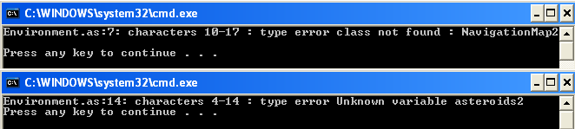
Figure 10: Errors caught by the compiler when I intentionally messed up some code.

