Design and Implementation of a 32-Bit Five-Stage SimpleRisc Processor in Logisim
Chad Lucas
Electrical Engineering, University of N.D.
Grand Fork, ND
Chad.Lucas@und.edu

Abstract—In this project we designed and implemented a 32-bit five stage Risc processor. Using Logisim we designed the key 5 stages of a central processing unit (CPU) where we successfully demonstrate the process and execution of a factorial computation program.
Index Terms—Central Processor Unit (CPU), SimpleRisc, Instruction Set Architecture (ISA), Logisim, register, ALU

I. Introduction
The Central Processing Unit (CPU) fetches, decodes and executes instructions of a program, one at a time. Each instruction is a single operation such as add, load or store that is encoded as a 32-bit binary value. The complete set of instructions a CPU understands is known as the Instruction Set Architecture (ISA). Our design will use a SimpleRisc ISA that includes 21 operations.
Our processors datapath is divided into 5 stages. The first stage is the Instruction Fetch (IF). This stage fetches the instruction from memory (ROM) at the address held in the Program Counter (PC). Second stage is the Operand Fetch (OF), which splits the instruction into fields, such as opcode, rd (register destination) and reads the source registers to get the operands. Next is the Execute (EX) stage where the Arithmetic Logic Unit (ALU) performs arithmetic and logic operations such as add, multiply and compare. The fourth stage, Memory Access (MA), is used by the load and store instructions to read and write data in memory (RAM). Finally, the Register Writeback (RW) stage which writes the result from either the ALU, the loaded memory value or the return address from the Program Counter (PC +4) into a register file.
The processor we built is 32-bit single cycle, meaning each instruction passes through all five stages in one clock cycle. Our design successfully ran a factorial program that executed 10! = 3,628,800 and storing the result into memory.
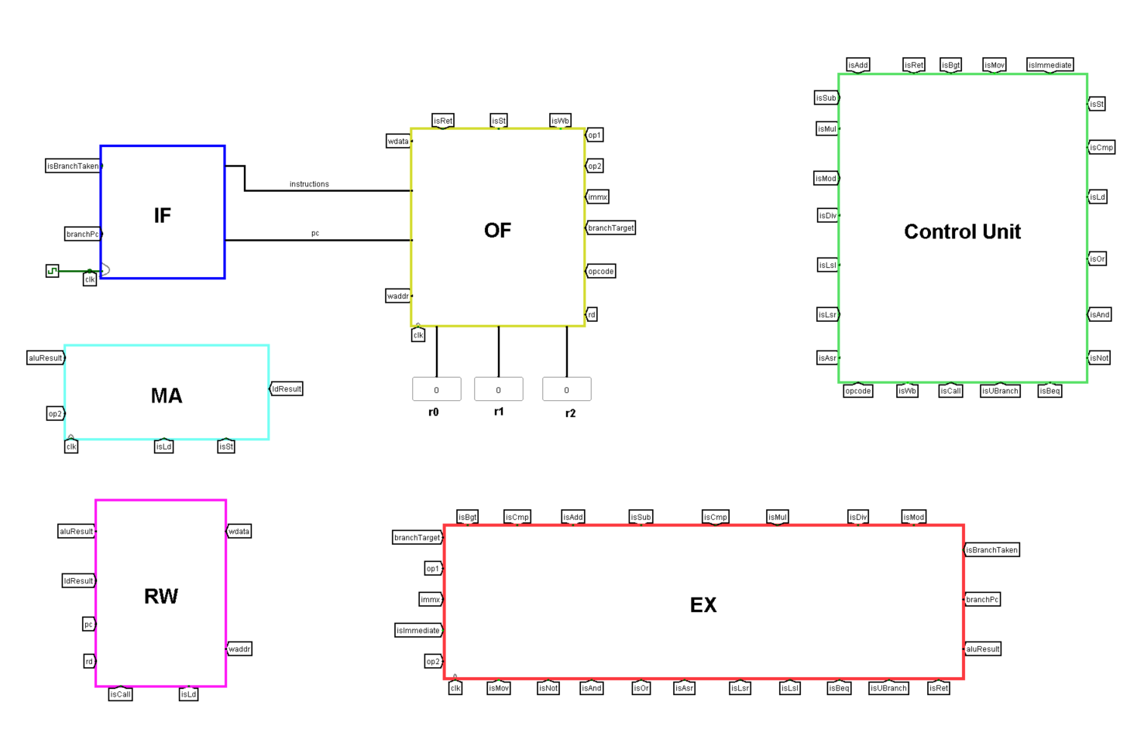
Fig. 1. Logisim main view of the complete 32-bit CPU.

II. Instruction Fetch (IF)
Each clock cycle in the IF stage keeps track of which instructions come next and fetches it, like how a software program runs one line at a time. It keeps track of which line it’s on by using a program counter the PC, which is a register that holds the current instruction. It fetches the instructions from a Read-only Memory (ROM). Each instruction is 32 bits which is 4 bytes, therefore the next instruction sits at PC + 4. Instruction format can be seen in Fig 2.
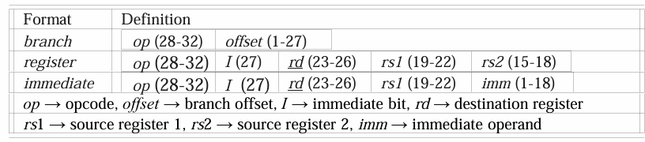
Fig. 2. 32-bit instruction format.

The IF stage also includes branch options. These are instructions that allow the program to jump to a different address instead of the next instructions. This branch statement allows for operations like if-statements and loops, such as bgt, which jumps when the previous comparison is greater than. These branch operations are handled by the mux that picks branchPC instead of PC + 4 as is shown in figure 2.
All program instruction for our factorial program are held in the ROM for execution as a 32-bit instruction, one per row.
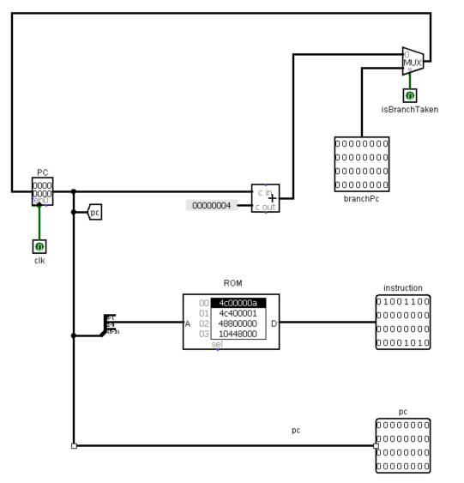
Fig. 3. IF stage circuit diagram.

III. Operand Fetch (OF)
The job of the OF is to decode the 32-bit instruction into its fields, fetch the register operands from the register file, to compute the branch target (PC + offset), compute the immediate (16 bits + 2 modifiers) and to generate the control signals to hand them off to the EX stage.
The OF stage is probably the most complex stage for understanding the signal path if we look at Fig. 4 we see the 32-bit instruction signal is branched off in several directions. This is where the signal gets decoded and we see that 5 bits [31-27] are for the opcode, bits [25-22] is for the destination register (rd), and bits [25-14] go into the two muxes to select which register are read from the register file (raddr1 and raddr2). 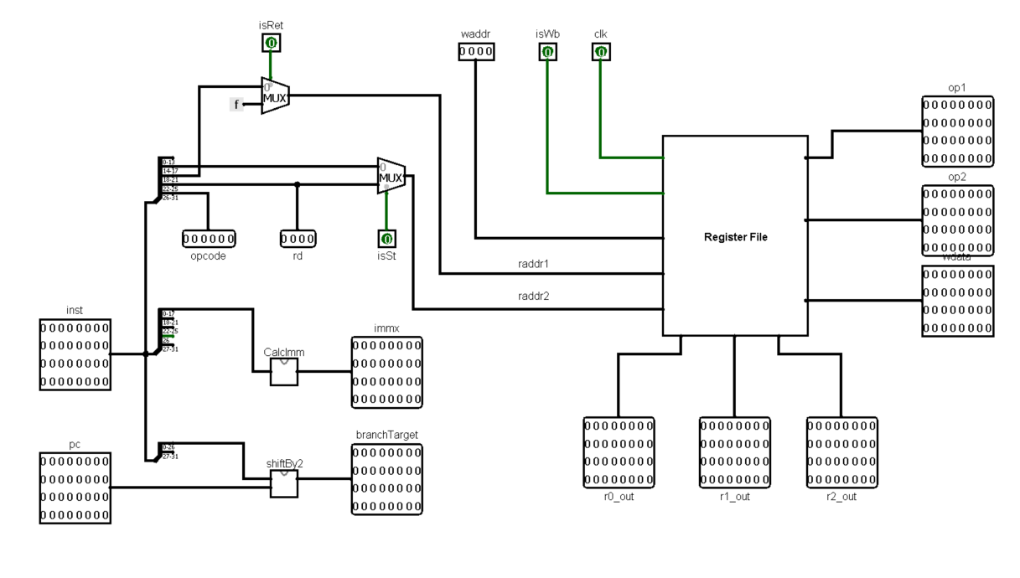
Fig. 4. OF stage circuit diagram.

A. Immediate and Branch Target
The other signal path of the instructions also handles the immediate value and the branch target. The immediate value starts at 18 bits and gets extended to 32 bits, if it wasn’t extended the ALU wouldn’t be able to process it.
For the program to jump to a new address the branch target is calculated by shifting the offset left by 2 and adding it to the PC. This allows the program to jump to another part of the code, it’s how loops and if-statements work.

B. Register File
The Register File is made up of 16 registers shown at the bottom of Fig.5 and each register is 32-bits wide. The register file is important, due to the fact it allows the CPU to store the values the program is currently working on. The two muxes allow for the read operation. The read uses raddr1 and raddr2 to choose which register is outputted as op1 or op2, which go into the EX stage. The write operation uses the decoder and waddr as the selector, this makes sure only one register is selected since wdata is connected to all 16 registers.

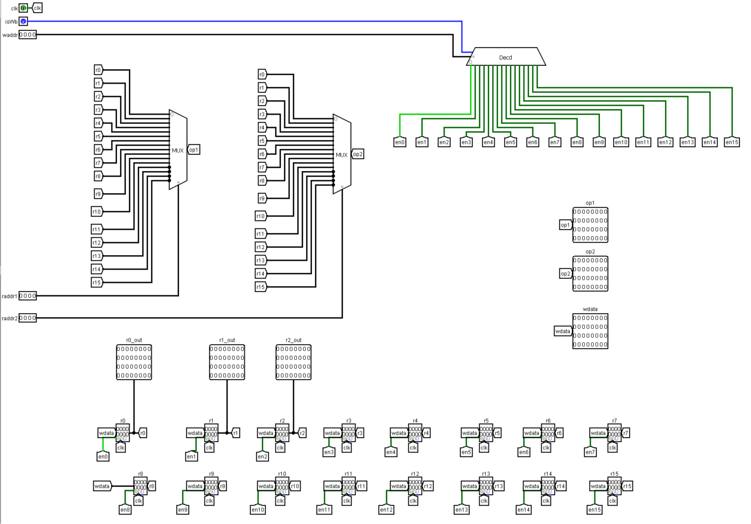
Fig. 5. Register file circuit diagram.

C. Control Unit
The Control Unit is the traffic controller for the datapath. The inputs are the 5-bit opcode and the immediate bit, which allows it to produce the 22 control signals such as isAdd or isNot, listed in Table I. This is made possible by the decoder that is shown in the Control Unit circuit diagram in Fig 6. The decoder turns the opcode into the correct output instruction.

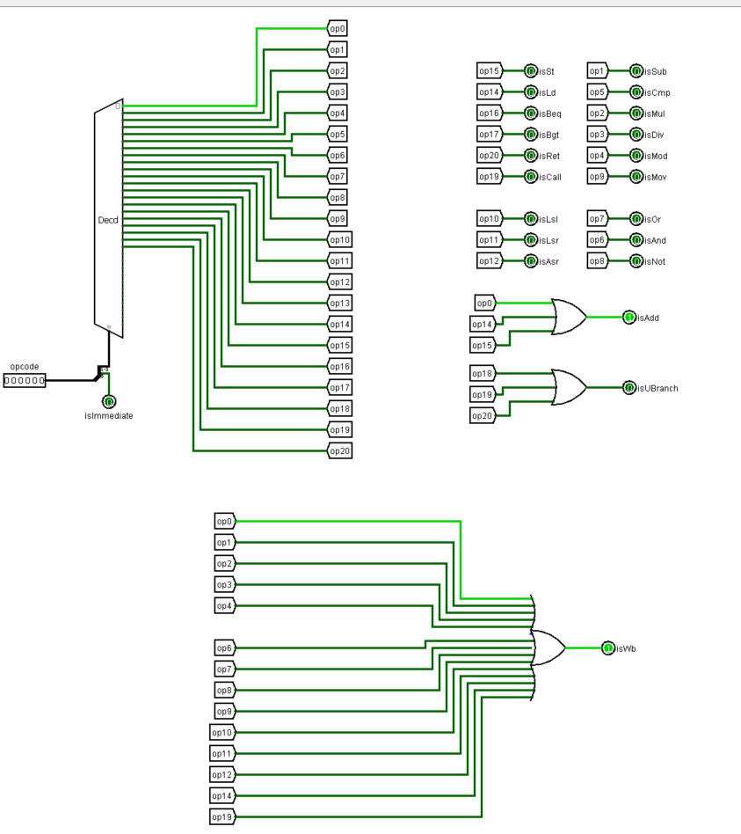
Fig. 6.Control Unit circuit diagram.

TABLE I
Control Signals and the Instructions That Assert Them
Signal | Instructions that assert it
isSt | st
isLd | ld
isBeq | beq
isBgt | bgt
isRet | ret
isImmediate | any instruction with I = 1
isWb | add, sub, mul, div, mod, and, or, not, mov, lsl, lsr, asr, ld, call
isUBranch | b, call, ret
isCall | call
isAdd | add, ld, st
isSub | sub
isCmp | cmp
isMul | mul
isDiv | div
isMod | mod
isLsl | lsl
isLsr | lsr
isAsr | asr
isOr | or
isAnd | and
isNot | not
isMov | mov
isAdd is also asserted for ld and st because the ALU computes their memory address (rs1 + imm).

IV. Execute (EX)

The EX stage is where the instructions get processed by the ALU and perform all the arithmetic and logic. The ALU has 2 inputs A and B, where A is from op1 and B is either from op2 or the immediate value. The result (aluResult) moves to the next stage to MA and RW or the branch that goes back to IF.
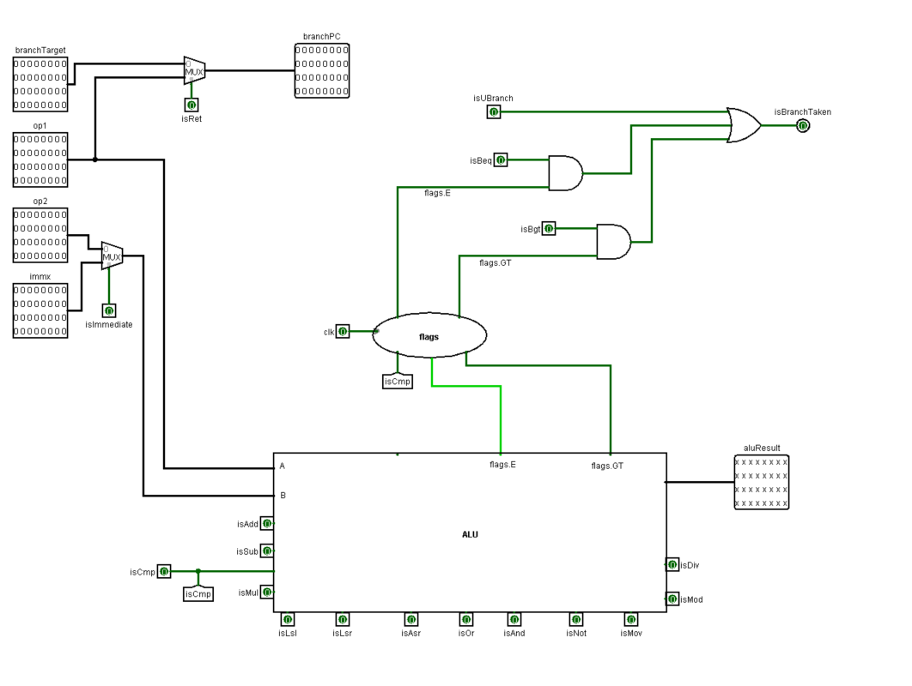
Fig. 7. EX stage circuit diagram.

A. Arithmetic Logic Unit (ALU)
As shown in Fig. 8 our ALU circuit performs the logic and arithmetic instructions such as add, multiply, AND and or logic operations. The control signal comes through from the priority encoder which is the enable pin for the mux that outputs our aluResult. The ALU is also responsible for determining the equal and greater than flags by comparing the A and B inputs.

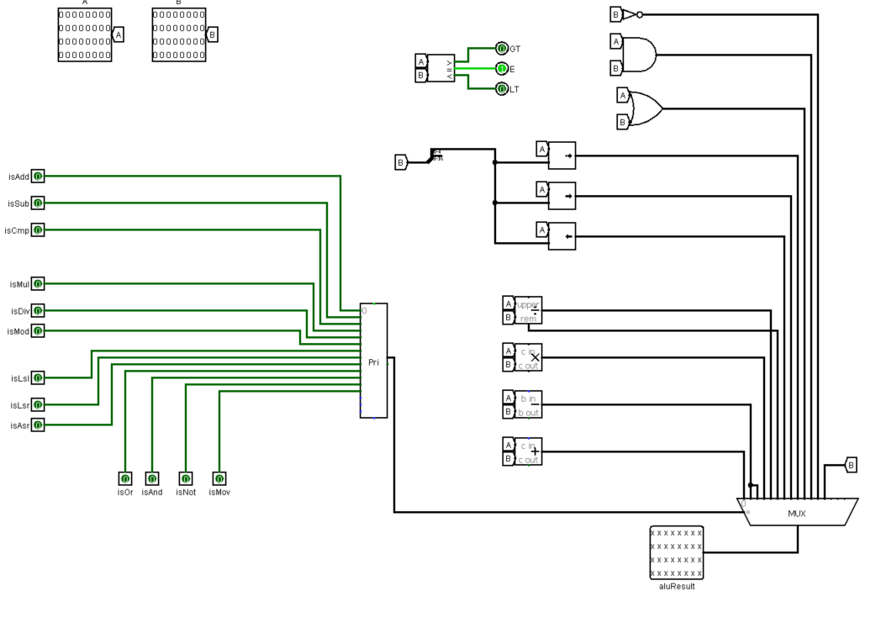
Fig. 8. ALU circuit diagram

1) Flag Storage
Inside the EX circuit there is a subcircuit that sets the flags. These consist of 2 d-flip flops that store the flags E (equal) and GT (greater than) from the ALU as seen in Fig 8. The flags need to be saved because the instruction moves each clock tick and the branch instruction runs one cycle after cmp so the results would be lost. The flip flops are enabled by isCmp this prevents other instructions from overwriting the flags before the branch uses them.
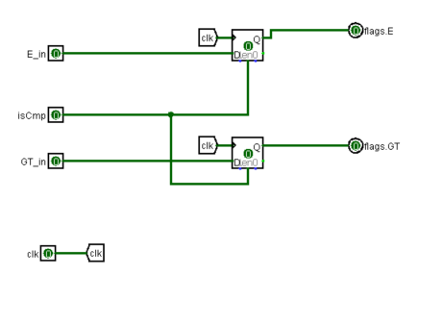
Fig. 9 Flag D flip-flop circuit diagram

B. Branch Unit
The branch unit gets its inputs from the Control Unit, the EX flip flops, and the OF stage. The branch controls figure out if the program jumps and if so where to jump to. The isBranchTaken checks three cases isUbranch, isBeq AND E and isBgt AND GT. The mux outputs the jump address as shown in Fig 7 top left corner.
[

V. Memory Access (MA)
The MA stage is used to load and store the instructions. The memory address is provided by the ALU which adds the register and its offset. When isSt is enable the value of op2 is written into the RAM and when isLd is enable the address is outputted to ldResult. 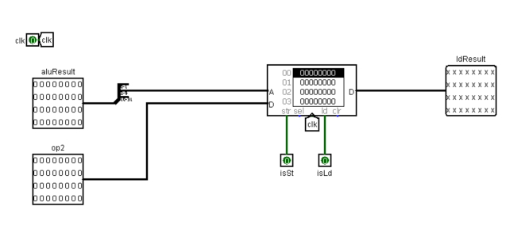
Fig. 10 The MA circuit with isSt and isLd pins

VI. Register Writeback (RW) — Stage 5
The RW state is the last step and one of the basic steps in the overall process. This is where the results gets written back into the register file. A multiplexer picks which result to write and another mux picks where to write as shown in Fig 11.
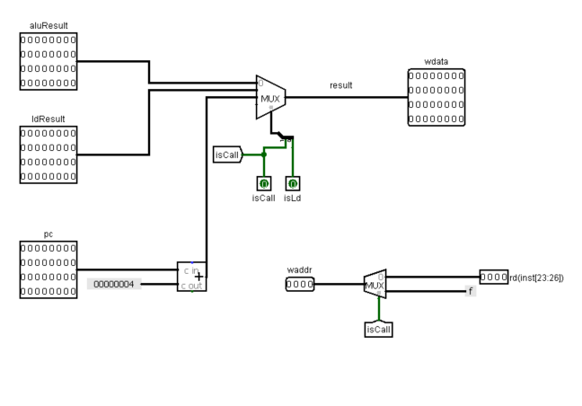
Fig. 11 The RW circuit diagram,

VII. Results and Conclusion

A. Running the Factorial Program
To run the factorial program, we first open the IF circuit. Then we need to load the nine instructions (as shown in Table II) as hex values into the ROM. Then turn on the clock by enabling Ticks Enable in the Simulation tab. Then the program will cycle through the nine instructions and print out the value on register r1 on the main circuit screen under the OF block as shown in Fig 10.

TABLE II
Factorial Program: Assembly, Binary Fields, and Hex Encoding
Addr | Assembly | Binary (opcode I rd rs1 imm/rs2 or offset) | Hex
0 | mov r0, 10 | 01001 1 0000 0000 000000000000001010 | 4C00000A
4 | mov r1, 1 | 01001 1 0001 0000 000000000000000001 | 4C400001
8 | mov r2, r0 | 01001 0 0010 0000 0000 00000000000000 | 48800000
12 | mul r1, r1, r2 | 00010 0 0001 0001 0010 00000000000000 | 10448000
16 | sub r2, r2, 1 | 00001 1 0010 0010 000000000000000001 | 0C880001
20 | cmp r2, 1 | 00101 1 0000 0010 000000000000000001 | 2C080001
24 | bgt .loop | 10001 111111111111111111111111101 | 8FFFFFFD
28 | st r1, 5[r2] | 01111 1 0001 0010 000000000000000101 | 7C480005
32 | b . (halt) | 10010 000000000000000000000000000 | 90000000
Branch instructions (bgt, b) use the format opcode + 27-bit offset. The bgt offset is (12 − 24) ÷ 4 = −3; the final b has offset 0, so it jumps to itself and halts the program.

B. Results 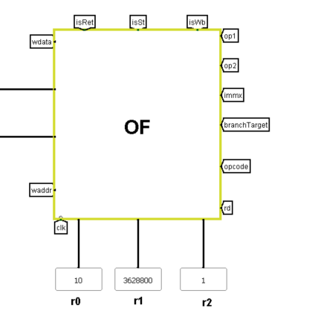
Fig. 12 The result of the factorial program shown in r1 register

C. Conclusion
We successfully designed and built a 32-bit five-stage SimpleRisc processor in Logisim. We wrote a program to calculate 10! = 3,628,800. One challenge that arose was building the Register File, it was difficult to figure out how to select 16 different registers and produce our op1 and op2 values. The solutions was to create 2 different 16-to-1 multiplexer with the raddr1 and raddr2 as the select line to pick the register value we need.
As an extra step, we ported the CPU to Verilog and tested our circuit in a different environment to get matching results for our factorial program. We ran it on a Digilent FPGA, where pressing a button runs the program and the result is displayed over HDMI as shown in Fig 13. Its shown as a 32-bit binary number as 0000 0000 0011 0111 0101 1111 0000 0000 , which is the10!=3,628,800 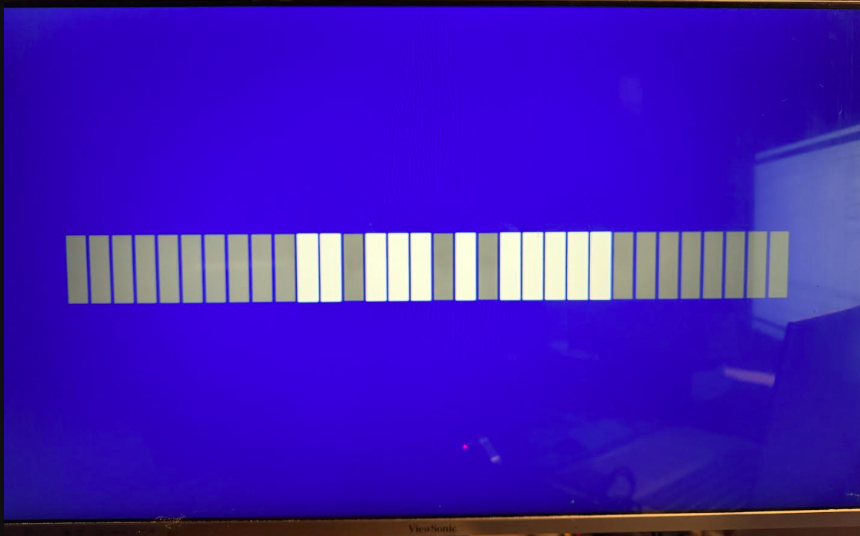
Fig. 13 The result of the factorial program in Verilog.

Our system could improve by adding pipelining which would allow each stage to work on different instructions at the same time instead of waiting for the previous instruction to finish all five stage.

References
[1] S. R. Sarangi, Computer Organization and Architecture. New Delhi, India: McGraw Hill Education, 2015.

