In AML (Azure Machine Learning), to code, whether using Notebooks or VSCode, each user should have its own compute instance (basically a virtually machine managed by Azure).

A compute instance is personal and cannot be shared among users. It should be created by the user themself or by an administrator and assigned to the user to own it. The compute instances appear under "Compute".

The user is responsible of launching and stopping the instance.

The instance can be accessed using Notebooks, VSCode or a Terminal.

When a compute instance is accessed, it points automatically to a shared storage.

Under this path, anything saved will be accessed by any other user in the same AML instance, through Notebooks or another instance. The instances storage can be accessed using the terminal with absolute paths.

3 work modes are available in AML: Azure Notebooks, Conda Notebooks and VSCode

All these environments need a compute to be used. The compute should be attached to the user.

**Quick-start guide :**

1. Go to "Compute" and create a compute instance. It may take few minutes

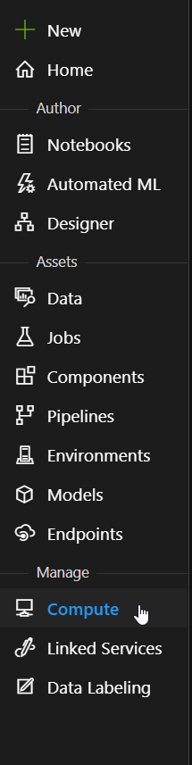

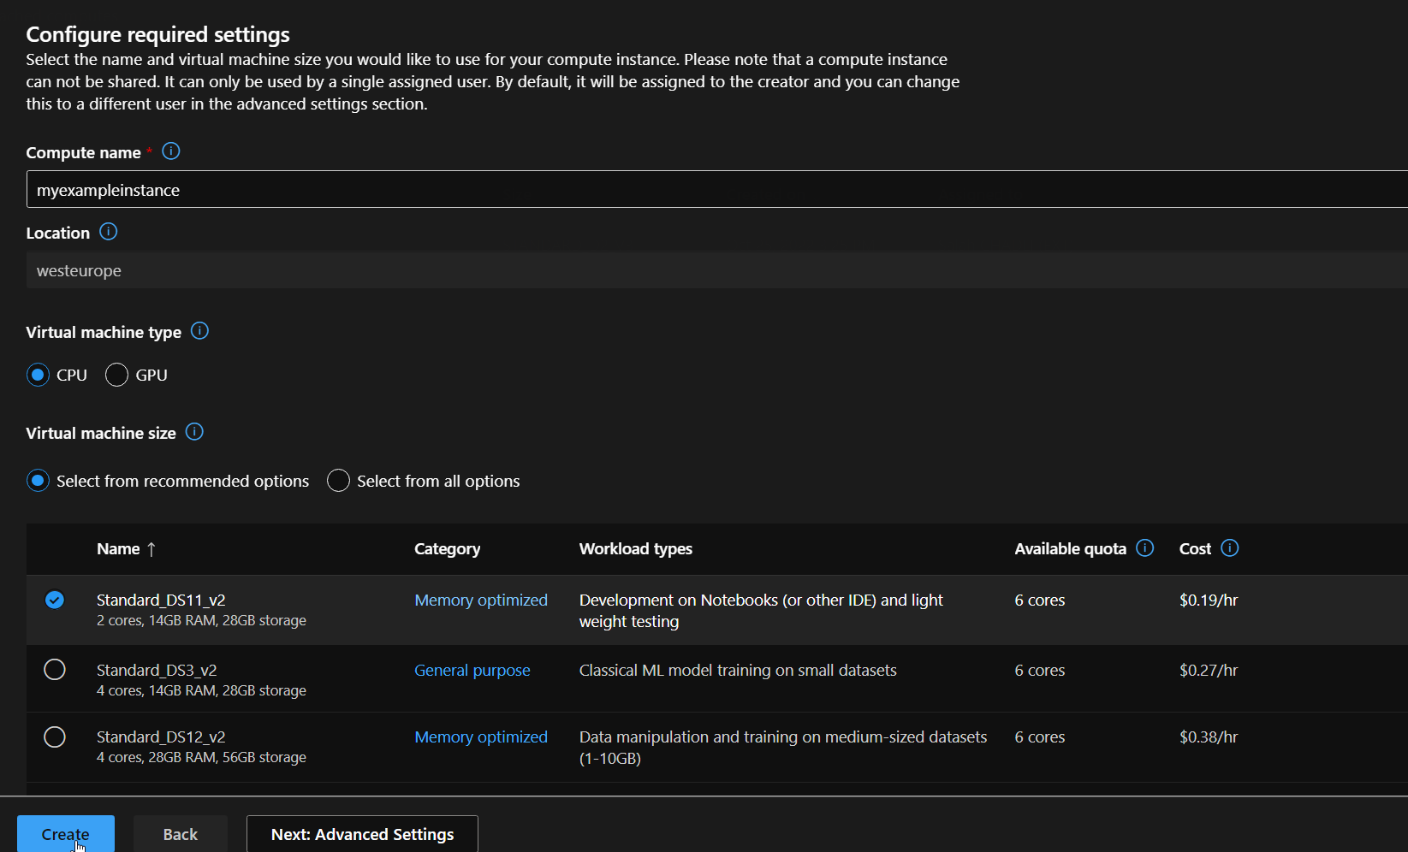

1. Launch the created instance using JupyterLab



1. Configure Git and clone this Github repository under your user directory in (/Users/$username)

https://github.com/chadlis/mlprojectexample

1. Follow the code structure given in the example to create your project (cf. README.md)
2. The instance should be stopped when not used. A schedule can be defined in the instance settings.