Chad Pietersen T231738

Ivcd105  Project 2

Website design and seo

# Content

Contents

Content 1

Business Name: Wikipedia 3

Type of Business 3

Purpose of the Business 3

Key Activities 4

Content Creation 4

Community Moderation 4

Fundraising 4

Technology Development 4

Target Audience or Users 4

Unique Selling Proposition (USP) 4

Business Model 4

History 4

Vision for the Future 4

Experience when visiting Wikipedia 5

1. Management Framework for Creating Websites: 6

Clear Objectives 6

User-Centered Design (UCD) 6

Content Strategy 6

Responsive Design 6

Content Management System (CMS) 6

2. Packaging Information/Information Chunking: 6

Use Headings and Subheadings 7

Bulleted and Numbered Lists 7

Short Paragraphs 7

Visual Aids 7

3. Specify an Overall Look and Feel (Text, Color, Images, Illustrations, Animation): 7

Consistent Branding 7

Typography 7

Color Scheme 7

Images and Illustrations 8

Animation 8

4. Creating Stickiness: 8

User-Friendly Navigation 8

Call-to-Action (CTA) 8

Engaging Content 8

Feedback Mechanisms 8

Performance Optimization 8

5. Keyword/Key Phrase Research and Analysis (Discovery Process): 9

Keyword Research 9

Competitor Analysis 9

Long-Tail Keywords 10

Keyword Mapping 10

6. How to Improve the Searchability of a Website - On-Page and Off-Page Ranking Factors: 10

On-Page Optimization 10

High-Quality Content 10

Title Tags and Meta Descriptions 10

Header Tags 10

URL Structure 10

7. Off-Page Optimization: 11

Backlinks 11

Social Signals 11

User Experience (UX) 11

8. External Link Building, Social Media, and Public Relations (WebPR): 11

Link Building 11

Social Media 11

Public Relations (WebPR) 11

Task 1: Organization Research

# Business Name: Wikipedia

Type of Business: Wikipedia is a nonprofit online encyclopedia and reference resource.

Purpose of the Business: Wikipedia's primary purpose is to provide free, reliable, and accessible information to people around the world. It aims to collect and disseminate knowledge on a wide range of topics, allowing anyone with internet access to read, edit, and contribute to its articles. Wikipedia is driven by the goal of democratizing knowledge and making it freely available to everyone.

Key Activities: Wikipedia's key activities include:

Content Creation: Wikipedia relies on volunteers to create, edit, and update its articles on various subjects. It has a vast community of editors who contribute their knowledge and expertise.

Community Moderation: Wikipedia maintains a system of checks and balances through community moderation to ensure the quality and accuracy of its content. Editors review and improve articles, and there are guidelines for sourcing and neutrality.

Fundraising: Wikipedia runs annual fundraising campaigns to cover its operating costs, including server maintenance, staff salaries, and other expenses necessary to keep the platform running.

Technology Development: Wikipedia continuously develops its software and platform to enhance user experience, accessibility, and security.

Target Audience or Users: Wikipedia's target audience is virtually anyone with internet access. It caters to a global audience of students, researchers, educators, professionals, and the public seeking information on a wide range of topics.

Unique Selling Proposition (USP): Wikipedia's unique selling proposition is its commitment to providing free and open access to knowledge. It distinguishes itself from traditional encyclopedias by allowing anyone to contribute, making it a collaborative and constantly evolving resource.

Business Model: Wikipedia operates as a nonprofit organization and relies on donations from users and supporters to fund its operations. It is not driven by profit but by the goal of knowledge dissemination.

History: Wikipedia was launched on January 15, 2001, by Jimmy Wales and Larry Sanger. It has since grown to become one of the largest and most visited reference websites globally, with millions of articles in multiple languages.

Vision for the Future: Wikipedia's vision is to continue expanding its content, improving accessibility, and ensuring the accuracy and reliability of its articles. It aims to remain a free and open resource for generations to come, furthering its mission of sharing knowledge with the world.

**Wikipedia's unique status as a nonprofit, collaborative, and open-access encyclopedia sets it apart from many traditional businesses, as its primary focus is on knowledge dissemination rather than profit generation.**

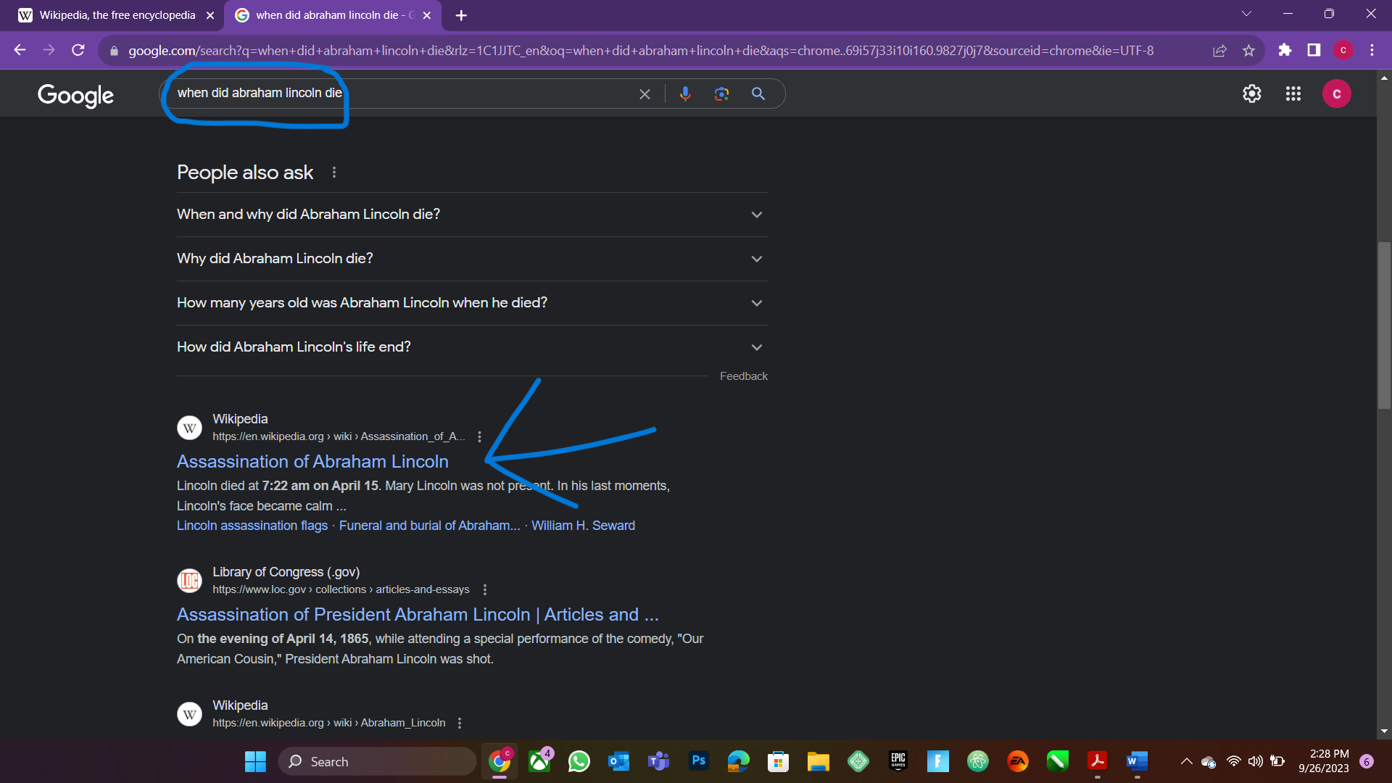

## Experience when visiting Wikipedia

In conclusion visiting Wikipedia offers a straightforward and user-friendly experience. You can search for information on a wide range of topics, explore well-structured articles with rich content, and access references for verification. It's a collaborative platform with a global community of editors, and it's ad-free, providing free and open access to knowledge for all.

Task 2: Effective Guidelines for a Website Design and Search Engine Optimization Research

# Management Framework for Creating Websites:

Clear Objectives: Start with a well-defined purpose for your website. Understand what you want to achieve, whether it's providing information, selling products, or building a community.

User-Centered Design (UCD): Prioritize the needs and preferences of your target audience. Use techniques like user personas, surveys, and usability testing to gather insights.

Content Strategy: Develop a content strategy that aligns with your objectives. Organize content logically, using categories, hierarchies, and tagging to make it easily navigable.

Responsive Design: Ensure your website is responsive, meaning it adapts to various screen sizes and devices, including mobile phones and tablets.

Content Management System (CMS): Consider using a CMS like WordPress, Drupal, or Joomla to simplify content creation and maintenance.

# Packaging Information/Information Chunking:

Use Headings and Subheadings: Break up content into sections with clear headings and subheadings. This aids readability and makes it easier for users to skim for relevant information.

Bulleted and Numbered Lists: Present lists or steps in a clear and concise manner using bullet points or numbers.

Short Paragraphs: Keep paragraphs brief and to the point. Use white space effectively to avoid overwhelming users with dense text.

Visual Aids: Incorporate relevant images, infographics, and videos to supplement text and convey information more effectively.

# Specify an Overall Look and Feel (Text, Color, Images, Illustrations, Animation):

Consistent Branding: Ensure that your website's design aligns with your brand identity, including the use of brand colors, logos, and fonts.

Typography: Choose readable fonts and maintain consistency throughout the website. Use font sizes and styles to emphasize key content.

Color Scheme: Select a harmonious color palette that aligns with your brand and evokes the desired emotional response. Ensure good contrast for readability.

Images and Illustrations: Use high-quality, relevant visuals that enhance your content. Optimize images to ensure fast loading times.

Animation: Implement animations judiciously to enhance user engagement but avoid excessive animations that can distract or slow down the site.

# Creating Stickiness:

User-Friendly Navigation: Design a clear and intuitive navigation menu. Use breadcrumb trails and site maps for complex websites.

Call-to-Action (CTA): Include compelling CTAs that guide users to take desired actions, such as signing up for newsletters, making purchases, or sharing content on social media.

Engaging Content: Regularly update your content to keep it fresh and relevant. Use storytelling techniques to engage users emotionally.

Feedback Mechanisms: Implement user feedback mechanisms, such as contact forms or surveys, to gather input and improve the website based on user suggestions.

Performance Optimization: Ensure fast page loading times, as slow websites can drive users away. Compress images, use content delivery networks (CDNs), and minimize unnecessary scripts.

***By following these guidelines, you can create a website that not only looks appealing but also provides a positive user experience, effectively communicates your message, and keeps visitors engaged and coming back for more.***

Search Engine Optimization (SEO) is a critical digital marketing strategy that aims to improve a website's visibility in search engine results. Here's an overview of how SEO can benefit a website and the key components involved:

# Keyword/Key Phrase Research and Analysis (Discovery Process):

Keyword Research: Start by identifying relevant keywords and key phrases that your target audience is likely to use when searching for products, services, or information related to your website.

Competitor Analysis: Study your competitors to see which keywords they are targeting and how they are performing in search results. Tools like Google Keyword Planner, SEMrush, and Ahrefs can assist in this process.

Long-Tail Keywords: In addition to broad keywords, consider long-tail keywords, which are more specific and often have lower competition. Long-tail keywords can attract highly targeted traffic.

Keyword Mapping: Organize keywords into groups and map them to specific pages or content on your website to ensure relevance.

# How to Improve the Searchability of a Website - On-Page and Off-Page Ranking Factors:

On-Page Optimization:

High-Quality Content: Create valuable, informative, and engaging content that addresses the needs of your target audience. Use relevant keywords naturally within the content.

Title Tags and Meta Descriptions: Optimize title tags and meta descriptions for each page, including relevant keywords and a compelling call to action.

Header Tags: Use header tags (H1, H2, H3, etc.) to structure your content logically and incorporate keywords in headers where relevant.

URL Structure: Ensure that URLs are clean, concise, and contain keywords. Avoid using long and confusing URLs.

# Off-Page Optimization:

Backlinks: Build high-quality, authoritative backlinks from reputable websites. Backlinks are a significant off-page ranking factor and can improve your site's authority.

Social Signals: Maintain an active presence on social media platforms. Social signals, such as shares and engagement, can indirectly impact your SEO.

User Experience (UX): Ensure your website is user-friendly and offers a positive experience. Fast loading times, mobile-friendliness, and easy navigation are essential.

# External Link Building, Social Media, and Public Relations (WebPR):

Link Building: Acquire backlinks from authoritative websites by creating valuable, shareable content and reaching out to relevant influencers or bloggers in your niche. Guest posting and creating link-worthy infographics are common strategies.

Social Media: Promote your content on social media platforms to increase its visibility and engagement. Social signals can indirectly influence your search engine rankings.

Public Relations (WebPR): Building a positive online reputation through public relations efforts can improve your website's credibility and indirectly impact SEO. This may involve online mentions, reviews, and media coverage.

***In summary, effective SEO involves a multifaceted approach that includes keyword research, on-page and off-page optimization, and strategic efforts to build external links and enhance your online presence through social media and public relations. Implementing these strategies can improve your website's searchability, increase organic traffic, and ultimately benefit your online presence and business success. It's important to note that SEO is an ongoing process, and staying up to date with industry trends and search engine algorithms is crucial for long-term success.***

# References

Business Name: Wikipedia

Type of Business: Nonprofit online encyclopedia and reference resource.

Purpose of the Business: Wikipedia. (2011). Purpose. [Online]. Available at: https://en.wikipedia.org. (Accessed: 22 September 2023).

Key Activities: Wikipedia. (2011). Key Activities. [Online]. Available at: https://en.wikipedia.org. (Accessed: 22 September 2023).

Target Audience or Users: Wikipedia. (2011). Target Audience or Users. [Online]. Available at: https://en.wikipedia.org. (Accessed: 22 September 2023).

Unique Selling Proposition (USP): Wikipedia. (2011). Unique Selling Proposition (USP). [Online]. Available at: https://en.wikipedia.org. (Accessed: 22 September 2023).

Business Model: Wikipedia. (2011). Business Model. [Online]. Available at: https://en.wikipedia.org. (Accessed: 22 September 2023).

History: Wikipedia. (2011). History. [Online]. Available at: https://en.wikipedia.org. (Accessed: 22 September 2023).

Vision for the Future: Wikipedia. (2011). Vision for the Future. [Online]. Available at: https://en.wikipedia.org. (Accessed: 22 September 2023).

Please use these references as needed in your work, ensuring that you properly cite the source when referencing Wikipedia's information.

Jordaan, K. (2023). e-WorldFile. In e-Marketing in the South African Context [PDF file]. Centurion Academy. Retrieved from https://moodle-ca.co.za

Jordaan, K. (2023). WebsitesFile. In e-Marketing in the South African Context [PDF file]. Centurion Academy. Retrieved from https://moodle-ca.co.za

Jordaan, K. (2023). SEMFile. In e-Marketing in the South African Context [PDF file]. Centurion Academy. Retrieved from https://moodle-ca.co.za

Jordaan, K. (2023). SEOFile. In e-Marketing in the South African Context [PDF file]. Centurion Academy. Retrieved from https://moodle-ca.co.za

Jordaan, K. (2023). Online AdvertisingFile. In e-Marketing in the South African Context [PDF file]. Centurion Academy. Retrieved from https://moodle-ca.co.za

Jordaan, K. (2023). e-CommerceFile. In e-Marketing in the South African Context [PDF file]. Centurion Academy. Retrieved from https://moodle-ca.co.za

Jordaan, K. (2023). Email MarketingFile. In e-Marketing in the South African Context [PDF file]. Centurion Academy. Retrieved from https://moodle-ca.co.za

Jordaan, K. (2023). Mobile MarketingFile. In e-Marketing in the South African Context [PDF file]. Centurion Academy. Retrieved from https://moodle-ca.co.za

Jordaan, K. (2023). Social Media MarketingFile. In e-Marketing in the South African Context [PDF file]. Centurion Academy. Retrieved from https://moodle-ca.co.za

Jordaan, K. (2023). e-Marketing ResearchFile. In e-Marketing in the South African Context [PDF file]. Centurion Academy. Retrieved from https://moodle-ca.co.za

Jordaan, K. (2023). e-Marketing Strategy and Planning. In e-Marketing in the South African Context [PDF file]. Centurion Academy. Retrieved from https://moodle-ca.co.za