During runtime:

If you use pixel:

* ( as a measure of size]
* as the screen density of device increases your elements will get smaller

if you use dp:

* [ as a measure of size ]
* As the screen density increases
* The scale factor increases
* Result:: renders your elements as intended

Human Fingertip is about 50 dp

XHDPI SCALE FACTOR = 2

PX = DP * (DPI / 160)

1920 = DP * (320/160) = DP * 2 = 1920 / 2 = 960 DP VERTICAL

1200 = DP * (320/160) = 1200 / 2 = 600 DP HORIZONTAL

So use dp for views and layouts

Use sp for textview

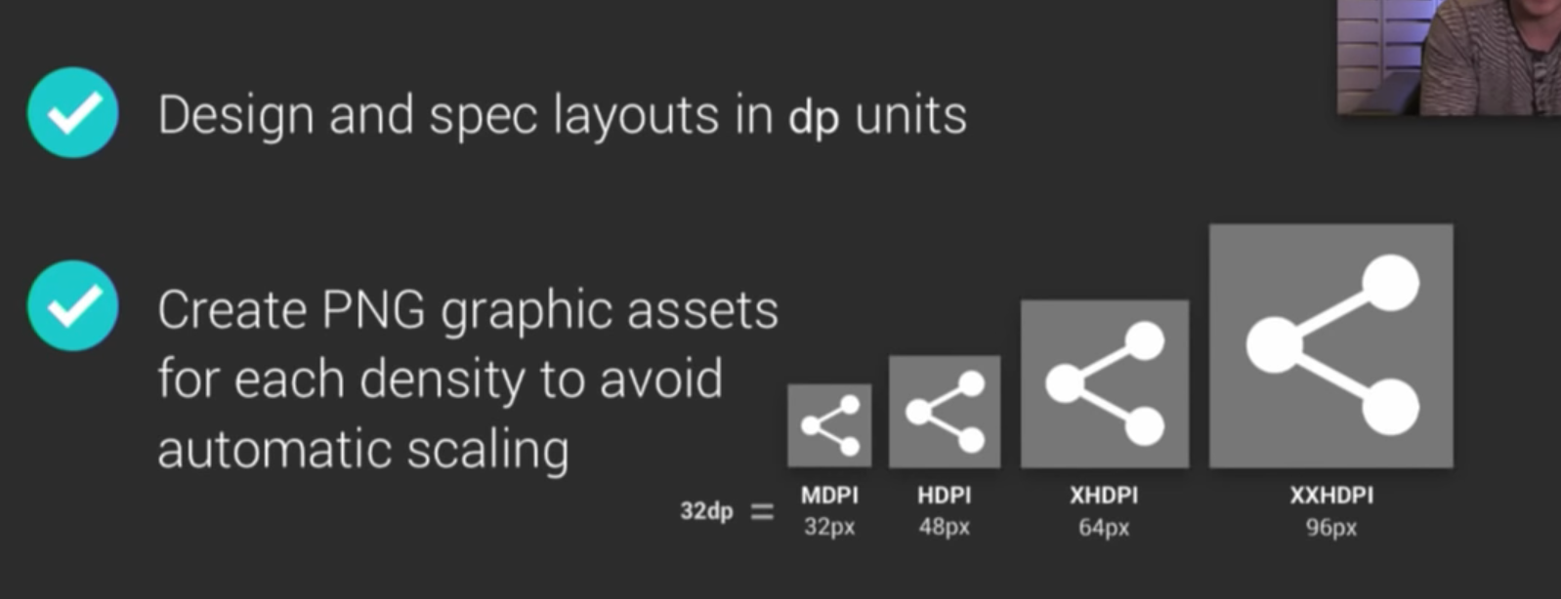

|  |  |  |  |
| --- | --- | --- | --- |
| General Definitions | | | |
| Pixel | One dot | Px | No scale |
| Density independent px | Indie of screen | Dp dip | Scale per screen density |
| Scale independent px | Only for text view | Sp | Dp and user prefer |
|  |  |  |  |
|  |  |  |  |

|  |  |  |  |
| --- | --- | --- | --- |
| Relationship – dp dpi px | | | |
| Px = dp * (dpi / 160 ] ; | | So 1 dp = | scale |
| Mpdi | Px = 1 dp * (160 dpi / 160 ] | 1 px | 1 x |
| Hdpi | Px = 1 dp * [240 dpi / 160 ] | 1.5 px | 1.5 x |
| Xhdpi |  | 2 px | 2.0 x |
| Xxxhpdi | 640 / 160 | 4 px | 4.0 x |

|  |  |  |  |
| --- | --- | --- | --- |
| Screen density | | | |
| Dpi | Dots per inch |  |  |
| Density independent px | Indie of screen | Dp | Scale per screen density |
| Scale independent px | Only for text view | Sp | Dp and user prefer |
|  |  |  |  |
|  |  |  |  |

|  |  |  |  |
| --- | --- | --- | --- |
| Screen Size and Screen Resolution | | | |
| Resolution | Size | Horizontal | Vertical |
| Half HD | 5.5 in | 720 | 1280 |
| Full HD | 5.5 in | 1080 | 1920 |
|  |  |  |  |
|  |  |  |  |

|  |  |  |  |
| --- | --- | --- | --- |
| Android logical pixel density “buckets” | | | |
| Logicl density | Name | Scale |  |
| 160 [baseline device] | M dpi | 1.0 x |  |
| 240 | H dpi | 1.5 x |  |
| 320 | Xh dpi | 2.0 x |  |
| 480 | Xxh dpi | 2.5 x |  |
| 640 | XXX dpi | 3.0 x |  |