

FFPAC Application Milestone #1

Team GVSU

Chad Mersino

Chris Schaefer

Laura Young

**Milestone #1 Report**

**Intended Progress:**

The first milestone presentation reflects 7 weeks worth of work already into this winter semester. Our group imagined our total progress on this application to be here currently (weekly basis):

* Became acquainted with group members (Week 1)
  + Learned schedules, planned meeting times and discussed strengths and weaknesses of ourselves. Came up with design process to ensure efficient development.
* Meet FFPAC representatives (Week 2)
  + Met Ross and Helen to get basic overview of requirements and features. Experienced how application will be applied.
* Obtained tools and applications to develop the application (Week 3)
  + Used PHPStorm and AMP as utensils to help with development.
* Development of front end of website at basic level (Week 4)
  + Implemented basic page features and menus to efficiently navigate the basic structures of the program.
* Developed basic database to interact with front end website (Week 5)
  + Created a few tables to help transfer data between them and give the website some functionality as means of example and for development.
* Received Database (Allendale campus only) from Laura (Week 6)
  + Met Laura at her office and received production data that we can use as entries for the database.
* Summarized progress and updated time entries on Wiki (Week 7)
  + Evaluated progress, created report based off progress and created presentation for milestone date.

**Progress Made:**

Currently, our group has an application that is a rough outline of what we wish to have completed for the FFPAC. Some of these features include selecting a room on Allendale campus, view a list of complaints and notes per room, a survey for users to improve the website, a section to complete a new complaint about a room and a walkthrough page that contains all the features on the site in one location. The database is currently being updated with the user changes for valid users only.

Our progress for the project seems to be on schedule for where our group would like to be. There were no major setbacks in development, just in getting actual production data that GVSU has for their list of classes. We are still waiting on the final version of the Grand Rapids campus to be presented to us so we can add those values to the database as well.

Another minor setback would be that we have not shown a good version of our project to the FFPAC themselves. Since we are going off of original assumptions and our vision of how the project looks now, the customer will more than likely have things they wish to be implemented or removed entirely from the site. This delay from talking to our representatives might end up haunting the group and can bring us more work than help. Since we are building the application for them, what they desire is what we will give them. If our vision of what they want is different from what they will want, the changes will obviously be made.

This program is intended to bring efficiency and aid to the users who will be revising the rooms on GVSU’s campuses. This brings the faculty a centralized location to store this information that can be used to make revisions for any classroom changes. We want to ensure that all mediums are able to run our application so that the convenience will be as high as possible for this project.

With our development process and the amount of work needed for the functionality to be there, we will have extra time to implement any extra features (like room selection via map of campus, color schemes, extra security/ login measures, etc.) along with overcoming any major setbacks along the way.

**Projected Progress:**

With our current pace of development from now until Week 11, we plan on having the following completed:

* Connecting the front end to the database (Week 8)
  + Ensure that entries are updated correctly and database is storing correct values
* Receive constructive feedback from FFPAC representatives (Week 9)
  + Schedule a meeting with Ross and Helen to demonstrate the website as it stands. Get their impressions of what they see and make any requested changes.
* Implementing the feedback (Week 10)
  + After meeting with Ross and Helen, delegate the revisions amongst group members and push the code by the end of the week.
* Entering the given data into the database (Week 11)
  + Once we receive all the data from the Grand Rapids campus, along with any more revisions to classes made in the past that are not in the current Allendale table, from Laura, we can ensure that our values used in the final project are true.

**Conclusion:**

Since we are on schedule, our group is confident in moving forward into the semester with the predictions made above for the second milestone. We took careful notes when it came to hearing what Ross and Helen wanted in this application. Since there are numerous examples of this type of program, having inspiration from other places helped mold the overall form of how this application runs and appears. With extra time, any extraordinary features that are not necessary but are very interesting and can aid the functionality of the project can be attended to.

**Gantt Charts:**

Current:

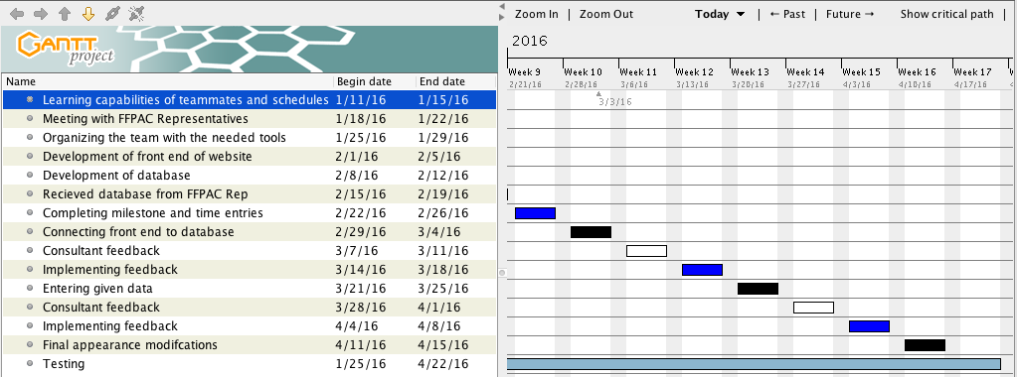

Milestone 1:

