ZAMASWAZI DLAMINI-MANDELA

ANNOUNCES 2019 USA LECTURE TOUR

**_____________________________________________________________________________________________**

**Princess Zamaswazi (Swati) Mandela**, has a story to tell.

Champion for building bridges between the powerful and the powerless.

Business developer, public speaker and self-described serial entrepreneur.

Featured in the Book “200 Women”.

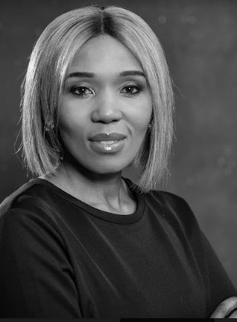

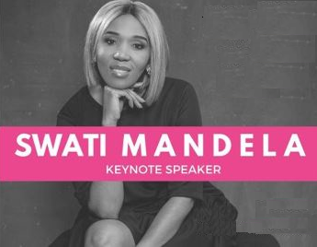

**“Each of us is responsible for creating the world in which we want to live in.”** -Swati Mandela

* Global Mentor for AIME
* Founding partner and managing director of Qunu Workforce, South Africa’s leading consultancy in creating equality in the workforce for those living with disabilities.
* Entrepreneur – Fashion Designer
* Midrand Graduate Institute
* Keynote Speaker at Enactus World Cup Canada, Pine Ridge, Stylecon Newport Beach and Dixie University.
* Co-Author of Winnie Mandela’s “491 Days: Prison Number 1323/69.”
* Wrote the foreword for “From Prison to President: The Letters of Nelson Mandela”

____________________________________ ______________________________________

336-749-2590 • info@groundgameinternational.com• twitter.com/princessdlamini

SWATI MANDELA

**_____________________________________________________________________________________________**

**From Fortune 500 companies to government agencies, non-profit organizations and universities, Mandela is becoming one of the top speakers in the world.**



**“Important, Relevant and Absolutely Essential”**

**“Engaging, Humorous and Thought-Provoking”**

**“Powerful and Entertaining”**

**"** **Be 'relentless' in your quest for freedom, equality.**”

-Swati Mandela

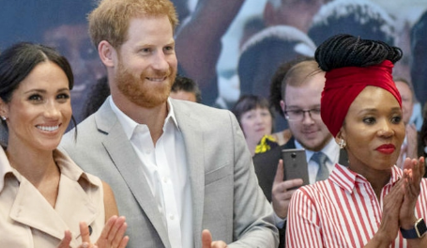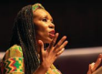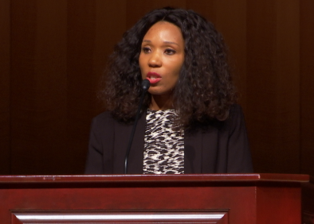

“**Swati Dlamini Mandela** took it to heart when her late grandfather, Nelson Mandela, South Africa’s first black president, issued a call to action when he turned 90: He had done his part, he said, and now was the time for others to step up to make the world a better place.”

-Daily Pilot

“Watching **Swati Mandela** speak was beyond inspiring.”

-Miracle of Mobility

“**Swati** is considered one of the most stylish women in South Africa and StyleCon is pleased to support her as she shares her important story.”

-StyleCon

SWATI MANDELA

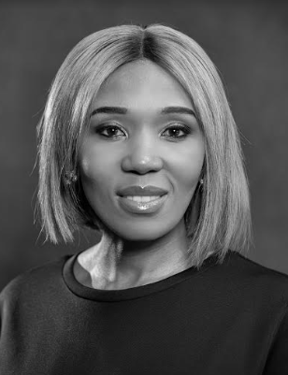**_____________________________________________________________________________________________**

**Princess Zamaswazi (Swati) Mandela**, has a story to tell. It is not merely the chronicle of a young girl growing up in the shadow of arguably the most influential couple of the 20th century, her grandparents Nelson and Winnie Mandela, although that is certainly a part of it.

Rather, Swati’s is the story of a high-achieving young South African woman who turned her celebrity into a global platform to empower women, and to fight for social justice, equality for those living with disabilities, and educational opportunities for disadvantaged youth.

That fight has taken many forms, from teaching her considerable entrepreneurial and public relations skills, to fundraising and consultancy. Recently it has pivoted to incorporate her engaging personality and wealth of knowledge and experience into a public speaking tour. Rather than telling her story one-on-one and to small groups, she is becoming a roving goodwill ambassador of sorts, spreading her message to hundreds and thousands at a time.

Currently, Swati and her team are organizing a lecture tour of U.S. colleges and universities, as well as select civic, business, educational and social groups. She plans to launch the yearlong tour in spring 2019. The full itinerary will be announced no later than December 2018.

Swati, grew up in a world of contrasts. Even as her grandfather was becoming an iconic, revered figure throughout the world, in her native land, the media and post-Apartheid patriarchal system were vilifying her grandmother. Aware of the horrors her grandfather had endured, while at the same time observing the scorn heaped upon her grandmother, she began to understand the role the media played in shaping opinion and both correcting and enabling injustice. She went on to earn her bachelor’s degree in Applied Public Relations from Midrand Graduate Institute in 2002. She worked for several communications firms, including Blackrock and Tincan, and in the press office of prestigious fashion designer House of Busby, before taking a position as spokesperson and chief fundraiser for 21 Icons. Among her successful projects for the firm were lead roles in producing documentaries on South Africa’s three Nobel Peace Prize winners: Desmond Tutu, F.W. de Klerk and, of course, Nelson Mandela.

Since 2015 she has been the managing director of Qunu Workforce, whose mandate is to create equality in the workplace for those living with disabilities. She is also a director of Long Walk To Freedom (LWTF), a non-profit that provides libraries for disadvantaged schools.

She is co-author of “491 Days,” a book written by her grandmother that details the brutality she received living under an Apartheid state. She also wrote the foreword to the book, “The Prison Letters of Nelson Mandela” (Published 2018), a collection of Nelson Mandela’s prison letters spanning the 27 years he was held as a political prisoner. Swati is proud to serve as a Global Ambassador/Mentor for AIME, an organization dedicated to building a “World Of Mentoring”, a bridge between universities and high schools.

Swati is a self-described serial entrepreneur. In 2017, Swati launched her luxury clothing label Swati by Roi Kaskara.

During her career climb, Swati had been pondering ways to improve the human condition. Her ideas began to coalesce during speaking engagements at Enactus World Cup Canada, Pine Ridge, Stylecon Newport Beach and Dixie University.

Her Feb. 2017 keynote address at Dixie University, a Utah liberal arts college, centered on her family’s legacy in building a sense of community in post-Apartheid South Africa.  Having been inspired by her grandmother who was a guiding light to women who endured the struggles of the Apartheid era, her proposed 2019 tour will expand on that theme, with an emphasis on the changing roles of women and children in society, social injustices against women, women’s empowerment, rights of the disabled, and other vital societal issues.

Swati is the daughter of Prince Thumbumuzi Dlamini and Princess Zenani Mandela. She resides in Johannesburg, South Africa.

To schedule an event or an interview with Swati Mandela, or for further information contact:

Ground Game International, LLC

1922 South Martin Luther King Drive

Suite #228

Winston Salem, NC 27107

Phone: 336-749-2590 Fax: 833-801-5633

Email: [info@groundgameinternational.com](mailto:info@groundgameinternational.com)