|  |  |
| --- | --- |
| Page Path | Global Mobility > Immigration > Entry Guidance |
| Location | Global |
| Article Title | Announcements |
| Excerpt | Immigration rules are complex and constantly changing. Check here to see what’s new. |
| Keywords | Immigration announcement, immigration updates |

# Entry Guidance

Immigration rules are complex and constantly changing. Check here to see what’s new.

[Context]

## Who It’s For

Employees considering or preparing to work in another country

[End context]

[Highlights]

* President Trump's 2017 Executive Orders on US immigration might impact some Facebook employees moving to the US for work.
* The Immigration team has proactively contacted all Facebook employees who are known to be impacted by the Executive Orders. If you have NOT been contacted by Immigration but believe you may be impacted by the EOs, please email [immigration@fb.com.](mailto:immigration@fb.com)
* For updates, see the [US Immigration Updates Group](https://www.facebook.com/groups/220125335116576/?fref=ts).
* Be sure you know your rights if you’re detained at the US border.

[End highlights]

[Details]

Decision Tree

Based on the Executive Order, we've developed a decision tree regarding entry to the US. If you plan to travel to the US, please review the tree as your ﬁrst point of reference, and contact [immigration@fb.com](mailto:immigration@fb.com) with additional questions.

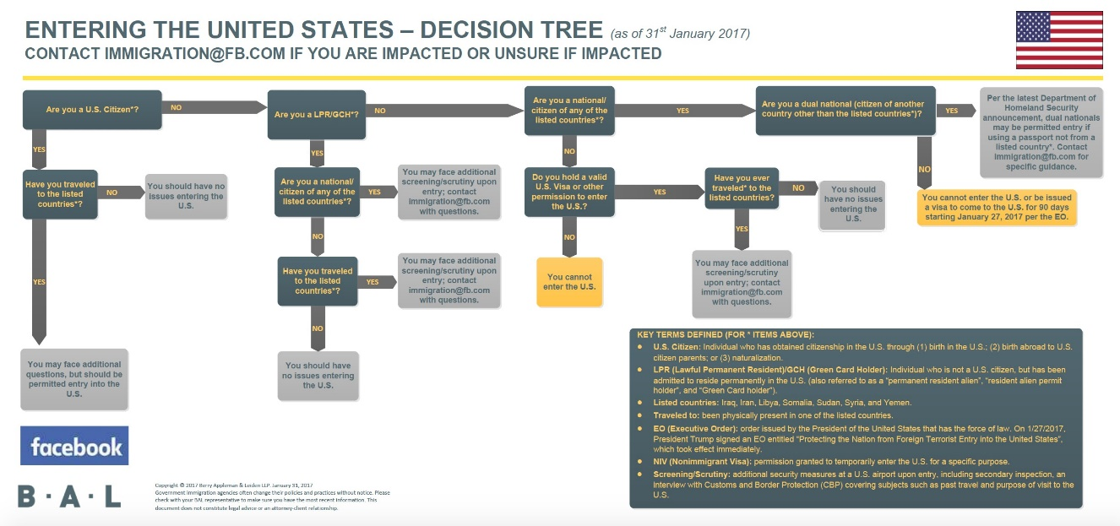

## Physical Security

If you encounter any security concerns during travel, please contact Facebook’s Global Security Operations Center (GSOC) at 650-384-2000 or [security@fb.com.](mailto:security@fb.com) The GSOC operates 24/7/365 and is here to support your physical safety and security during business travel.

If you encounter immigration issues with entry to the US at the airport or border crossing, contact the GSOC. They will route you to the appropriate contact (such as the Immigration team and/or Legal).

## Information Security

In general, traveling to the US with Facebook-issued or personal devices is ﬁne. However, given the current immigration landscape, we strongly recommend that travelers coming to the US:

* **Leave any devices you don't need at home**. You can get loaner devices from your closest Helpdesk, a Helpdesk at your destination or by emailing Help@.
* **Limit the data you store on the device**. This includes removing data automatically synced to your device, such as Dropbox, email, etc. For assistance with removing Dropbox & associated ﬁles, [click here](https://www.dropbox.com/en/help/41).
* **Remove the Yubikey from your device**.
* **If immigration officials ask you for access to the devices, you’re the best person to decide how to react given the circumstances.** You shouldn’t take into account protecting Facebook data when deciding how to act if asked to unlock devices. If you feel you should provide access, it’s OK. Remember, your personal well-being and security are most important.
* **At your ﬁrst opportunity, report the incident to GSOC**. Email [Security@fb.com](mailto:Security@fb.com) or call +1 650-384-2000.

For additional general guidance and tips when traveling, please visit <https://fburl.com/travelsecurity>.

## What to Do if You're Detained at the US Border

If you're detained at the US border, you should:

* Ask to speak to a lawyer. While there is no guarantee of the right to an attorney, you can and should ask, especially if you're asked to sign anything.
* Refuse to sign anything you don't understand.
* Ask to speak with your family. Again, there’s no guarantee of this right, but you may ask.
* Ask for food, water and/or bathroom access.

Keep in mind, your rights are limited at the US border. For example:

* You don’t have a right to an attorney when you apply for admission to the US and an immigration oﬃcer is inspecting you to decide whether or not you’ll be admitted. However, if the questions relate to anything other than your immigration status (such as an alleged criminal matter), you do have a right to an attorney and should request one.
* If you’re detained, you should inquire whether or not you’re in “custody.” If you’re in custody, then you have a right to an attorney and don’t need to answer any additional questions.