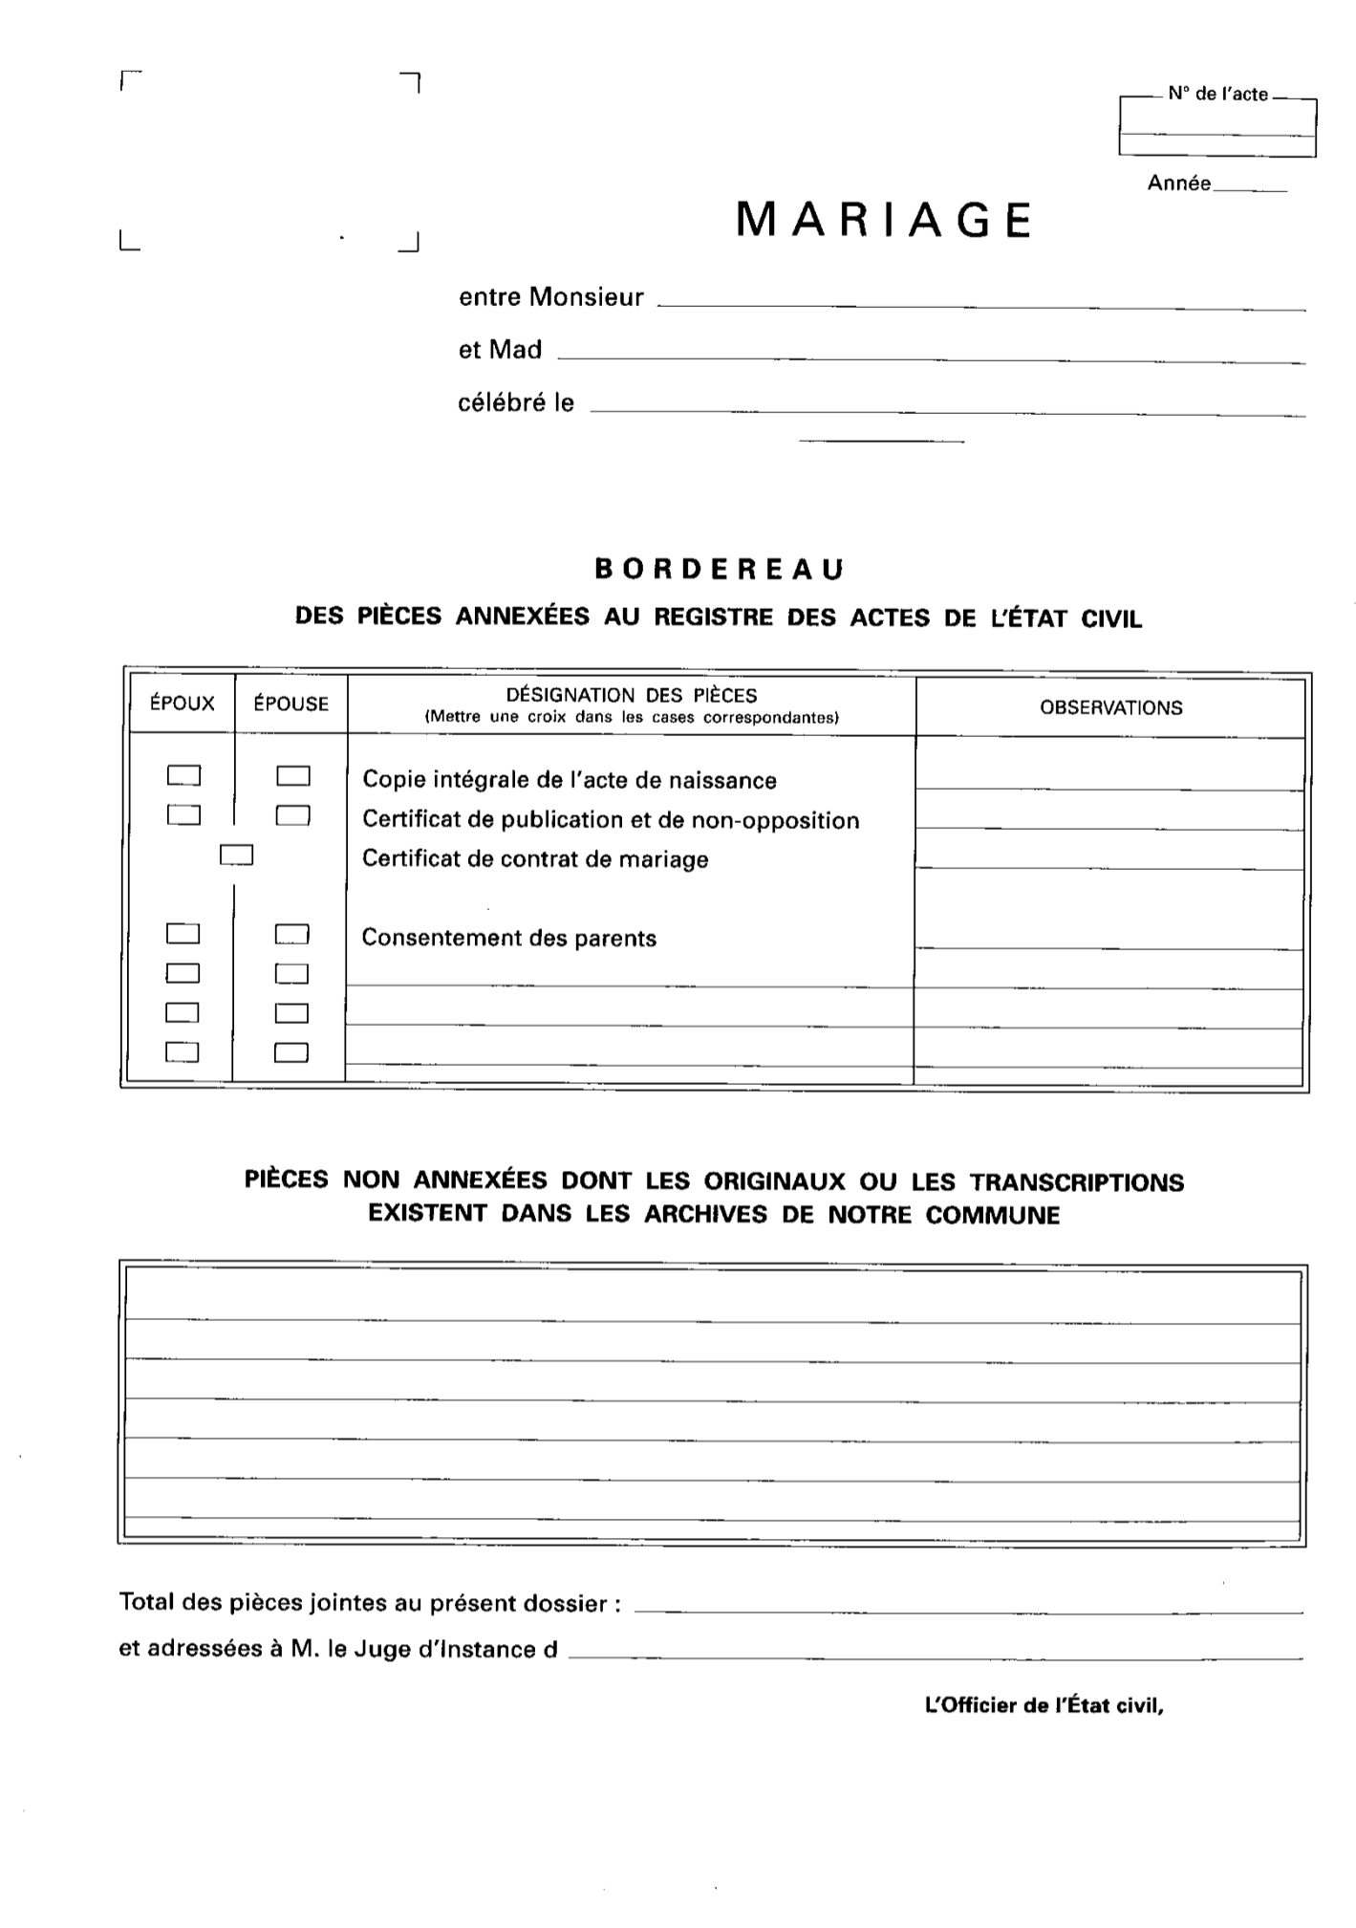
[numActe]
[prenomEpouse] [nomEpouse]
[prenomEpoux] [nomEpoux]
[dateMariage]
[annee]

