Statistical Analysis Report
  - Quarto starter template
Zarathu
2026-06-24
Table of contents

1. Overview
This report is a Quarto starter template. Replace the demo data import in global.R, update varlist, and rerun this document.

2. Baseline Characteristics
Table 1
Variable | Sex | Male | Female | p | sig
n |  | 138 | 90
Age (years) |  | 63.34 ± 9.14 | 61.08 ± 8.85 | 0.064
Age >= 65 years (%) | No | 71 (51.4) | 57 (63.3) | 0.103
 | Yes | 67 (48.6) | 33 (36.7)
ECOG performance status (%) | 0 | 36 (26.3) | 27 (30.0) | 0.823
 | 1 | 71 (51.8) | 42 (46.7)
 | 2 | 29 (21.2) | 21 (23.3)
 | 3 | 1 ( 0.7) | 0 ( 0.0)
ECOG >= 2 (%) | No | 107 (78.1) | 69 (76.7) | 0.928
 | Yes | 30 (21.9) | 21 (23.3)
Weight loss |  | 11.22 ± 12.98 | 7.77 ± 13.18 | 0.060
Weight loss >= 10 (%) | No | 66 (51.6) | 55 (64.0) | 0.099
 | Yes | 62 (48.4) | 31 (36.0)
Values are median (IQR) or n (%). P by Wilcoxon rank-sum test for continuous variables and Chi-squared or Fisher's exact test for categorical variables.

3. Survival Analysis
Table 2
Variable | crude HR(95%CI) | crude P value | adj. HR(95%CI) | adj. P value
sex: Female vs Male | 0.588 (0.424,0.816) | 0.0015 | 0.558 (0.396,0.788) | < 0.001
age | 1.019 (1.001,1.037) | 0.0419 | 1.013 (0.994,1.033) | 0.1755
ph.ecog: ref.=0
1 | 1.446 (0.98,2.134) | 0.0634 | 1.584 (1.053,2.382) | 0.0273
2 | 2.5 (1.61,3.883) | < 0.001 | 2.731 (1.664,4.483) | < 0.001
3 | 9.097 (1.218,67.937) | 0.0314 | 8.686 (1.135,66.457) | 0.0373
wt.loss | 1.001 (0.989,1.013) | 0.8282 | 0.991 (0.978,1.004) | 0.1749
Hazard ratios and 95% confidence intervals were estimated using Cox proportional hazards regression.
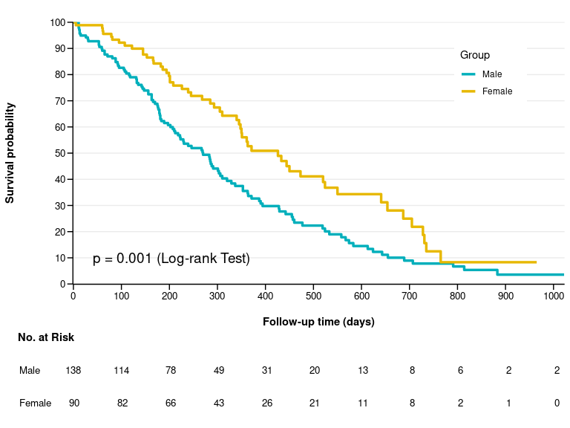
Figure 1: Kaplan-Meier curve by sex

4. Result Summary
- Replace this section with the main numerical findings after checking the final tables.
- Keep interpretation consistent with the model and endpoint definitions.
- Exported files are saved as Tables.xlsx and Figures.pptx when analysis.R is sourced.

5. Statistical Analysis
Baseline characteristics were summarized as median (interquartile range) for continuous variables and number (percentage) for categorical variables. Continuous variables were compared using the Wilcoxon rank-sum test, and categorical variables were compared using the chi-squared test or Fisher’s exact test, as appropriate. Time-to-event outcomes were analyzed using Kaplan-Meier curves and compared using the log-rank test. Hazard ratios and 95% confidence intervals were estimated using Cox proportional hazards regression.
All analyses were performed using R 4.5.2 (R Foundation for Statistical Computing, Vienna, Austria).

