**Homework #10 – MySQL**

Cowboys Bamazon is an online store that specializes in the sales of Dallas Cowboys replica jerseys. The store maintains an inventory of both current players and past Cowboys legends. Prices may vary, so happy shopping!

The following screenshots depict the functionality and application flow.

Launch application from Terminal to see the welcome message and current inventory:

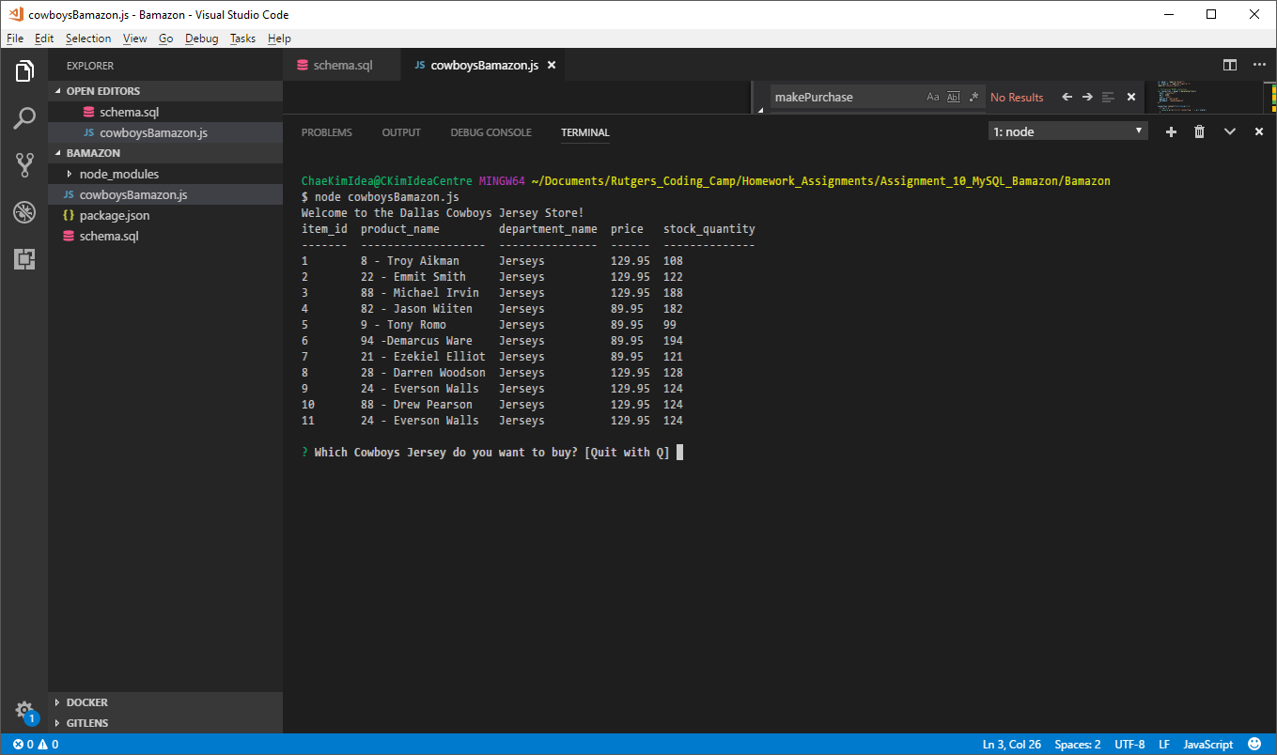

User makes a valid selection and purchase:

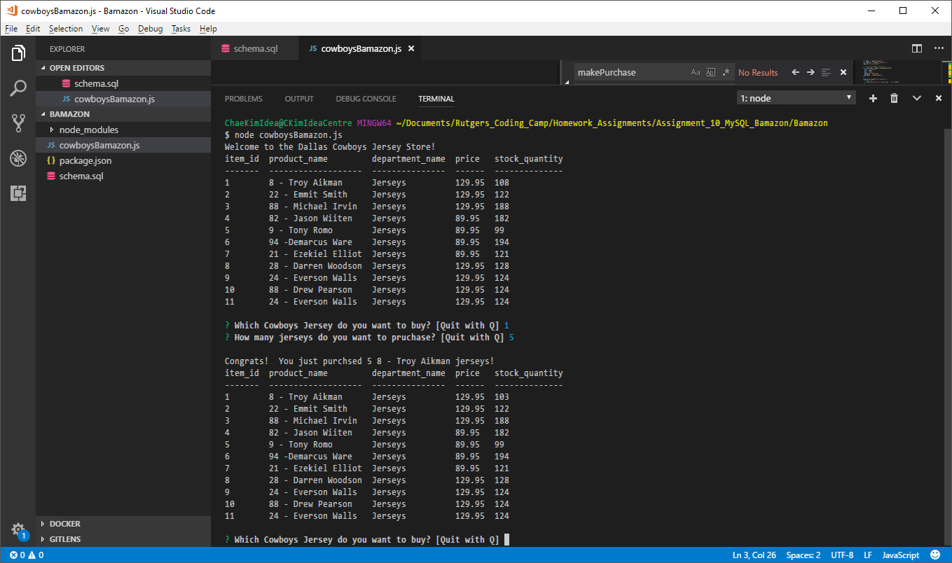

User then quits:

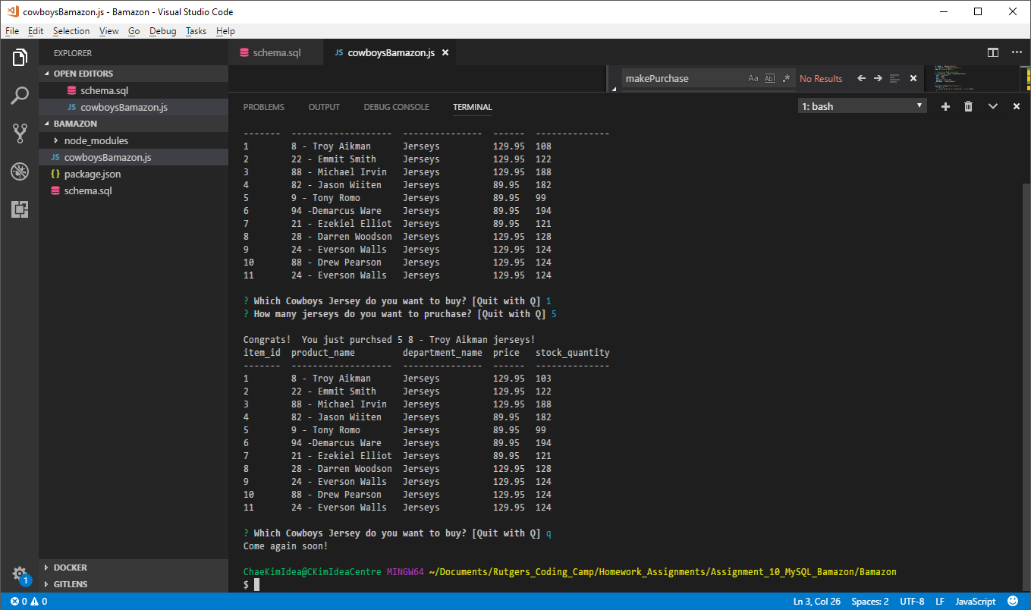

User makes an invalid product selection:

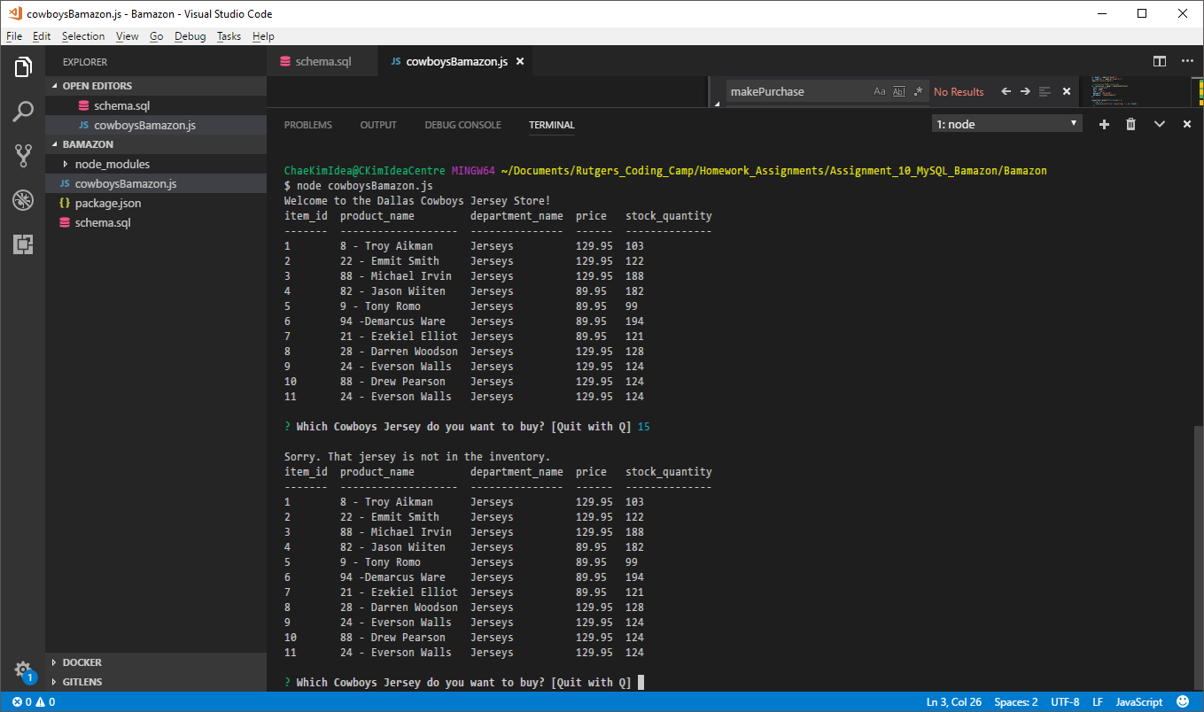

Not enough inventory in-stock:

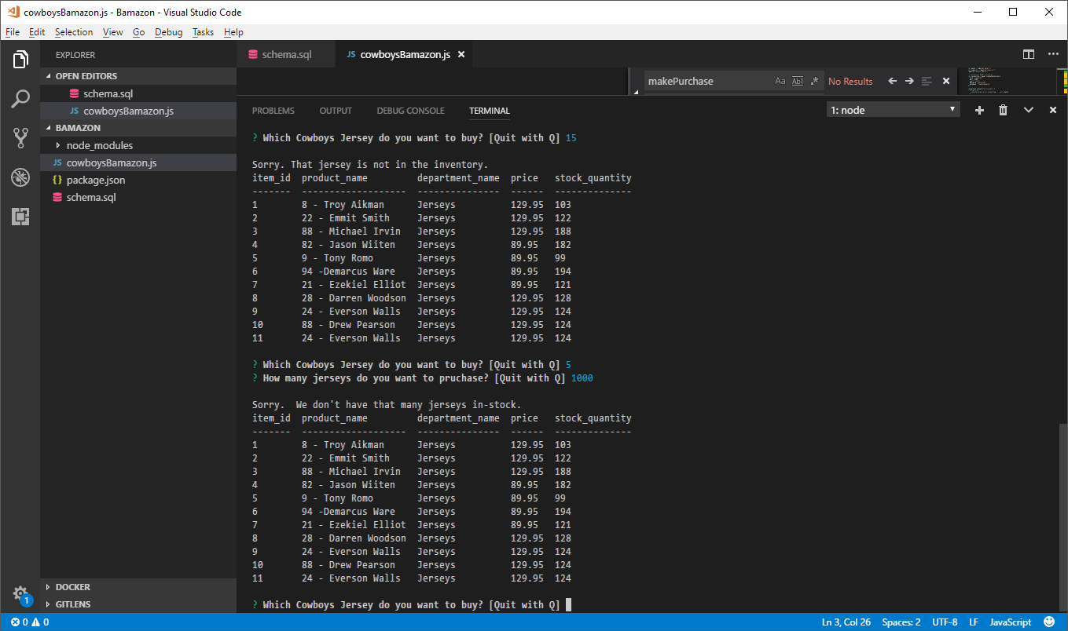

User makes a purchase and inventory is successfully reduced:

